Stage 1 Physics - Medical Science

Investigations Folio

Sight, Light, Hearing and Sound Design Investigation

You are to investigate an aspect of light or sound that has a real world application.
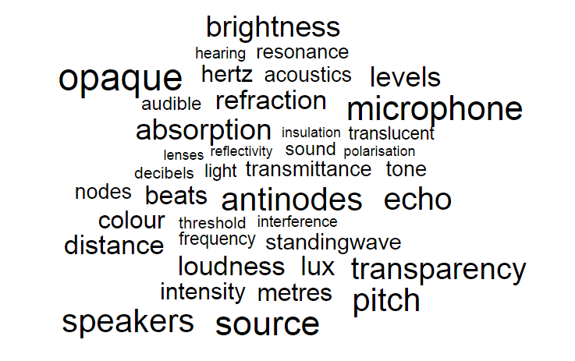
What is a situation/condition/scenario involving light or sound that you are interested in?
What is one aspect of this situation that you can measure?
What are all the things that could affect this aspect?
What will you change? What will you measure? How can you measure your variables?
How will you keep the other aspects constant?

You have access to standard laboratory equipment. Additionally you may use your smartphone or tablet - they can be tone generators, frequency analysers, audio frequency counters, dB meters, lux meters, colour temperature meters and a light source. Your computer may also be able to perform some of these functions.

An example of a student question: How does the speed of a car influence the noise level in the cabin? Justification: Noise level can affect human health.
Lesson 1 – Deconstructing the problem and designing your Investigation (in class under test conditions)
Come up with a question and refine that to a hypothesis. State your independent and dependent variables. State any other variables that may impact your dependent variable. Investigate (and possibly try out) possible ways to test your hypothesis. Determine how you can keep appropriate variables constant. List equipment and describe a step by step procedure. Use annotations to justify the decisions you make about variables, measurements, etc in your design.
This will be handed up on ____________________.

Lesson 2 - Performing the investigation
When you have received feedback and approval for your design, you will undertake the investigation.
You will have a double lesson to undertake the investigation, however if you are investigating real world phenomena outside of the classroom you may get permission to collect your data ahead of the lesson.

Prepare a report on the investigation you undertake.

The Design
Deconstruction
Summarise the way you have broken down the problem.
Purpose
State the purpose of the investigation clearly. State your rationale of investigation to a real world purpose.
Hypothesis
Write the question you investigated.
Identify the independent and dependent variables in your investigation.
Describe how you kept plan to keep other factors constant, why and how you will keep them constant.
Equipment
List the equipment or measuring instruments used.
Procedure
Describe the steps involved in your investigation. You are encouraged to use labelled diagrams.
Include a blank data table to show how you would record the results.

Annotate your deconstruction and design to justify the decisions you have made about such things as the weed you have chosen, the independent and dependent variables, how and why you will control other variables, number of trials, measurements.
Evidence of deconstruction, the method/procedure chosen as most appropriate, and a justification of the plan of action must be a maximum of 4 sides of an A4 page.
The Report Checklist
Introduction:
State hypothesis, variables
Materials and Method:
Materials used in the actual investigation
Steps in the investigation that you actually performed.
Data Representation
Record data and observations in table(s) using correct significant figures.
Plot a graph of your results - a line graph for continuous data, a column graph is discontinuous data.
Analysis and Interpretation
Describe the pattern of your results.
Include calculations you have made.
Explain your results using physics concepts.
Evaluation
Identify any anomalous results and suggest a reason(s) for them.
Discuss possible sources of random errors and the effect upon precision.
Discuss possible sources of systematic errors.
Place errors in order of impact.
Discuss the precision of your results.
Describe any further areas of investigation.
Conclusion
Write a conclusion with a justification that is based on the results of your investigation.
Relate your conclusion to the hypothesis and the purpose of your investigation.
Evidence of deconstruction must be attached to the practical report.

Stage 1 Physics - Medical Science Student Name:

Sight, Light, Hearing and Sound Design Investigation

 |  | A | B | C | D | E
The investigation design done before the experiment. | IAE1 | Critically deconstructs a problem and designs a logical, coherent, and detailed physics investigation. | Logically deconstructs a problem and designs a well-considered and clear physics investigation. | Deconstructs a problem and designs a considered and generally clear physics investigation. | Prepares a basic deconstruction of a problem and an outline of a physics investigation. | Attempts a simple deconstruction of a problem and a procedure for a physics investigation. | I
Results: Present the data collected in a table of results.  A line graph with a line or curve of best fit OR a column graph. Max-min bars will show the precision of your measurements.  Describe the trends and relationships as shown by your data. | IAE2 | Obtains, records, and represents data, using  appropriate conventions and formats accurately  and highly effectively. | Obtains, records, and displays findings of  investigations, using appropriate conventions  and formats mostly accurately and effectively. | Obtains, records, and displays findings of  investigations, using generally appropriate  conventions and formats with some errors but  generally accurately and effectively. | Obtains, records, and displays findings of  investigations, using conventions and formats  inconsistently, with occasional accuracy and  effectiveness. | Attempts to record and display some descriptive  results of an investigation, with limited accuracy  or effectiveness. | I
Discussion: Analyse and evaluate precision of your data and a description of sources of errors. Conclusion includes a clear and concise statement based on the data; supports or refutes the hypothesis. Any relationships established. | IAE3 | Systematically analyses and interprets data and evidence to formulate logical conclusions with detailed justification. | Logically analyses and interprets data and evidence to formulate suitable conclusions with reasonable justification. | Undertakes some analysis and interpretation of data and evidence to formulate generally appropriate conclusions with some justification. | Describes data and undertakes some basic interpretation to formulate a basic conclusion. | Attempts to describe results and/or interpret data to formulate a basic conclusion. | I
Discussion: Evaluate your procedure and discuss reliability and precision. | IAE4 | Critically and logically evaluates procedures and  their effects on data. | Logically evaluates procedures and their effects  on data. | Evaluates procedures and some of their effects  on data. | Attempts to evaluate procedures or suggest an  effect on data. | Acknowledges that procedures affect data. | I
Demonstration of physics understanding throughout the report, particularly the introduction and the interpretation of results. | KA1 | Demonstrates deep and broad knowledge and understanding of a range of physics concepts. | Demonstrates some depth and breadth of knowledge and understanding of a range of physics concepts. | Demonstrates knowledge and understanding of a general range of physics concepts. | Demonstrates some basic knowledge and partial understanding of physics concepts. | Demonstrates limited recognition and awareness of physics concepts. | I
Spelling, grammar, sentence and paragraph structure.  Appropriate use of physics terminology  Neat and clear presentation in an appropriate format | KA4 | Communicates knowledge and understanding of physics coherently with highly effective use of appropriate terms, conventions, and representations. | Communicates knowledge and understanding of physics mostly coherently with effective use of appropriate terms, conventions, and representations. | Communicates knowledge and understanding of physics generally effectively, using some appropriate terms, conventions, and representations. | Communicates basic physics information, using some appropriate terms, conventions, and/or representations. | Attempts to communicate information about physics. | I

