Clef and Pitch Awareness

Write the given note onto the other staves AT THE SAME PITCH.
i.e.
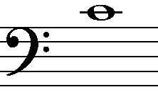

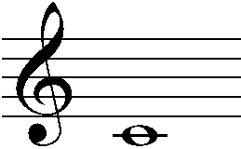
given note
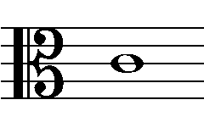

See blank template on page 2 for reproducing this question.

Other uses for this template;
The same blank template could also be used to ask INTERVAL questions.
i.e. Write a Major 3rd above/below the “given note.” Write your answer on both remaining blank staves ensuring that you are aware each clef.

Clef and Pitch Awareness







