Stage 2 Modern History
The Weimar Government – Sources Analysis

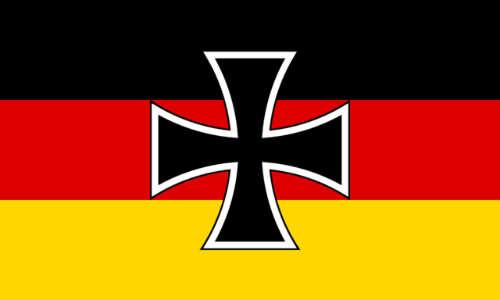

Due Date:
Word Limit: Maximum of 1000 words
Assessment Conditions: 1 week of class and homework time
Label your file: SACENUMBER-2MOD20-AT1-Weimar Sources
e.g. 123456R-2MOD20-AT1-Weimar Sources
- Please attach the assessment rubric sheet as the first page of your document
- Upload your work as a PDF to Canvas
- 1 ½ line spacing. Text must be justified.
- Identify your work with your SACE number and not your name in the bottom right hand footer.
- Include a word count on the final page of your completed work.

Instructions: Using the attached sources answer the following questions. Respond in full sentences and incorporate the sources into your answers where relevant. Points refer to the number of points you should make in each answer.

- Examine Source 2. What is one observation that can be made from this source about the benefits of the new Weimar constitution? [1 point]

- Using Source 3, identify two impressions of life in Berlin for those visiting Germany between 1924 and 1929. [2 points]

- What two conclusions about economic problems facing the Weimar Government can be drawn from Source 6? Use evidence from the sources to support your answer. [3 points]

- To what extent does Source 3 support the representation of Weimar Germany as depicted in Source 5? [4 points]

- Examine Source 1 and Source 4. With reference to the nature of the sources, assess the strengths and limitations of each source for historians researching Weimar Germany. [4 points]
- ‘Weimar Germany was characterised only by problems between 1919-29.’
Evaluate this proposition with reference to all of the sources. [6 points]

Assessment Criteria:
The assessment design criteria that will be assessed in this task are below (bolded)

 | Understanding and Exploration | Application and Evaluation | Analysis
 | UE1 Understanding and exploration of historical concepts.  UE2 Understanding and exploration of the role of ideas, people, and events in history.  . | AE1 Application of the skills of historical inquiry to examine and evaluate sources and interpretations.  AE2 Interpretation and synthesis of evidence to support arguments and draw conclusions.  AE3 Communication of reasoned historical arguments, with appropriate acknowledgment of sources. | A1 Analysis of ways in which the development of the modern world has been shaped by both internal and external forces and challenges.  A2 Analysis of interactions and relationships in the modern world and their short-term and long-term impacts on national, regional, and/or international development.

Checklist: In order to meet each criterion, you should aim to do the following in your response.

Assessment Criteria
Understanding and Exploration

- Show that you understand the sources clearly by using your own words rather than just copying the source.
- Read each question carefully and only answer what is being asked – do not go off track
Application and Evaluation
- Use relevant evidence from the sources when answering questions
- When cross-referencing sources (qu. 4) look for both comparisons and contrasts between the sources. Use supporting evidence to back these up
- When analysing the uses and limitations of sources (qu. 5) do not just summarise the sources. Consider the nature, origin and purpose of the source as well as the information that it provides. Deal with each source individually
- Use all the sources when answering qu. 6 do not just summarise each source – use the sources to support and justify your answer to the proposition
- Express your views clearly in continuous prose and in the form of historical argument
- Use formal language – avoid slang or colloquial language
- Acknowledge the sources appropriately – within a sources analysis such as this, you can do this by referring to the source within the sentence: e.g. as stated in source 6), or you can reference the source in brackets after you have used it (source 6)

Assessment Sheet
The Weimar Government – Sources Analysis

- | Understanding and Exploration | Application and Evaluation | Analysis
A | In-depth understanding and exploration of historical concepts.  Comprehensive understanding and insightful exploration of the role of ideas, people, and events in history. | Perceptive application of the skills of historical inquiry to critically examine and evaluate sources and interpretations.  Insightful interpretation and synthesis of relevant evidence to support arguments and draw highly relevant conclusions.  Communication of well-reasoned, coherent, and insightful historical arguments, with appropriate acknowledgment of sources. | Critical analysis of ways in which the development of the modern world has been shaped by both internal and external forces and challenges.  Insightful and critical analysis of interactions and relationships in the modern world and their short-term and long-term impacts on national, regional, and/or international development.
B | Some complexity in understanding and exploration of historical concepts.  Some depth of understanding and thoughtful exploration of the role of ideas, people, and events in history. | Well-considered application of the skills of historical inquiry to examine and evaluate sources and interpretations.  Some depth in interpretation and synthesis of mostly relevant evidence to support arguments and draw mostly relevant conclusions.  Communication of reasoned and coherent historical arguments, with some insights, and with appropriate acknowledgment of sources. | Some depth in analysis of ways in which the development of the modern world has been shaped by both internal and external forces and challenges.  Well-considered analysis of interactions and relationships in the modern world and their short-term and long-term impacts on national, regional, and/or international development.
C | Understanding and exploration of historical concepts.  Understanding and considered exploration of the role of ideas, people, and events in history. | Application of the skills of historical inquiry to examine sources and interpretations, with some evaluation.  Some interpretation and synthesis of generally relevant evidence to support arguments, and draw some relevant conclusions.  Communication of generally reasoned and coherent historical arguments, with appropriate acknowledgment of sources. | Description, with some analysis, of ways in which the development of the modern world has been shaped by both internal and external forces and challenges.  Description, with some analysis, of interactions and relationships in the modern world and their short-term and long-term impacts on national, regional, and/or international development.
D | Some recognition of historical concepts.  Recognition and basic understanding, with some exploration, of the role of ideas, people, and events in history. | Basic application of some skills of historical inquiry to select and use sources.  Use of some information, with partial relevance to support an argument or interpretation, and draw basic conclusions.  Communication of partial development of a historical argument, with attempted acknowledgment of sources. | Description of one or more ways in which the development of the modern world has been shaped by internal and/or external forces and/or challenges.  Superficial description of one or more interactions or relationships in the modern world.
E | Attempted engagement with one or more historical concepts.  Awareness of one or more idea, person, or event in history. | Attempted application of the skills of historical inquiry to select and use one or more sources.  Attempted use of information of limited relevance.  Attempted description of a historical event, with limited acknowledgment of sources. | Attempted description of a way in which the modern world has been shaped by an internal or external force or challenge.  Attempted description of an interaction or relationship in the modern world.

