
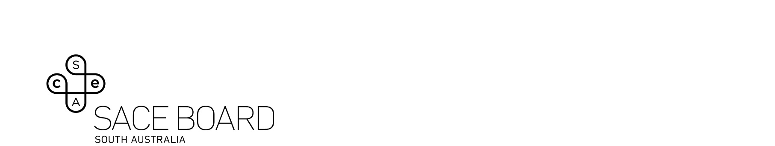
2023 Women’s Studies Subject Assessment Advice

Overview
Subject assessment advice, based on the 2023 assessment cycle, gives an overview of how students performed in their school and external assessments in relation to the learning requirements, assessment design criteria, and performance standards set out in the relevant subject outline. They provide information and advice regarding the assessment types, the application of the performance standards in school and external assessments, and the quality of student performance.
Teachers should refer to the subject outline for specifications on content and learning requirements, and to the subject operational information for operational matters and key dates.

School Assessment
Teachers can improve the moderation process and the online process by:
- ensuring the uploaded responses have font size minimum ten, at least 1.15 spacing and word count included.

Assessment Type 1: Text Analysis
For this assessment type, students undertake one or two text analysis assessments in which they analyse, for gender bias, the representation of gender in a text or texts, including cultural texts.
Teachers can elicit more successful responses by encouraging students to explore texts that include diversity of women’s experiences and ways of thinking.
The more successful responses commonly:
- used a range of texts or a text that enabled in-depth analysis of both the diversity of women’s experiences and their similarities
- analysed specific parts of the text/s that reflected bias views, treatment or stereotypes of women, with an intersectional approach
- used the language of gender analysis and understood a range of concepts e.g., gendered dichotomy, androcentrism, internalised misogyny
- fluently embedded evidence from the texts into the analysis
- demonstrated sufficient depth and breadth of understanding in relation to the construction of gender and gender relations
- established a connection between women’s identities and their social location.
The less successful responses commonly:
- did not cover the diversity of women’s experiences and focused on one society or similar societies
- recounted the text, rather than analysed the construction of gender within the text/s
- the choice of text/s chosen influenced the ability of the student to meet the assessment criteria
- were descriptive and narrative in approach; gender was described, rather than explored.

Assessment Type 2: Essay
For this assessment type, students undertake one or two text analysis assessments in which they analyse, for gender bias, the representation of gender in a text or texts, including cultural texts.
Teachers can elicit more successful responses by ensuring the question allows for students to write analytically and persuasively and allow students to construct their own focus and essay question.
The more successful responses commonly:
- had questions that allowed students to explore a gender issue, persuasively
- used a range of sources and referenced appropriately
- used a feminist framework for the exploration of the differences and commonalities between women
- used consistent formatting, with a clear focus for each paragraph
- demonstrated high levels of skills in the applied use of the language of gender.
The less successful responses commonly:
- had a statement rather than a specific question, e.g. ‘Does the way the western media report violence against women, perpetuate this violence by victim blaming or provide a way of changing attitudes to violence against women?’, encourages a gender analysis and the student to write from a point of view
- lacked reference to the cultural diversity and experiences of a range of women
- chose a question that did not have a gender focus
- demonstrated a limited acknowledgement of sources
- were a narrative rather than a persuasive essay.

Assessment Type 3: Folio
For this assessment type students undertake three gender analysis assessments.
Teachers can elicit more successful responses by covering three different issues and presenting work in different formats/ mediums.
The more successful responses commonly:
- illustrated perceptive and analytical insights in a creative form
- included varied task types and offered students a broad way of demonstrating the assessment criteria for each element of the folio
- covered a range of issues across different times, context, and cultures
- used a range of sources to demonstrate in-depth investigation
- analysed the concepts of identity in terms of class, sexuality, race, culture and religion; took an intersectional approach within a feminist framework.
The less successful responses commonly:
- covered similar issues across the tasks
- described rather than analysed the issues
- made minimal references to gender with limited use of gender-specific language.

External Assessment

Assessment Type 4: Issues Analysis
Students undertake one issues analysis. The following specific features of the assessment design criteria for the subject are assessed in the issues analysis task:
- knowledge and understanding — KU1
- gender analysis — GA1 and GA2
- investigation and evaluation — IE1
- communication — C1, C2, and C3.
Generally, most students demonstrated a sound understanding of gender and its impact on individuals and on specific groups.
Some issues analysis tasks utilised extensive quotes and were heavily referenced. Students must also ensure that a gender analysis of the issue is developed. While some displayed an in-depth investigation at an A level, the emphasis on gender analysis was more apparent in the C range. Students should aim to strike a better balance between these aspects.
The more successful responses commonly:
- demonstrated an understanding of gender and intersectionality in a personal sense and as an attribute that shapes a sense of identity, and in a political sense, as a pervasive social construction that can facilitate or hinder social relationships and access to institutions
- investigated, analysed, and deconstructed a number of particular examples in relation to their question, supported by referenced evidence
- demonstrated in-depth investigation and acknowledgement of all sources with consistent referencing
- demonstrated sophisticated, accurate and consistent use of the language of gender analysis that reinforced their point of view, in a persuasive style, embedding fluently the evidence in the analysis.
The less successful responses commonly:
- presented a health or social focused response, limiting the gender focus. This has been present in previous years and while the response is often well written and researched, it does not address some of the assessment criteria. E.g., discussed types of FGM, but did not address the ways of thinking behind it and the positioning and view of women
- extensively addressed the ways of effecting change and strategies for empowerment, when not addressed in this assessment type
- lacked depth and diversity of investigation.

General
In all assessment types, some students narrated and described, rather than analysed gender related to the chosen issue. As in previous years, students struggled with the evaluation of strategies for empowerment; they did not make a judgement on the various strategies’ effectiveness.
Students can achieve in the A band without reaching the maximum word limit. It is also to be noted that when an assessment type has more than one task, the evidence is viewed across the tasks in the assessment type and graded holistically, not allocated a percentage per task.
Overall, the standard across assessment types was consistently high and a range of issues explored.

