Personal Learning Plan

Learning Requirements Assessment Design Criteria
Understanding Capabilities
UC1 Understanding and explaining the selected capability or capabilities.

Developing Personal and Learning Goals
DP1 Identifying and exploring personal and learning goals and developing strategies to achieve them.
DP2 Interacting with others in developing and refining their strategies.
DP3 Developing the selected capability or capabilities relevant to achieving their goals.

Reviewing the Learning
RL1 Reviewing personal and learning goals and reflecting on the effectiveness of strategies to achieve them.
RL2 Reviewing the development of the selected capability or capabilities, and how this helps to achieve their goals.

1. identify, explore, and develop personal and learning goals, and strategies to achieve them
2. select, understand, and explain one or more capabilities relevant to achieving their goals
3. develop the selected capability or capabilities
4. review their learning.

Capabilities
The capabilities that have been identified are:
- literacy
- numeracy
- information and communication technology capability
- critical and creative thinking
- personal and social capability
- ethical understanding
- intercultural understanding

Evidence of Learning
Assessment Type 1: Folio
For this assessment type, students provide evidence of their learning in relation to the following assessment design criteria:
• understanding capabilities
• developing personal and learning goals.

Assessment Type 2: Review
For this assessment type, students provide evidence of their learning in relation to the following assessment design criterion:
• reviewing the learning.

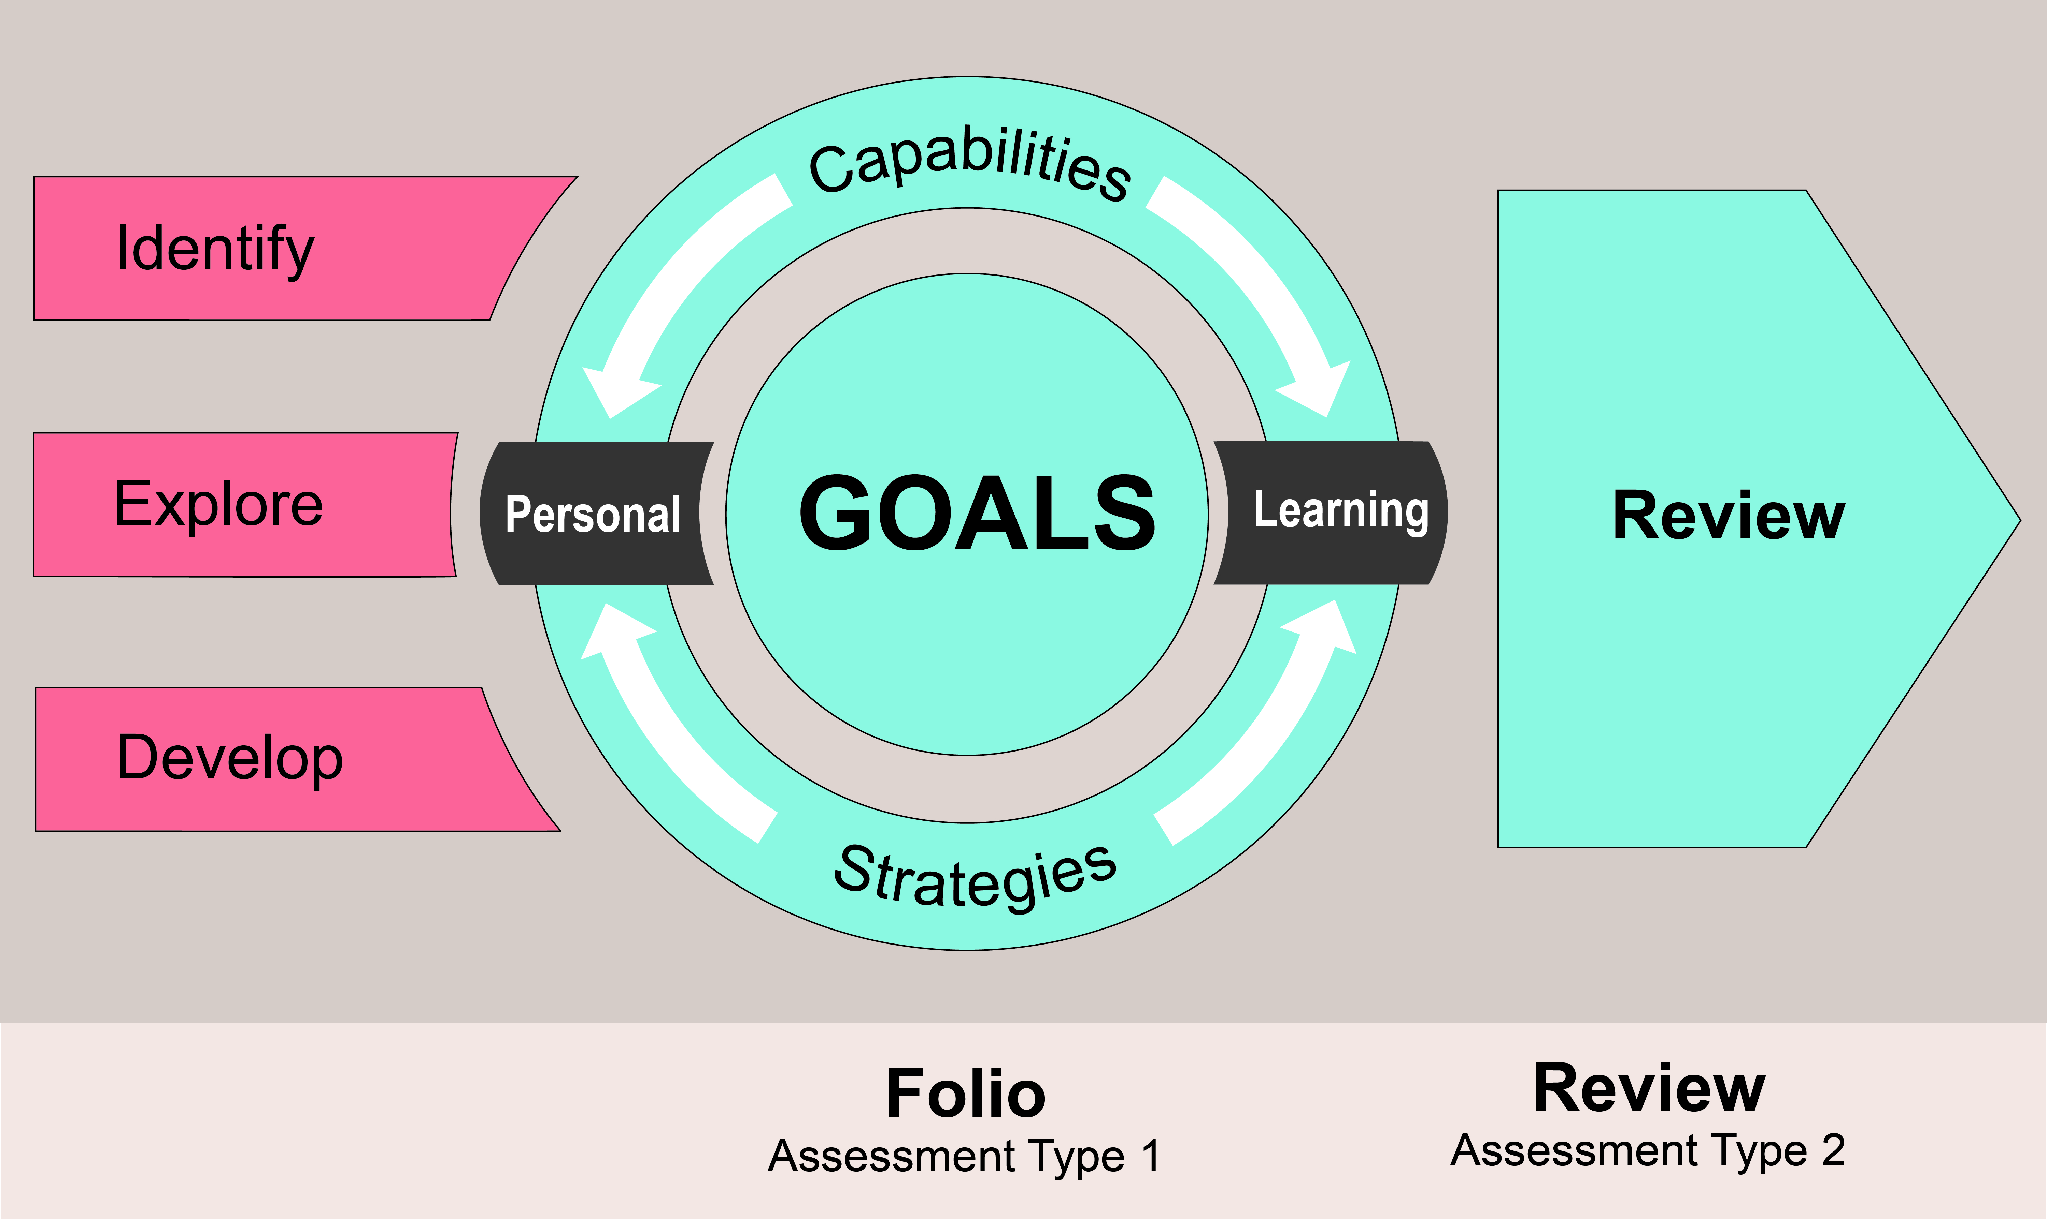

Performance Standards for the Stage 1 Personal Learning Plan

Assessment Type 1: Folio Assessment Type 2: Review

 | Understanding the Capabilities | Developing Personal and Learning Goals | Reviewing the Learning
A | Clearly explains understanding of the selected capability or capabilities, with insightful and detailed examples. | Clearly identifies personal and learning goals and purposefully explores them in detail. Develops a range of effective strategies to achieve them.  Interacts purposefully with others, in developing and refining strategies.  Effectively develops the selected capability or capabilities relevant to achieving his or her goals, in well-planned, insightful, and/or creative ways. | Clearly reviews personal and learning goals with insightful reflection on the effectiveness of strategies to achieve them.  Reviews the development of the selected capability or capabilities, with insights into how this helps to achieve his or her goals.
B | Explains understanding of the selected capability or capabilities, with some detailed examples. | Identifies personal and learning goals and explores them in some detail. Develops some effective strategies to achieve them.  Generally interacts effectively with others, in developing and refining strategies.  Develops the selected capability or capabilities relevant to achieving his or her goals, in a way that is mostly effective, and generally organised or creative. | Reviews personal and learning goals, with some insights into the effectiveness of strategies to achieve them.  Reviews the development of the selected capability or capabilities, with some ideas about how this helps to achieve his or her goals.
C | Gives some explanation of what the selected capability or capabilities are, with brief examples. | Identifies personal and learning goals and explores some aspects of these goals. Develops at least one effective strategy to achieve them.  Interacts with others, in developing and making some refinement to strategies.  Develops the selected capability or capabilities relevant to achieving his or her goals, in a way that has some effectiveness, and some organisation or creativity. | Reviews personal and learning goals, with some reflection on the effectiveness of the strategy or strategies to achieve them.  Reviews the development of the selected capability or capabilities, with an idea about how this helps to achieve his or her goals.
D | Gives some basic description of the selected capability or capabilities, with limited examples. | Identifies one or more personal or learning goals and locates some information that may be relevant to the goal(s). Describes aspects of a possible strategy that may help to achieve the goal(s).  Interacts with others with limited effectiveness, to talk about possible strategies.  Develops an aspect of the selected capability or capabilities, with partial effectiveness. The relevance to the goal(s) may not be clear. | Describes one or more personal or learning goals with some recount of learning in the subject.  Describes own participation in an activity to develop the selected capability or capabilities, with a vague link to goals.
E | Attempts to describe at least one capability and give an example. | Identifies a personal or learning goal without any realistic strategies to achieve it. Attempts to locate information that may be relevant to the goal.  Gives limited responses to questions from others about possible strategies.  Attempts to develop an aspect of the selected capability or capabilities, with limited effectiveness or relevance to the goal. | Gives limited responses to questions about learning in the subject.  Gives limited responses to questions about own participation in an activity to develop the selected capability or capabilities. Makes a superficial statement about a selected capability in attempting to identify a link to a goal.

