**AT1: Skills and Applications Tasks**

**Topic 2: Complex Numbers**

This Skills and Applications Task is divided into two parts. Part 1 is to be completed without a calculator or notes. For Part 2, you may have access to your graphics calculator and one A4 page of handwritten notes. You will commence with both parts of the task but will not have access to your calculator or notes until Part 1 is collected.

**Part 1: No calculator or notes 25 minutes Total = 19 marks**

**QUESTION 1 (3 marks)**

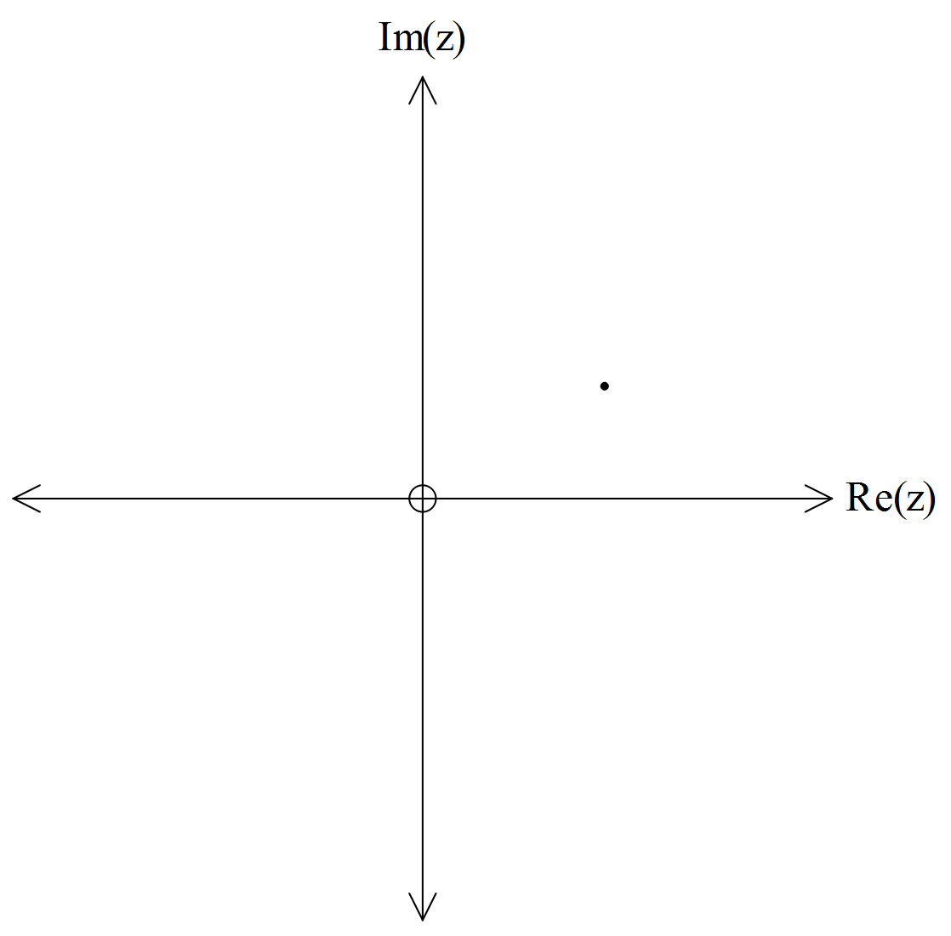

Given , show on the complex plane the position of *each* of the following complex numbers:

(a) 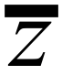

*z*

(b) 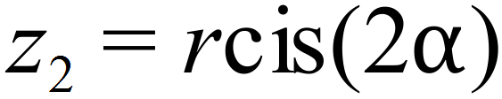

(c) 

(3 marks)

**QUESTION 2 (3 marks)**

Find *exact* values for the real numbers *a* and *b* if 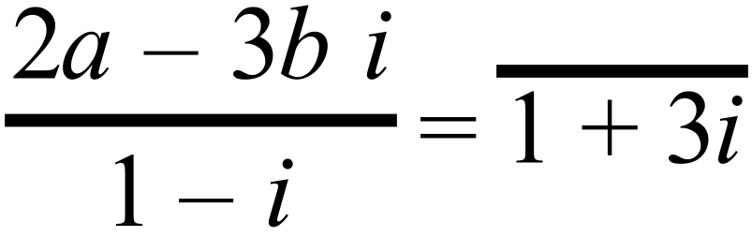.

|  |  |  |  |  |  |  |  |  |  |  |  |  |  |  |  |  |  |  |  |  |  |  |  |  |  |  |  |  |  |
| --- | --- | --- | --- | --- | --- | --- | --- | --- | --- | --- | --- | --- | --- | --- | --- | --- | --- | --- | --- | --- | --- | --- | --- | --- | --- | --- | --- | --- | --- |
|  |  |  |  |  |  |  |  |  |  |  |  |  |  |  |  |  |  |  |  |  |  |  |  |  |  |  |  |  |  |
|  |  |  |  |  |  |  |  |  |  |  |  |  |  |  |  |  |  |  |  |  |  |  |  |  |  |  |  |  |  |
|  |  |  |  |  |  |  |  |  |  |  |  |  |  |  |  |  |  |  |  |  |  |  |  |  |  |  |  |  |  |
|  |  |  |  |  |  |  |  |  |  |  |  |  |  |  |  |  |  |  |  |  |  |  |  |  |  |  |  |  |  |
|  |  |  |  |  |  |  |  |  |  |  |  |  |  |  |  |  |  |  |  |  |  |  |  |  |  |  |  |  |  |
|  |  |  |  |  |  |  |  |  |  |  |  |  |  |  |  |  |  |  |  |  |  |  |  |  |  |  |  |  |  |
|  |  |  |  |  |  |  |  |  |  |  |  |  |  |  |  |  |  |  |  |  |  |  |  |  |  |  |  |  |  |
|  |  |  |  |  |  |  |  |  |  |  |  |  |  |  |  |  |  |  |  |  |  |  |  |  |  |  |  |  |  |
|  |  |  |  |  |  |  |  |  |  |  |  |  |  |  |  |  |  |  |  |  |  |  |  |  |  |  |  |  |  |
|  |  |  |  |  |  |  |  |  |  |  |  |  |  |  |  |  |  |  |  |  |  |  |  |  |  |  |  |  |  |
|  |  |  |  |  |  |  |  |  |  |  |  |  |  |  |  |  |  |  |  |  |  |  |  |  |  |  |  |  |  |
|  |  |  |  |  |  |  |  |  |  |  |  |  |  |  |  |  |  |  |  |  |  |  |  |  |  |  |  |  |  |
|  |  |  |  |  |  |  |  |  |  |  |  |  |  |  |  |  |  |  |  |  |  |  |  |  |  |  |  |  |  |

(3 marks)

**QUESTION 3 (6 marks)**

The figure below shows the unit circle on which  , where  .



The line *RT* is a tangent to the circle at the point *R*(1, 0)

(a) Show that point *T* has co-ordinates 

|  |  |  |  |  |  |  |  |  |  |  |  |  |  |  |  |  |  |  |  |  |  |  |  |  |  |  |  |  |  |
| --- | --- | --- | --- | --- | --- | --- | --- | --- | --- | --- | --- | --- | --- | --- | --- | --- | --- | --- | --- | --- | --- | --- | --- | --- | --- | --- | --- | --- | --- |
|  |  |  |  |  |  |  |  |  |  |  |  |  |  |  |  |  |  |  |  |  |  |  |  |  |  |  |  |  |  |
|  |  |  |  |  |  |  |  |  |  |  |  |  |  |  |  |  |  |  |  |  |  |  |  |  |  |  |  |  |  |
|  |  |  |  |  |  |  |  |  |  |  |  |  |  |  |  |  |  |  |  |  |  |  |  |  |  |  |  |  |  |
|  |  |  |  |  |  |  |  |  |  |  |  |  |  |  |  |  |  |  |  |  |  |  |  |  |  |  |  |  |  |
|  |  |  |  |  |  |  |  |  |  |  |  |  |  |  |  |  |  |  |  |  |  |  |  |  |  |  |  |  |  |
|  |  |  |  |  |  |  |  |  |  |  |  |  |  |  |  |  |  |  |  |  |  |  |  |  |  |  |  |  |  |
|  |  |  |  |  |  |  |  |  |  |  |  |  |  |  |  |  |  |  |  |  |  |  |  |  |  |  |  |  |  |
|  |  |  |  |  |  |  |  |  |  |  |  |  |  |  |  |  |  |  |  |  |  |  |  |  |  |  |  |  |  |
|  |  |  |  |  |  |  |  |  |  |  |  |  |  |  |  |  |  |  |  |  |  |  |  |  |  |  |  |  |  |
|  |  |  |  |  |  |  |  |  |  |  |  |  |  |  |  |  |  |  |  |  |  |  |  |  |  |  |  |  |  |
|  |  |  |  |  |  |  |  |  |  |  |  |  |  |  |  |  |  |  |  |  |  |  |  |  |  |  |  |  |  |
|  |  |  |  |  |  |  |  |  |  |  |  |  |  |  |  |  |  |  |  |  |  |  |  |  |  |  |  |  |  |
|  |  |  |  |  |  |  |  |  |  |  |  |  |  |  |  |  |  |  |  |  |  |  |  |  |  |  |  |  |  |

(3 marks)

(b) Show that 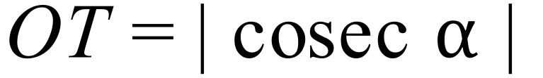.

|  |  |  |  |  |  |  |  |  |  |  |  |  |  |  |  |  |  |  |  |  |  |  |  |  |  |  |  |  |  |
| --- | --- | --- | --- | --- | --- | --- | --- | --- | --- | --- | --- | --- | --- | --- | --- | --- | --- | --- | --- | --- | --- | --- | --- | --- | --- | --- | --- | --- | --- |
|  |  |  |  |  |  |  |  |  |  |  |  |  |  |  |  |  |  |  |  |  |  |  |  |  |  |  |  |  |  |
|  |  |  |  |  |  |  |  |  |  |  |  |  |  |  |  |  |  |  |  |  |  |  |  |  |  |  |  |  |  |
|  |  |  |  |  |  |  |  |  |  |  |  |  |  |  |  |  |  |  |  |  |  |  |  |  |  |  |  |  |  |
|  |  |  |  |  |  |  |  |  |  |  |  |  |  |  |  |  |  |  |  |  |  |  |  |  |  |  |  |  |  |
|  |  |  |  |  |  |  |  |  |  |  |  |  |  |  |  |  |  |  |  |  |  |  |  |  |  |  |  |  |  |
|  |  |  |  |  |  |  |  |  |  |  |  |  |  |  |  |  |  |  |  |  |  |  |  |  |  |  |  |  |  |

(1 mark)

(c) Using the result from part (a) and (b) (i), and with reasoning, prove for the given values of  that .

|  |  |  |  |  |  |  |  |  |  |  |  |  |  |  |  |  |  |  |  |  |  |  |  |  |  |  |  |  |  |
| --- | --- | --- | --- | --- | --- | --- | --- | --- | --- | --- | --- | --- | --- | --- | --- | --- | --- | --- | --- | --- | --- | --- | --- | --- | --- | --- | --- | --- | --- |
|  |  |  |  |  |  |  |  |  |  |  |  |  |  |  |  |  |  |  |  |  |  |  |  |  |  |  |  |  |  |
|  |  |  |  |  |  |  |  |  |  |  |  |  |  |  |  |  |  |  |  |  |  |  |  |  |  |  |  |  |  |
|  |  |  |  |  |  |  |  |  |  |  |  |  |  |  |  |  |  |  |  |  |  |  |  |  |  |  |  |  |  |
|  |  |  |  |  |  |  |  |  |  |  |  |  |  |  |  |  |  |  |  |  |  |  |  |  |  |  |  |  |  |
|  |  |  |  |  |  |  |  |  |  |  |  |  |  |  |  |  |  |  |  |  |  |  |  |  |  |  |  |  |  |
|  |  |  |  |  |  |  |  |  |  |  |  |  |  |  |  |  |  |  |  |  |  |  |  |  |  |  |  |  |  |
|  |  |  |  |  |  |  |  |  |  |  |  |  |  |  |  |  |  |  |  |  |  |  |  |  |  |  |  |  |  |
|  |  |  |  |  |  |  |  |  |  |  |  |  |  |  |  |  |  |  |  |  |  |  |  |  |  |  |  |  |  |
|  |  |  |  |  |  |  |  |  |  |  |  |  |  |  |  |  |  |  |  |  |  |  |  |  |  |  |  |  |  |
|  |  |  |  |  |  |  |  |  |  |  |  |  |  |  |  |  |  |  |  |  |  |  |  |  |  |  |  |  |  |
|  |  |  |  |  |  |  |  |  |  |  |  |  |  |  |  |  |  |  |  |  |  |  |  |  |  |  |  |  |  |

(2 marks)

**QUESTION 4 (7 marks)**

Consider 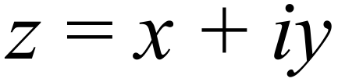 and 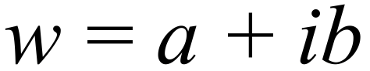 which are complex numbers.

1. Prove that 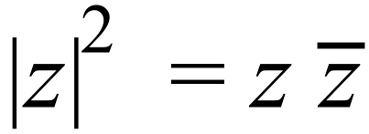 .

|  |  |  |  |  |  |  |  |  |  |  |  |  |  |  |  |  |  |  |  |  |  |  |  |  |  |  |  |  |  |
| --- | --- | --- | --- | --- | --- | --- | --- | --- | --- | --- | --- | --- | --- | --- | --- | --- | --- | --- | --- | --- | --- | --- | --- | --- | --- | --- | --- | --- | --- |
|  |  |  |  |  |  |  |  |  |  |  |  |  |  |  |  |  |  |  |  |  |  |  |  |  |  |  |  |  |  |
|  |  |  |  |  |  |  |  |  |  |  |  |  |  |  |  |  |  |  |  |  |  |  |  |  |  |  |  |  |  |
|  |  |  |  |  |  |  |  |  |  |  |  |  |  |  |  |  |  |  |  |  |  |  |  |  |  |  |  |  |  |
|  |  |  |  |  |  |  |  |  |  |  |  |  |  |  |  |  |  |  |  |  |  |  |  |  |  |  |  |  |  |
|  |  |  |  |  |  |  |  |  |  |  |  |  |  |  |  |  |  |  |  |  |  |  |  |  |  |  |  |  |  |
|  |  |  |  |  |  |  |  |  |  |  |  |  |  |  |  |  |  |  |  |  |  |  |  |  |  |  |  |  |  |
|  |  |  |  |  |  |  |  |  |  |  |  |  |  |  |  |  |  |  |  |  |  |  |  |  |  |  |  |  |  |

(2 marks)

(b) Prove that 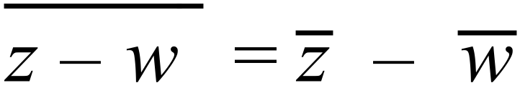 .

|  |  |  |  |  |  |  |  |  |  |  |  |  |  |  |  |  |  |  |  |  |  |  |  |  |  |  |  |  |  |
| --- | --- | --- | --- | --- | --- | --- | --- | --- | --- | --- | --- | --- | --- | --- | --- | --- | --- | --- | --- | --- | --- | --- | --- | --- | --- | --- | --- | --- | --- |
|  |  |  |  |  |  |  |  |  |  |  |  |  |  |  |  |  |  |  |  |  |  |  |  |  |  |  |  |  |  |
|  |  |  |  |  |  |  |  |  |  |  |  |  |  |  |  |  |  |  |  |  |  |  |  |  |  |  |  |  |  |
|  |  |  |  |  |  |  |  |  |  |  |  |  |  |  |  |  |  |  |  |  |  |  |  |  |  |  |  |  |  |
|  |  |  |  |  |  |  |  |  |  |  |  |  |  |  |  |  |  |  |  |  |  |  |  |  |  |  |  |  |  |
|  |  |  |  |  |  |  |  |  |  |  |  |  |  |  |  |  |  |  |  |  |  |  |  |  |  |  |  |  |  |
|  |  |  |  |  |  |  |  |  |  |  |  |  |  |  |  |  |  |  |  |  |  |  |  |  |  |  |  |  |  |
|  |  |  |  |  |  |  |  |  |  |  |  |  |  |  |  |  |  |  |  |  |  |  |  |  |  |  |  |  |  |
|  |  |  |  |  |  |  |  |  |  |  |  |  |  |  |  |  |  |  |  |  |  |  |  |  |  |  |  |  |  |

(2 marks)

(c) Let the point P represent the complex number z and the point Q represent the complex number *w*.

(i) Explain why 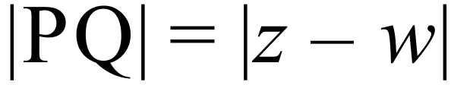 .

|  |  |  |  |  |  |  |  |  |  |  |  |  |  |  |  |  |  |  |  |  |  |  |  |  |  |  |  |  |  |
| --- | --- | --- | --- | --- | --- | --- | --- | --- | --- | --- | --- | --- | --- | --- | --- | --- | --- | --- | --- | --- | --- | --- | --- | --- | --- | --- | --- | --- | --- |
|  |  |  |  |  |  |  |  |  |  |  |  |  |  |  |  |  |  |  |  |  |  |  |  |  |  |  |  |  |  |
|  |  |  |  |  |  |  |  |  |  |  |  |  |  |  |  |  |  |  |  |  |  |  |  |  |  |  |  |  |  |
|  |  |  |  |  |  |  |  |  |  |  |  |  |  |  |  |  |  |  |  |  |  |  |  |  |  |  |  |  |  |
|  |  |  |  |  |  |  |  |  |  |  |  |  |  |  |  |  |  |  |  |  |  |  |  |  |  |  |  |  |  |

(1 mark)

(ii) Hence, using the results of the parts above, show that 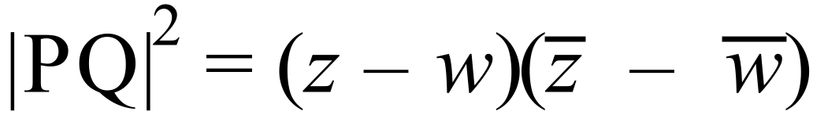 .

|  |  |  |  |  |  |  |  |  |  |  |  |  |  |  |  |  |  |  |  |  |  |  |  |  |  |  |  |  |  |
| --- | --- | --- | --- | --- | --- | --- | --- | --- | --- | --- | --- | --- | --- | --- | --- | --- | --- | --- | --- | --- | --- | --- | --- | --- | --- | --- | --- | --- | --- |
|  |  |  |  |  |  |  |  |  |  |  |  |  |  |  |  |  |  |  |  |  |  |  |  |  |  |  |  |  |  |
|  |  |  |  |  |  |  |  |  |  |  |  |  |  |  |  |  |  |  |  |  |  |  |  |  |  |  |  |  |  |
|  |  |  |  |  |  |  |  |  |  |  |  |  |  |  |  |  |  |  |  |  |  |  |  |  |  |  |  |  |  |
|  |  |  |  |  |  |  |  |  |  |  |  |  |  |  |  |  |  |  |  |  |  |  |  |  |  |  |  |  |  |
|  |  |  |  |  |  |  |  |  |  |  |  |  |  |  |  |  |  |  |  |  |  |  |  |  |  |  |  |  |  |
|  |  |  |  |  |  |  |  |  |  |  |  |  |  |  |  |  |  |  |  |  |  |  |  |  |  |  |  |  |  |
|  |  |  |  |  |  |  |  |  |  |  |  |  |  |  |  |  |  |  |  |  |  |  |  |  |  |  |  |  |  |
|  |  |  |  |  |  |  |  |  |  |  |  |  |  |  |  |  |  |  |  |  |  |  |  |  |  |  |  |  |  |

(2 marks)

**End of Part 1. Part 1 will be collected at the end of 25 minutes.**

**Be sure to check your work thoroughly before handing it up at the end of the allocated time.**

**Part 2: Calculator and notes may be used 35 minutes Total = 27 marks**

**Name/Registration Number ……………………………..**

**QUESTION 5 (5 marks)**

1. Write  in polar form.

|  |  |  |  |  |  |  |  |  |  |  |  |  |  |  |  |  |  |  |  |  |  |  |  |  |  |  |  |  |  |
| --- | --- | --- | --- | --- | --- | --- | --- | --- | --- | --- | --- | --- | --- | --- | --- | --- | --- | --- | --- | --- | --- | --- | --- | --- | --- | --- | --- | --- | --- |
|  |  |  |  |  |  |  |  |  |  |  |  |  |  |  |  |  |  |  |  |  |  |  |  |  |  |  |  |  |  |
|  |  |  |  |  |  |  |  |  |  |  |  |  |  |  |  |  |  |  |  |  |  |  |  |  |  |  |  |  |  |
|  |  |  |  |  |  |  |  |  |  |  |  |  |  |  |  |  |  |  |  |  |  |  |  |  |  |  |  |  |  |
|  |  |  |  |  |  |  |  |  |  |  |  |  |  |  |  |  |  |  |  |  |  |  |  |  |  |  |  |  |  |
|  |  |  |  |  |  |  |  |  |  |  |  |  |  |  |  |  |  |  |  |  |  |  |  |  |  |  |  |  |  |
|  |  |  |  |  |  |  |  |  |  |  |  |  |  |  |  |  |  |  |  |  |  |  |  |  |  |  |  |  |  |

(2 marks)

1. Hence determine the exact value of 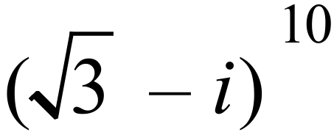 in the form 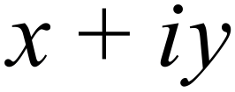 .

|  |  |  |  |  |  |  |  |  |  |  |  |  |  |  |  |  |  |  |  |  |  |  |  |  |  |  |  |  |  |
| --- | --- | --- | --- | --- | --- | --- | --- | --- | --- | --- | --- | --- | --- | --- | --- | --- | --- | --- | --- | --- | --- | --- | --- | --- | --- | --- | --- | --- | --- |
|  |  |  |  |  |  |  |  |  |  |  |  |  |  |  |  |  |  |  |  |  |  |  |  |  |  |  |  |  |  |
|  |  |  |  |  |  |  |  |  |  |  |  |  |  |  |  |  |  |  |  |  |  |  |  |  |  |  |  |  |  |
|  |  |  |  |  |  |  |  |  |  |  |  |  |  |  |  |  |  |  |  |  |  |  |  |  |  |  |  |  |  |
|  |  |  |  |  |  |  |  |  |  |  |  |  |  |  |  |  |  |  |  |  |  |  |  |  |  |  |  |  |  |
|  |  |  |  |  |  |  |  |  |  |  |  |  |  |  |  |  |  |  |  |  |  |  |  |  |  |  |  |  |  |
|  |  |  |  |  |  |  |  |  |  |  |  |  |  |  |  |  |  |  |  |  |  |  |  |  |  |  |  |  |  |
|  |  |  |  |  |  |  |  |  |  |  |  |  |  |  |  |  |  |  |  |  |  |  |  |  |  |  |  |  |  |

(3 marks)

**QUESTION 6 (3 marks)**

The circle shown below is the graph of the complex numbers *z*, where  .

 is one endpoint of *OP*, the diameter of the circle. Find the *exact* values of both the complex number *a*, in the form  and the real number *b*.



|  |  |  |  |  |  |  |  |  |  |  |  |  |  |  |  |  |  |  |  |  |  |  |  |  |  |  |  |  |  |
| --- | --- | --- | --- | --- | --- | --- | --- | --- | --- | --- | --- | --- | --- | --- | --- | --- | --- | --- | --- | --- | --- | --- | --- | --- | --- | --- | --- | --- | --- |
|  |  |  |  |  |  |  |  |  |  |  |  |  |  |  |  |  |  |  |  |  |  |  |  |  |  |  |  |  |  |
|  |  |  |  |  |  |  |  |  |  |  |  |  |  |  |  |  |  |  |  |  |  |  |  |  |  |  |  |  |  |
|  |  |  |  |  |  |  |  |  |  |  |  |  |  |  |  |  |  |  |  |  |  |  |  |  |  |  |  |  |  |
|  |  |  |  |  |  |  |  |  |  |  |  |  |  |  |  |  |  |  |  |  |  |  |  |  |  |  |  |  |  |
|  |  |  |  |  |  |  |  |  |  |  |  |  |  |  |  |  |  |  |  |  |  |  |  |  |  |  |  |  |  |
|  |  |  |  |  |  |  |  |  |  |  |  |  |  |  |  |  |  |  |  |  |  |  |  |  |  |  |  |  |  |
|  |  |  |  |  |  |  |  |  |  |  |  |  |  |  |  |  |  |  |  |  |  |  |  |  |  |  |  |  |  |
|  |  |  |  |  |  |  |  |  |  |  |  |  |  |  |  |  |  |  |  |  |  |  |  |  |  |  |  |  |  |
|  |  |  |  |  |  |  |  |  |  |  |  |  |  |  |  |  |  |  |  |  |  |  |  |  |  |  |  |  |  |
|  |  |  |  |  |  |  |  |  |  |  |  |  |  |  |  |  |  |  |  |  |  |  |  |  |  |  |  |  |  |
|  |  |  |  |  |  |  |  |  |  |  |  |  |  |  |  |  |  |  |  |  |  |  |  |  |  |  |  |  |  |
|  |  |  |  |  |  |  |  |  |  |  |  |  |  |  |  |  |  |  |  |  |  |  |  |  |  |  |  |  |  |
|  |  |  |  |  |  |  |  |  |  |  |  |  |  |  |  |  |  |  |  |  |  |  |  |  |  |  |  |  |  |

(3 marks)

**QUESTION 7 (6 marks)**(a) Express in exact 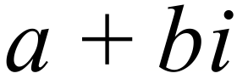 form. 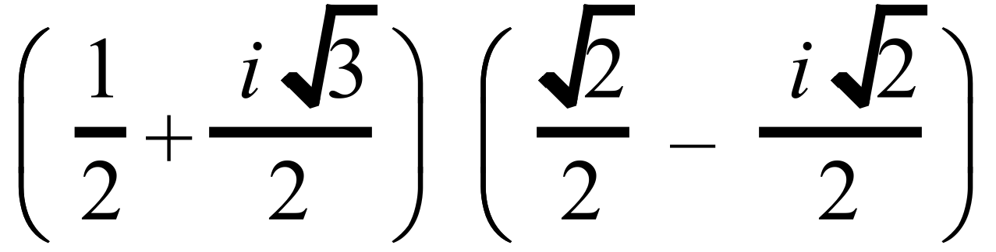

|  |  |  |  |  |  |  |  |  |  |  |  |  |  |  |  |  |  |  |  |  |  |  |  |  |  |  |  |  |  |
| --- | --- | --- | --- | --- | --- | --- | --- | --- | --- | --- | --- | --- | --- | --- | --- | --- | --- | --- | --- | --- | --- | --- | --- | --- | --- | --- | --- | --- | --- |
|  |  |  |  |  |  |  |  |  |  |  |  |  |  |  |  |  |  |  |  |  |  |  |  |  |  |  |  |  |  |
|  |  |  |  |  |  |  |  |  |  |  |  |  |  |  |  |  |  |  |  |  |  |  |  |  |  |  |  |  |  |
|  |  |  |  |  |  |  |  |  |  |  |  |  |  |  |  |  |  |  |  |  |  |  |  |  |  |  |  |  |  |
|  |  |  |  |  |  |  |  |  |  |  |  |  |  |  |  |  |  |  |  |  |  |  |  |  |  |  |  |  |  |
|  |  |  |  |  |  |  |  |  |  |  |  |  |  |  |  |  |  |  |  |  |  |  |  |  |  |  |  |  |  |
|  |  |  |  |  |  |  |  |  |  |  |  |  |  |  |  |  |  |  |  |  |  |  |  |  |  |  |  |  |  |

(2 marks)

1. Write in polar form:
2. 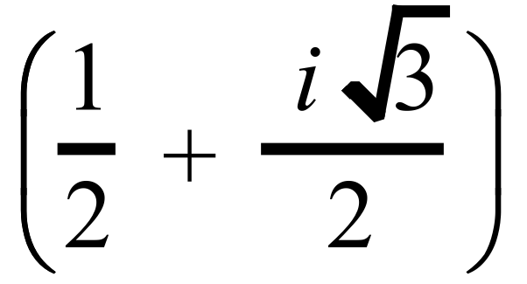

|  |  |  |  |  |  |  |  |  |  |  |  |  |  |  |  |  |  |  |  |  |  |  |  |  |  |  |  |  |  |  |
| --- | --- | --- | --- | --- | --- | --- | --- | --- | --- | --- | --- | --- | --- | --- | --- | --- | --- | --- | --- | --- | --- | --- | --- | --- | --- | --- | --- | --- | --- | --- |
|  |  |  |  |  |  |  |  |  |  |  |  |  |  |  |  |  |  |  |  |  |  |  |  |  |  |  |  |  |  |  |
|  |  |  |  |  |  |  |  |  |  |  |  |  |  |  |  |  |  |  |  |  |  |  |  |  |  |  |  |  |  |  |
|  |  |  |  |  |  |  |  |  |  |  |  |  |  |  |  |  |  |  |  |  |  |  |  |  |  |  |  |  |  |  |
|  |  |  |  |  |  |  |  |  |  |  |  |  |  |  |  |  |  |  |  |  |  |  |  |  |  |  |  |  |  |  |

(1 mark)

1. 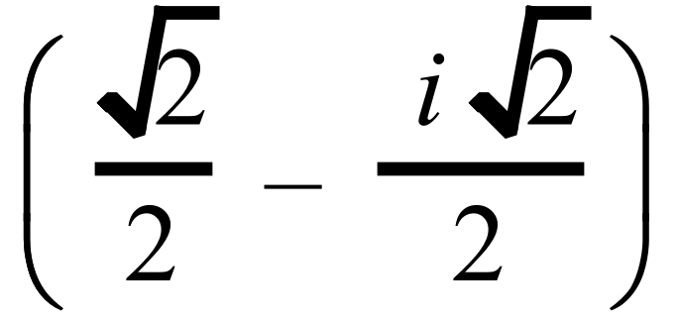

|  |  |  |  |  |  |  |  |  |  |  |  |  |  |  |  |  |  |  |  |  |  |  |  |  |  |  |  |  |  |  |
| --- | --- | --- | --- | --- | --- | --- | --- | --- | --- | --- | --- | --- | --- | --- | --- | --- | --- | --- | --- | --- | --- | --- | --- | --- | --- | --- | --- | --- | --- | --- |
|  |  |  |  |  |  |  |  |  |  |  |  |  |  |  |  |  |  |  |  |  |  |  |  |  |  |  |  |  |  |  |
|  |  |  |  |  |  |  |  |  |  |  |  |  |  |  |  |  |  |  |  |  |  |  |  |  |  |  |  |  |  |  |
|  |  |  |  |  |  |  |  |  |  |  |  |  |  |  |  |  |  |  |  |  |  |  |  |  |  |  |  |  |  |  |
|  |  |  |  |  |  |  |  |  |  |  |  |  |  |  |  |  |  |  |  |  |  |  |  |  |  |  |  |  |  |  |

(1 mark)

1. 

|  |  |  |  |  |  |  |  |  |  |  |  |  |  |  |  |  |  |  |  |  |  |  |  |  |  |  |  |  |  |  |
| --- | --- | --- | --- | --- | --- | --- | --- | --- | --- | --- | --- | --- | --- | --- | --- | --- | --- | --- | --- | --- | --- | --- | --- | --- | --- | --- | --- | --- | --- | --- |
|  |  |  |  |  |  |  |  |  |  |  |  |  |  |  |  |  |  |  |  |  |  |  |  |  |  |  |  |  |  |  |
|  |  |  |  |  |  |  |  |  |  |  |  |  |  |  |  |  |  |  |  |  |  |  |  |  |  |  |  |  |  |  |
|  |  |  |  |  |  |  |  |  |  |  |  |  |  |  |  |  |  |  |  |  |  |  |  |  |  |  |  |  |  |  |
|  |  |  |  |  |  |  |  |  |  |  |  |  |  |  |  |  |  |  |  |  |  |  |  |  |  |  |  |  |  |  |

(1 mark)

1. Using the results of part (a) and part (b), show exactly that

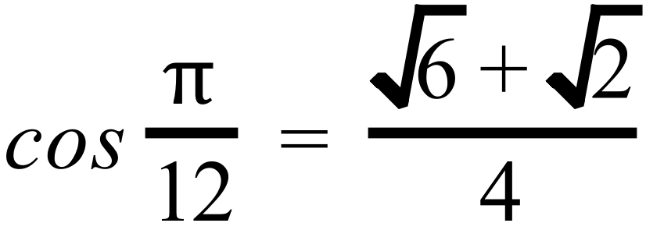 and 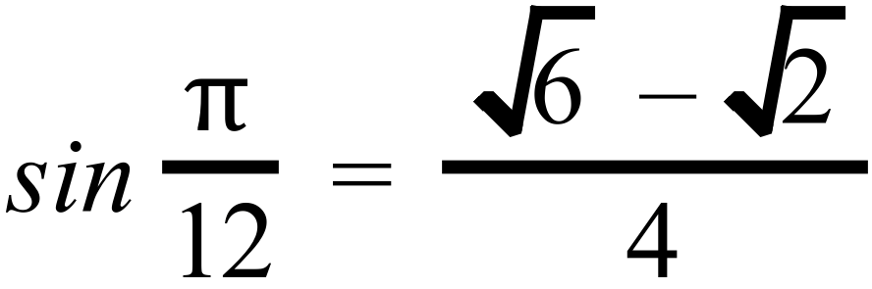

|  |  |  |  |  |  |  |  |  |  |  |  |  |  |  |  |  |  |  |  |  |  |  |  |  |  |  |  |  |  |  |
| --- | --- | --- | --- | --- | --- | --- | --- | --- | --- | --- | --- | --- | --- | --- | --- | --- | --- | --- | --- | --- | --- | --- | --- | --- | --- | --- | --- | --- | --- | --- |
|  |  |  |  |  |  |  |  |  |  |  |  |  |  |  |  |  |  |  |  |  |  |  |  |  |  |  |  |  |  |  |
|  |  |  |  |  |  |  |  |  |  |  |  |  |  |  |  |  |  |  |  |  |  |  |  |  |  |  |  |  |  |  |
|  |  |  |  |  |  |  |  |  |  |  |  |  |  |  |  |  |  |  |  |  |  |  |  |  |  |  |  |  |  |  |
|  |  |  |  |  |  |  |  |  |  |  |  |  |  |  |  |  |  |  |  |  |  |  |  |  |  |  |  |  |  |  |

(1 mark)

**QUESTION 8 (13 marks)**

1. Given , solve 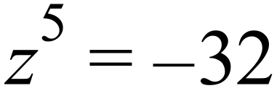 using De Moivre’s Theorem and express your answers as 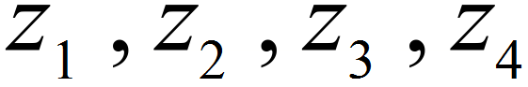 and 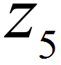 where *z* is in polar form and 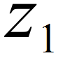 is the complex number with the smallest positive argument.

|  |  |  |  |  |  |  |  |  |  |  |  |  |  |  |  |  |  |  |  |  |  |  |  |  |  |  |  |  |  |
| --- | --- | --- | --- | --- | --- | --- | --- | --- | --- | --- | --- | --- | --- | --- | --- | --- | --- | --- | --- | --- | --- | --- | --- | --- | --- | --- | --- | --- | --- |
|  |  |  |  |  |  |  |  |  |  |  |  |  |  |  |  |  |  |  |  |  |  |  |  |  |  |  |  |  |  |
|  |  |  |  |  |  |  |  |  |  |  |  |  |  |  |  |  |  |  |  |  |  |  |  |  |  |  |  |  |  |
|  |  |  |  |  |  |  |  |  |  |  |  |  |  |  |  |  |  |  |  |  |  |  |  |  |  |  |  |  |  |
|  |  |  |  |  |  |  |  |  |  |  |  |  |  |  |  |  |  |  |  |  |  |  |  |  |  |  |  |  |  |
|  |  |  |  |  |  |  |  |  |  |  |  |  |  |  |  |  |  |  |  |  |  |  |  |  |  |  |  |  |  |
|  |  |  |  |  |  |  |  |  |  |  |  |  |  |  |  |  |  |  |  |  |  |  |  |  |  |  |  |  |  |
|  |  |  |  |  |  |  |  |  |  |  |  |  |  |  |  |  |  |  |  |  |  |  |  |  |  |  |  |  |  |
|  |  |  |  |  |  |  |  |  |  |  |  |  |  |  |  |  |  |  |  |  |  |  |  |  |  |  |  |  |  |
|  |  |  |  |  |  |  |  |  |  |  |  |  |  |  |  |  |  |  |  |  |  |  |  |  |  |  |  |  |  |
|  |  |  |  |  |  |  |  |  |  |  |  |  |  |  |  |  |  |  |  |  |  |  |  |  |  |  |  |  |  |
|  |  |  |  |  |  |  |  |  |  |  |  |  |  |  |  |  |  |  |  |  |  |  |  |  |  |  |  |  |  |
|  |  |  |  |  |  |  |  |  |  |  |  |  |  |  |  |  |  |  |  |  |  |  |  |  |  |  |  |  |  |
|  |  |  |  |  |  |  |  |  |  |  |  |  |  |  |  |  |  |  |  |  |  |  |  |  |  |  |  |  |  |
|  |  |  |  |  |  |  |  |  |  |  |  |  |  |  |  |  |  |  |  |  |  |  |  |  |  |  |  |  |  |
|  |  |  |  |  |  |  |  |  |  |  |  |  |  |  |  |  |  |  |  |  |  |  |  |  |  |  |  |  |  |
|  |  |  |  |  |  |  |  |  |  |  |  |  |  |  |  |  |  |  |  |  |  |  |  |  |  |  |  |  |  |
|  |  |  |  |  |  |  |  |  |  |  |  |  |  |  |  |  |  |  |  |  |  |  |  |  |  |  |  |  |  |
|  |  |  |  |  |  |  |  |  |  |  |  |  |  |  |  |  |  |  |  |  |  |  |  |  |  |  |  |  |  |
|  |  |  |  |  |  |  |  |  |  |  |  |  |  |  |  |  |  |  |  |  |  |  |  |  |  |  |  |  |  |
|  |  |  |  |  |  |  |  |  |  |  |  |  |  |  |  |  |  |  |  |  |  |  |  |  |  |  |  |  |  |

(5 marks)

1. Draw your solutions on the Argand diagram below:

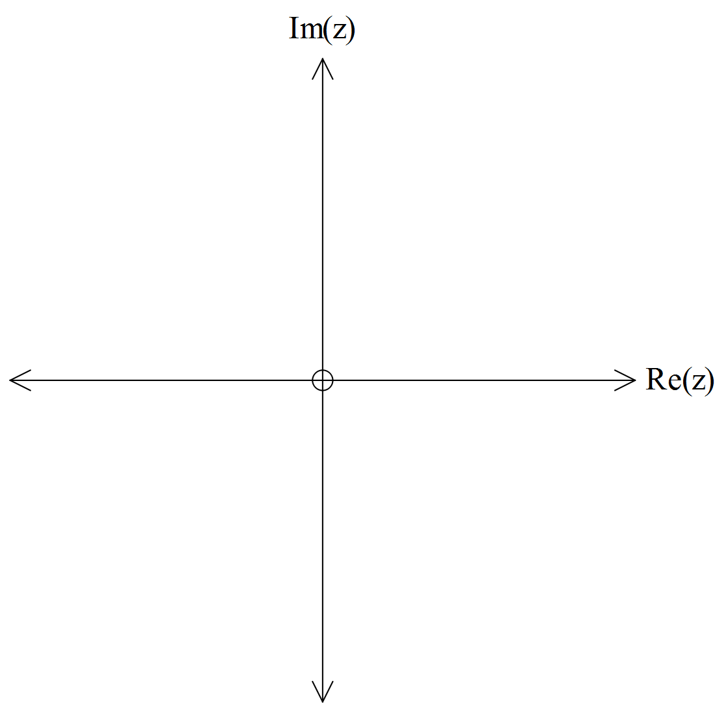

(2 marks)

1. Write down the conjugate pairs of solutions and explain why they are conjugate pairs.

|  |  |  |  |  |  |  |  |  |  |  |  |  |  |  |  |  |  |  |  |  |  |  |  |  |  |  |  |  |  |
| --- | --- | --- | --- | --- | --- | --- | --- | --- | --- | --- | --- | --- | --- | --- | --- | --- | --- | --- | --- | --- | --- | --- | --- | --- | --- | --- | --- | --- | --- |
|  |  |  |  |  |  |  |  |  |  |  |  |  |  |  |  |  |  |  |  |  |  |  |  |  |  |  |  |  |  |
|  |  |  |  |  |  |  |  |  |  |  |  |  |  |  |  |  |  |  |  |  |  |  |  |  |  |  |  |  |  |
|  |  |  |  |  |  |  |  |  |  |  |  |  |  |  |  |  |  |  |  |  |  |  |  |  |  |  |  |  |  |
|  |  |  |  |  |  |  |  |  |  |  |  |  |  |  |  |  |  |  |  |  |  |  |  |  |  |  |  |  |  |
|  |  |  |  |  |  |  |  |  |  |  |  |  |  |  |  |  |  |  |  |  |  |  |  |  |  |  |  |  |  |
|  |  |  |  |  |  |  |  |  |  |  |  |  |  |  |  |  |  |  |  |  |  |  |  |  |  |  |  |  |  |
|  |  |  |  |  |  |  |  |  |  |  |  |  |  |  |  |  |  |  |  |  |  |  |  |  |  |  |  |  |  |
|  |  |  |  |  |  |  |  |  |  |  |  |  |  |  |  |  |  |  |  |  |  |  |  |  |  |  |  |  |  |
|  |  |  |  |  |  |  |  |  |  |  |  |  |  |  |  |  |  |  |  |  |  |  |  |  |  |  |  |  |  |
|  |  |  |  |  |  |  |  |  |  |  |  |  |  |  |  |  |  |  |  |  |  |  |  |  |  |  |  |  |  |
|  |  |  |  |  |  |  |  |  |  |  |  |  |  |  |  |  |  |  |  |  |  |  |  |  |  |  |  |  |  |
|  |  |  |  |  |  |  |  |  |  |  |  |  |  |  |  |  |  |  |  |  |  |  |  |  |  |  |  |  |  |
|  |  |  |  |  |  |  |  |  |  |  |  |  |  |  |  |  |  |  |  |  |  |  |  |  |  |  |  |  |  |

(3 marks)

1. Hence write 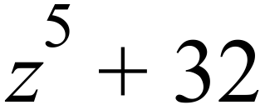 as the product of two quadratic factors and one linear factor.

|  |  |  |  |  |  |  |  |  |  |  |  |  |  |  |  |  |  |  |  |  |  |  |  |  |  |  |  |  |  |
| --- | --- | --- | --- | --- | --- | --- | --- | --- | --- | --- | --- | --- | --- | --- | --- | --- | --- | --- | --- | --- | --- | --- | --- | --- | --- | --- | --- | --- | --- |
|  |  |  |  |  |  |  |  |  |  |  |  |  |  |  |  |  |  |  |  |  |  |  |  |  |  |  |  |  |  |
|  |  |  |  |  |  |  |  |  |  |  |  |  |  |  |  |  |  |  |  |  |  |  |  |  |  |  |  |  |  |
|  |  |  |  |  |  |  |  |  |  |  |  |  |  |  |  |  |  |  |  |  |  |  |  |  |  |  |  |  |  |
|  |  |  |  |  |  |  |  |  |  |  |  |  |  |  |  |  |  |  |  |  |  |  |  |  |  |  |  |  |  |
|  |  |  |  |  |  |  |  |  |  |  |  |  |  |  |  |  |  |  |  |  |  |  |  |  |  |  |  |  |  |
|  |  |  |  |  |  |  |  |  |  |  |  |  |  |  |  |  |  |  |  |  |  |  |  |  |  |  |  |  |  |
|  |  |  |  |  |  |  |  |  |  |  |  |  |  |  |  |  |  |  |  |  |  |  |  |  |  |  |  |  |  |
|  |  |  |  |  |  |  |  |  |  |  |  |  |  |  |  |  |  |  |  |  |  |  |  |  |  |  |  |  |  |
|  |  |  |  |  |  |  |  |  |  |  |  |  |  |  |  |  |  |  |  |  |  |  |  |  |  |  |  |  |  |
|  |  |  |  |  |  |  |  |  |  |  |  |  |  |  |  |  |  |  |  |  |  |  |  |  |  |  |  |  |  |
|  |  |  |  |  |  |  |  |  |  |  |  |  |  |  |  |  |  |  |  |  |  |  |  |  |  |  |  |  |  |
|  |  |  |  |  |  |  |  |  |  |  |  |  |  |  |  |  |  |  |  |  |  |  |  |  |  |  |  |  |  |
|  |  |  |  |  |  |  |  |  |  |  |  |  |  |  |  |  |  |  |  |  |  |  |  |  |  |  |  |  |  |
|  |  |  |  |  |  |  |  |  |  |  |  |  |  |  |  |  |  |  |  |  |  |  |  |  |  |  |  |  |  |

(3 marks)

Performance Standards for Stage 2 Specialist Mathematics

| - | Concepts and Techniques | Reasoning and Communication |
| --- | --- | --- |
| A | Comprehensive knowledge and understanding of concepts and relationships.  Highly effective selection and application of mathematical techniques and algorithms to find efficient and accurate solutions to routine and complex problems in a variety of contexts.  Successful development and application of mathematical models to find concise and accurate solutions.  Appropriate and effective use of electronic technology to find accurate solutions to routine and complex problems. | Comprehensive interpretation of mathematical results in the context of the problem.  Drawing logical conclusions from mathematical results, with a comprehensive understanding of their reasonableness and limitations.  Proficient and accurate use of appropriate mathematical notation, representations, and terminology.  Highly effective communication of mathematical ideas and reasoning to develop logical and concise arguments.  Effective development and testing of valid conjectures, with proof. |
| B | Some depth of knowledge and understanding of concepts and relationships.  Mostly effective selection and application of mathematical techniques and algorithms to find mostly accurate solutions to routine and some complex problems in a variety of contexts.  Some development and successful application of mathematical models to find mostly accurate solutions.  Mostly appropriate and effective use of electronic technology to find mostly accurate solutions to routine and some complex problems. | Mostly appropriate interpretation of mathematical results in the context of the problem.  Drawing mostly logical conclusions from mathematical results, with some depth of understanding of their reasonableness and limitations.  Mostly accurate use of appropriate mathematical notation, representations, and terminology.  Mostly effective communication of mathematical ideas and reasoning to develop mostly logical arguments.  Mostly effective development and testing of valid conjectures, with substantial attempt at proof. |
| C | Generally competent knowledge and understanding of concepts and relationships.  Generally effective selection and application of mathematical techniques and algorithms to find mostly accurate solutions to routine problems in a variety of contexts.  Successful application of mathematical models to find generally accurate solutions.  Generally appropriate and effective use of electronic technology to find mostly accurate solutions to routine problems. | Generally appropriate interpretation of mathematical results in the context of the problem.  Drawing some logical conclusions from mathematical results, with some understanding of their reasonableness and limitations.  Generally appropriate use of mathematical notation, representations, and terminology, with reasonable accuracy.  Generally effective communication of mathematical ideas and reasoning to develop some logical arguments.  Development and testing of generally valid conjectures, with some attempt at proof. |
| D | Basic knowledge and some understanding of concepts and relationships.  Some selection and application of mathematical techniques and algorithms to find some accurate solutions to routine problems in some contexts.  Some application of mathematical models to find some accurate or partially accurate solutions.  Some appropriate use of electronic technology to find some accurate solutions to routine problems. | Some interpretation of mathematical results.  Drawing some conclusions from mathematical results, with some awareness of their reasonableness or limitations.  Some appropriate use of mathematical notation, representations, and terminology, with some accuracy.  Some communication of mathematical ideas, with attempted reasoning and/or arguments.  Attempted development or testing of a reasonable conjecture. |
| E | Limited knowledge or understanding of concepts and relationships.  Attempted selection and limited application of mathematical techniques or algorithms, with limited accuracy in solving routine problems.  Attempted application of mathematical models, with limited accuracy.  Attempted use of electronic technology, with limited accuracy in solving routine problems. | Limited interpretation of mathematical results.  Limited understanding of the meaning of mathematical results, their reasonableness, or limitations.  Limited use of appropriate mathematical notation, representations, or terminology, with limited accuracy.  Attempted communication of mathematical ideas, with limited reasoning.  Limited attempt to develop or test a conjecture. |