Phase 1 Role Clarification and Task Planning

Phase 1 focuses on role clarification and the allocation of tasks that the school must undertake in order to prepare them to administer the practice window opening in August and the November final examinations.

Role Clarification
Phase 1 requires the nominated school SACE Coordinator and IT Manager to collaborate on planning of the tasks the school needs to undertake in preparing for e-exams. Depending on the size of your school, you may be nominated to both roles. The activity on task planning, steps out the individual tasks to ensure each role has clarity around the tasks that they need to undertake in relation to the administration of e-exams.
In addition to the SACE Coordinator and IT Manager roles, the principal determines and appoints relevant persons to administer SACE examinations in the school.
Phase 2 training will provide more detail on these roles for administering the SACE Electronic Examination System. These roles are represented diagrammatically below.
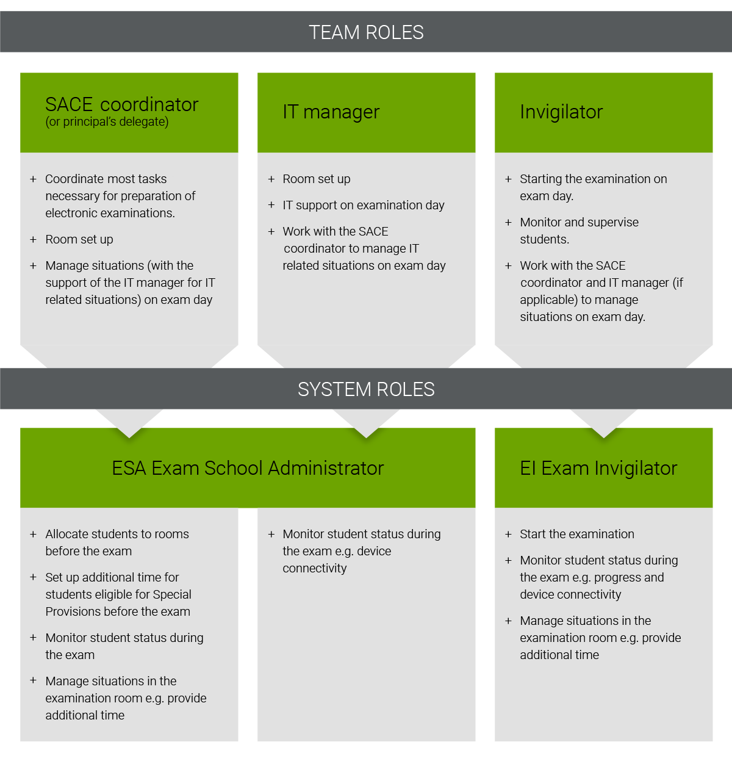

Task Planning
There are several tasks required to take place within schools prior to, during and after the practice window and final examinations. It is important that the school is aware of, and plans for, undertaking these tasks to ensure the smooth administration of the SACE electronic examinations.
Each task on the Phase 1 Worksheet should be completed to show:
1. Who is assigned to take responsibility of the task?
A task might be undertaken by more than one role. The majority of activities are often undertaken by either the SACE Coordinator and/or the IT Manager. However, activities may be nominated to other roles involved in the administration of the SACE electronic examinations. Where it is a shared responsibility, please identify this on the worksheet.
It is important that each person involved in undertaking these tasks is notified of their involvement and responsibilities. There is further training available (Phase 2 and Phase 3) which multiple participants may need to undertake to ensure they have a good understanding of their role in administering the electronic examination process.

2. At what stage of the process does the task occur?
The tasks listed occur at varying stages throughout the e-exams process, from early preparation, just prior to the examinations, on the day of the examinations and after the examinations.

Identify at what stage the individual tasks are to occur. If unsure, you can contact the askSACE team for further information.

Phase 1 Worksheet
Download and save the Phase 1 Worksheet to complete.
It is important that this worksheet is completed collaboratively between the SACE Coordinator and IT Manager (where more than one person).
You do not need to submit this worksheet to the SACE Board.
Further information about these tasks will be provided in the Phase 2 and Phase 3 training for SACE Coordinators and Invigilators.
If you have any questions about the e-exams roles, task planning or anything else, please contact the askSACE team .

