Stage 2 Workplace Practices
Area of Study 1: Industry and Work Knowledge
Topic 1: Work in Australian Society
Assessment Type 1: Folio

Task
In relation to your workplace (club/sport association/dance school/dance association) club/dance school, demonstrate your knowledge of paid and unpaid roles, the contribution of volunteers, their value and the issues they face.
Description of Assessment
1. Develop a series of interview questions to investigate the dot points below.
2. Conduct an interview with a volunteer in your workplace (your club / dance school).
3. Prepare a report using primary (e.g. interview(s) and secondary (e.g. internet) resources about the nature and value of volunteer work in your workplace.

In relation to your sport/dance, your report should include:
- a brief description of volunteering in your sport
- an explanation of the roles, responsibilities, knowledge and skills of paid and unpaid workers in your workplace
- an investigation and analysis the work related issues of volunteering – e.g. attracting and retaining volunteers, volunteer skill levels, unpopular tasks, working relationships, impacts on life-work balance, recognition, ‘politics’ of the workplace,
- discuss the value of workplace volunteering for both the volunteer and the workplace.
Assessment Conditions
The report can be presented in a written, oral or a multimodal form. Acknowledge all sources used and include a copy of the interview transcript as an appendix.

This task is used with the kind permission of Marden Senior College.
Learning Requirements | Assessment Design Criteria | Capabilities
1. Understand and explain concepts of industry and work  2. Analyse the relationships between work-related issues and practices in workplaces  3. Demonstrate knowledge of the roles of individuals, government legislation and policies, unions, and employer groups in work-related and workplace issues  4. Investigate the dynamic nature of work-related and workplace issues, cultures, and/or environments locally, nationally, and/or globally  5. Demonstrate and apply generic work skills and, where relevant, industry knowledge and skills, in a workplace and/or work-related context  6. Reflect on and evaluate learning experiences in/about the workplace. | Knowledge and Understanding  The specific features are as follows:  KU1 Understanding of knowledge, skills, and competencies appropriate to the relevant industry (i.e. the industry in which the student undertakes vocational learning and/or VET units of competency).  KU2 Understanding and explanation of concepts and issues related to industry and work.  Application  The specific features are as follows:  A1 Application of generic work skills and, where relevant, industry knowledge in the workplace or a work-related context.  A2 Application of relevant knowledge and skills in the context of an industry workplace.  A3 Achievement in units of competency as assessed by the RTO, where VET is included.  Investigation and Analysis  The specific features are as follows:  IA1 Analysis of the relationships between work-related issues, tasks, and/or practices in the workplace.  IA2 Investigation of the dynamic nature of work-related and workplace issues, tasks, cultures, and/or environments locally, nationally, and/or globally.  Reflection and Evaluation  The specific feature is as follows:  RE1 Reflection on and evaluation of learning experiences in/about an industry, and self-evaluation. | Communication  Citizenship  Personal Development  Work  Learning

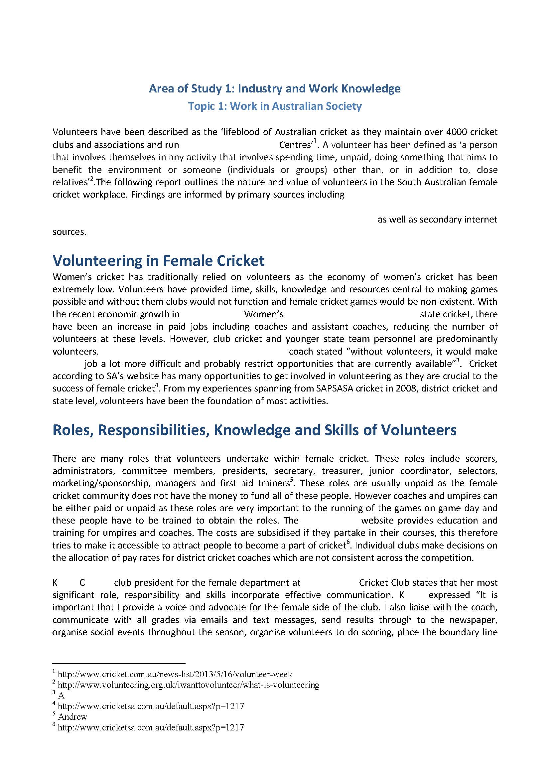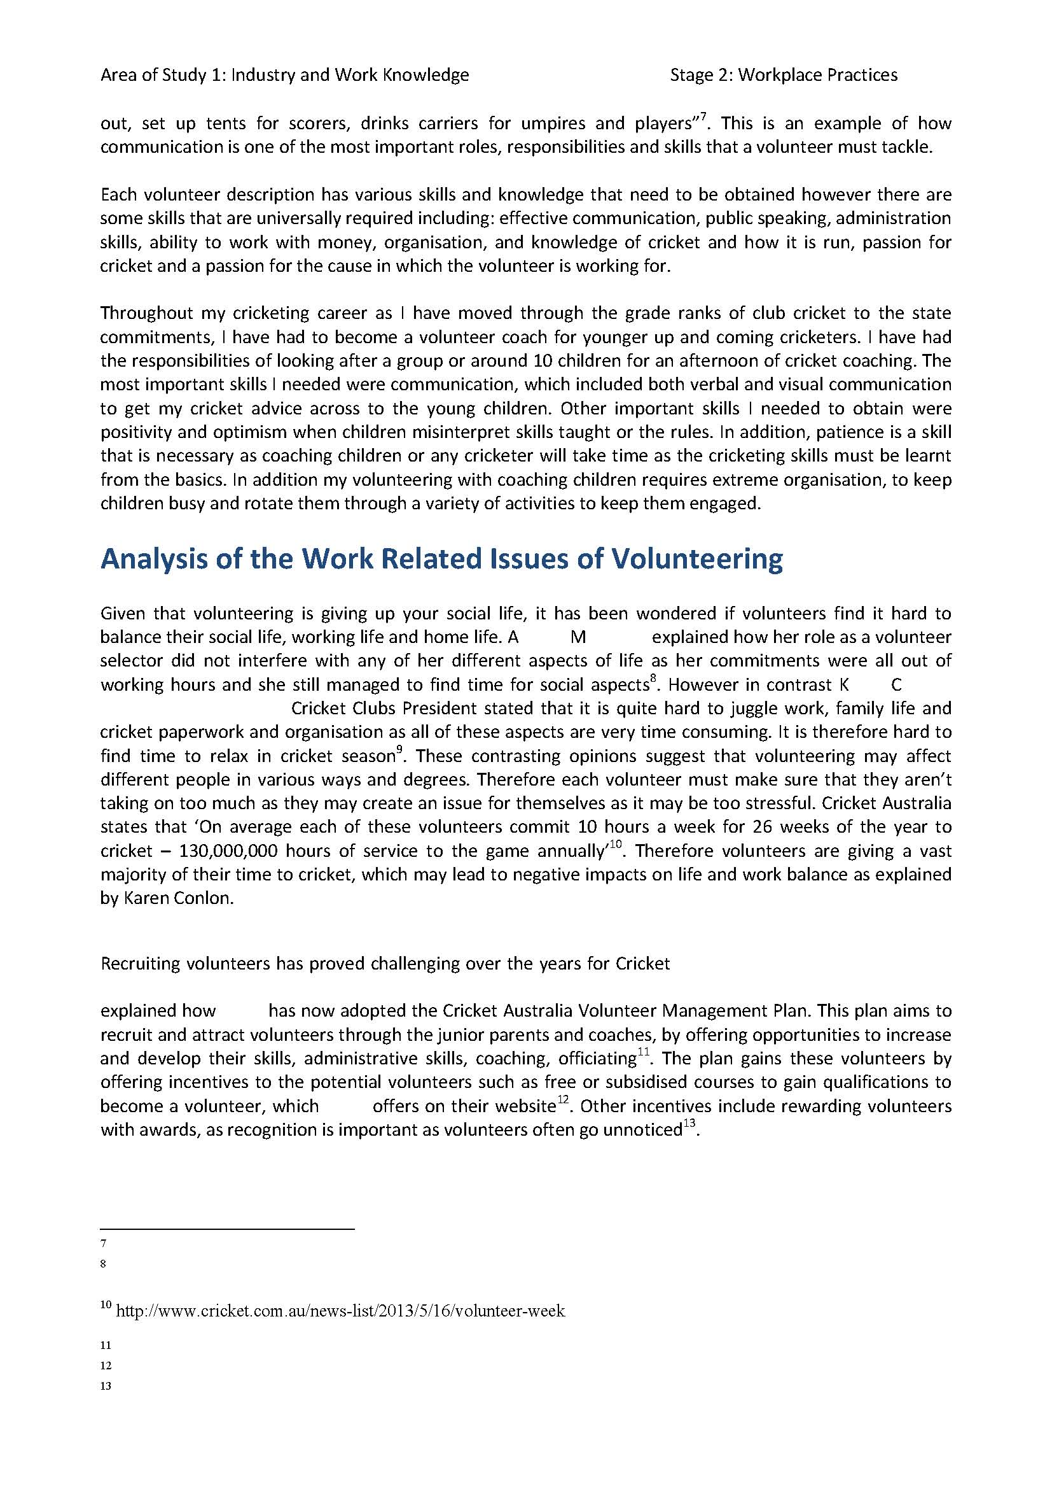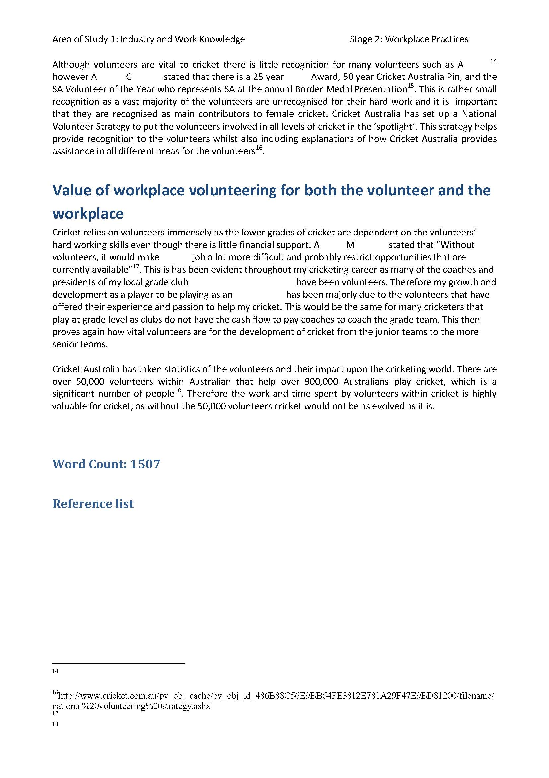
Student Response
Investigation and Analysis
Thorough and detailed investigation regarding volunteering in cricket. Perceptive and well-informed analysis of this work-related topic, including student’s own perspective.
Investigation and Analysis
Well-informed investigation and analysis regarding issues related to volunteering from a volunteer’s perspective.
Knowledge and Understanding
Comprehensive understanding of the roles and responsibilities of volunteers in cricket. Insightful explanation regarding skills and knowledge required to be a volunteer. Student has related this to their own experience as a volunteer.
Stage 2 Workplace Practices
Area of Study 1: Industry and Work Knowledge
Topic 3: Industrial Relations
Assessment Type 1: Folio
Task
Conduct an appraisal of your workplace (club/school/association). Use this information to critically analyse the relationships between work-related issues and practices.
Description of Assessment
- Develop an Occupational Health Safety and Welfare (OHS&W) checklist. (Hint - web search/ask your club/school for OHS&W checklists to assist you in developing your own checklist and writing your report)
- Conduct the appraisal using the checklist you have developed using primary / secondary resources where possible ( eg policies/photographs/evidence/observations)
- Using the information you gathered, prepare a report which critically analyses workplace issues and practices.
Your report should:
- summarise your findings of the current OHS&W practices in your workplace
- analyse the strengths and weaknesses of the OHS&W of these practices
- reflect on what you learnt through this process and evaluate your personal OHS&W practices and attitudes
- conclude and make relevant recommendations for a safer workplace
Assessment Conditions
The report can be presented in a written, oral or multimodal form, which can include graphics. Acknowledge any primary or secondary resources used.

This task is used with the kind permission of Marden Senior College.
Learning Requirements | Assessment Design Criteria | Capabilities
1. Understand and explain concepts of industry and work  2. Analyse the relationships between work-related issues and practices in workplaces  3. Demonstrate knowledge of the roles of individuals, government legislation and policies, unions, and employer groups in work-related and workplace issues  4. Investigate the dynamic nature of work-related and workplace issues, cultures, and/or environments locally, nationally, and/or globally  5. Demonstrate and apply generic work skills and, where relevant, industry knowledge and skills, in a workplace and/or work-related context  6. Reflect on and evaluate learning experiences in/about the workplace. | Knowledge and Understanding  The specific features are as follows:  KU1 Understanding of knowledge, skills, and competencies appropriate to the relevant industry (i.e. the industry in which the student undertakes vocational learning and/or VET units of competency).  KU2 Understanding and explanation of concepts and issues related to industry and work.  Application  The specific features are as follows:  A1 Application of generic work skills and, where relevant, industry knowledge in the workplace or a work-related context.  A2 Application of relevant knowledge and skills in the context of an industry workplace.  A3 Achievement in units of competency as assessed by the RTO, where VET is included.  Investigation and Analysis  The specific features are as follows:  IA1 Analysis of the relationships between work-related issues, tasks, and/or practices in the workplace.  IA2 Investigation of the dynamic nature of work-related and workplace issues, tasks, cultures, and/or environments locally, nationally, and/or globally.  Reflection and Evaluation  The specific feature is as follows:  RE1 Reflection on and evaluation of learning experiences in/about an industry, and self-evaluation. | Communication  Citizenship  Personal Development  Work  Learning

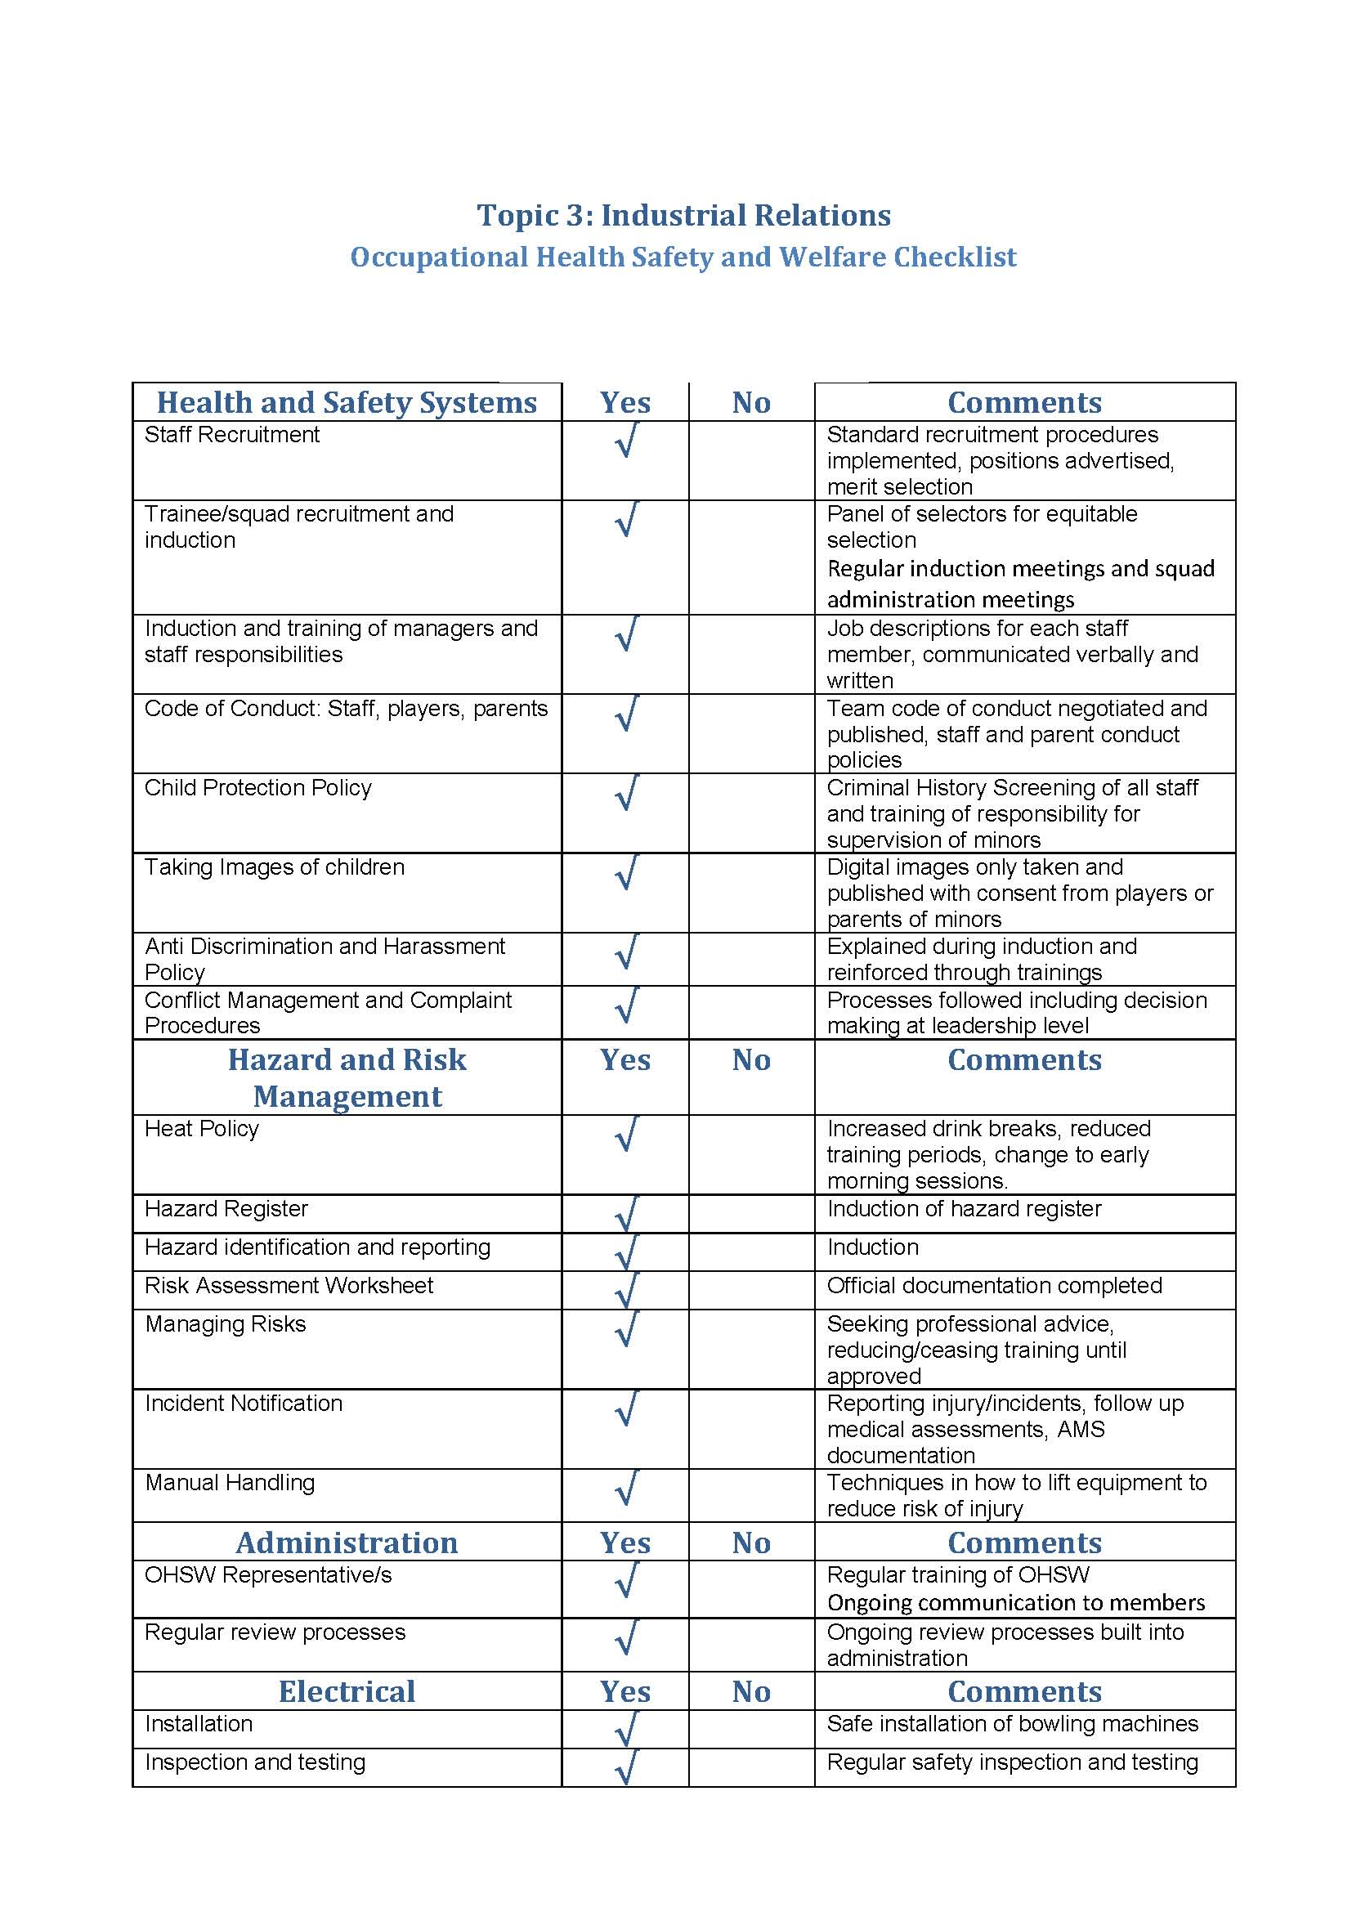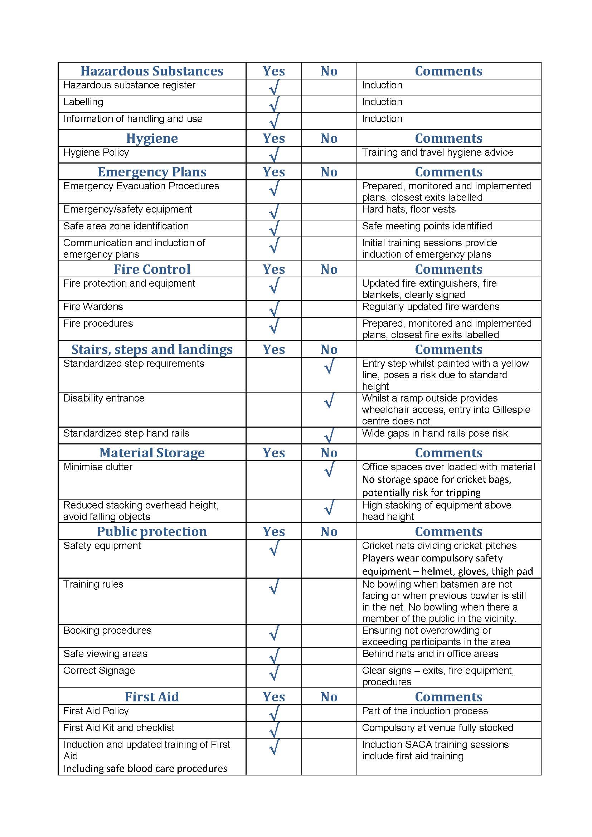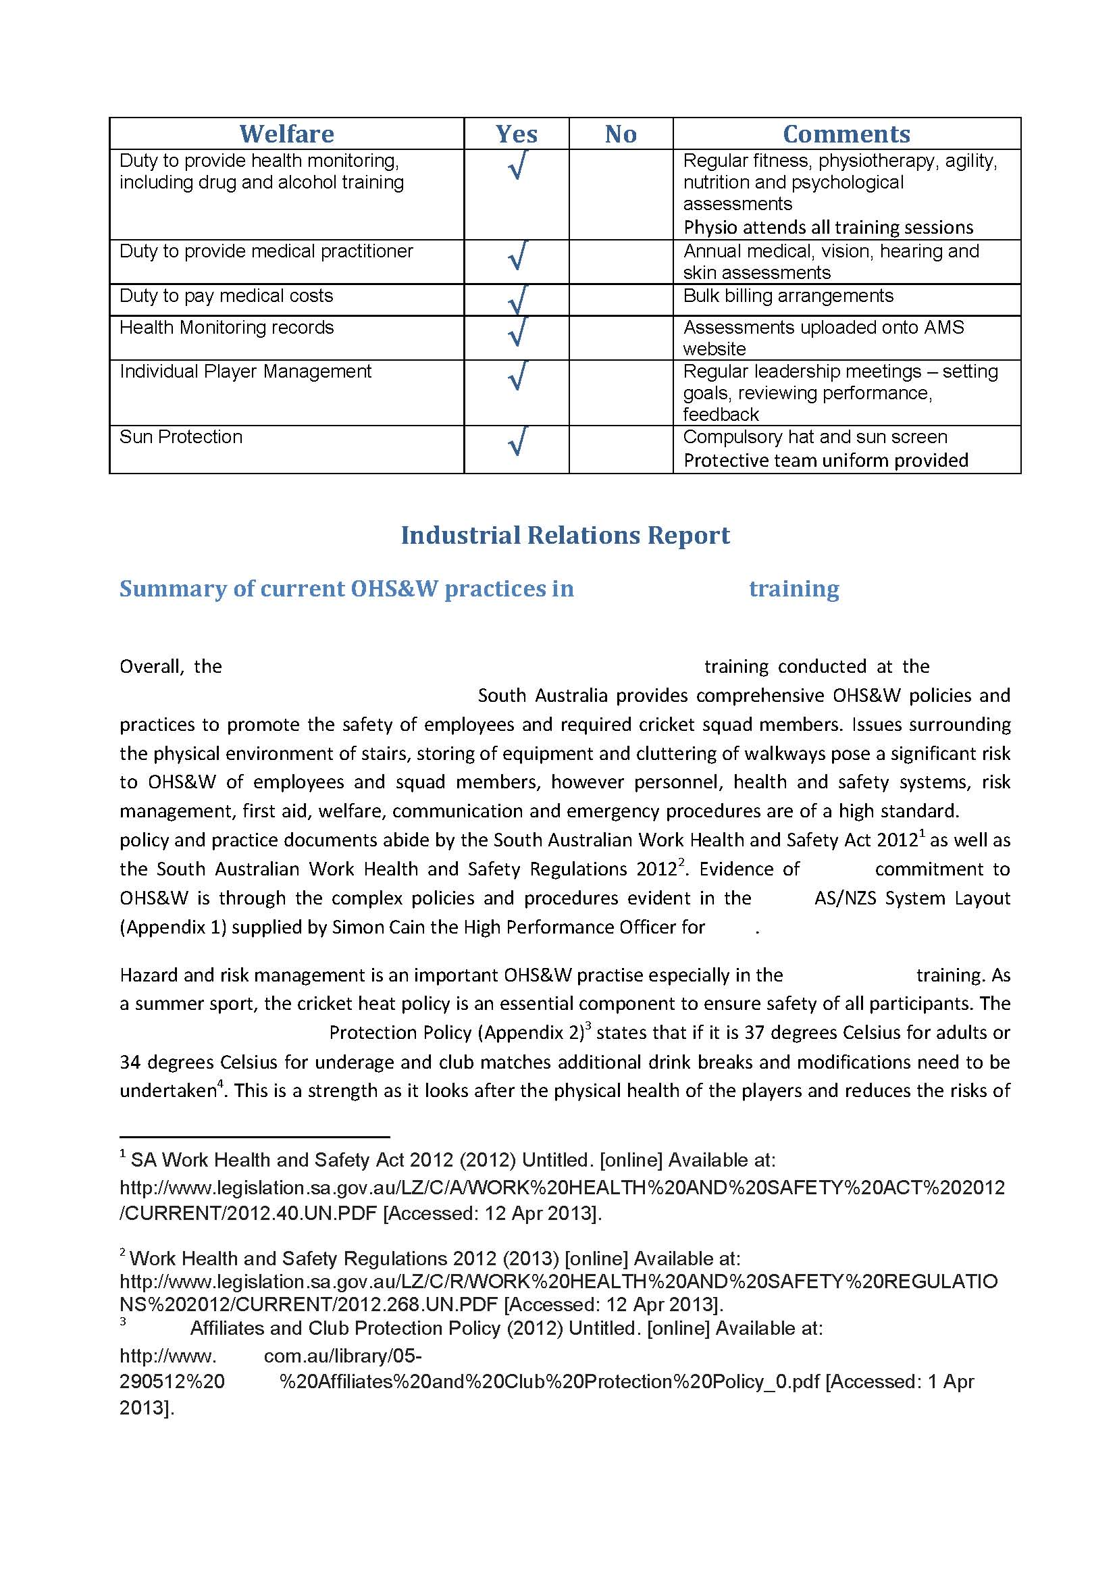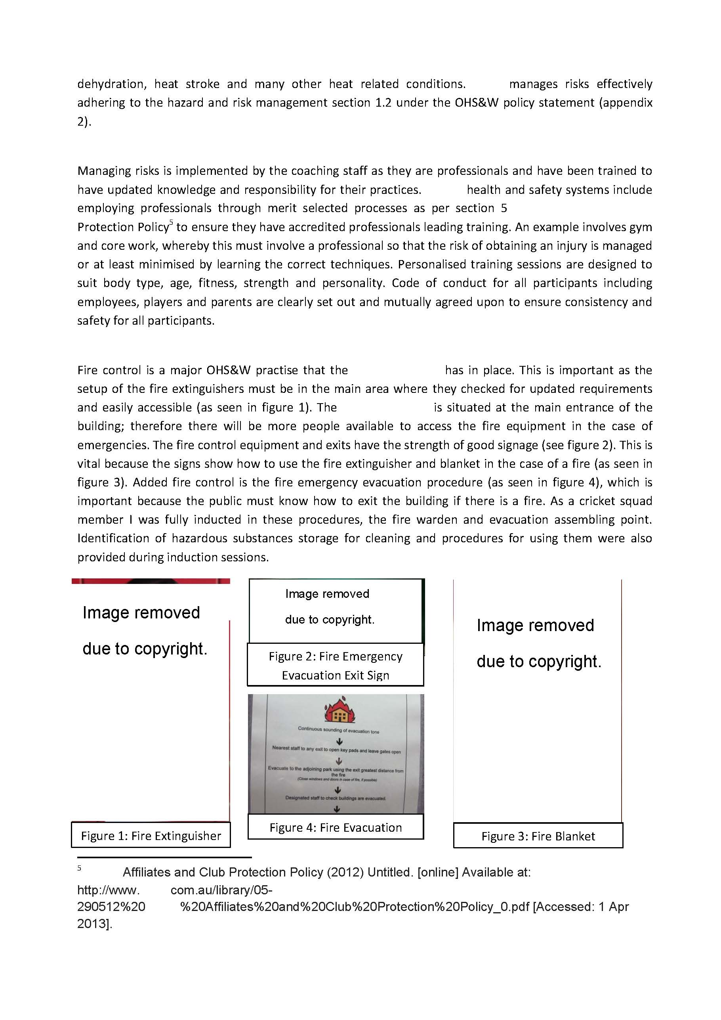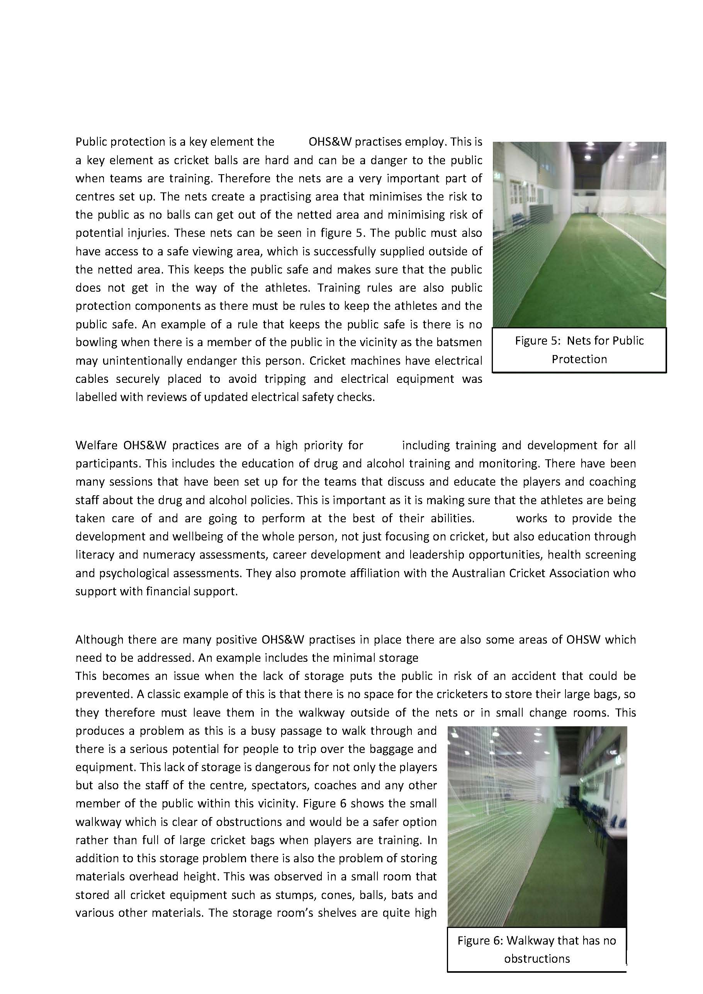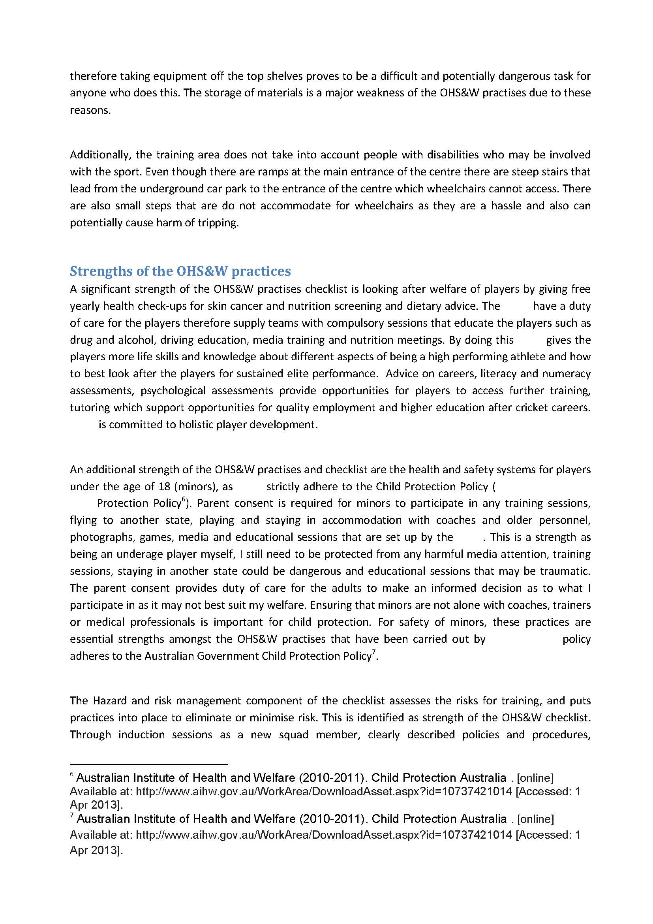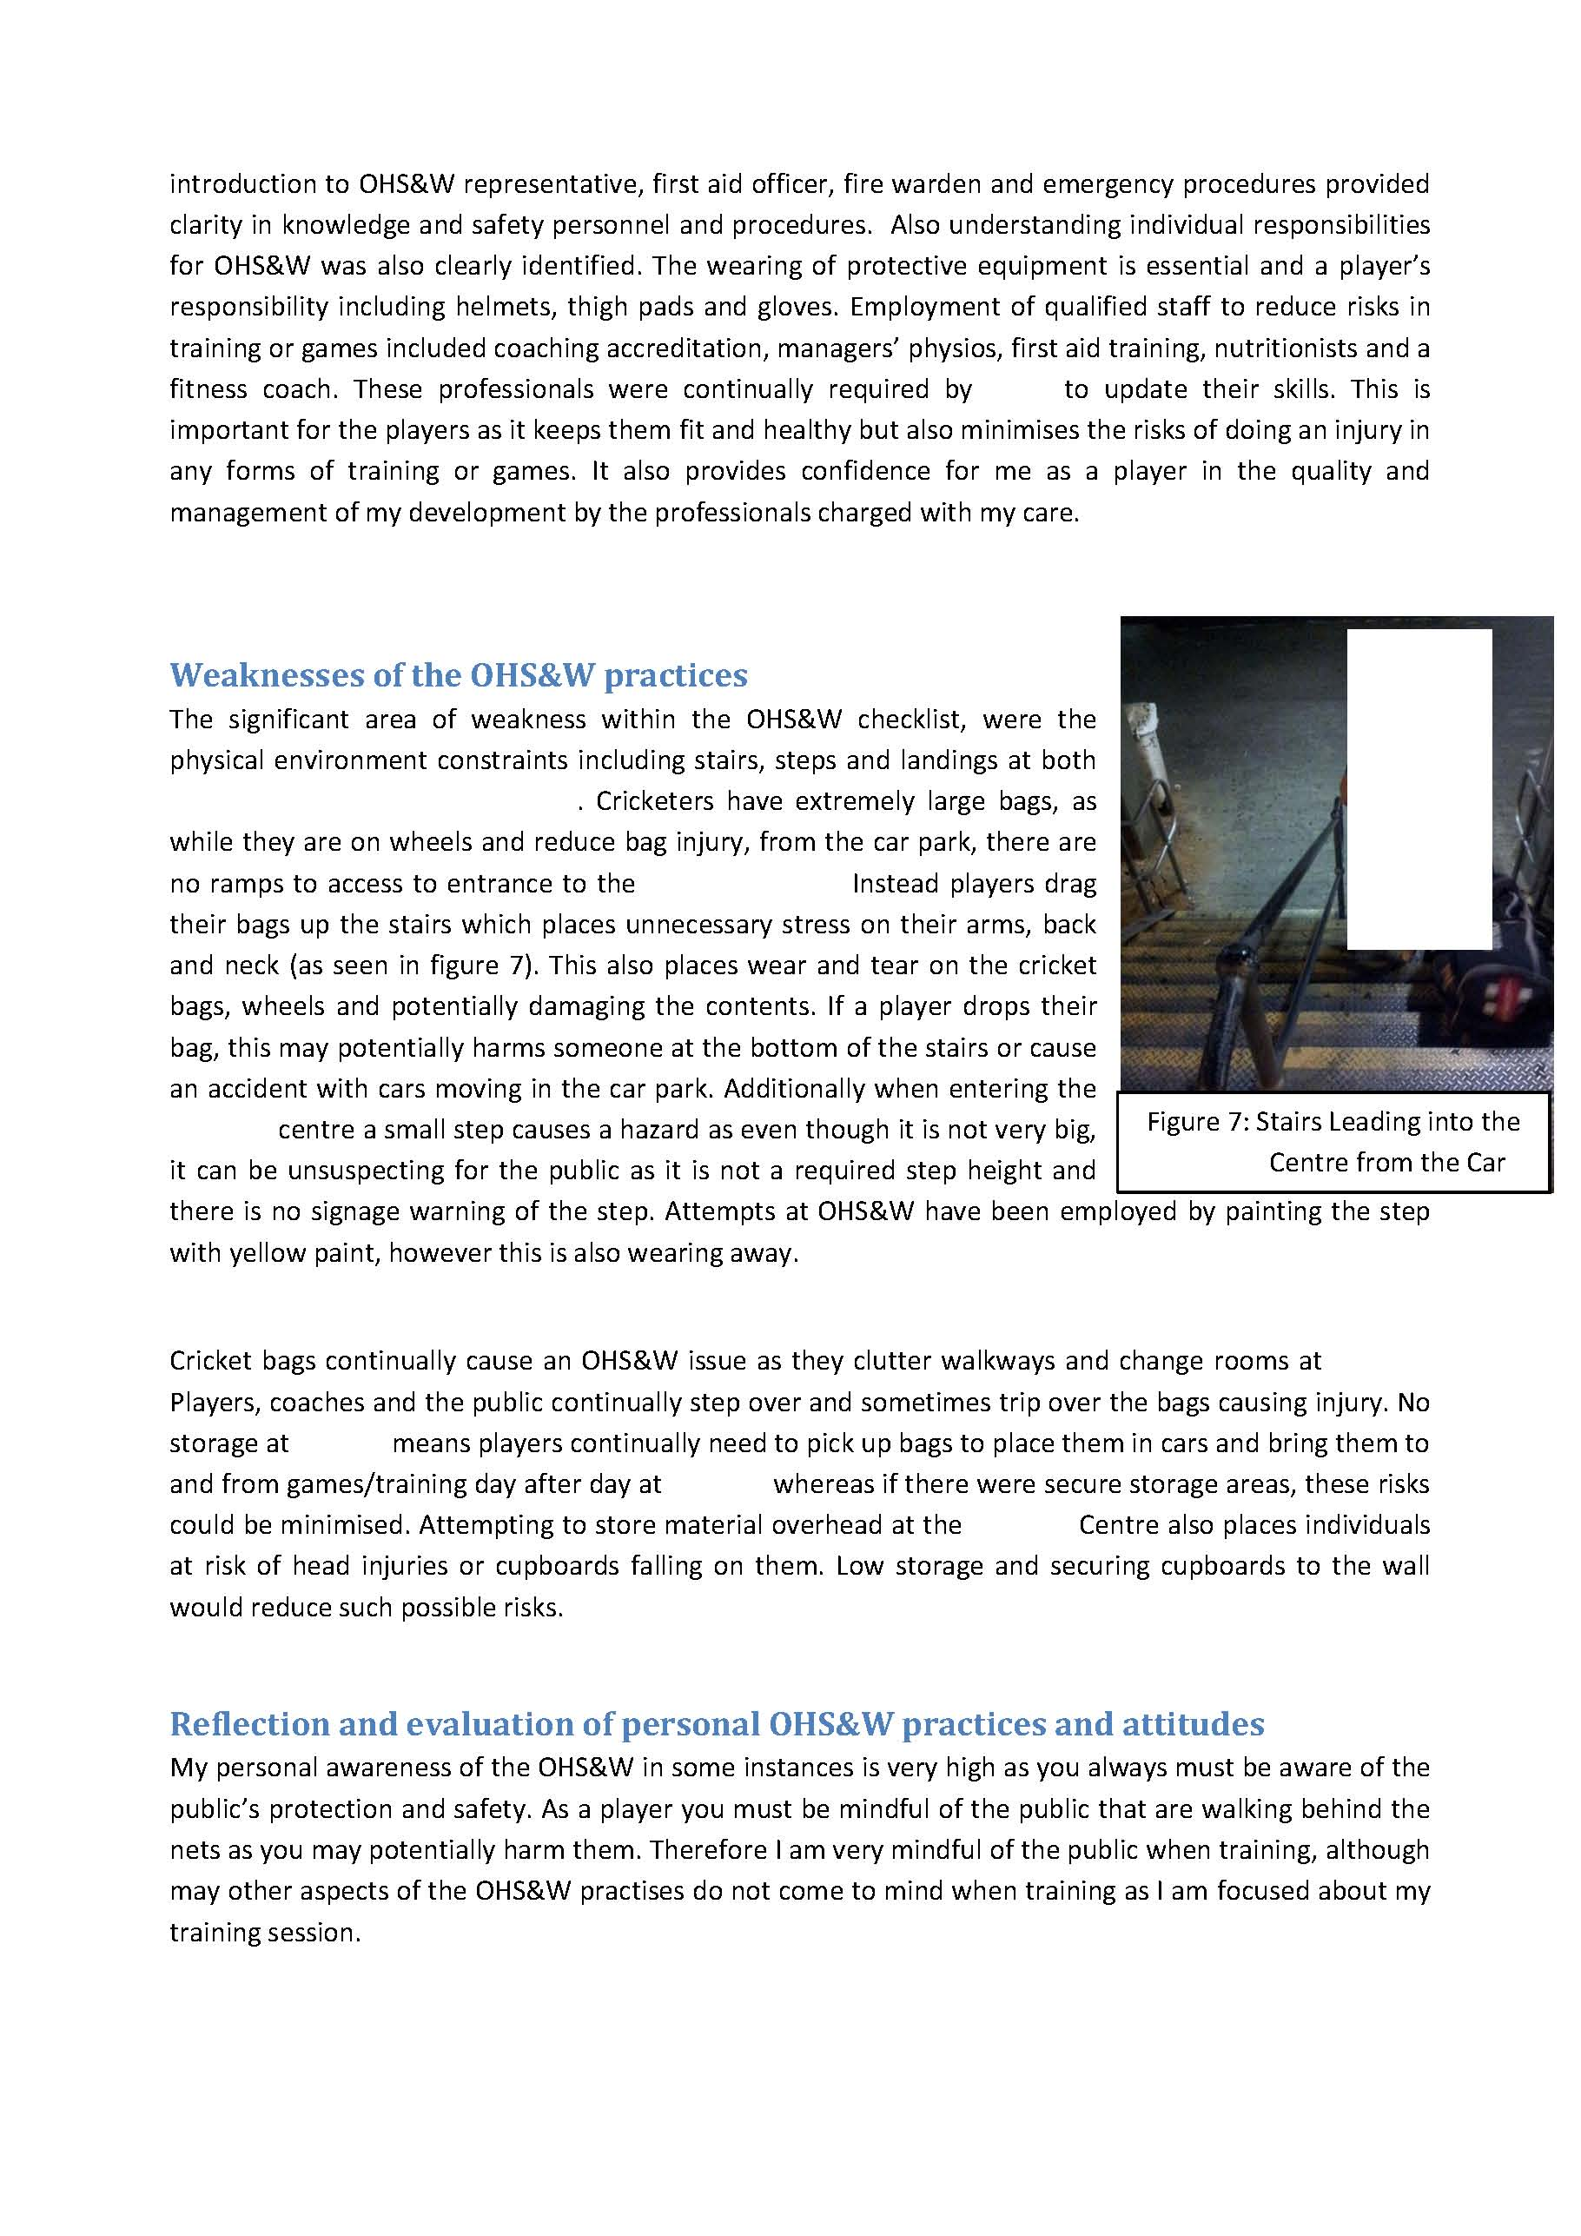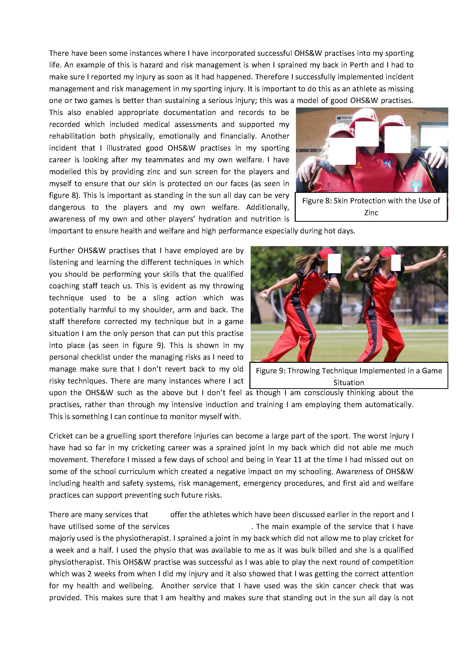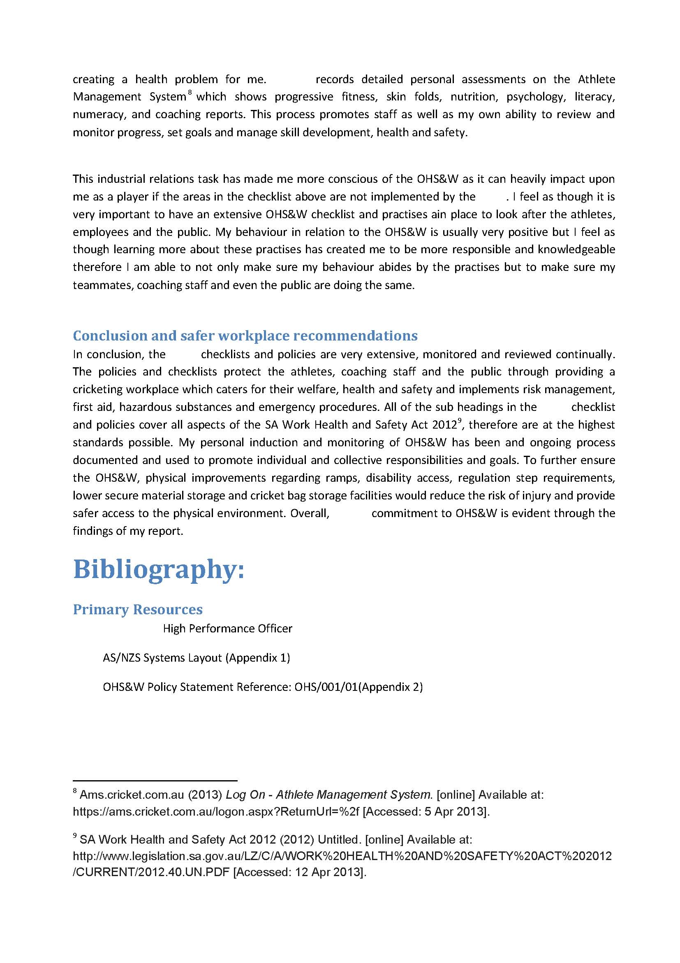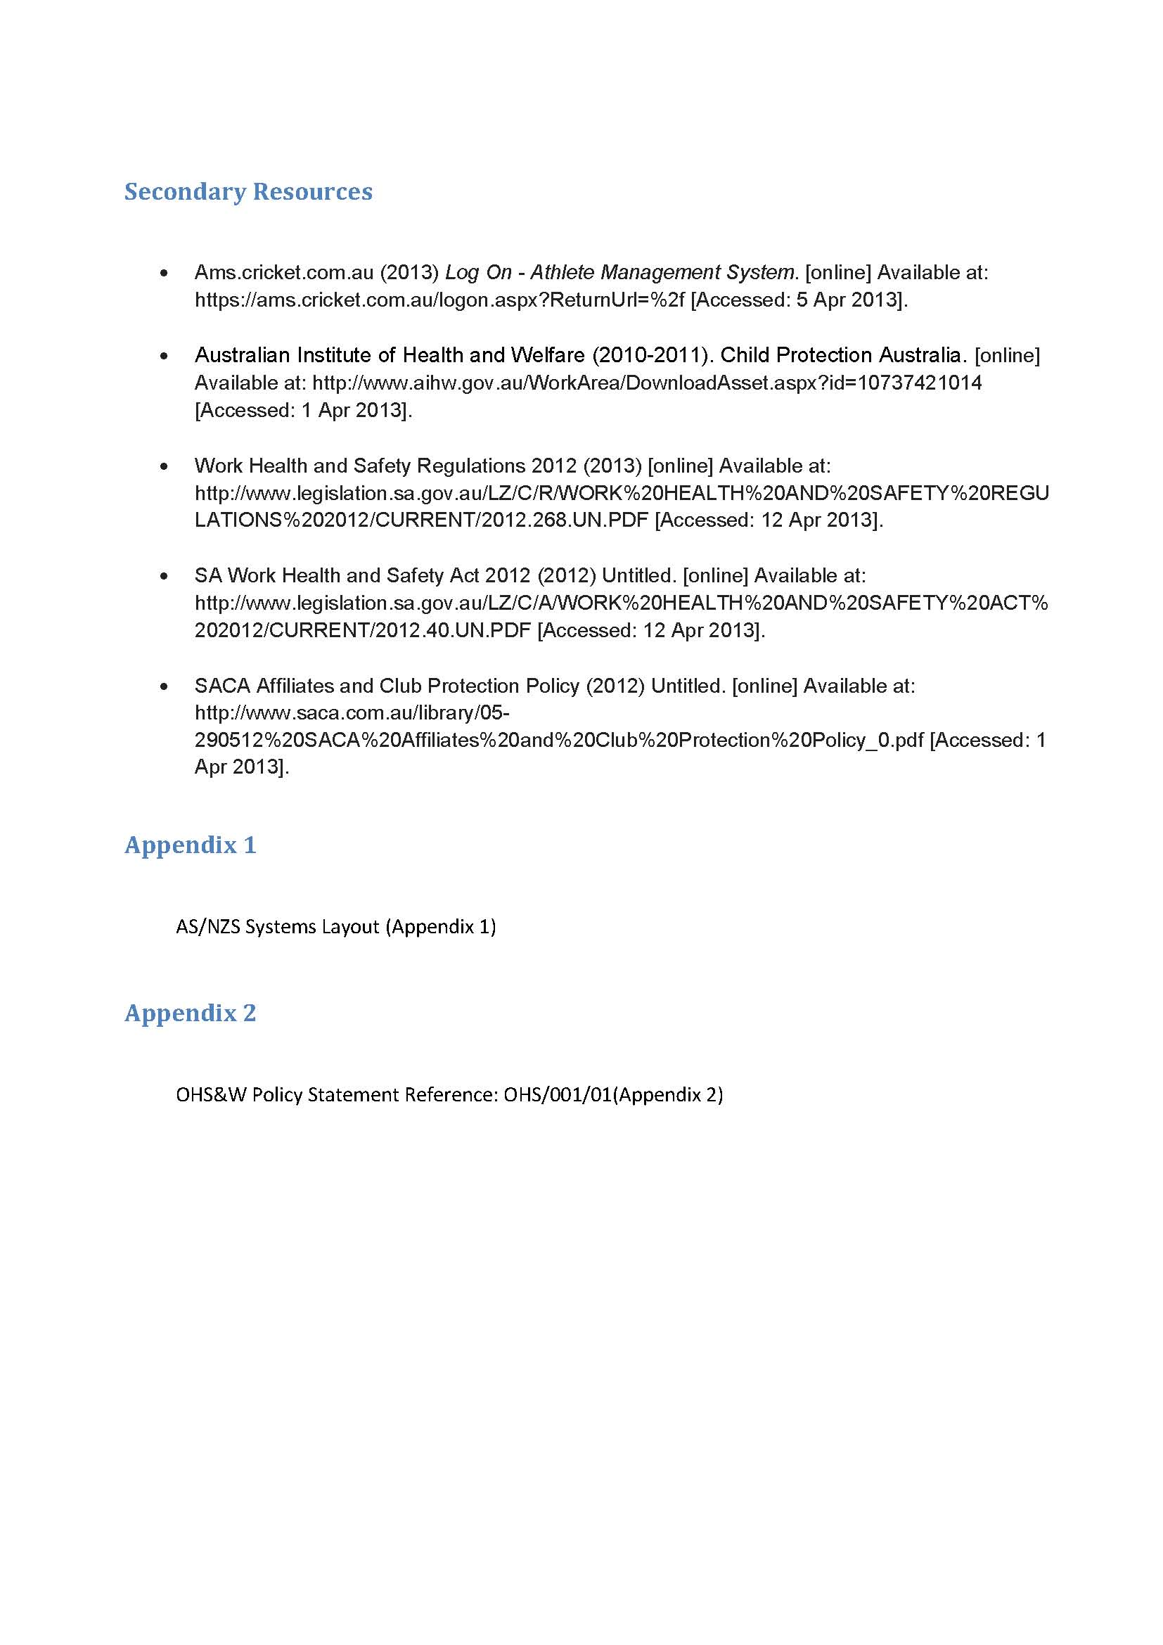
Student Response
Investigation and Analysis
Thorough investigation of relevant policies, laws and regulations specific to the workplace. Perceptive and well-informed analysis of the relationship between requirements and the workplace.
Knowledge and Understanding
Comprehensive understanding at an advanced level of the knowledge required within the relevant industry.
Knowledge and Understanding
Insightful explanation of the importance of managing OHS&W risks. The student has used an example to demonstrate this knowledge and understanding.
Investigation and Analysis
Perceptive and well-informed analysis of OHS&W issues in the workplace. Specific workplace examples are provided.
Knowledge and Understanding
Comprehensive understanding at an advanced level of the knowledge required within the relevant industry.
Knowledge and Understanding
Student provides an insightful and perceptive explanation of OHS&W practices for players under 18, making reference to relevant policy.
Knowledge and Understanding
Perceptive understanding of the OHS&W issue and insightful explanation of the resulting OHS&W implications and issues.
Investigation and Analysis
Well-informed analysis of identified OHS&W issue and the specific impact/outcomes in the workplace.
Reflection and Evaluation
Thorough and insightful reflection of student learning about OHS&W. In-depth self-evaluation of how student has implemented OHS&W strategies and practices. Excellent use of personal examples.
Stage 2 Workplace Practices
Area of Study 1: Industry and Work Knowledge
Topic 4: Finding Employment
Assessment Type 1: Folio
Task
Demonstrate effective communication and interpersonal skills by producing a personal portfolio. Applying for a job/scholarship/sponsorship involves a formal process requiring an understanding of the culture and environment that you are seeking to enter.
Description of Assessment
Develop a personal portfolio that showcases your skills, achievements, knowledge and qualities to gain one of the following:
- a place in an employment related training program
- sponsorship
- an audition/trial
- a scholarship (dance school, college, academy, institute)
- a coaching or refereeing/umpiring position
- any job you could realistically apply for.
Assessment Conditions
- Identify one of the above as the focus/position of your personal portfolio and state this as your aim.
- Investigate and summarise your findings regarding the focus/position and the requirements.
- Write a letter of application detailing your strengths, knowledge, skills and achievements in context of the position you seek.
- Include your CV/resume detailing achievements to date.

Relevant and recent evidence may include the following:
- audio/filmed evidence of performance
- photographs (trophies, teams, squads, performances, etc.)
- testimonials/references
- letters of application (to colleges, institutions, sponsors, academies)
- newspaper clippings of your achievements
- certificates/awards
- academic reports
- community involvement.

Your portfolio may take the form of:
- website
- scrapbook
- display folder
- CD/DVD
- PowerPoint
- written report
- poster/brochure.

DO NOT INCLUDE THE ORIGINAL COPIES OF CERTIFICATES
Learning Requirements | Assessment Design Criteria | Capabilities
1. Understand and explain concepts of industry and work  2. Analyse the relationships between work-related issues and practices in workplaces  3. Demonstrate knowledge of the roles of individuals, government legislation and policies, unions, and employer groups in work-related and workplace issues  4. Investigate the dynamic nature of work-related and workplace issues, cultures, and/or environments locally, nationally, and/or globally  5. Demonstrate and apply generic work skills and, where relevant, industry knowledge and skills, in a workplace and/or work-related context  6. Reflect on and evaluate learning experiences in/about the workplace. | Knowledge and Understanding  The specific features are as follows:  KU1 Understanding of knowledge, skills, and competencies appropriate to the relevant industry (i.e. the industry in which the student undertakes vocational learning and/or VET units of competency).  KU2 Understanding and explanation of concepts and issues related to industry and work.  Application  The specific features are as follows:  A1 Application of generic work skills and, where relevant, industry knowledge in the workplace or a work-related context.  A2 Application of relevant knowledge and skills in the context of an industry workplace.  A3 Achievement in units of competency as assessed by the RTO, where VET is included.  Investigation and Analysis  The specific features are as follows:  IA1 Analysis of the relationships between work-related issues, tasks, and/or practices in the workplace.  IA2 Investigation of the dynamic nature of work-related and workplace issues, tasks, cultures, and/or environments locally, nationally, and/or globally.  Reflection and Evaluation  The specific feature is as follows:  RE1 Reflection on and evaluation of learning experiences in/about an industry, and self-evaluation. | Communication  Citizenship  Personal Development  Work  Learning

This task is used with the kind permission of Marden Senior College.

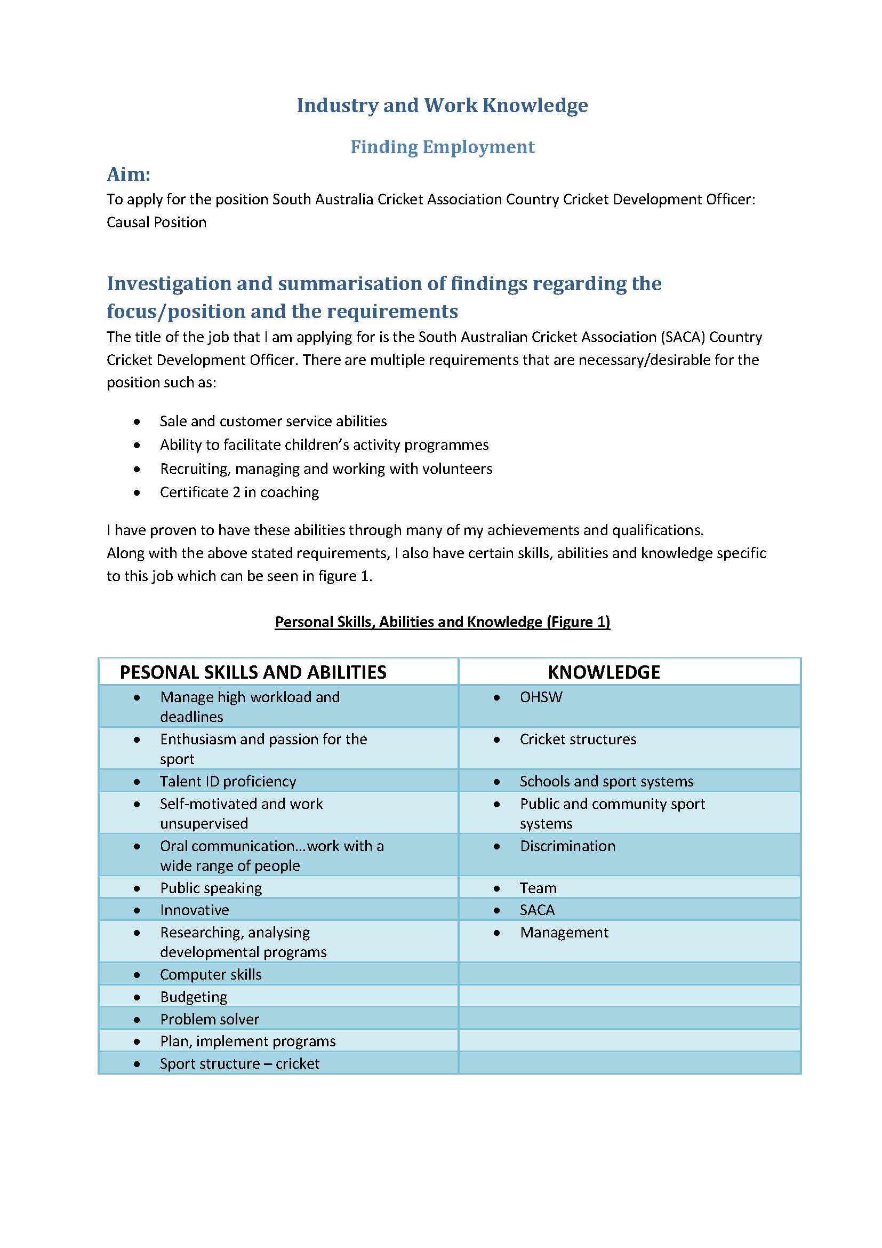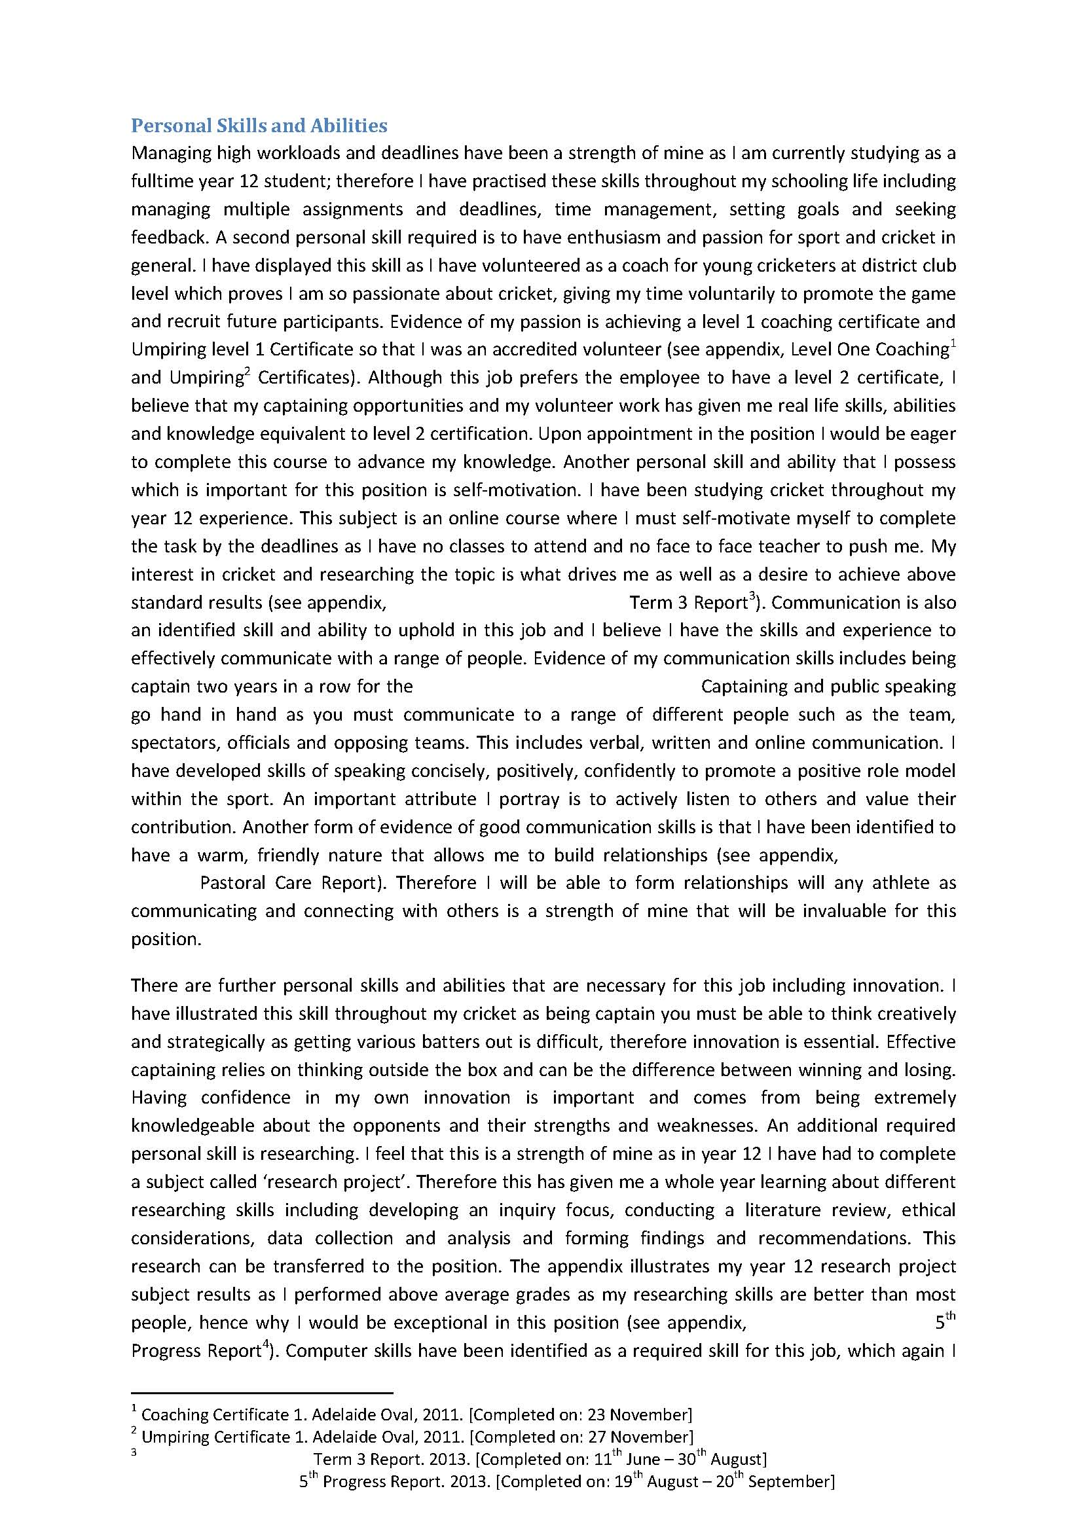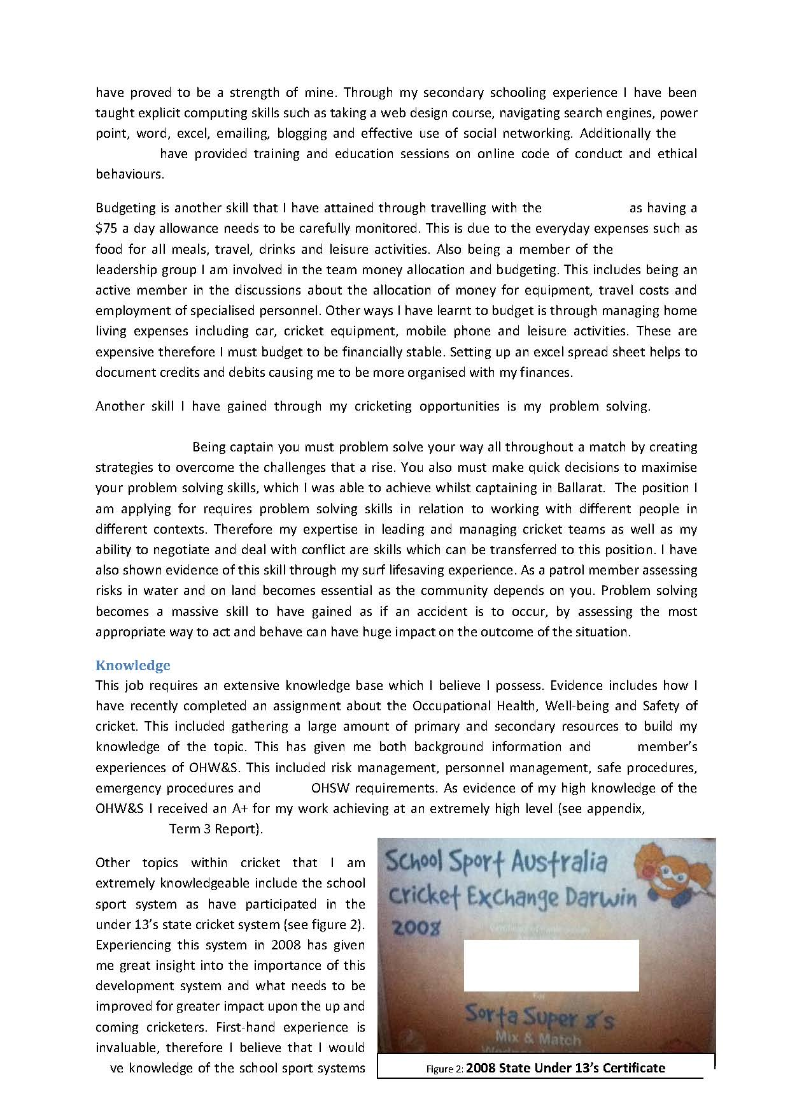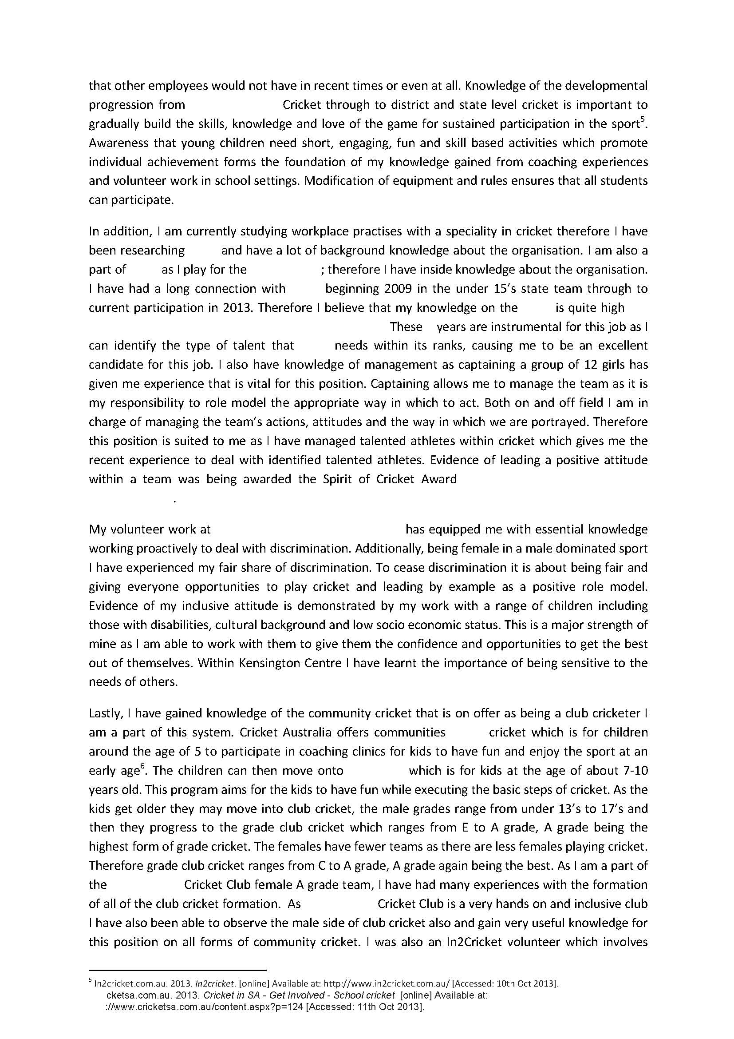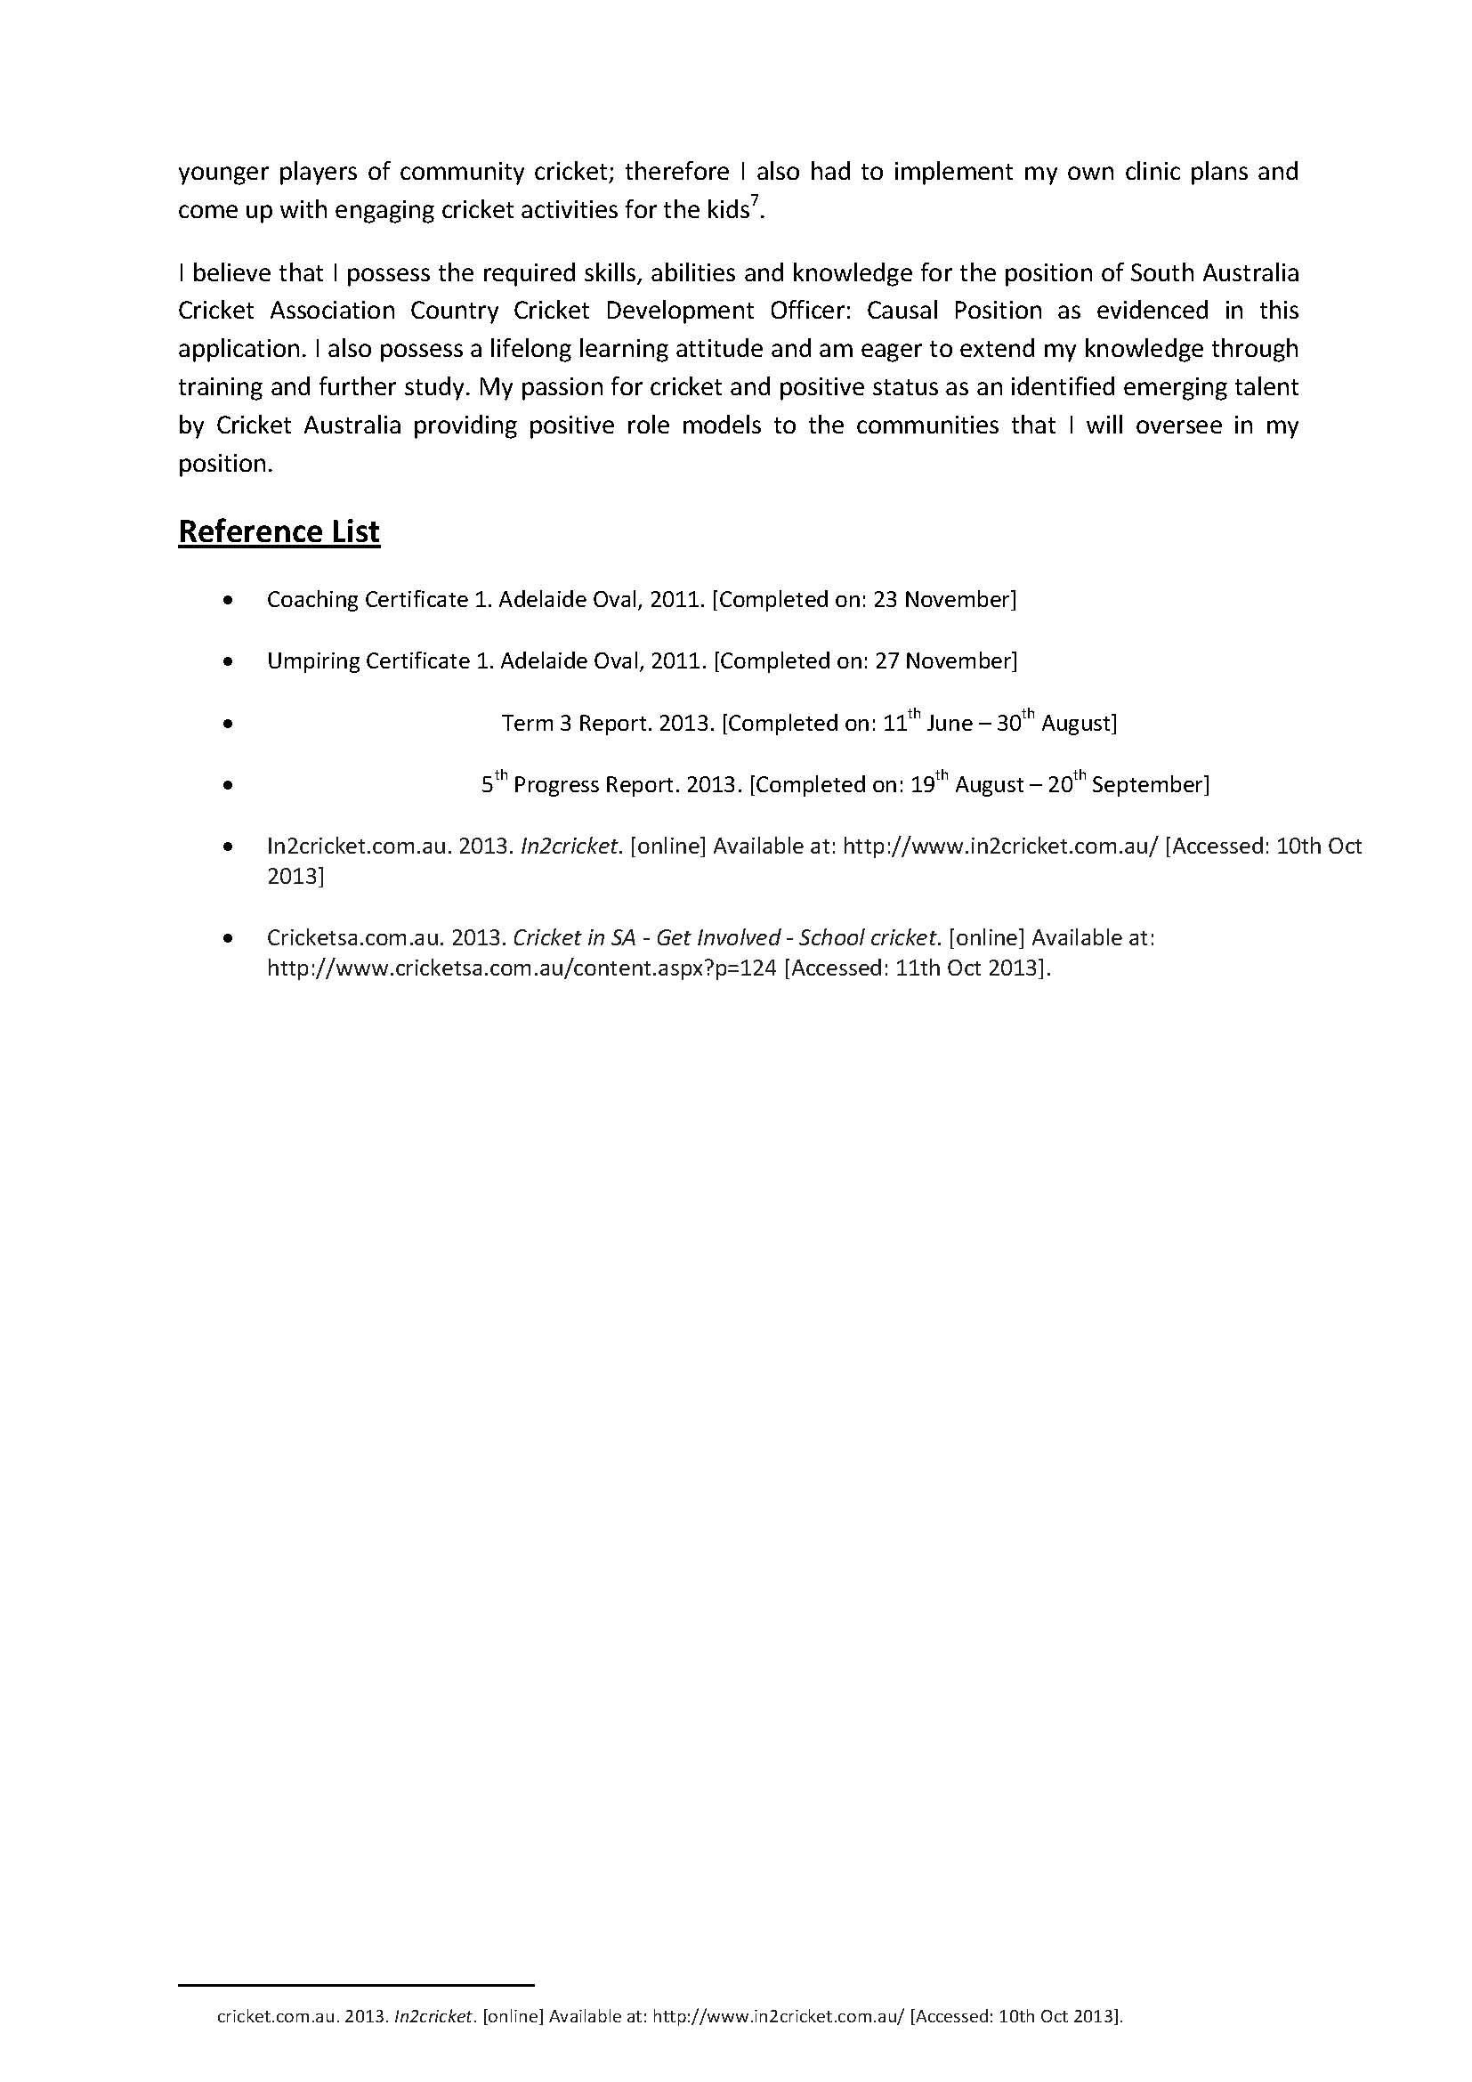
Student Response
Knowledge and Understanding
Very comprehensive understanding at an advanced level of the knowledge and skills required to work in the relevant industry. Excellent use of examples providing evidence of student’s understanding of the requirements for working in the specific job role.
Investigation and Analysis
Thorough and well-informed investigation regarding the requirements for the position.
These three tasks have been used with the kind permission of Marden Senior College.

Additional Comments
Together, these three responses for Assessment Type 1: Folio in a 20-credit Workplace Practices subject represent an A+ grade.

Work in Australian Society
The student has demonstrated a comprehensive understanding of volunteering within their industry setting including the knowledge and skills required by volunteers. Perceptive understanding of the broad concepts and issues related to volunteering in cricket, use of own examples from students own volunteering examples supports this understanding.
The student has undertaken a thorough, detailed and well-informed investigation and analysis of volunteering in cricket. Excellent use of secondary resources to inform the students understanding, evident in the analysis they have undertaken.
Industrial Relations
The student has demonstrated a very comprehensive understanding of OHS&W practices and issues in their workplace context. The student has used workplace and personal examples to demonstrate their perceptive analysis and understanding of OHS&W and the associated workplace issues.
Finding Employment
Comprehensive understanding at an advanced level of the knowledge, skills and competencies required to work in the relevant industry. The student has used relevant examples as evidence of their skills and abilities and how they could use these in the context of the chosen position.
The student did submit their CV/resume and application letter with this assignment, however they have been omitted for privacy reasons.
Performance Standards for Stage 2 Workplace Practices
 | Knowledge and Understanding | Application | Investigation and Analysis | Reflection and Evaluation
A | Comprehensive understanding at an advanced level of knowledge, skills, and competencies appropriate to the relevant industry.  Perceptive understanding and insightful explanation of broad concepts and issues related to industry and work. | Highly proficient and innovative application of a range of generic work skills and, where relevant, extensive industry knowledge in the workplace or a work-related context.  Perceptive application of highly relevant knowledge and skills in the context of an industry workplace.  Where VET is included, units of competency must have been successfully achieved; the student must have demonstrated competency as assessed by the relevant RTO. | Perceptive and well-informed analysis of the relationships between a range of work-related issues, tasks, and practices in the workplace.  Thorough, detailed, and well-informed investigation of the dynamic nature of a range of work-related and workplace issues, tasks, cultures, and/or environments locally, nationally, and/or globally. | Thorough and insightful reflection on a range of learning experiences in/about an industry, with in-depth self-evaluation.
B | Well-informed understanding of knowledge, skills, and competencies appropriate to the relevant industry.  Clear understanding and well-informed explanation of broad concepts and issues related to industry and work. | Proficient application of a range of generic work skills and, where relevant, broad industry knowledge in the workplace or a work-related context.  Well-considered application of relevant knowledge and skills in the context of an industry workplace.  Where VET is included, units of competency must have been successfully achieved; the student must have demonstrated competency as assessed by the relevant RTO. | Well-informed analysis of the relationships between a range of  work-related issues, tasks, and practices in the workplace.  Detailed and informed investigation of the dynamic nature of a number of  work-related and workplace issues, tasks, cultures, and/or environments locally, nationally, and/or globally. | Detailed and considered reflection on a number of learning experiences in/about an industry, with some in-depth self-evaluation.
C | Informed understanding of knowledge, skills, and competencies appropriate to the relevant industry.  General understanding and informed explanation of broad concepts and issues related to industry and work. | Appropriate application of selected generic work skills and, where relevant, industry knowledge in the workplace or a work-related context.  Considered application of most of the relevant knowledge and skills in the context of an industry workplace.  Where VET is included, units of competency may have been successfully achieved; the student may have demonstrated competency as assessed by the relevant RTO. | Informed analysis of the relationships between a number of work-related issues, tasks, and practices in the workplace.  Informed investigation of the dynamic nature of some work-related and workplace issues, tasks, cultures, and/or environments locally, nationally, and/or globally. | Some considered reflection on learning experiences in/about an industry, with some self-evaluation.
D | Recognition of knowledge, skills, and/or competencies appropriate to the relevant industry.  Some understanding and description of aspects of broad concepts and issues related to industry or work. | Attempted application of selected generic work skills or, where relevant, some industry knowledge in the workplace or a work-related context.  Attempted application of some knowledge and skills in the context of an industry workplace.  Where VET is included, units of competency may have been successfully achieved; the student may have demonstrated aspects of competency as assessed by the relevant RTO. | Description of the relationship between some aspects of work-related issues, tasks, or practices in the workplace.  Attempted investigation of some aspects of the nature of work-related and/or workplace issues, tasks, cultures, or environments. | Some reflective description and attempted evaluation of learning experiences in/about an industry.
E | Limited recognition of knowledge, skills, or competencies appropriate to the relevant industry.  Recall of some aspects of broad concepts or issues related to industry or work. | Attempted application of one or more generic work skills or, where relevant, limited industry knowledge in the workplace or a work-related context.  Identification of limited knowledge and skills in the context of an industry workplace.  Where VET is included, units of competency may have been successfully achieved; the student may have demonstrated limited aspects of competency as assessed by the relevant RTO. | Identification and attempted description of one or more work-related issues.  Emerging recognition of one or more aspects of the nature of work-related or workplace issues or environments. | Recall of some learning experiences in/about an industry.

