STAGE 1 MATHEMATICS
Assessment Type 2: Mathematical Investigation
Packaging for Christmas Balls
The Investigation
A manufacturer of Christmas balls is trying to determine the most efficient way to package the balls, such that the packaging is practical and cost efficient. The packaging is made from a pliable plastic that can easily be bent at an angle, on a curve and cut with the correct calibrations of a wrapping machine. A condition for the packaging is that the container must fully enclose the balls i.e. all ends must have covers.
All mathematical calculations must be shown. Note: scale diagrams may be used if required.
Part A: Initial investigation of a model
Initially the Christmas balls are to be in packages containing four balls each of equal radius.
Using a radius of ____cm (as given by your teacher), determine the total surface area if the balls are to be packaged in the following three arrangements:
i) A rectangular prism with the balls aligned as shown below (all ends sealed)
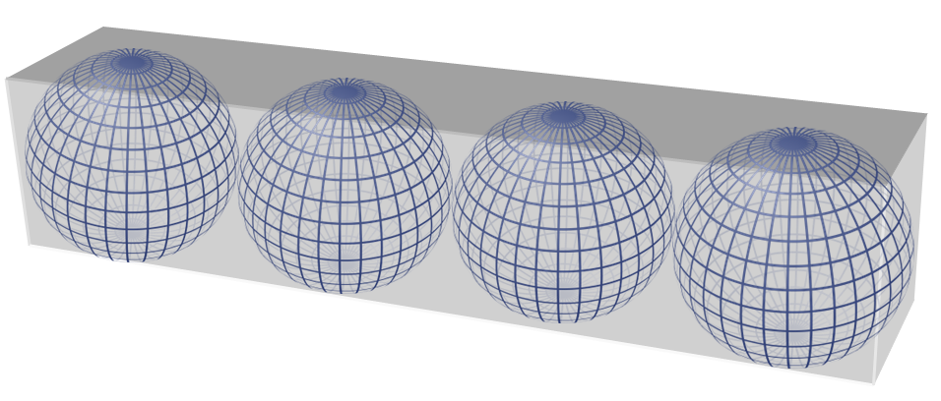

ii) A cylinder with the balls aligned side to side as shown below (all ends sealed)
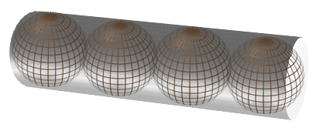

- A triangular prism with the balls aligned side to side as shown below (all ends sealed)
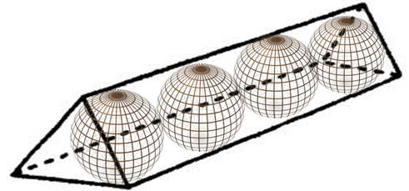

- Select at least two further possible designs for the packaging of four Christmas balls and determine the total surface area for each.
Some possible examples are shown below, however, you can also design your own.
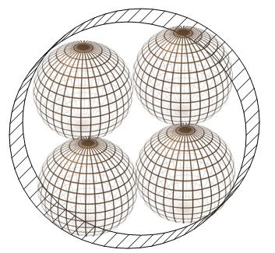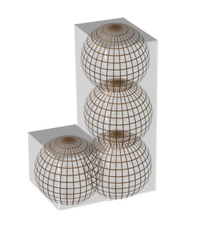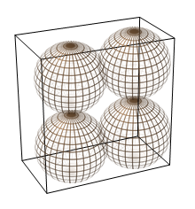

- Based on your calculations, determine which style of packaging would have the least total surface area.
- For each of the styles of packaging you selected, determine the function of the total surface area (TSA) in terms of $r$, the radius of each Christmas ball.
- Using technology, support your findings for the packaging of four Christmas balls with radius $r$ cm.

Part B: Further investigation of the model
- Further your investigation by considering packaging for a different number of Christmas balls with the same radius. For example, you might consider 8 Christmas balls which could lead to a cube or 9 Christmas balls could lead to a trapezoid prism. Compare your shape with least total surface area (TSA) from Part A to a shape from Part B with the same number of balls. For example, if the rectangular prism had the least total surface area with 4 balls, calculate the TSA with 8 balls. Is it still the least compared to a cube with 8 balls?
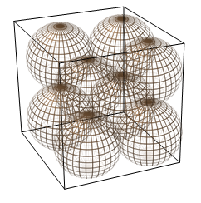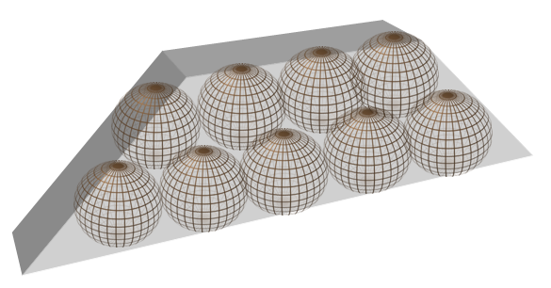

Part C: Conjecture
Consider your findings and develop a conjecture.
The conjecture may consider:
- The style of packaging despite the number of balls being packaged.
- The style of packaging in relation to a number pattern for the number of balls e.g. odd number, even number etc.
Discuss how this has been supported through your investigation.
Report
Your report on the mathematical investigation should include the following:

- an outline of the problem and context
- the method required to find a solution, in terms of the mathematical model or strategy used
- the application of the mathematical model or strategy, including:
  - relevant data and/or information
  - mathematical calculations and results, using appropriate representations
  - the analysis and interpretation of results, including consideration of the reasonableness and limitations of the results
- the results and conclusions in the context of the problem
- a bibliography and appendices, as appropriate.

The format of an investigation report may be written or multimodal.

The investigation report should be a maximum of 8 pages if written, or the equivalent in multimodal form.

Assessment Design Criteria

Concepts and Techniques
CT1 Knowledge and understanding of concepts and relationships
CT2 Selection and application of mathematical techniques and algorithms to find solutions to problems in a variety of contexts
CT3 Application of mathematical models
CT4 Use of electronic technology to find solutions to mathematical problems

Reasoning and Communication
RC1 Interpretation of mathematical results
RC2 Drawing conclusions from mathematical results, with an understanding of their reasonableness and limitations
RC3 Use of appropriate mathematical notation, representations, and terminology
RC4 Communication of mathematical ideas and reasoning to develop logical arguments
RC5 Development and testing of valid conjectures

Performance Standards for Stage 1 Mathematics
 | Concepts and Techniques | Reasoning and Communication
A | Comprehensive knowledge and understanding of concepts and relationships.  Highly effective selection and application of mathematical techniques and algorithms to find efficient and accurate solutions to routine and complex problems in a variety of contexts.  Successful development and application of mathematical models to find concise and accurate solutions.  Appropriate and effective use of electronic technology to find accurate solutions to routine and complex problems. | Comprehensive interpretation of mathematical results in the context of the problem.  Drawing logical conclusions from mathematical results, with a comprehensive understanding of their reasonableness and limitations.  Proficient and accurate use of appropriate mathematical notation, representations, and terminology.  Highly effective communication of mathematical ideas and reasoning to develop logical and concise arguments.  Effective development and testing of valid conjectures.
B | Some depth of knowledge and understanding of concepts and relationships.  Mostly effective selection and application of mathematical techniques and algorithms to find mostly accurate solutions to routine and some complex problems in a variety of contexts.  Some development and successful application of mathematical models to find mostly accurate solutions.  Mostly appropriate and effective use of electronic technology to find mostly accurate solutions to routine and some complex problems. | Mostly appropriate interpretation of mathematical results in the context of the problem.  Drawing mostly logical conclusions from mathematical results, with some depth of understanding of their reasonableness and limitations.  Mostly accurate use of appropriate mathematical notation, representations, and terminology.  Mostly effective communication of mathematical ideas and reasoning to develop mostly logical arguments.  Mostly effective development and testing of valid conjectures.
C | Generally competent knowledge and understanding of concepts and relationships.  Generally effective selection and application of mathematical techniques and algorithms to find mostly accurate solutions to routine problems in a variety of contexts.  Successful application of mathematical models to find generally accurate solutions.  Generally appropriate and effective use of electronic technology to find mostly accurate solutions to routine problems. | Generally appropriate interpretation of mathematical results in the context of the problem.  Drawing some logical conclusions from mathematical results, with some understanding of their reasonableness and limitations.  Generally appropriate use of mathematical notation, representations, and terminology, with reasonable accuracy.  Generally effective communication of mathematical ideas and reasoning to develop some logical arguments.  Development and testing of generally valid conjectures.
D | Basic knowledge and some understanding of concepts and relationships.  Some selection and application of mathematical techniques and algorithms to find some accurate solutions to routine problems in some contexts.  Some application of mathematical models to find some accurate or partially accurate solutions.  Some appropriate use of electronic technology to find some accurate solutions to routine problems. | Some interpretation of mathematical results.  Drawing some conclusions from mathematical results, with some awareness of their reasonableness or limitations.  Some appropriate use of mathematical notation, representations, and terminology, with some accuracy.  Some communication of mathematical ideas, with attempted reasoning and/or arguments.  Attempted development or testing of a reasonable conjecture.
E | Limited knowledge or understanding of concepts and relationships.  Attempted selection and limited application of mathematical techniques or algorithms, with limited accuracy in solving routine problems.  Attempted application of mathematical models, with limited accuracy.  Attempted use of electronic technology, with limited accuracy in solving routine problems. | Limited interpretation of mathematical results.  Limited understanding of the meaning of mathematical results, their reasonableness or limitations.  Limited use of appropriate mathematical notation, representations, or terminology, with limited accuracy.  Attempted communication of mathematical ideas, with limited reasoning.  Limited attempt to develop or test a conjecture.

