Stage 1 Biology: Investigation Folio Task

Topic 2: Infectious Diseases

Transfer of Infectious Disease: A Practical Model and Experiment to Test the effectiveness of toilet paper and hand soap.

Introduction and Purpose of Task:
Diseases can be transmitted by a number of different methods including air, direct contact, food, animals and faeces.
The purpose of this task is to demonstrate how microorganisms may be transferred between hosts. The model being used assesses the effectiveness of toilet paper as a physical barrier and the role of hand washing in the prevention of spread of disease.
The aim of the practical:
- to determine how well toilet paper prevents microbes getting onto your hands
- to determine if washing your hands is effective in preventing microbe transmissions
- to model how pathogens can be transmitted

The Experiment:
Materials per group:
Lawn plates of Saccharomyces cerevisiae (bakers’ yeast) on malt extract agar (useful reference for making lawn plates is http://www.nuffieldfoundation.org/practical-biology/making-spread-or-‘lawn’-plate accessed on 31/08/2018.)
Malt extract agar plates
Different brands of toilet paper*
Different types of soaps*
Safety Notes:
Risk: Use of live organisms, requires safe handling and appropriate disposal
Risk: Washing hands with soaps- skin sensitivities should be considered
Risk: Do not open agar plates unless told to do so
Method:
- Label the bases of three sterile malt agar plates with your name, the date and A, B or C.
- Wash your hands thoroughly (teacher will demonstrate before this step) using hot water and soap*, then dry them on a clean paper towel.
- Open one lawn plate of yeast (Saccharomyces cerevisiae). Wipe the surface lightly with two fingers, as shown in the diagram below.
- Lift the lid of dish A. Touch the agar surface lightly with the same two fingers. Quickly replace the lid.

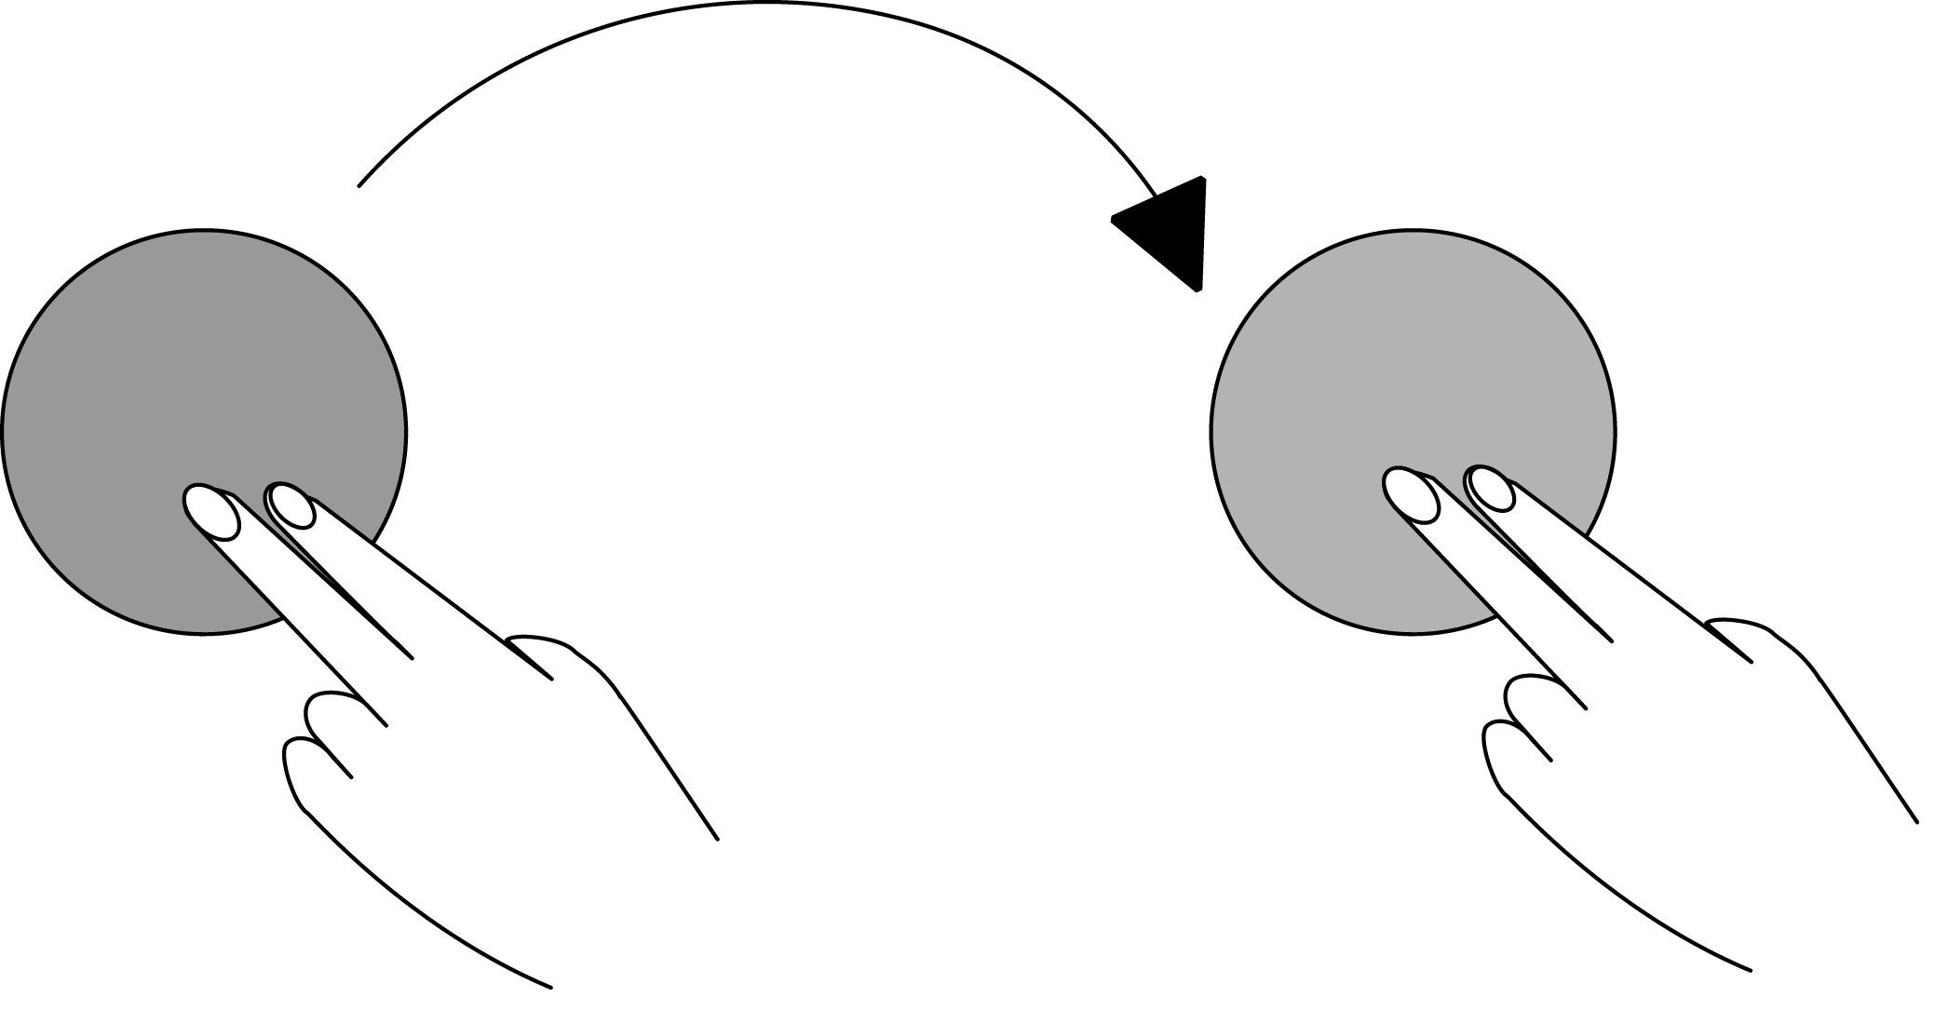
Plate A
Lawn Plate of Yeast
- Wash your hands thoroughly again with hot water and the same soap as in step 2, using the same method as demonstrated earlier by your teacher.
- Wrap your two fingers with one layer of one brand of toilet paper*.
- Open a new lawn plate of yeast. Wipe your fingers over the surface – trying to wipe them in the same way as you did in step 3.
New Lawn Plate of Yeast
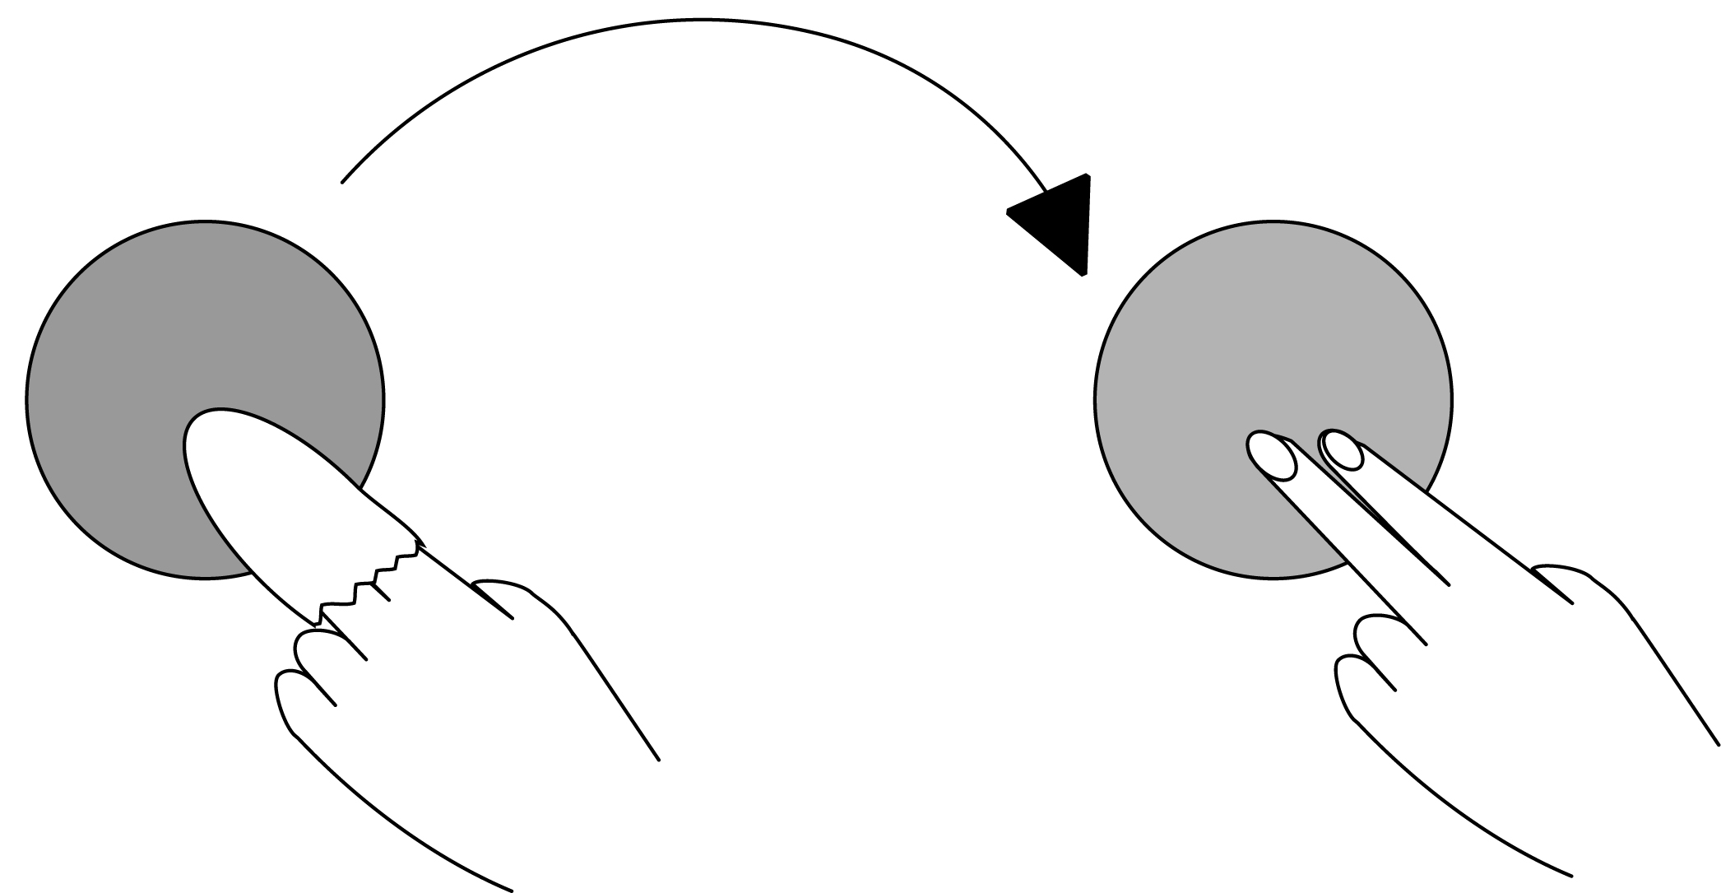
Plate B
- Remove the toilet paper and put it straight into the bag provided for disposal. Do not allow these fingers to touch anything, work carefully and quickly.
- Lift the lid of dish B. Touch the agar surface lightly with these same two fingers and quickly replace the lid. Again, try to use the same method for touching the agar plate as you used in step 4.
- Wash your hands thoroughly again with hot water and the same soap as used in steps 2 and 5.
- Wrap your fingers again in the same brand of toilet paper as in step 6, wipe your wrapped fingers on a new lawn plate of yeast, remove the toilet paper and place into the bag provided for disposal, then
- Wash your hands thoroughly with the type of soap used in steps 2, 5 and 10 and THEN touch the surface of agar plate C with your washed fingers, using the same method as in steps 4 and 9.
- Tape the lid on the agar plate and give it to your teacher to incubate inverted for 2-3 days at room temperature (20-25ºC).
- The experiment is then repeated, using different soap for hand washing and different brands of toilet paper. Your teacher will tell you what to use and what combination you will use.
- Examine the agar plate and record the data without opening the plates.
- Collect the data from all groups in the class.

The Investigation Report must include: (needs to be an individual report)
An appropriate introduction – introduces the theory behind the practical
Aim: what is the purpose of the experiment?
Identification of all the variables
Materials used and Method followed (insert exact Materials and Method used based on the task sheet)
Safety Audit
Results Table(s)
Discussion- includes analysis of the data and evaluation of the method
Consider these things:
- Compare the results to what you predicted would happen
- Is there observable differences between the toilet paper- can this be linked to the data, does the handwashing make a difference to the transmission of the yeast?
- Did the results show that one soap was better than the others?
- Did all groups get the same results?
- Reliability of the data?
- What applications do these kinds of experiments have for people in society or in industry?
- What recommendations would you make about the use of toilet paper and effectiveness of soaps in handwashing?

Conclusion- relates to the data, what does this data tell you? Is there enough data to draw a justified conclusion? Discuss the limitations of any conclusions drawn or recommendations made.
Reference List (Harvard Referencing System) - not assessed in this task, but required.
Assessment Conditions for this task:
A double lesson to undertake the practical in an allocated group. Time to collect data.

Each student to submit a practical report according to the guidelines below.

Students may submit one draft for feedback

Word Count: maximum of 1000 words or 6 minutes for an oral presentation for the introduction, analysis, evaluation and conclusion sections of the report.
Final copy is due 2 weeks after the experiment is completed.
Acknowledgement of source of information for this task:
http://www.nuffieldfoundation.org/practical-biology/how-good-your-toilet-paper accessed 3/02/2016
Assessment Design Criteria
Investigation, Analysis and Evaluation: 2, 3, 4 Knowledge and Application: 1, 4
Guidelines for how to address the Performance Standards in the report:
Section of the Report | Requirements/Indicators | Performance Standards
Introduction | Relevant biological Information presented that relates specifically to the practical being investigated.  The information relates to the aim of the experiment. | KA1
Aim | Has the correct format  Indicates the purpose of the experiment  Independent and dependent variables are identifiable. | KA1
Hypothesis | Has the correct format- is not in the form of a question  Links the independent and dependent variable and is a prediction. | IAE1  KA1
Method | Describes how the independent variable is changed, is detailed and describes how the dependent variable is measured.  All variables should be identified. | Method itself is not assessed as it is provided to the students.
Results | Table has the correct format  Data is represented in an appropriate manner- all data is shown  Significant figures are correct  Graphs are drawn appropriately- axis are labelled, appropriate scale used, title, size, correct format | IAE2
Discussion | Explains all the data obtained. Trends are identified and related to the relevant biological concepts.  Provides reasoning based on the data for supporting or rejecting the hypothesis  Evaluates the experimental method  Identifies potential sources of random and systematic error specifically and effect on data  Discusses the data’s reliability, precision, accuracy and validity | KA1,  IAE3  IAE4
Conclusion | Indicates whether the aim of the experiment has been met and restates the overall trend of the experiment.  Provides justification and discusses any limitations of the experiment and the conclusion drawn. | IAE3
Safety Audit | Detailed analysis of the potential risks, hazards and how they are managed and the precautions taken in the classroom | IAE1  KA1
Communication | Use of appropriate biological terms and conventions | KA4
Reference List | Harvard Referencing Used  Sources correctly cited.  Bibliography provided | KA4

Performance Standards
 | Investigation, Analysis and Evaluation | Knowledge and Application
A | Critically deconstructs a problem and designs a logical, coherent, and detailed biological investigation.  Obtains, records, and represents data, using appropriate conventions and formats accurately and highly effectively.  Systematically analyses and interprets data and evidence to formulate logical conclusions with detailed justification.  Critically and logically evaluates procedures and their effect on data. | Demonstrates deep and broad knowledge and understanding of a range of biological concepts.  Applies biological concepts highly effectively in new and familiar contexts.  Critically explores and understands in depth the interaction between science and society.  Communicates knowledge and understanding of biology coherently, with highly effective use of appropriate terms, conventions, and representations.
B | Logically deconstructs a problem and designs a well-considered and clear biological investigation.  Obtains, records, and represents data, using appropriate conventions and formats mostly accurately and effectively.  Logically analyses and interprets data and evidence to formulate suitable conclusions with reasonable justification.  Logically evaluates procedures and their effect on data. | Demonstrates some depth and breadth of knowledge and understanding of a range of biological concepts.  Applies biological concepts mostly effectively in new and familiar contexts.  Logically explores and understands in some depth the interaction between science and society.  Communicates knowledge and understanding of biology mostly coherently, with effective use of appropriate terms, conventions, and representations.
C | Deconstructs a problem and designs a considered and generally clear biological investigation.  Obtains, records, and represents data, using generally appropriate conventions and formats with some errors but generally accurately and effectively.  Undertakes some analysis and interpretation of data and evidence to formulate generally appropriate conclusions with some justification.  Evaluates procedures and some of their effect on data. | Demonstrates knowledge and understanding of a general range of biological concepts.  Applies biological concepts generally effectively in new or familiar contexts.  Explores and understands aspects of the interaction between science and society.  Communicates knowledge and understanding of biology generally effectively, using some appropriate terms, conventions, and representations.
D | Prepares a basic deconstruction of a problem and an outline of a deconstruction and biological investigation.  Obtains, records, and represents data, using conventions and formats inconsistently, with occasional accuracy and effectiveness.  Describes data and undertakes some basic interpretation to formulate a basic conclusion.  Attempts to evaluate procedures or suggest an effect on data. | Demonstrates some basic knowledge and partial understanding of biological concepts.  Applies some biological concepts in familiar contexts.  Partially explores and recognises aspects of the interaction between science and society.  Communicates basic biological information, using some appropriate terms, conventions, and/or representations.
E | Attempts a simple deconstruction of a problem and a procedure for a biological investigation.  Attempts to record and represent some data, with limited accuracy or effectiveness.  Attempts to describe results and/or interpret data to formulate a basic conclusion.  Acknowledges that procedures affect data. | Demonstrates limited recognition and awareness of biological concepts.  Attempts to apply biological concepts in familiar contexts.  Attempts to explore and identify an aspect of the interaction between science and society.  Attempts to communicate information about biology.

