Stage 1 Modern History
Assessment Type 1: Historical Skills Task – Sources Analysis

Protest Movements – The Vietnam War

An iconic photo from the conflict in Vietnam, taken in 1972 after a US napalm bombing

Due Date:
Drafts Due:
Word Limit: 800 words
Assessment Conditions: 1 weeks of class and homework time

ASSESSMENT CONTEXT:
We have been studying the conflict between the US and North Vietnam in the 1960s and how this sparked many protests. This war was fought long and hard and was controversial for many reasons. This was the first media war, and the tactics employed by the US were seen on televisions across America and the world. This sources analysis looks at these tactics and asks you to analyse the strength and weaknesses of both sides of the conflict.

Instructions: Using the attached sources answer the following questions. Respond in full sentences and incorporate the sources into your answers where relevant

- From source three identify any one tactical benefit of the tunnels used by the Vietcong [1 mark]

- What does source six suggest about the comparative strength of the Vietnamese and the American forces? [2 marks]

- What conclusions can be drawn from source two about the lives of Vietcong soldiers during the conflict? [2 marks]

- To what extent are the experiences of American and VC soldiers similar as seen in sources one and two? [4 marks]

- Discuss the usefulness and limitations of sources four and five for an historian studying the reasons for US tactics during the Vietnam war. [5 marks]

- Using all the sources, explain why the strategies employed by the US might have been ineffective against the Vietcong forces. [6 marks]

Sources

Protest Movements – The Vietnam War

Source One: A US Army soldier’s account of never knowing who the enemy was  One afternoon, I was standing on the corner waiting to catch a truck when a little shoe shine boy came up to me. He’d been around for about 6 months. We all knew his name. He had a little box that you put your foot up on. He’s working on my boots and I look up and see this bar girl that I knew across the street calling my name and waving for me to come over to her. I decided to see what she wanted. Just about the same time another little kid came running by and grabbed the shoeshine’s hat. The shoeshine boy ran after the kid as I was crossing the street. The shoeshine’s box blew up. It was a satchel charge that took out 23 Americans. I got knocked to the ground, unconscious for a few seconds, but I wasn’t hurt.  Source: Harpur, James (1996). War Without End. Longman. Australia. Pp. 82 | Source Two: Memoir of Truong Nhu Tang Viet Cong soldier  ‘We lived like hunted animals, an existence that demanded constant physical and mental alertness… Ready to move at any instant, we kept our personal encumbrances to a minimum. Two pairs of black pyjamas, a couple of pairs of underpants, a mosquito net, and a few square yards of light nylon (handy as a raincoat or roof) were all that a guerrilla owned’  Source: Wood John (1990). Vietnam & the Indochina Conflict. Macmillan. New Zealand. Pp 55

Source Three: A Vietcong (Vietnamese communist) tunnel complex

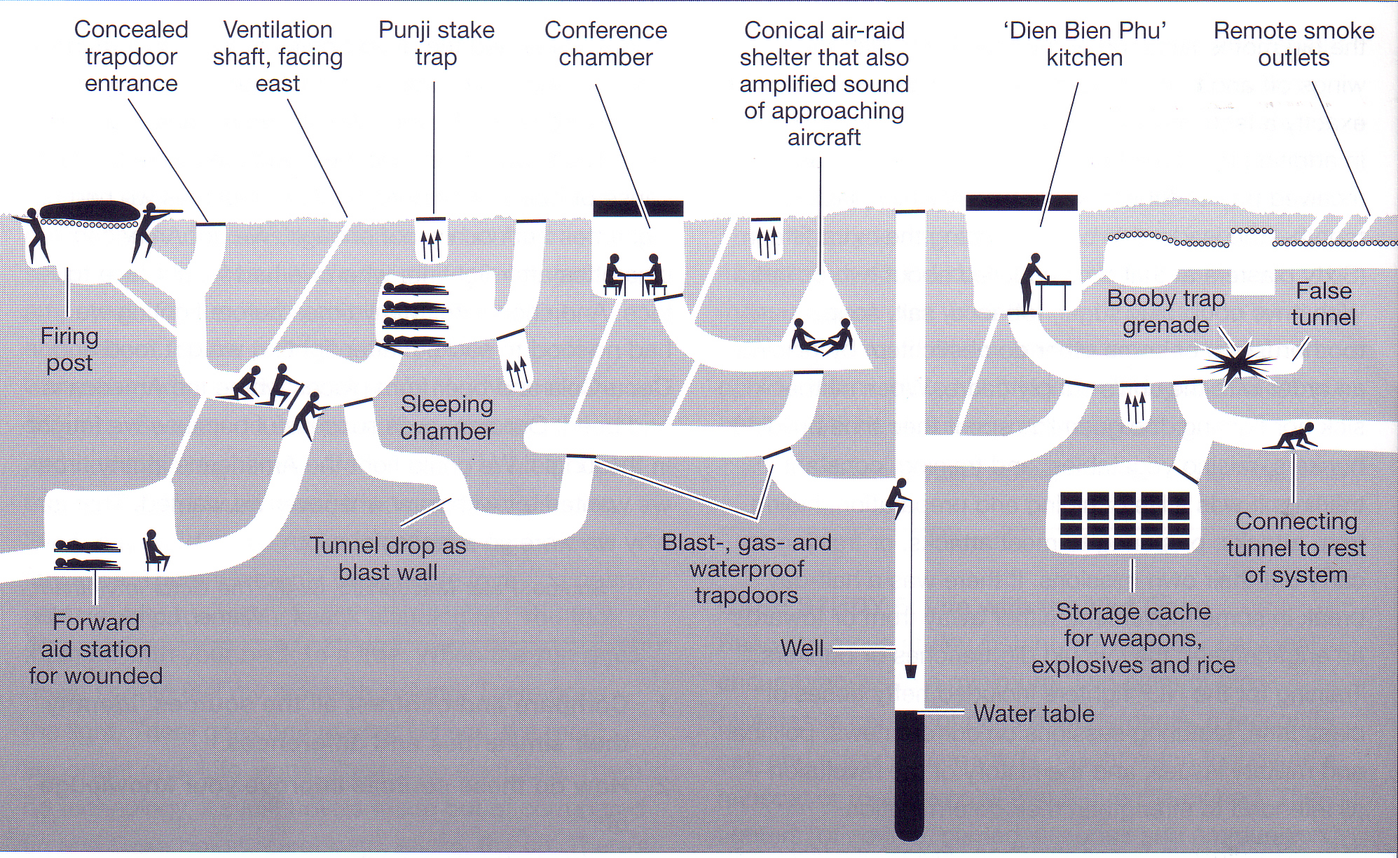

Source: Cantwell, Thomas (2003). Contested Spaces. Conflict in Indochina. The McGraw-Hill Corporation. Australia. Pp. 100

Source Four: Philip Caputo, a US marine

There was no pattern to these patrols and operations. Without a front, flanks or rear, we fought a formless war, against a formless enemy who evaporated the morning jungle mists, only to materialise in some unexpected place. It was a haphazard, episodic sort of combat. Most of the time, nothing happened: but when something did, it happened instantaneously and without warning. Rifle, or machine gun fire would erupt with heart-stopping suddenness…’

Source: Cantwell, Thomas (2003). Contested Spaces. Conflict in Indochina. The McGraw-Hill Corporation. Australia. Pp. 98
Source Five: An historian’s account  The bombing  ‘By the end of the Vietnam War seven million tons of bombs had been dropped on Vietnam, more than twice the total bombs dropped on Europe and Asia in WWII – almost one 500-pound bomb for every human being in Vietnam. It was estimated there were 20 million bomb craters in the country.  Zinn, H (1980). A People’s History of the United States | Source Six: War of the elephant and the flea  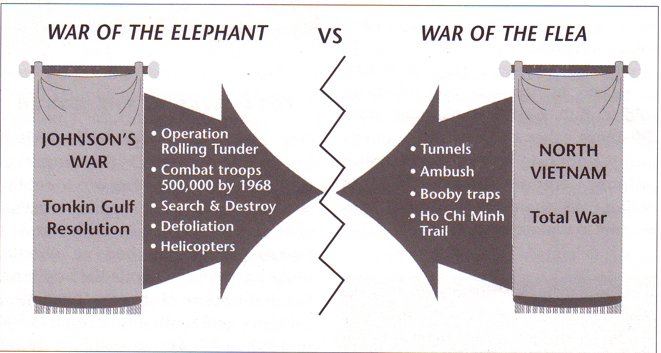  Source: Wood John (1990). Vietnam & the Indochina Conflict. MacMillan. New Zealand. Pp 56

Assessment design criteria:
The assessment design criteria that will be assessed in this task are below (in bold)

Understanding and Exploration | Application and Evaluation | Analysis
The specific features are as follows:  UE1 Understanding and exploration of historical concepts  UE2 Understanding and exploration of the role of ideas, people, and events in history | The specific features are as follows:  AE1 Application of the skills of historical inquiry to examine and evaluate sources and interpretations  AE2 Use of evidence to support arguments and draw conclusions  AE3 Communication of reasoned historical arguments, with acknowledgment of sources | The specific feature is as follows:  A1 Analysis of short-term and long-term impacts of developments and/or movements in the modern world  A2 Analysis of ways in which societies in the modern world have been shaped by both internal and external forces and challenges

Checklist:
In order to meet these criteria you should aim to do the following in your responses – check these off before you hand up the task!

Assessment criteria | ✓
Understanding and Exploration
- Use clear and concise examples from the sources to illustrate your understanding
Application and Evaluation
- Use relevant evidence to support your argument
- Show an understanding of the uses and limitations of sources
- Communicate your answers in clear and concise prose

Stage 1 Modern History

Protest Movements – Vietnam war
Assessment Sheet

 | UNDERSTANDING & EXPLORATION | APPLICATION & EVALUATION | ANALYSIS
A | In-depth understanding and exploration of historical concepts.  Comprehensive understanding and insightful exploration of the role of ideas, people, and events in history. | Perceptive application of the skills of historical inquiry to critically examine and evaluate sources and interpretations.  Discerning use of relevant evidence to support arguments and draw insightful and relevant conclusions.  Communication of well-reasoned, coherent, and insightful historical arguments, with appropriate acknowledgment of sources. | Critical analysis of short- and long-term impacts of developments and/or movements in the modern world.  Insightful and critical analysis of ways in which societies in the modern world have been shaped by both internal and external forces and challenges.
B | Some depth in understanding and exploration of historical concepts.  Some depth of understanding and thoughtful exploration of the role of ideas, people, and events in history. | Thoughtful application of the skills of historical inquiry to examine and evaluate sources and interpretations.  Well-considered use of mostly relevant evidence to support arguments, and draw mostly relevant conclusions.  Communication of reasoned and coherent historical arguments, with some insights, and with appropriate acknowledgment of sources. | Some depth in analysis of short- and long-term impacts developments and/or movements in the modern world.  Well-considered analysis of ways in which societies in the modern world have been shaped by both internal and external forces and challenges.
C | Understanding and exploration of historical concepts.  Understanding and considered exploration of the role of ideas, people, and events in history. | Application of the skills of historical inquiry to examine sources and interpretations, with some evaluation.  Use of generally relevant evidence to support arguments, and draw some relevant conclusions.  Communication of generally reasoned and coherent historical arguments, with acknowledgment of sources. | Description, with some analysis, of short- and long-term impacts of developments and/or movements in the modern world.  Description, with some analysis, of ways in which societies in the modern world have been shaped by both internal and external forces and challenges.
D | Some recognition of historical concepts.  Recognition and basic understanding the role of ideas, people, and events in history. | Basic application of some skills of historical inquiry to select and use sources.  Use of some information with partial relevance to support an argument, and draw basic conclusions.  Partial communication of a historical argument, with attempted acknowledgment of sources. | Description of basic short- and/or long-term impacts of a development and/or movement in the modern world.  Superficial description of one or more ways in which societies in the modern world have been shaped by an internal or external force or challenge.
E | Attempted engagement with one or more historical concepts.  Awareness of one or more ideas, people, or events in history. | Attempted application of the skills of historical inquiry to select and use one or more sources.  Attempted use of information of limited relevance.  Attempted description of a historical event, with limited or no acknowledgment of sources. | Attempted description of a short- or long-term impact of a development or movement in the modern world.  Attempted description of one way in which a society in the modern world has been shaped by an internal or external force.
Teacher Comment:

