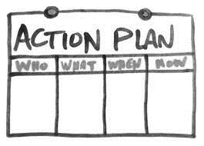 Planning Process
Chosen song _______________________________________________________________________

Source (i.e. website, book) ________________________________________________________________________________________

Section of song chosen to manipulate (i.e. verse, chorus, from bar? to bar?)
________________________________________________________________________________________________________________

How will I begin my arrangement? ___________________________________________________________________________________________________________________________________________________________________________________________________________________________________________________________________________________________________________________________________________________

How will I manipulate MELODY? | How will I manipulate RHYTHM? | How will I manipulate DYNAMICS?
How will I end my arrangement? ___________________________________________________________________________________________________________________________________________________________________________________________________________________________________________________________________________________________________________________________________________________

Further creative ideas:

