Stage 2 Business Innovation
Task 2: Consultancy Infographic & Analysis
Assessment Type 1: Business Skills (40%)
Weighting: 10%

As part of this task, you will work within the Transforming Business concept to transform a business:
Purpose
For this task you are required to take on the role of a consultant in order to review an existing business model and identify areas of improvement. As a business consultant, you need to provide feedback on opportunities to improve the potential viability of the business by identifying, exploring and communicating areas of risk within the business model. In your feedback to the existing business owner/s, you need to explore the specific opportunities and challenges for that business in the digital age. You must engage in primary and secondary research as a form of developing business intelligence.

Task Description
You are required to individually produce an infographic identifying the following factors:
- The challenges and opportunities for the business in the digital age
- Opportunities for growth
- Risks in the current model
You will submit a further, more in-depth analysis of the above. The infographic and analysis will collectively be no more than 800 words.

Start by:
- Investigating and mapping out the BMC
- Examining the existing business model to identify potential risks and opportunities for improvement using risk analysis tools such as a SWOT, PESTLE, STEEP.
- Create business intelligence by collecting and processing relevant data from stakeholders in relation to the business model. Utilise portfolio testing tools and testing methods to gain this intelligence. The ‘Testing Business Ideas’ textbook has an array of tools.
- Analyse specific areas of risk with the current business model that present challenged and opportunities for this business in the digital age. Draw on your problem finding and solving strategies!

Assessment Conditions
Format:
Consultancy Infographic and Analysis. This could be added to an adobe spark page. (AE1 & 2)
Word Count:
To a maximum of 800 words or equivalent in multimodal format.

Assessment Design Criteria
CA2 Create and apply business intelligence to iteratively develop business models and plans
AE1 Evaluate business models and plans
AE2 Analyse and evaluate opportunities and challenges for business in the digital age

- | Finding and Solving Problems | Contextual Application | Analysis and Evaluation
A | Insightful identification and exploration of problems and/or needs using customer-focused approaches  Highly creative generation of innovative and viable solutions to problems and/or needs using customer-focused approaches | Perceptive and highly effective contextual application of decision-making and project management tools and strategies  Astute and highly strategic creation and application of business intelligence to iteratively develop business models and plans  Astute and perceptive contextual application of communication and/or collaborative skills. | Discerning evaluation of business models and plans  Critical analysis and perceptive evaluation of opportunities and challenges for business in the digital age  Insightful analysis and evaluation of social, economic, environmental, and/or ethical impacts of global and local business.
B | Well-considered identification and exploration of problems and/or needs using customer-focused approaches  Creative generation of viable solutions with some innovation to problems and/or needs using customer-focused approaches | Well-considered and mostly effective contextual application of decision-making, project management and change management tools and strategies  Strategic creation and application of business intelligence to iteratively develop business models and plans  Mostly perceptive contextual application of communication and/or collaborative skills. | Mostly discerning evaluation of business models and plans  Mostly critical analysis and evaluation of opportunities and challenges for business in the digital age  Well-considered analysis and evaluation of social, economic, environmental, and/or ethical impacts of global and local business.
C | Considered identification and exploration of problems and/or needs using customer-focused approaches  Mostly creative generation of viable solutions to problems and/or needs using customer-focused approaches | Considered contextual application of decision-making, project management and change management tools and strategies  Competent creation and application of business intelligence to iteratively develop business models and plans  Effective contextual application of communication and/or collaborative skills. | Considered evaluation of business models and plans  Some critical analysis and evaluation of opportunities and challenges for business in the digital age  Considered analysis and evaluation of social, economic, environmental, and/or ethical impacts of global and local business.
D | Some identification and exploration of problems and/or needs using customer-focused approaches  Some generation of solutions to problems and/or needs using customer-focused approaches | Some application of decision-making, project management and change management tools and strategies  Some creation and application of business intelligence to iteratively develop business models and plans  Some contextual application of communication and/or collaborative skills. | Some analysis and description of business models and plans  Some analysis and description of opportunities and challenges for business in the digital age  Some analysis and description of social, economic, environmental, and/or ethical impacts of global and local business.
E | Attempted identification and exploration of problems and/or needs using customer-focused approaches  Attempted generation of solutions to problems and/or needs using customer-focused approaches | Attempted application of decision-making, project management and change management tools and strategies  Attempted creation and application of business intelligence to iteratively develop business models and plans  Attempted application of communication and/or collaborative skills. | Attempted description of business models and plans  Description of opportunities and challenges for business in the digital age  Description of social, economic, environmental, and/or ethical impacts of global and local business.

Extra Guidelines – Task Process
Select an existing business and start by creating an initial Business Model Canvas with what you already know about the business. You will need to do some research! | ◻
You will need to examine the business through secondary research in the first instance. | ◻
Undertake a SWOT analysis and or other analysis tools such as PESTLE / STEEP / MOST / CATWOE and use your secondary research to justify comments in these areas. | ◻
Create business Intelligence to collect data from stakeholders of the the business related to the business model canvas e.g. suppliers, customers, competitors, government and external stakeholders. | ◻
Use existing portfolio tools (On SOCS, Mural, textbook and internet) to collect data from stakeholders of the business related to the business model canvas | ◻
Start to identify some possible areas of opportunity and growth by analysing the completed business model canvas. You can use the Stanford D-school method cards to generate ideas for possible opportunities. | ◻
Draw on your problem finding and solving strategies to identify and explore areas of risk within the current business model. | ◻
Analyse and evaluate the particular challenges and opportunities that are present for that business in the digital age.  Compose an 800-word Infographic and analysis that addresses the following areas:  - Opportunities for growth  - Risks in the current model  - Challenges and opportunities for the business in the digital age.  Below is an example  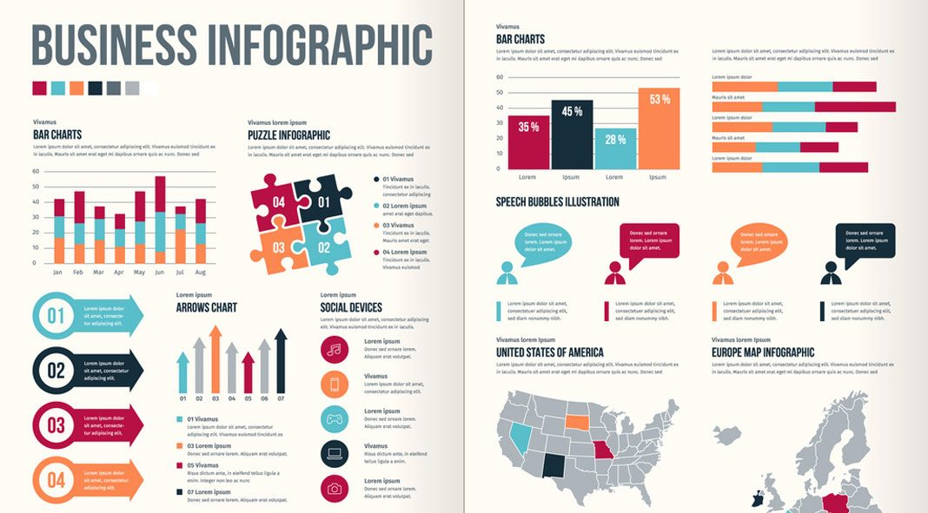 | ◻
Key words to be included:  ◻ Digital Age  ◻ Business Model and Business Plan  ◻ Risks and/or challenges  ◻ Opportunities  ◻ Business Intelligence  ◻ Market Research  ◻ Iteration | ◻

