Stage 2 Earth and Environmental Science
Program 2: Assessment Type 2: Skills and Applications Task

This task provides the opportunity to demonstrate your understanding of how oceans can affect weather systems.

All of your work for this task is to be submitted electronically using MS Word and MS Excel.
All activities are completed under teacher supervision in class. Activity 2 can be started while Activity 1 is underway.

1. Practical Activity
In groups, construct models of the ocean and the land to test the following hypothesis:
“The warming and cooling rates of land are greater than those of the ocean.”

Materials (per group)
- 2 buckets or deep foil trays
- water
- sand
- 2 temperature sensors
- 2 retort stands

Procedure (work in groups)
- Fill one bucket with sand and one bucket with water. Make sure the buckets are filled to the same level. Use retort stands to position the temperature sensors 2 – 3 cm under the surface in each bucket. Leave both buckets in the shade until they reach the same temperature.
- Once the temperature in both buckets is the same, put them in direct sunlight. Record the temperature every two minutes until a clear trend in the data is seen. Print out one copy of the graph of temperature versus time for each group member.
- Move the buckets back into the shade. Record the temperature every two minutes until a clear trend is seen. Print the graph for each group member.

Analysis (work individually)
Attach the printouts of the two graphs.

1. Compare the rate of change in temperature for the two buckets as they warmed and as they cooled.

2. Use your results to explain whether the hypothesis is confirmed, refuted or uncertain.

3. Discuss the limitations of your model in representing land and ocean.

2. Data analysis activity
Use the following information to test the following hypothesis:
The warming and cooling rates of land are greater than those of the ocean at similar latitudes in Australia.

Three regions in Australia with latitude of 35°S are Adelaide, Murray Bridge and Albany. Their locations are shown as on the map below:

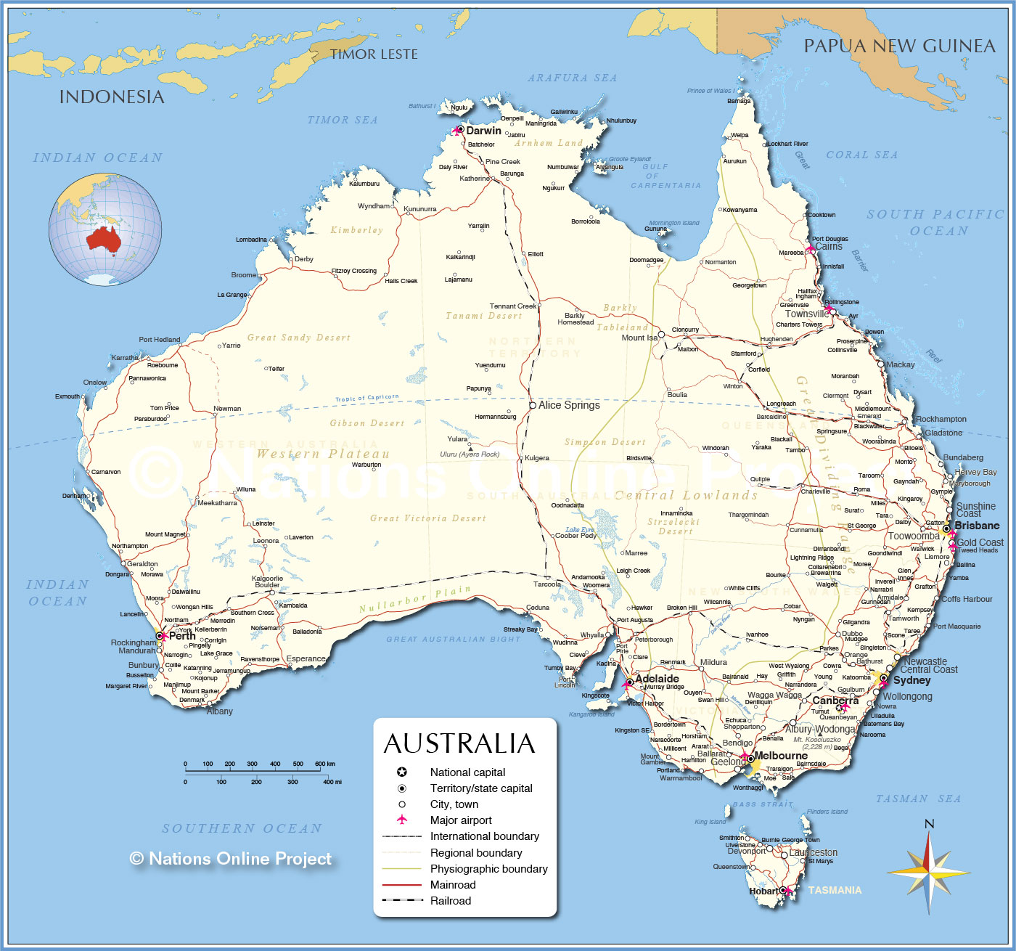
http://www.nationsonline.org/oneworld/map/australia-map.htm

The 7-day weather forecast, for a week in March, is given for each region on the next page.
Use this information to answer the questions that follow.

1. The following data table has been constructed to display the temperatures for Adelaide and Murray Bridge for this week.

 |  | Adelaide |  |  | Murray Bridge
 | max (°C) | min (°C) | range (°C) | max (°C) | min (°C) | range (°C)
Wed | 31 | 18 | 13 | 35 | 15 | 20
Thu | 31 | 19 | 12 | 35 | 16 | 19
Fri | 30 | 18 | 12 | 32 | 15 | 17
Sat | 26 | 17 | 9 | 26 | 15 | 11
Sun | 24 | 16 | 8 | 23 | 15 | 8
Mon | 26 | 16 | 10 | 25 | 13 | 12
Tue | 28 | 17 | 11 | 30 | 14 | 16
AVERAGE | 28.0 | 17.3 | 10.7 | 29.4 | 14.7 | 14.7

2. (a) Use MS Excel to draw a well-labelled graph to show the range of temperatures in Adelaide and Murray Bridge over the seven days.

(b) Use your graph to explain whether the hypothesis is confirmed, refuted or uncertain.

3. Complete a similar data table in MS Excel to display the temperatures for Adelaide and Albany for this week. Use the functions in MS Excel to calculate the ranges and average values.

4. (a) Use MS Excel to draw a well-labelled graph to show the range of temperatures in Adelaide and Albury over the seven days.

(b) Use your graph to describe the similarity and difference in temperatures between these two regions.

(c) Discuss one factor that could contribute to the difference in temperatures between these two regions.

3. Ocean research
This activity focuses on science as a human endeavour.

The Global Ocean Observing System
http://www.goosocean.org/

- Use information from this website to discuss the reasons for setting up this global observation system.

(b) Describe examples of how the work of the people at GOOS illustrates science as a human endeavour.

Integrated Marine Observing Systems
http://imos.org.au/argo.html

Argo Floats
Argo is an international collaboration that collects high-quality temperature and salinity profiles from the upper 2000m of the ice-free global ocean and currents from intermediate depths. The data come from battery-powered autonomous floats that spend most of their life drifting at depth where they are stabilised by being neutrally buoyant at the "parking depth" pressure by having a density equal to the ambient pressure and a compressibility that is less than that of sea water. At present there are several models of profiling float used in Argo. All work in a similar fashion but differ somewhat in their design characteristics. At typically 10-day intervals, the floats pump fluid into an external bladder and rise to the surface over about 6 hours while measuring temperature and salinity. Satellites or GPS determine the position of the floats when they surface, and the floats transmit their data to the satellites. The bladder then deflates and the float returns to its original density and sinks to drift until the cycle is repeated. Floats are designed to make about 150 such cycles.

http://www.argos-system.org/argos/why-choose-argos/

Use information from the sites above and other websites to answer the following questions about Argo.

(c) Describe the purpose of Argo(s) and how it helps the scientific community.

(e) Describe how an Argo float collects information and how this information is used.

Performance Standards for Stage 2 Earth and Environmental Science
- | Investigation, Analysis, and Evaluation | Knowledge and Application
A | Designs a logical, coherent, and detailed earth and environmental science investigation.  Obtains, records, and represents data, using appropriate conventions and formats accurately and highly effectively.  Systematically analyses and interprets data and evidence to formulate logical conclusions with detailed justification.  Critically and logically evaluates procedures and their effect on data. | Demonstrates deep and broad knowledge and understanding of a range of earth and environmental science concepts.  Develops and applies earth and environmental science concepts highly effectively in new and familiar contexts.  Critically explores and understands in depth the interaction between science and society.  Communicates knowledge and understanding of earth and environmental science coherently, with highly effective use of appropriate terms, conventions, and representations.
B | Designs a well-considered and clear earth and environmental science investigation.  Obtains, records, and represents data, using appropriate conventions and formats mostly accurately and effectively.  Logically analyses and interprets data and evidence to formulate suitable conclusions with reasonable justification.  Logically evaluates procedures and their effect on data. | Demonstrates some depth and breadth of knowledge and understanding of a range of earth and environmental science concepts.  Develops and applies earth and environmental science concepts mostly effectively in new and familiar contexts.  Logically explores and understands in some depth the interaction between science and society.  Communicates knowledge and understanding of earth and environmental science mostly coherently, with effective use of appropriate terms, conventions, and representations.
C | Designs a considered and generally clear earth and environmental science investigation.  Obtains, records, and represents data, using generally appropriate conventions and formats with some errors, but generally accurately and effectively.  Undertakes some analysis and interpretation of data and evidence to formulate generally appropriate conclusions with some justification.  Evaluates procedures and some of their effect on data. | Demonstrates knowledge and understanding of a general range of earth and environmental science concepts.  Develops and applies earth and environmental science concepts generally effectively in new or familiar contexts.  Explores and understands aspects of the interaction between science and society.  Communicates knowledge and understanding of earth and environmental science generally effectively, using some appropriate terms, conventions, and representations.
D | Prepares the outline of an earth and environmental science investigation.  Obtains, records, and represents data, using conventions and formats inconsistently, with occasional accuracy and effectiveness.  Describes data and undertakes some basic interpretation to formulate a basic conclusion.  Attempts to evaluate procedures or suggest an effect on data. | Demonstrates some basic knowledge and partial understanding of earth and environmental science concepts.  Develops and applies some earth and environmental science concepts in familiar contexts.  Partially explores and recognises aspects of the interaction between science and society.  Communicates basic earth and environmental science information, using some appropriate terms, conventions, and/or representations.
E | Identifies a simple procedure for an earth and environmental science investigation.  Attempts to record and represent some data, with limited accuracy or effectiveness.  Attempts to describe results and/or interpret data to formulate a basic conclusion.  Acknowledges that procedures affect data. | Demonstrates limited recognition and awareness of earth and environmental science concepts.  Attempts to develop and apply earth and environmental science concepts in familiar contexts.  Attempts to explore and identify an aspect of the interaction between science and society.  Attempts to communicate information about earth and environmental science.

