Locally Assessed Languages
Continuers Level
OFFICIAL
2024 Subject Outline | Stage 1 and Stage 2

Published by the SACE Board of South Australia,
11 Waymouth Street, Adelaide, South Australia 5000
Copyright © SACE Board of South Australia 2010
First published 2010
Reissued for 2011 (published online October 2010,
printed January 2011), 2012, 2013, 2014, 2015, 2016,
2017, 2018, 2019, 2020, 2021, 2022, 2023, 2024
ISBN 978 1 74102 685 6 (online Microsoft Word version)
ref: A1095190
This subject outline is accredited for teaching at Stage 1 from 2010 and at Stage 2 from 2011

contents
Introduction 1
Subject Description 1
Capabilities 2
Literacy in Locally Assessed Languages at Continuers Level 3
Numeracy in Locally Assessed Languages at Continuers Level 4
Aboriginal and Torres Strait Islander Knowledge, Cultures, and Perspectives 4
Stage 1 Locally Assessed Languages Continuers Level 5
Learning Scope and Requirements 6
Learning Requirements 6
Content 6
Assessment Scope and Requirements 8
Evidence of Learning 8
Assessment Design Criteria 8
School Assessment 10
Performance Standards 12
Assessment Integrity 18
Support materials 19
Subject-specific Advice 19
Advice on Ethical Study and Research 19
Stage 2 Locally Assessed Languages Continuers Level 21
Learning Scope and Requirements 21
Learning Requirements 22
Content 22
Assessment Scope and Requirements 25
Evidence of Learning 25
Assessment Design Criteria 25
School Assessment 27
External Assessment 30
Performance Standards 32
Assessment Integrity 38
Support Materials 39
Subject-specific Advice 39
Advice on Ethical Study and Research 39
Appendix A: Language-specific Information 40
Chinese 40
French 47
German 50
Indonesian 53
Italian 57
Japanese 62
Modern Greek 68
Spanish 68
Vietnamese 68

Introduction
Subject description
A locally assessed language at continuers level is a 10-credit or a 20-credit subject at Stage 1, and a 20-credit subject at Stage 2.
The subject outline for locally assessed languages at continuers level has been developed from the Collaborative Curriculum and Assessment Framework for Languages (CCAFL), which is a national model for the teaching, learning, and assessment of language subjects. The three levels in the framework are:
- beginners — for students with little or no previous knowledge of the language
- continuers — for students who will have studied the language for 400 to 500 hours by the time they have completed Stage 2, or who have an equivalent level of knowledge
- background speakers — for students who have a background in the language and who have had more than 1 year’s education in a country where the language is spoken.
Eligibility criteria apply for entry to a program at beginners level, and to a program at continuers level when a program at background speakers level is also available in the language.
In locally assessed languages at continuers level, students develop their skills to communicate meaningfully with people across cultures. Students are given opportunities to develop knowledge, awareness, and understanding of other languages and cultures in relation to their own. Students reflect on their own attitudes, beliefs, and values, and develop an understanding of how culture and identity are expressed through language.
Students develop and apply linguistic and intercultural knowledge, understanding, and skills by:
- interacting with others to exchange information, ideas, opinions, and experiences in [Language]
- creating texts in [Language] for specific audiences, purposes, and contexts to express information, feelings, ideas, and opinions
- analysing a range of texts in [Language] to interpret meaning
- examining relationships between language, culture, and identity, and reflecting on the ways in which culture influences communication.
Students develop an understanding of how [Language] is used effectively and appropriately by using various combinations of the skills of listening, speaking, viewing, reading, and writing for a range of purposes in a variety of contexts. Students explore a range of prescribed themes and topics from the perspectives of diverse individuals and groups in the [Language]-speaking communities and in their own community.
Refer to Appendix A for language-specific information on the nine locally assessed languages at continuers level: Chinese, French, German, Indonesian, Italian, Japanese, Modern Greek, Spanish, and Vietnamese.

Capabilities
The capabilities connect student learning within and across subjects in a range of contexts. They include essential knowledge and skills that enable people to act in effective and successful ways.
The five capabilities that have been identified are:
- communication
- citizenship
- personal development
- work
- learning.
The capabilities, in particular those for communication and citizenship, are reflected in the learning requirements, content, assessment design criteria, and performance standards of the locally assessed languages at continuers level. In [Language] at continuers level, students develop intercultural communication skills to communicate effectively and appropriately in a variety of contexts for a range of purposes.
Communication
Students develop their ability to communicate and interact effectively and appropriately in a variety of contexts, within and across languages and cultures.
By interacting with others to exchange information, ideas, opinions, and experiences in [Language], students develop their ability to interpret and understand interactions between diverse individuals. They develop their understanding of how meaning is created and interpreted in the process of communication.
Students develop and apply linguistic and intercultural knowledge, understanding, and skills. They create texts in [Language] and analyse and interpret meaning in a range of written, spoken, visual, and multimodal texts that are in [Language], to share new insights and information with others.
Students examine relationships between language, culture, and identity by comparing and making connections between languages and cultures, and reflecting on the ways in which culture influences communication.
Citizenship
Students develop their intercultural communication skills to interact effectively and appropriately with people within and across local and global communities. The development of intercultural communication skills has the potential to contribute to social cohesiveness through better communication and understanding, and helps students to know and understand themselves, others, and the world around them.
Students develop their own understanding of diverse ways of knowing, being, and doing, through meaningful interaction with other peoples and other cultures, and through analysis of linguistic and cultural similarities and differences.
Students explore themes and topics from perspectives of diverse individuals and communities, including their own. Through this learning, students gain an understanding of how cultural concepts and practices affect how people see the world, interact, and communicate with others. They have opportunities to see their own view of the world in context, as one of many.
Students develop the ability to understand and interpret meaning from a variety of texts and are sensitive to the ideas, values, and beliefs presented in those texts.

Personal development
Students’ personal, linguistic, and cultural identity is strengthened through the study of languages. They develop their understanding of the relationship between language and culture, and an awareness of the role of languages and culture in human interaction and identity. Students develop personal ways of responding to linguistic and cultural diversity by interpreting and reflecting on their own intercultural experiences and by considering the ways in which they might respond in the future.
Students’ learning experiences in language also offer opportunities to consolidate and extend their interpersonal skills and skills in self-expression.
During the program of study, students explore aspects of their personal world, for example, sense of self, aspirations, personal values, opinions, ideas, and relationships with others. They reflect on their own attitudes, beliefs, values, and perspectives. In doing so, students develop awareness and understanding of the ways in which their own language and culture shape their actions, personal behaviour, thoughts, attitudes, perceptions, and identity.
Work
Students develop an understanding that learning a language helps them to live and work successfully as linguistically and culturally aware citizens of the world. Through their language learning, students develop communication, intercultural, and interpersonal skills, which are valued skills for employment in a changing workforce. Students can apply these skills to living and working in a global environment.
Students explore change as it affects the world of work from the perspective of the [Language]-speaking communities and their own communities.
Learning
Language learning develops students’ cognitive skills through analytical, critical, creative, and reflective thinking. These skills help students to become effective and organised communicators, analysers, and researchers.
Students acquire an active working knowledge of [Language] by identifying, exploring, and explaining features of [Language] such as lexicology, morphology, phonology, orthography, and syntax.
Language learning enables students to understand the dynamic nature of language and how language is used as an expression of identity.
Language learning requires students to understand and create links between existing and new knowledge. Students apply their knowledge and understanding of their own and other languages and cultures to developing their intercultural communication skills.
Literacy in LOCALLY ASSESSED LANGUAGES AT CONTINUERS LEVEL
Learning in [Language] strongly supports students’ general literacy development.
Through their study of [Language], students deepen their knowledge and understanding of how language functions. They gain insights into the nature, styles, and purposes of language, and consider the dimensions of context and audience. Students are able to make connections between [Language] and English and/or other languages through recognising patterns and by comparing similarities and differences between languages.
Students develop skills to communicate effectively and appropriately in [Language] in a variety of contexts for a range of purposes and audiences. Language learning also provides ideal opportunities for students to develop and refine the communication skills of listening, speaking, reading, and writing. Students have opportunities to engage with and reflect on the ways in which texts are created for specific purposes and audiences.
Numeracy in LOCALLY ASSESSED LANGUAGES AT CONTINUERS LEVEL
Students use and understand pattern, order, and relationships and develop understanding of concepts such as time, number, and space in different cultures as expressed through language. Students become familiar with numbers, dates, and terms for mathematical operations in [Language].
Students apply numeracy skills when they use tables or graphs for analysis to support an idea, opinion, or position when creating texts and interacting in [Language].
Aboriginal and Torres Strait Islander knowledge, cultures, and perspectives
In partnership with Aboriginal and Torres Strait Islander communities, and schools and school sectors, the SACE Board of South Australia supports the development of high-quality learning and assessment design that respects the diverse knowledge, cultures, and perspectives of Indigenous Australians.
The SACE Board encourages teachers to include Aboriginal and Torres Strait Islander knowledge and perspectives in the design, delivery, and assessment of teaching and learning programs by:
- providing opportunities in SACE subjects for students to learn about Aboriginal and Torres Strait Islander histories, cultures, and contemporary experiences
- recognising and respecting the significant contribution of Aboriginal and Torres Strait Islander peoples to Australian society
- drawing students’ attention to the value of Aboriginal and Torres Strait Islander knowledge and perspectives from the past and the present
- promoting the use of culturally appropriate protocols when engaging with and learning from Aboriginal and Torres Strait Islander peoples and communities.

Stage 1 Locally Assessed
Languages Continuers Level

Learning scope and requirements
Learning requirements
The learning requirements summarise the knowledge, skills, and understanding that students are expected to develop and demonstrate through their learning in Stage 1 locally assessed languages at continuers level.
In these subjects, students are expected to develop and apply linguistic and intercultural knowledge, understanding, and skills to:
1. interact with others to exchange information, ideas, opinions, and experiences in [Language]
2. create texts in [Language] to express information, feelings, ideas, and opinions
3. analyse texts that are in [Language] to interpret meaning
4. examine relationships between language, culture, and identity, and reflect on the ways in which culture influences communication.
Content
A Stage 1 locally assessed language at continuers level is a 10-credit subject or a 20-credit subject.
Stage 1 [Language] at continuers level is organised around three prescribed themes and a number of prescribed topics and suggested subtopics.
These themes have been selected to promote meaningful communication and enable students to extend their understanding of the interdependence of language, culture, and identity.
The prescribed themes are consistent across all languages at continuers level. The prescribed topics may vary from one language to another.
Themes, Topics, and Subtopics
Refer to Appendix A for language-specific information.
There are three prescribed themes:
- The Individual
- The [Language]-speaking Communities
- The Changing World.
The theme ‘The Individual’ enables students to explore aspects of their personal world, for example, sense of self, aspirations, personal values, opinions, ideas, and relationships with others. This theme also enables students to study topics from the perspectives of other people.
The theme ‘The [Language]-speaking Communities’ explores topics from the perspectives of diverse individuals and groups within those communities or the communities as a whole, and encourages students to reflect on their own attitudes, beliefs, and values and develop an understanding of how culture and identity are expressed through language.
The theme ‘The Changing World’ enables students to explore change as it affects the world of work and other topics, as specified in Appendix A.

These themes have a number of prescribed topics and suggested subtopics with which students engage in their study of [Language]. The placement of topics under one or more of the three themes is intended to provide a particular perspective or perspectives on each of the topics. The suggested subtopics expand on the topics and provide guidance to students and teachers on how the topics may be treated.
The topics are broad enough to allow flexibility in school programs, but specific enough to be of practical assistance to students and teachers. Not all topics will require the same amount of study time.
Students should study a range of spoken, written, visual, and multimodal texts in [Language] in their treatment of themes, topics, and subtopics. The language that students use to respond to a text may be either the language they are studying or English, as specified in each assessment type.
The length of time and depth of treatment for each topic will depend on a number of factors, including the:
- particular learning requirement(s) being covered
- degree of familiarity that the student has with topics studied previously
- needs and interests of the students
- nature of the language itself
- linguistic and conceptual complexity of the texts selected for study
- linguistic and sociocultural distance between the topic and the student’s own world and experience
- assessments (including ways in which they are structured and the conditions under which they are set)
- language of the response
- access to resources.
Teachers should structure and organise programs based on the prescribed themes and topics so that they address all the learning requirements of this subject outline.
Text Types
Refer to pages 23 to 24 for information.
Students should be familiar with and able to produce the following kinds of writing: descriptive, narrative, personal, informative, persuasive, evaluative, imaginative.
Vocabulary
Although there are no prescribed vocabulary lists, students should be familiar with a range of vocabulary and idioms relevant to the topics prescribed in this subject outline.
Dictionaries
Students should be encouraged to use monolingual and/or bilingual printed dictionaries and develop the necessary skills and confidence to do so effectively.
Grammar
Refer to Appendix A for language-specific information.

Assessment scope and requirements
Assessment at Stage 1 is school based.
Evidence of learning
The following assessment types enable students to demonstrate their learning in Stage 1 locally assessed languages at continuers level:
- Assessment Type 1: Interaction
- Assessment Type 2: Text Production
- Assessment Type 3: Text Analysis
- Assessment Type 4: Investigation.
For a 10-credit subject, students should provide evidence of their learning through five assessments. Students undertake:
- one interaction
- one text production
- one text analysis
- one response in [Language] and one reflective response in English for the investigation.
Each assessment type should have a weighting of at least 20%.
For a 20-credit subject, students should provide evidence of their learning through ten assessments, with at least two assessments from each assessment type. The remaining assessments may be undertaken from any assessment type. Each assessment type should have a weighting of at least 20%.
Teachers should ensure a balance of macro skills, and of knowledge, skills, and topics across the set of the assessments.
Assessment design criteria
The assessment design criteria are based on the learning requirements and are used by teachers to:
- clarify for the student what he or she needs to learn
- design opportunities for the student to provide evidence of his or her learning at the highest possible level of achievement.
The assessment design criteria consist of specific features that:
- students should demonstrate in their learning
- teachers look for as evidence that students have met the learning requirements.
For these subjects the assessment design criteria are:
- ideas
- expression
- interpretation and reflection.

The specific features of these criteria are described below.
The set of assessments, as a whole, must give students opportunities to demonstrate each of the specific features by the completion of study of the subject.
Ideas
The specific features are as follows:
I1 Relevance
- relevance to context, purpose, audience, and topic
- conveying appropriate detail, ideas, information, or opinions
- creating interest and engaging the audience.
I2 Depth of treatment of ideas, information, or opinions
- depth and breadth of content
- elaboration of ideas and support of opinions
- planning and preparation.
Expression
The specific features are as follows:
E1 Capacity to convey information accurately and appropriately
– range of expression (i.e. linguistic structures and features)
– accuracy of expression (i.e. linguistic structures and features, grammar)
– use of cohesive devices
– appropriateness of expression, including cultural appropriateness
– clarity of expression, including fluency, pronunciation, and intonation.
E2 Coherence in structure and sequence
– organisation of information and ideas
– use of the conventions of text types.
E3 Capacity to interact and maintain a conversation
– interaction on topics (i.e. relating to interlocutor, interest in the topic)
– use of communication strategies (i.e. comprehension, responding to cues)
– fluency of responses.
Interpretation and Reflection
The specific features are as follows:
IR1 Interpretation of meaning in texts, by identifying and explaining
– the content (general and specific information)
– the context, purpose, and audience of the text
– concepts, perspectives, and ideas represented in the text.
IR2 Analysis of the language in texts
– linguistic and cultural features (e.g. word choice, expressions, idiom)
– stylistic features (e.g. tone, register, phrasing and repetition, textual features and organisation).

IR3 Reflection
– reflection on how cultures, values, beliefs, practices, and ideas are represented or expressed in texts
– reflection on own values, beliefs, practices, and ideas in relation to those represented or expressed in the texts studied
– reflection on own learning.
School assessment
Assessment Type 1: Interaction
Students interact with others to exchange information, ideas, opinions, and experiences in spoken [Language].
Students may participate in, for example, conversations, interviews, and discussions, or give multimodal presentations or talks to specific audiences and respond to questions in [Language].
The design of the assessments should specify a context, purpose, and audience.
For this assessment type, students provide evidence of their learning primarily in relation to the following assessment design criteria:
- ideas
- expression.
Assessment Type 2: Text Production
Students create text(s), in which they express ideas and/or information and/or opinions and/or feelings in written [Language].
This may include writing articles, blogs, diary entries, emails, reports, reviews, short stories, brochures, or broadsheets, or responding to a stimulus such as a letter, email, article, advertisement, blog, song, short story, or film.
The design of the assessments should specify:
- a context, purpose, and audience
- the text type for production
- the kind of writing required (e.g. informative, imaginative, narrative, personal, persuasive, or descriptive).
For this assessment type, students provide evidence of their learning primarily in relation to the following assessment design criteria:
- ideas
- expression.
Assessment Type 3: Text Analysis
Students analyse and interpret a text or texts that are in [Language] with a response or responses in [Language] and/or English.
Students analyse and interpret meaning and reflect on language use by responding to written, spoken, or multimodal texts in [Language], for example, magazine and newspaper articles, diary entries, advertisements, brochures, reports, literary texts, blogs, conversations, interviews, announcements, talks, songs, speeches, voicemail, podcasts, radio broadcasts, and websites.

The design of the assessments should enable students to:
- interpret meaning in text(s), by identifying and explaining
- the content (general and specific information)
- the context, purpose, and audience of the text
- concepts, perspectives, and ideas represented in texts
- analyse the language in text(s) (e.g. tone, register, linguistic, cultural, and stylistic features)
- reflect on how cultures, values, beliefs, practices, and ideas are represented or expressed in text(s).
When selecting texts for interpretation, teachers should take into consideration the processing demands placed on students, for example, the:
- nature and complexity of ideas in the text
- reading time required to access meaning in the text (based on the length of text and the processing demands of the writing system of the language).
For this assessment type, students provide evidence of their learning primarily in relation to the following assessment design criteria:
- expression
- interpretation and reflection.
Assessment Type 4: Investigation
Students undertake an investigation demonstrating research and personal reflection on a cultural or social aspect or issue of a topic or subtopic associated with ‘The [Language]-speaking Communities’ or ‘The Changing World’ themes. The aspect or issue for research may be chosen by negotiation with, or at the direction of, the teacher. Students should complete both assessments for the investigation:
- an oral or written or multimodal response in [Language] (e.g. a report, article, blog, presentation, talk, podcast, or website)
- a reflective response in English.
An Oral or Written or Multimodal Response in [Language]
Students:
- interact with people to exchange information, ideas, opinions, and experiences in spoken [Language]. Students may give a multimodal presentation, talk, or speech to a specific audience and respond to questions
or
- create a text, in which they express ideas, information, and opinions about their investigation in written [Language]. This may include, for example, writing articles, blogs, or reports.
The design of the assessment(s) should specify a context, purpose, and audience. The design of an assessment requiring a written response should specify the text type for production and the specific kind of writing required (e.g. informative, imaginative, narrative, personal, persuasive, evaluative, or descriptive).
A Reflective Response in English
Students reflect on their experience in undertaking the investigation in English.
Students may reflect on, for example:
- learning that was new, surprising, challenging
- how the learning may have changed their thinking
- how cultures, values, beliefs, practices, and ideas are represented or expressed in the texts studied

- their own values, beliefs, practices, and ideas in relation to those represented or expressed in texts studied
- how the investigation has increased their understanding of the [Language]-speaking communities
- how their learning in their investigation has contributed to their understanding of themselves (e.g. identity, culture(s), values).
Students:
- write a reflective response (e.g. a reflective essay, a personal journal entry, a blog)
or
- give an oral presentation, talk, speech, etc. to a specific audience
or
- participate in a discussion (individual or round table).
For this assessment type, students provide evidence of their learning in relation to the following assessment design criteria:
- ideas
- expression
- interpretation and reflection.
Performance standards
The performance standards describe five levels of achievement, A to E.
Each level of achievement describes the knowledge, skills, and understanding that teachers refer to in deciding how well a student has demonstrated his or her learning on the basis of the evidence provided.
During the teaching and learning program the teacher gives students feedback on their learning, with reference to the performance standards.
At the student’s completion of study of a subject, the teacher makes a decision about the quality of the student’s learning by:
- referring to the performance standards
- taking into account the weighting of each assessment type
- assigning a subject grade between A and E.
Teachers can use a SACE Board school assessment grade calculator to help them to assign the subject grade. The calculator is available on the SACE website (www.sace.sa.edu.au).
A generic set of performance standards has been developed for languages at continuers level.
The complexity of language and ideas in texts selected for interpretation, and the complexity of ideas that students exchange and express when interacting and creating texts, will vary between languages. The complexity of language and ideas is based on, for example, the nature of the writing system and the linguistic and cultural distance of the language from English.

Performance Standards for Stage 1 Locally Assessed Languages at Continuers Level
- | Ideas | Expression |  | Interpretation and Reflection
A | Relevance  Responses are consistently relevant to context, purpose, audience, and topic.  Responses consistently convey the appropriate detail, ideas, information, and opinions.  Responses successfully create the desired impact and interest, and engage the audience.  Depth of Treatment of Ideas, Information, or Opinions  Depth and breadth in the treatment of ideas, information, or opinions on familiar topics.  Effective elaboration of ideas and support of opinions.  Comprehensive evidence of planning and preparation. | Capacity to Convey Information Accurately and Appropriately  Familiar vocabulary and sentence structures are used with a high degree of accuracy in familiar contexts.  Some errors when trying to use more complex structures, but errors do not usually impede meaning.  Effective use of a range of cohesive devices to connect ideas.  Expression consistently appropriate to the cultural and social context.  Fluent expression and effective use of intonation and stress, with mostly accurate pronunciation.  Coherence in Structure and Sequence  Information and ideas are organised logically and coherently.  Conventions of the text type are observed. | Capacity to Interact and Maintain a Conversation  Interaction is sustained on familiar topics with minimal input from the interlocutor. Interest and enthusiasm for the topic of conversation are conveyed highly effectively.  Use of a number of communication strategies to maintain interaction (e.g. using new vocabulary encountered during interaction, asking for repetition, affirming, self-correcting).  Responses to open-ended questions on familiar topics are quick, confident, and fluent. There may be some hesitation when dealing with unfamiliar topics. | Interpretation of Meaning in Texts  Thoughtful interpretation of texts containing familiar and unfamiliar language and content on a range of familiar topics.  Conclusions are drawn about purpose, audience, message (argument) of the text, and justified with evidence from the text.  Concepts, perspectives, and ideas represented in the text are identified and explained with clarity and insight.  Analysis of the Language in Texts  The functions of particular linguistic and cultural features in the text are explained clearly.  Ways in which stylistic features used for effect in the text (e.g. register, tone, textual features/organisation) are explained clearly.  Reflection  In-depth reflection on how cultures, values, beliefs, practices, and ideas are represented or expressed in texts.  Insightful reflection on own values, beliefs, ideas, and practices in relation to those represented in texts.  Thoughtful reflection on own learning.
B | Relevance  Responses are mostly relevant to context, purpose, audience, and topic.  Responses mostly convey the appropriate detail, ideas, information, and opinions.  Responses generally create the desired impact and interest, and engage the audience.  Depth of Treatment of Ideas, Information, or Opinions  Breadth and some depth in the treatment of ideas, information, or opinions on familiar topics.  Generally effective elaboration of ideas, and some support of opinions.  Sound planning and preparation. | Capacity to Convey Information Accurately and Appropriately  Familiar vocabulary and sentence structures are used with a sound degree of accuracy in familiar contexts.  Errors made when more complex structures are attempted may sometimes impede meaning.  Use of simple cohesive devices to link ideas.  Expression is mostly appropriate to the cultural and social context.  Some degree of fluency. Responses are hesitant when dealing with unfamiliar contexts. Reasonably accurate pronunciation and intonation.  Coherence in Structure and Sequence  Mostly coherent organisation of information and ideas.  Most conventions of the text type are observed. | Capacity to Interact and Maintain a Conversation  Use of well-rehearsed language to maintain an interaction on familiar topics. Some reliance on input from the interlocutor to maintain interaction. Interest in the topic is conveyed effectively.  Use of a number of communication strategies to maintain interaction (e.g. responding to correction by the interlocutor, using prepared phrases to indicate lack of comprehension and ask for support).  Some fluency in responding to questions on familiar topics. Occasional silences because of lack of comprehension and time required to process more complex language. | Interpretation of Meaning in Texts  Key ideas represented in texts containing familiar language and familiar content are identified and explained.  Some conclusions are drawn about purpose, audience, message (argument) of the text, and supported with some relevant examples from the text.  Concepts, perspectives, and ideas represented in the text are generally identified and explained with some clarity.  Analysis of the Language in Texts  The functions of particular linguistic features in the text are identified and described. Cultural features in the text are recognised and described (e.g. idiom, rhetoric, expressions).  Stylistic features in the text are identified (e.g. register, tone, textual features/organisation).  Reflection  Some depth in reflection on how cultures, values, beliefs, practices, and ideas are represented or expressed in texts.  Some depth in reflection on own values, beliefs, practices, and ideas in relation to those represented in texts.  Some depth in reflection on own learning.
C | Relevance  Responses are generally relevant to the topic and purpose, with some relevance to context and audience.  Responses generally convey simple ideas and opinions, with generally appropriate information.  Responses generally create some interest and partly engage the audience.  Depth of Treatment of Ideas, Information, or Opinions  Some variety in the treatment of information and simple ideas or opinions on familiar topics.  Simple sentences usually containing one idea are used with some effectiveness to convey meaning and support an opinion.  Competent planning and preparation. | Capacity to Convey Information Accurately and Appropriately  Use of familiar vocabulary and sentence structures and well-rehearsed language to convey meaning. Structure often based on word order derived from English when attempts are made to elaborate.  Accuracy tends to be variable with some quite basic errors. Generally accurate when using formulaic expressions and rehearsed patterns.  Often relies on one or two cohesive devices to link ideas.  Expression generally appropriate to the cultural and social context.  Some hesitancy in responding. Pronunciation and information are understandable.  Coherence in Structure and Sequence  Generally coherent organisation of information and ideas.  Some of the conventions of the text type are observed (e.g. can use rehearsed salutations). | Capacity to Interact and Maintain a Conversation  Use of well-rehearsed language to maintain an interaction by responding to simple questions on familiar topics. Reliance on the interlocutor to take the lead and maintain interaction. Some interest in the topic is conveyed.  Often relies on the interlocutor’s sentence patterns to respond. Partial understanding of questions may lead to a response that is not relevant.  Responses may be hesitant and fluency is often confined to learnt material. | Interpretation of Meaning in Texts  Identifies and explains some relevant information from texts on familiar topics containing predictable and familiar language structures.  Competent understanding of context, purpose, and audience, supported with isolated examples from the text.  Main concepts, ideas, and one or more perspectives in the text are identified, with some explanation.  Analysis of the Language in Texts  Particular linguistic and cultural features of the text are identified.  Particular stylistic features are identified.  Reflection  Some reflection on, with mostly description of, cultures, values, beliefs, practices, and ideas represented or expressed in texts.  Some reflection on own values, beliefs, practices, and ideas in relation to those represented in texts.  Some reflection on learning experiences.
D | Relevance  Responses partially relevant to the topic and purpose.  Responses convey some basic information that may be appropriate.  Responses include one or more elements of interest that may engage the audience.  Depth of Treatment of Ideas, Information, or Opinions  Some basic treatment of information or ideas relating to simple aspects of familiar topics.  Simple sentences are used with partial effectiveness to convey an idea or opinion. Sentences may be short or incomplete.  Some planning and preparation. | Capacity to Convey Information Accurately and Appropriately  Reliance on learnt structures and formulaic expressions to convey meaning. Learnt vocabulary and structures are recombined to create simple sentences on very familiar topics.  The language produced contains frequent errors and only partially communicates what is intended. Responses may resemble literal translations from first language.  A cohesive device may be used, with some effectiveness.  Expression occasionally appropriate to the cultural and social context.  Frequent hesitancy in responding. Pronunciation may impede meaning.  Coherence in Structure and Sequence  Responses tend to be a series of loosely connected sentences.  Inconsistent use of limited conventions of the text type. | Capacity to Interact and Maintain a Conversation  Routine courtesy phrases and basic structures are used to respond to simple questions on familiar topics. Interaction is maintained by input from the interlocutor. Some interest in the topic may be conveyed.  Utterances rarely consist of more than two or three words and there are frequent pauses, repetition, and inaccuracies.  Repetition, rephrasing of questions, and a slowed rate of speech are required for comprehension. | Interpretation of Meaning in Texts  Keywords and some supporting details are identified in texts dealing with familiar situations.  Some basic understanding of context, purpose, and/or audience.  Identification of one or more concepts or ideas, with specific information in the text transcribed rather than interpreted.  Analysis of the Language in Texts  One or more basic linguistic and/or cultural features of the text are identified.  One or more stylistic features are identified.  Reflection  One or more familiar aspects of cultures, values, beliefs, ideas, or practices represented or expressed in texts are identified.  One or more of own values, beliefs, practices, or ideas in relation to those represented in texts are described.  Learning experiences are recounted.
E | Relevance  Responses have limited relevance to the topic and purpose.  Responses attempt to convey some basic information, with limited appropriateness.  Responses attempt to include an element of interest.  Depth of Treatment of Ideas, Information, or Opinions  Attempted treatment of simple information relating to one or more aspects of familiar topics.  Responses are brief and often rely on a keyword to attempt to convey basic meaning.  Attempted planning or preparation. | Capacity to Convey Information Accurately and Appropriately  Limited range of vocabulary and sentence structures, with use of single words and set formulaic expressions, to convey basic information relating to familiar topics.  High incidence of basic errors that impede meaning, with evidence of the influence of syntax of English and/or other languages.  Attempted use of a cohesive device, with limited effectiveness.  Limited appropriateness of expression.  Always or mostly hesitant in responding. Pronunciation may still be strongly influenced by first or different language and impedes meaning.  Coherence in Structure and Sequence  Responses are disjointed.  Attempted use of one or more conventions of the text type. | Capacity to Interact and Maintain a Conversation  Relies on interlocutor to assist with communication breakdowns to complete sentences or to interpret intended meanings.  Mostly single words are used to respond. Frequent misunderstandings of simple questions.  Frequent long pauses to process questions. | Interpretation of Meaning in Texts  Isolated items of information are identified in texts on familiar topics containing simple language.  Identification of a context, purpose, or audience.  Understanding of information is limited to occasional isolated words (e.g. borrowed words, high-frequency social conventions).  Analysis of the Language in Texts  Attempted identification of a basic linguistic feature of the text.  Attempted identification of a stylistic feature.  Reflection  One or more formulaic cultural expressions are identified.  One or more of own values, beliefs, practices, or ideas are identified.  Learning experiences are listed.

Assessment integrity
The SACE Assuring Assessment Integrity Policy outlines the principles and processes that teachers and assessors follow to assure the integrity of student assessments. This policy is available on the SACE website (www.sace.sa.edu.au) as part of the SACE Policy Framework.
The SACE Board uses a range of quality assurance processes so that the grades awarded for student achievement in the school assessment are applied consistently and fairly against the performance standards for a subject, and are comparable across all schools.
Information and guidelines on quality assurance in assessment at Stage 1 are available on the SACE website (www.sace.sa.edu.au).

Support materials
Subject-specific advice
Online support materials are provided for each subject and updated regularly on the SACE website (www.sace.sa.edu.au). Examples of support materials are sample learning and assessment plans, annotated assessment tasks, annotated student responses, and recommended resource materials.
Advice on ethical study and research
Advice for students and teachers on ethical study and research practices is available in the guidelines on the ethical conduct of research in the SACE on the SACE website (www.sace.sa.edu.au).

Stage 2 Locally Assessed
Languages Continuers Level
LEARNING SCOPE AND REQUIREMENTS
LEARNING REQUIREMENTS
The learning requirements summarise the knowledge, skills, and understanding that students are expected to develop and demonstrate through their learning in Stage 2 locally assessed languages at continuers level.
In these subjects, students are expected to develop and apply linguistic and intercultural knowledge, understanding, and skills to:
1. interact with others to exchange information, ideas, opinions, and experiences in [Language]
2. create texts in [Language] to express information, feelings, ideas, and opinions
3. analyse texts that are in [Language] to interpret meaning
4. examine relationships between language, culture, and identity, and reflect on the ways in which culture influences communication.
CONTENT
A Stage 2 locally assessed language at continuers level is a 20-credit subject.
Stage 2 [Language] at continuers level is organised around three prescribed themes and a number of prescribed topics and suggested subtopics. These themes have been selected to promote meaningful communication and enable students to extend their understanding of the interdependence of language, culture, and identity. The themes, topics, and subtopics are intended to be covered across Stage 1 and Stage 2.
The prescribed themes are consistent across all languages at continuers level. The prescribed topics may vary from one language to another.
Themes, Topics, and Subtopics
Refer to Appendix A for language-specific information.
There are three prescribed themes:
- The Individual
- The [Language]-speaking Communities
- The Changing World.
The theme ‘The Individual’ enables students to explore aspects of their personal world, for example, sense of self, aspirations, personal values, opinions, ideas, and relationships with others. This theme also enables students to study topics from the perspectives of other people.

The theme ‘The [Language]-speaking Communities’ explores topics from the perspectives of diverse individuals and groups within those communities or the communities as a whole, and encourages students to reflect on their own attitudes, beliefs, and values and develop an understanding of how culture and identity are expressed through language.
The theme ‘The Changing World’ enables students to explore change as it affects the world of work and other topics, as specified in Appendix A.
These themes have a number of prescribed topics and suggested subtopics with which students engage in their study of [Language]. The placement of topics under one or more of the three themes is intended to provide a particular perspective or perspectives on each of the topics. The suggested subtopics expand on the topics and provide guidance to students and teachers on how the topics may be treated.
The topics are broad enough to allow flexibility in school programs, but specific enough to be of practical assistance to students and teachers. Not all topics will require the same amount of study time.
Students should study a range of spoken, written, visual, and multimodal texts in [Language] in their treatment of themes, topics, and subtopics. The language that students use to respond to a text may be either the language they are studying or English, as specified in each assessment type.
The length of time and depth of treatment for each topic will depend on a number of factors, including the:
- particular learning requirement(s) being covered
- degree of familiarity that the student has with topics studied previously
- needs and interests of the students
- nature of the language itself
- linguistic and conceptual complexity of the texts selected for study
- linguistic and sociocultural distance between the topic and the student’s own world and experience
- assessments (including ways in which they are structured, conditions under which they are set)
- language of the response
- access to resources.
Teachers should structure and organise programs based on the prescribed themes and topics so that they address all the learning requirements of this subject outline.
Text Types
In their teaching, learning, and assessment programs, teachers should introduce students to a wide range of text types. Text types for receptive use in teaching, learning, and assessment are not prescribed.
In the external examination, students may be expected to produce the following text types. Text types indicated with two asterisks ** are those that students will be required only to fill in.
Article
Conversation or dialogue
Diary or journal entry
Discussion (spoken, written, or online)
Form **
Interview
Invitation
Letter
List **
Map, plan, chart, or table **
Note, message, email, or blog
Personal profile or curriculum vitae **
Postcard
Report
Review
Script of a speech or talk
Story or narrative
Survey or questionnaire **
Timetable **
Students should be familiar with and able to produce the following kinds of writing: descriptive, narrative, personal, informative, persuasive, evaluative, imaginative.
Vocabulary
Although there are no prescribed vocabulary lists, students should be familiar with a range of vocabulary and idioms relevant to the topics prescribed in this subject outline.
Dictionaries
Students should be encouraged to use dictionaries and develop the necessary skills and confidence to do so effectively.
Students are allowed to use monolingual and/or bilingual printed dictionaries in the written examination.
Grammar
Refer to Appendix A for language-specific information.

ASSESSMENT SCOPE AND REQUIREMENTS
All Stage 2 subjects have a school assessment component and an external assessment component.
EVIDENCE OF LEARNING
The following assessment types enable students to demonstrate their learning in Stage 2 locally assessed languages at continuers level:
School Assessment (70%)
- Assessment Type 1: Folio (50%)
- Assessment Type 2: In-depth Study (20%)
External Assessment (30%)
- Assessment Type 3: Examination (30%).
Students should provide evidence of their learning through eight to ten assessments, including the external assessment component. Students undertake:
- three to five assessments for the folio
- one oral presentation in [Language], one written response to the topic in [Language], and one reflective response in English for the in-depth study
- one oral examination
- one written examination.
Teachers should ensure a balance of macro skills and of knowledge, skills, and topics across the set of assessments.
ASSESSMENT DESIGN CRITERIA
The assessment design criteria are based on the learning requirements and are used by:
- teachers to clarify for the student what he or she needs to learn
- teachers and assessors to design opportunities for the student to provide evidence of his or her learning at the highest possible level of achievement.
The assessment design criteria consist of specific features that:
- students should demonstrate in their learning
- teachers and assessors look for as evidence that students have met the learning requirements.
For these subjects the assessment design criteria are:
- ideas
- expression
- interpretation and reflection.

The specific features of these criteria are described below.
The set of assessments, as a whole, must give students opportunities to demonstrate each of the specific features by the completion of study of the subject.
Ideas
The specific features are as follows:
I1 Relevance
- relevance to context, purpose, audience, and topic
- conveying appropriate detail, ideas, information, or opinions
- creating interest and engaging the audience.
I2 Depth of treatment of ideas, information, or opinions
- depth and breadth of content
- elaboration of ideas and support of opinions
- planning and preparation.
Expression
The specific features are as follows:
E1 Capacity to convey information accurately and appropriately
- range of expression (i.e. linguistic structures and features)
- accuracy of expression (i.e. linguistic structures and features, grammar)
- use of cohesive devices
- appropriateness of expression, including cultural appropriateness
- clarity of expression, including fluency, pronunciation, and intonation.
E2 Coherence in structure and sequence
- organisation of information and ideas
- use of the conventions of text types.
E3 Capacity to interact and maintain a conversation and discussion
- interaction on topics (i.e. relating to the interlocutor, interest in the topic)
- use of communication strategies (i.e. comprehension, responding to cues)
- fluency of responses.
Interpretation and Reflection
The specific features are as follows:
IR1 Interpretation of meaning in texts, by identifying and explaining
- the content (general and specific information)
- the context, purpose, and audience of the text
- concepts, perspectives, and ideas represented in the text.
IR2 Analysis of the language in texts
- linguistic and cultural features (e.g. word choice, expressions, idiom)
- stylistic features (e.g. tone, register, phrasing and repetition, textual features and organisation).

IR3 Reflection
- reflection on how cultures, values, beliefs, practices, and ideas are represented or expressed in texts
- reflection on own values, beliefs, practices, and ideas in relation to those represented or expressed in the texts studied
- reflection on own learning.
SCHOOL ASSESSMENT
Assessment Type 1: Folio (50%)
There are three assessments for the folio:
- Interaction
- Text Production
- Text Analysis.
Students should undertake all three assessments for the folio at least once.
Interaction
Students interact with others to exchange information, ideas, opinions, and experiences in spoken [Language].
Students may participate in, for example, conversations, interviews, discussions, forums, or debates, or give multimodal presentations or talks to specific audiences and respond to questions in [Language] (5 to 7 minutes).
The design of the assessments should specify a context, purpose, and audience.
For interaction, students provide evidence of their learning primarily in relation to the following assessment design criteria:
- ideas
- expression.
Text Production
Students create a text, in which they express ideas and/or information and/or opinions and/or feelings in written [Language].
This may include writing articles, blogs, emails, diary entries, essays, reports, reviews, short stories, brochures, or broadsheets, or responding to a stimulus such as a blog, personal letter, letter to the editor, email, article, advertisement, film, or short story.
The design of the assessment(s) should specify:
- a context, purpose, and audience
- the text type for production
- the kind of writing required (e.g. informative, imaginative, narrative, personal, persuasive, evaluative, or descriptive).
For text production, students provide evidence of their learning primarily in relation to the following assessment design criteria:
- ideas
- expression.

Text Analysis
Students analyse and interpret texts that are in [Language] with a response or responses in [Language] and/or English. Teachers may negotiate the form of presentation of the response with students.
Students analyse and interpret meaning and reflect on language use by responding to written, spoken, or multimodal texts in [Language] (e.g. magazine and newspaper articles, diaries, advertisements, brochures, reports, literary texts, blogs, conversations, interviews, announcements, talks, songs, speeches, voicemail, podcasts, radio broadcasts, websites).
The design of the assessment(s) should enable students to:
- interpret meaning in text(s), by identifying and explaining
- the content (general and specific information)
- the context, purpose, and audience of the text
- concepts, perspectives, and ideas represented in texts
- analyse the language in texts (e.g. tone, register, linguistic, cultural, and stylistic features)
- reflect on how cultures, beliefs, values, practices, and ideas are represented or expressed in texts.
When selecting texts for interpretation teachers should take into consideration the processing demands placed on students, for example, the:
- nature and complexity of ideas in the text
- reading time required to access meaning in the text (based on the length of the text and the processing demands of the writing system of the language).
For text analysis, students provide evidence of their learning primarily in relation to the following assessment design criteria:
- expression
- interpretation and reflection.
Assessment Type 2: In-depth Study (20%)
There are three assessments for the in-depth study:
- one oral presentation in [Language] (3 to 5 minutes)
- one written response to the topic in [Language] (maximum of 600 characters/500 words)
- one reflective response in English (maximum of 600 words, or 5 to 7 minutes).
Students should undertake all three assessments for the in-depth study.
The three assessments should differ in context, audience, and purpose, and be supported by evidence of research, interpretation and text analysis, and preparation.
Students undertake an in-depth study demonstrating research and personal reflection on an aspect or aspects of a topic associated with ‘The [Language]-speaking Communities’ or ‘The Changing World’ themes. The in-depth study is intended to be more than learning a body of facts and reporting on them. It requires analysis and reflection.
The subject of the in-depth study will be the focus of the discussion section of the external oral examination. Details of the discussion are under ‘External Examination — Oral Examination — Section 2: Discussion’.
Teachers may either choose the topic of the in-depth study and the associated texts or support materials that the class will study, or allow each student to choose his or her own topic, and give advice and assistance in selecting and analysing appropriate texts. If the teacher chooses the topic of the in-depth study, then each student should research a different aspect of this topic.

It is important that there is some individuality in the research focus, so that students bring their own knowledge, insights, and opinions to their study. Students should participate as much as possible in selecting their own topic, so that they take ownership and view the study as a personal investigation of relevance and meaning to them. Some topics may enable students to make comparisons between their learning and their personal experience.
The texts that form the basis of the in-depth study will depend upon the availability of appropriate resources. These could include, for example, guest speakers, newspaper articles, websites, documentaries, films, short stories, songs, interviews, and oral histories, either in their original form or adapted for language learning. Texts used may also be subtitled, or produced in English, if appropriate.
A range of different texts relating to the topic of the in-depth study should be selected for analysis and interpretation, so that students are able to explore their topic in sufficient depth. At least three of the texts should be in [Language].
Students collate evidence of their preparation for the in-depth study for verification. Such evidence may include:
- a list of words, phrases, or expressions
- a draft of the response in [Language]
- a draft of the response in English
- personal notes, paragraphs, or short summaries relating to texts, analysed in the student’s own words
- personal reflections
- charts, maps, diagrams, pictures, as appropriate
- a bibliography or references.
The assessment of the in-depth study should enable students to demonstrate what they have learnt about the topic and to share findings, information, opinions, and interpretations with others.
An Oral Presentation in [Language] (3 to 5 minutes)
Students present ideas, opinions, information, and experiences in spoken [Language] about an aspect of their in-depth study. Students may participate in, for example, a multimodal presentation or a talk for a specific audience. The design of the assessment should specify a context, purpose, and audience.
A Written Response to the Topic in [Language] (maximum of 600 characters/500 words)
Students write one text in [Language], in which they express ideas and/or information and/or opinions in relation to their in-depth study.
The design of the assessment should specify:
- a context, purpose, and audience
- the text type for production
- the kind of writing required (e.g. informative, imaginative, narrative, personal, persuasive, or descriptive).
A Reflective Response in English (maximum of 600 words, or 5 to 7 minutes)
Students reflect on, for example, their experience in undertaking the in-depth study in English.
Students may reflect on:
- how the research experience was similar to or different from their preconceptions
- how the research has influenced their thinking about language and culture
- how cultures, values, ideas, practices, and beliefs are represented or expressed in the texts studied
- how the research has influenced their own understanding or perspectives on issues/topics
- learning that was new, surprising, or challenging
- how the learning may have changed their thinking
- how the in-depth study has increased their understanding of the [Language]-speaking communities
- how their learning in their in-depth study has contributed to their understanding of themselves (e.g. identity, culture(s), values)
- their own values, beliefs, practices, and ideas in relation to those represented or expressed in the texts studied
- how they may use this experience in the future.
Students are required to:
- write a reflective response, for example, a reflective essay, a personal journal entry, a blog
or
- give, for example, an oral presentation or talk to a specific audience.
For this assessment type, students provide evidence of their learning in relation to the following assessment design criteria:
- ideas
- expression
- interpretation and reflection.
EXTERNAL ASSESSMENT
Assessment Type 3: Examination (30%)
The examination consists of two assessments:
- an oral examination
- a written examination.
Oral Examination
The oral examination is designed to assess primarily students’ knowledge and skill in using spoken [Language]. The oral examination takes 10 to 15 minutes and has two sections.
Section 1: Conversation (approximately 5 to 7 minutes)
The examination begins with a conversation between the student and the examiner(s). It consists of a general conversation about the student’s personal world (e.g. life, family and friends, interests and aspirations).
Section 2: Discussion (approximately 5 to 8 minutes)
After the conversation the student indicates to the examiner(s) the subject of the in-depth study chosen for the discussion. The student may also briefly introduce the main focus of the in-depth study, in no more than 1 minute, alerting the examiner(s) to any objects brought to support the discussion. The student explores with the examiner(s) the subject of the in-depth study and refers to the texts studied. The student may also refer to personal experiences related to the subject of the in-depth study.
The student may support the conversation and discussion with objects such as photographs, pictures, and maps. Notes and cue cards are not permitted.
Written Examination
The 130-minute written examination has three sections:
- Section 1: Listening and Responding
- Section 2: Reading and Responding
- Section 3: Writing in [Language].
Students should be encouraged to use monolingual and/or bilingual printed dictionaries and develop the necessary skills and confidence to do so effectively.
Students are allowed to use printed dictionaries in the written examination.
Section 1: Listening and Responding (10 marks) 20 minutes (30 minutes when including 10 minutes reading time before the start of the listening texts)
Students analyse and interpret spoken texts and respond in English or [Language] to questions on the texts.
The questions may require students to:
- interpret the meaning in texts, by identifying and explaining
- the content (general and specific information)
- the context, purpose, and audience of the texts
- concepts, perspectives, and ideas represented in texts
- analyse aspects of the language in texts (e.g. tone, register, linguistic features).
The texts in this section will be related to one or more of the prescribed themes.
Students hear two texts in [Language] of different text types. The total listening time, for one reading of the texts without pauses, will be approximately 3.5 to 4 minutes.
One text may be short; that is, one reading of the text will be approximately 35 to 45 seconds. The other text will be longer. The maximum length of one reading of a single text may be up to 3 minutes. Each text will be heard twice. There will be a pause between the first and second readings, in which students may make notes. Students will be given sufficient time after the second reading to complete their answers.
In an e-exam, each text will be heard twice however, there will be no set pause times before or after listening texts. Students can navigate through the listening texts as they wish, and spend as much or little time on the answers as needed.
Students respond to a range of question types, such as completing a table, chart, list, or form; or responding to a message or open-ended questions. Questions will be written in English or [Language] or both, for answers in English or [Language] as specified.
Section 2: Reading and Responding
Section 2 of the written examination has two parts, Part A and Part B. The texts in both parts will be related to one or more of the prescribed themes.
Part A (10 marks) 20 minutes
In Part A students analyse and interpret a written text.
Students:
- interpret the meaning in the text, by identifying and explaining
- the content (general and specific information)
- the context, purpose, and audience of the text
- concepts, perspectives, and ideas represented in the text
- analyse aspects of the language in the text (e.g. tone, register, linguistic features).
Students may be required to:
- extract, summarise, and/or evaluate information from the text
- respond critically to the text
- compare and/or contrast aspects of the text.
Students read one text in [Language] of approximately 300 characters/250 words/400 ji in total.
Questions on the texts will be written in English or [Language] or both, for answers in English or [Language] as specified.
Part B (15 marks) (40 minutes)
In Part B students demonstrate both an understanding of a written text and the ability to express information and/or ideas and/or opinions and/or feelings by responding in [Language] to information provided in the text.
Students read a short text (approximately 200 characters/150 words/250 ji) in [Language], for example, a letter, message, advertisement, or notice. Students are required to express information and/or ideas and/or opinions and/or feelings in response to questions, statements, comments, and/or other specific items in the written text. The question will specify a purpose, a context, and an audience.
Students produce a text type drawn from those prescribed for productive use in this subject outline. Students write a response of 200 to 250 characters/words/ji in [Language].
The question will be written in English and [Language] for a response in [Language].
Section 3: Writing in [Language] (20 marks) 40 minutes
Students write one text in [Language], in which they express ideas and/or information and/or opinions and/or feelings. There will be a choice of two to four questions, which will be related to one or more of the prescribed themes.
Questions will accommodate a range of student interests and will give students opportunities to produce different kinds of writing (e.g. informative, imaginative, narrative, personal, persuasive, evaluative, or descriptive) by, for example:
- having different purposes, audiences, and contexts
- requiring different text types.
Students write a response of 350 to 400 characters/250 to 300 words/350 to 400 ji in [Language].
Questions will be written in English and [Language] for a response in [Language].
PERFORMANCE STANDARDS
The performance standards describe five levels of achievement, A to E.
Each level of achievement describes the knowledge, skills, and understanding that teachers and assessors refer to in deciding how well a student has demonstrated his or her learning on the basis of the evidence provided.
During the teaching and learning program the teacher gives students feedback on their learning, with reference to the performance standards.
At the student’s completion of study of each school assessment type, the teacher makes a decision about the quality of the student’s learning by:
- referring to the performance standards
- assigning a grade between A+ and E− for the assessment type.
The student’s school assessment and external assessment are combined for a final result, which is reported as a grade between A+ and E−.
A generic set of performance standards has been developed for languages at continuers level.
The complexity of language and ideas in texts selected for interpretation, and the complexity of ideas exchanged and expressed by students when interacting and creating texts, will vary between languages. The complexity of language and ideas is based on, for example, the nature of the writing system and the linguistic and cultural distance of the language from English.

Performance Standards for Stage 2 Locally Assessed Languages at Continuers Level
- | Ideas | Expression |  | Interpretation and Reflection
A | Relevance  Responses are consistently relevant to context, purpose, audience, and topic.  Responses consistently convey the appropriate detail, ideas, information, and opinions.  Responses successfully create the desired impact and interest, and engage the audience.  Depth of Treatment of Ideas, Information, or Opinions  Depth and breadth in the treatment of the topic and content are very detailed and varied.  Ideas are elaborated, opinions and arguments are supported and justified, and complex ideas are communicated effectively, with originality and creativity.  Comprehensive evidence of planning and preparation. | Capacity to Convey Information Accurately and Appropriately  Use of an extensive range of complex linguistic structures and features with a high degree of accuracy to achieve interest, flow, and cohesion.  A few errors may be evident when attempting to use more complex language, but errors do not impede meaning.  Effective use of a range of sophisticated cohesive devices to connect ideas.  Expression consistently appropriate to the cultural and social context.  Very effective communication with a high degree of fluency. Pronunciation is accurate, and there is little hesitation in the choice of linguistic resources. Intonation and stress are used effectively to enhance meaning.  Coherence in Structure and Sequence  Information and ideas are organised logically and coherently.  Conventions of the text type are observed. | Capacity to Interact and Maintain a Conversation and Discussion  Interaction is initiated, sustained, and spontaneous across a wide range of topics. Comments or opinions are adjusted or elaborated on in response to reactions and comments. Interest and enthusiasm for the topic of discussion are conveyed.  A variety of communication strategies are used with effect during interaction (e.g. using new vocabulary encountered during interaction, seeking clarification, using appropriate pause fillers).  Responses are quick, confident, and fluent. Topic shifts and unpredictable elements are handled well. | Interpretation of Meaning in Texts  Detailed and appropriate use of evidence from texts to support arguments/conclusions. Interpretations are enhanced by making connections within and/or between texts (e.g. comparing and contrasting information, ideas, and opinions).  Conclusions are drawn about the purpose, audience, and message (argument) of the text, and justified with evidence from the text.  Concepts, perspectives, and ideas represented in the text are identified and explained with clarity and insight.  Analysis of the Language in Texts  The functions of particular linguistic and cultural features in the text are explained with clarity and insight.  Detailed explanation of how stylistic features are used for effect in the text (e.g. register, tone, textual features/organisation).  Reflection  Critical reflection on how cultures, values, beliefs, practices, and ideas are represented or expressed in texts.  Sophisticated recognition and explanation of connections between own values, beliefs, practices, and ideas, and those explored in texts.  Critical reflection on own learning.
B | Relevance  Responses are mostly relevant to context, purpose, audience, and topic.  Responses mostly convey the appropriate detail, ideas, information, and opinions.  Responses generally create the desired impact and interest, and engage the audience.  Depth of Treatment of Ideas, Information, or Opinions  Breadth and some depth in the treatment of the topic.  Ideas are elaborated by offering additional details, and opinions are supported with examples. When dealing with unfamiliar topics, ideas are presented as a series of statements rather than as an argued position.  Sound planning and preparation. | Capacity to Convey Information Accurately and Appropriately  Use of a range of linguistic structures and features, with good control, to convey meaning.  Mostly accurate use of high-frequency vocabulary and sentence structures. Attempts are made to use some complex language, and errors sometimes impede meaning.  A range of cohesive devices is used to connect ideas.  Expression is mostly appropriate to the cultural and social context.  Effective communication, with some degree of fluency. Reasonably accurate pronunciation and intonation.  Coherence in Structure and Sequence  Mostly coherent organisation of information and ideas.  Most conventions of the text type are observed. | Capacity to Interact and Maintain a Conversation and Discussion  Interaction is maintained on a range of familiar topics. Some clarification or repetition is required to comprehend topic shifts into unfamiliar areas or when complex sentence constructions are used. Interest in the topic is conveyed effectively.  A number of communication strategies are used to maintain interaction (e.g. self-correcting, responding to correction by the interlocutor, seeking support and clarification).  Occasional pauses to process questions and to search for linguistic resources. | Interpretation of Meaning in Texts  Key ideas represented in texts are identified and explained. Interpretations of meaning are supported with some appropriate examples.  Some conclusions are drawn about the purpose, audience, and message (argument) of the text and supported with some relevant examples from the text.  Concepts, perspectives, and ideas represented in the text are generally identified and explained with some clarity.  Analysis of the Language in Texts  The functions of particular linguistic and cultural features in the text are described.  Some detail in explaining stylistic features in the text (e.g. register, tone, textual features/organisation).  Reflection  Some depth in reflection on how cultures, values, beliefs, practices, and ideas are represented or expressed in texts.  Some depth in reflection on own values, beliefs, practices, and ideas in relation to those represented in texts.  Thoughtful reflection on own learning.
C | Relevance  Responses are generally relevant to topic and purpose, with some relevance to context and audience.  Responses generally convey simple ideas and opinions, with generally appropriate information.  Responses generally create some interest, and partly engage the audience.  Depth of Treatment of Ideas, Information, or Opinions  Some variety in the treatment of information and simple ideas or opinions on mostly familiar topics.  Simple sentences usually containing one idea are used with some effectiveness to convey meaning and support an opinion.  Competent planning and preparation. | Capacity to Convey Information Accurately and Appropriately  Use of a range of linguistic structures and features to convey meaning. Reliance on rehearsed patterns.  Accuracy tends to be variable, with some basic errors. Generally accurate when using formulaic expressions and rehearsed patterns.  Cohesive devices are simple and repetitive. Reliance on a limited range of cohesive devices to connect ideas at sentence, paragraph, and whole text level.  Expression is generally appropriate to the cultural and social context.  Some hesitancy in responding. Pronunciation and intonation are understandable.  Coherence in Structure and Sequence  Generally coherent organisation of information and ideas.  Responses generally conform to the conventions of the text type. | Capacity to Interact and Maintain a Conversation and Discussion  Use of well-rehearsed language to maintain an interaction by responding to questions on familiar topics. Some reliance on the interlocutor to take the lead. Some interest in the topic is conveyed.  Use of prepared phrases to indicate lack of comprehension and ask for support. Often relies on the interlocutor’s sentence patterns to respond.  Occasional silences because of lack of comprehension and time required to process more complex language and to search for words. Responses may be repetitive. Some hesitation in communication when dealing with unfamiliar contexts. | Interpretation of Meaning in Texts  Identifies and explains some relevant information from texts on familiar topics containing predictable and familiar language structures.  Competent understanding of context, purpose, and audience, supported with isolated examples from the text.  Main concepts, ideas, and one or more perspectives in the text are identified, with some explanation.  Analysis of the Language in Texts  Particular linguistic and cultural features of the text are identified.  Identification of stylistic features in the text (e.g. idioms, rhetoric, expressions).  Reflection  Some reflection on cultures, values, beliefs, practices, and ideas represented or expressed in texts.  Some reflection on, with mostly description of, own values, beliefs, practices, and ideas in relation to those represented in texts.  Some reflection on own learning.
D | Relevance  Responses partially relevant to the topic and purpose.  Responses convey some basic information that may be appropriate.  Responses include one or more elements of interest that may engage the audience.  Depth of Treatment of Ideas, Information, or Opinions  Some basic treatment of information or ideas relating to simple aspects of familiar topics.  Simple sentences are used with partial effectiveness to convey an idea or opinion. Sentences may be short or incomplete.  Some planning and preparation. | Capacity to Convey Information Accurately and Appropriately  Use of simple vocabulary, short sentences, formulaic expressions, and rehearsed patterns to convey meaning. When attempts are made to elaborate, the structure is often based on word order derived from English.  Frequent errors and incorrect selection of words from the dictionary impede meaning.  A cohesive device may be used, with some effectiveness.  Expression occasionally appropriate to cultural and social context.  Frequent hesitancy in responding. Pronunciation may impede meaning.  Coherence in Structure and Sequence  Some basic organisation of information and/or ideas.  Some use of very basic conventions of the text type. | Capacity to Interact and Maintain a Conversation and Discussion  Routine courtesy phrases and basic structures are used to respond to simple questions on familiar topics. Reliance on the interlocutor to take the lead and maintain interaction. Some interest in the topic may be conveyed.  Reliance on repetition and rephrasing of questions. Partial understanding of questions may lead to a response that is not relevant.  Frequent silences may occur because of lack of comprehension and time required to search for words and construct answers. | Interpretation of Meaning in Texts  Keywords and some supporting detail are identified in texts dealing with familiar situations.  Some basic understanding of context, purpose, and/or audience.  Identification of one or more concepts or ideas, with specific information in texts transcribed rather than interpreted.  Analysis of the Language in Texts  One or more basic linguistic and/or cultural features of the text are identified.  One or more stylistic features are identified.  Reflection  One or more familiar aspects of cultures, values, beliefs, practices, or ideas represented or expressed in texts are identified.  One or more of own values, beliefs, practices, or ideas in relation to those represented in texts are described.  Learning experiences are recounted.
E | Relevance  Responses have limited relevance to the topic and purpose.  Responses attempt to convey some basic information, with limited appropriateness.  Responses attempt to include an element of interest.  Depth of Treatment of Ideas, Information, or Opinions  Attempted treatment of simple information relating to one or more aspects of familiar topics.  Responses are brief and often rely on a keyword to convey basic meaning.  Attempted planning or preparation. | Capacity to Convey Information Accurately and Appropriately  Use of a very limited range of vocabulary and sentence structures, with single words and set formulaic expressions to convey basic information. Reliance on anglicisms to convey meaning.  Frequent errors impede meaning.  Attempted use of a cohesive device, with limited effectiveness.  Limited appropriateness of expression.  Always or mostly hesitant in responding. Pronunciation impedes meaning.  Coherence in Structure and Sequence  Limited organisation of information or ideas.  Limited evidence of conventions of text type. | Capacity to Interact and Maintain a Conversation and Discussion  Reliance on interlocutor to assist with communication breakdowns to complete sentences or to interpret intended meanings.  Repetition, rephrasing of questions, and a slowed rate of speech are required for comprehension. Utterances rarely consist of more than two or three words. Frequent misunderstandings of simple questions.  Frequent long pauses to process questions and to search for words. May resort to using English to convey meaning. | Interpretation of Meaning in Texts  Isolated items of information are identified in texts on familiar topics containing simple language.  Identification of a context, purpose, or audience.  Understanding of information is limited to occasional isolated words (e.g. borrowed words, high-frequency social conventions).  Analysis of the Language in Texts  Attempted identification of a basic linguistic feature of the text.  Attempted identification of a stylistic feature.  Reflection  One or more formulaic cultural expressions are identified.  One or more of own values, beliefs, practices, or ideas are identified.  Learning experiences are listed.

ASSESSMENT INTEGRITY
The SACE Assuring Assessment Integrity Policy outlines the principles and processes that teachers and assessors follow to assure the integrity of student assessments. This policy is available on the SACE website (www.sace.sa.edu.au) as part of the SACE Policy Framework.
The SACE Board uses a range of quality assurance processes so that the grades awarded for student achievement, in both the school assessment and the external assessment, are applied consistently and fairly against the performance standards for a subject, and are comparable across all schools.
Information and guidelines on quality assurance in assessment at Stage 2 are available on the SACE website (www.sace.sa.edu.au).

SUPPORT MATERIALS
SUBJECT-SPECIFIC ADVICE
Online support materials are provided for each subject and updated regularly on the SACE website (www.sace.sa.edu.au). Examples of support materials are sample learning and assessment plans, annotated assessment tasks, annotated student responses, and recommended resource materials.
ADVICE ON ETHICAL STUDY AND RESEARCH
Advice for students and teachers on ethical study and research practices is available in the guidelines on the ethical conduct of research in the SACE on the SACE website (www.sace.sa.edu.au).

APPENDIX A: LANGUAGE-SPECIFIC INFORMATION
CHINESE
The Language
The language to be studied and assessed is the modern standard or official version of Chinese.
For the purpose of this subject outline, Modern Standard Chinese is Putonghua in the spoken form, and simplified character text in the written form. Throughout the Chinese-speaking communities, Modern Standard Chinese is also known as Mandarin, Guoyu, Huayu, Hanyu, Zhongwen, and Zhongguohua. The system of romanisation used in this subject outline is Hanyu Pinyin.
Simplified characters will be used in the Stage 2 external examination, and students are expected to write their answers in simplified characters.
The correct use of recognised non-binary pronouns is acceptable in examination and school assessment responses.
Themes, Topics, and Subtopics
There are three prescribed themes:
- The Individual
- The Chinese-speaking Communities
- The Changing World.
The following table shows the prescribed themes, prescribed topics, and suggested subtopics.

The Individual | The Chinese-speaking Communities | The Changing World
- Personal Identity  Examples  Appearance and personality  Family, friends, and relationships  Home and neighbourhood  Daily routine  - Education and Aspirations  Examples  School life — facilities, rules, routines, subjects, and examinations  Further education  Future plans  - Recreation and Leisure  Examples  Sport  Interests  Shopping  Eating out  Entertainment, parties  - Travel Experiences  Examples  Holidays and sightseeing  Travel plans and requirements  Transport and accommodation | - History and Culture  Examples  Traditions and beliefs  Festivals and customs  Legends and fables  Famous people  - Schooling  Examples  School life — subjects, study habits, routine  - Lifestyles  Examples  Leisure  Sports  Food types and cuisine  Media, film, TV  - Geography  Examples  Places of interest in China and the Chinese-speaking world  Urban and rural life | - Youth Issues  Examples  Entertainment  Technology in daily life  The environment  - The World of Work  Examples  Work skills and gaining employment  Careers and occupations  - Tourism and Hospitality  Examples  Tourism in Australia or China  Cross-cultural perspectives
Note: Bold = prescribed themes, bold italics = prescribed topics, italics = suggested subtopics
Text Types
Refer to pages 23 to 24 for information.
Vocabulary
All texts in the Stage 2 written examination will be written in simplified characters. Where words or phrases are used and it is reasonable to expect that students may not be familiar with them, they will be glossed in English. Students are expected to use simplified characters consistently in their written responses in Chinese.

Grammar
Grammar can be described as the organisation and relationship of all the elements that constitute a language as it functions.
There are many different theories of grammar, and a number of different approaches to its teaching and learning. The categories used below are not intended to promote or favour any particular theory of grammar.
Students will already have a reasonable understanding of the function of grammar in Chinese through prior knowledge or study.
Developing students’ ability to convey meaning effectively in a range of contexts will, however, necessarily involve extending their awareness of the system of structures that underlie the language, as well as their ability to apply and adapt this knowledge.
Students studying Chinese in a continuers-level program are expected to recognise and use the following grammatical items:

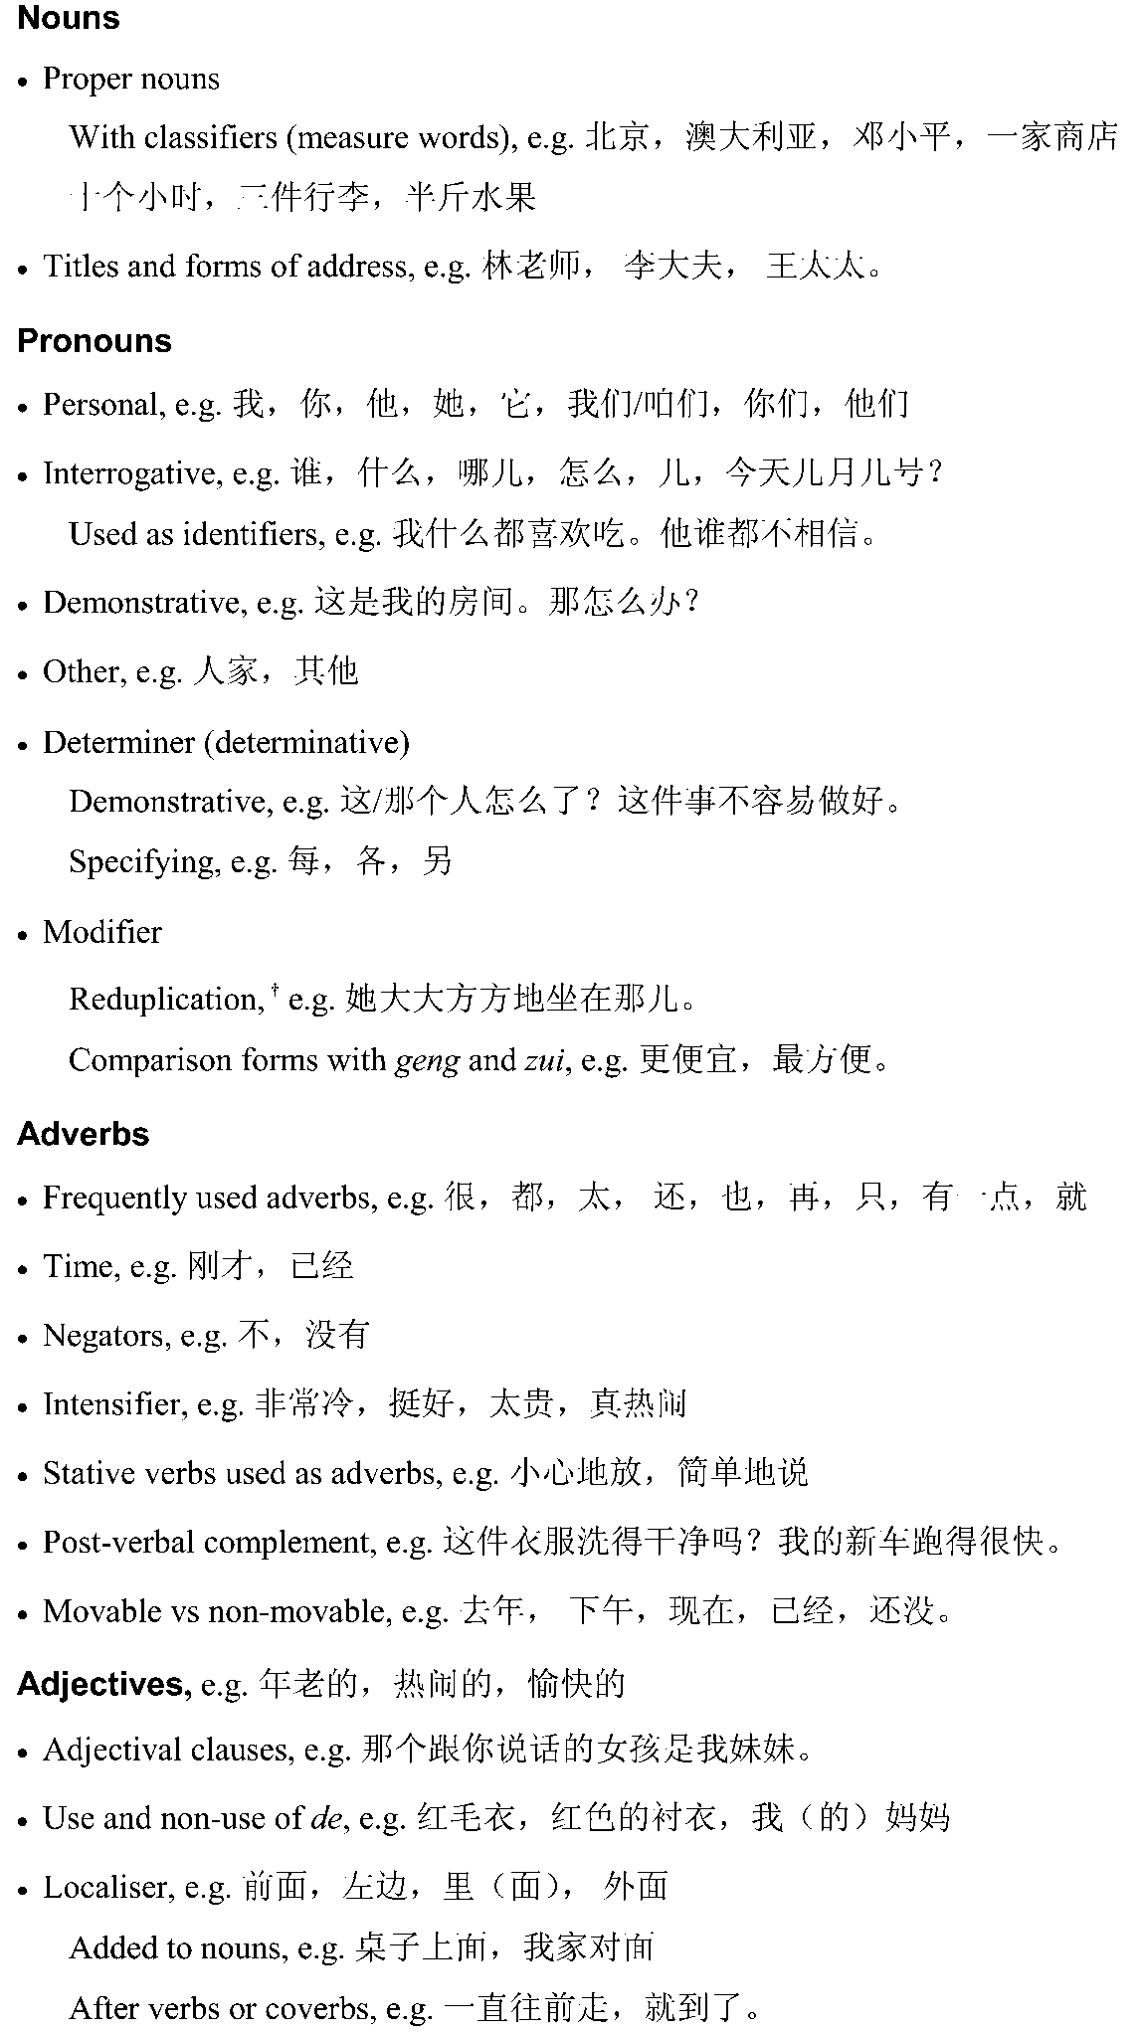
† for receptive use only

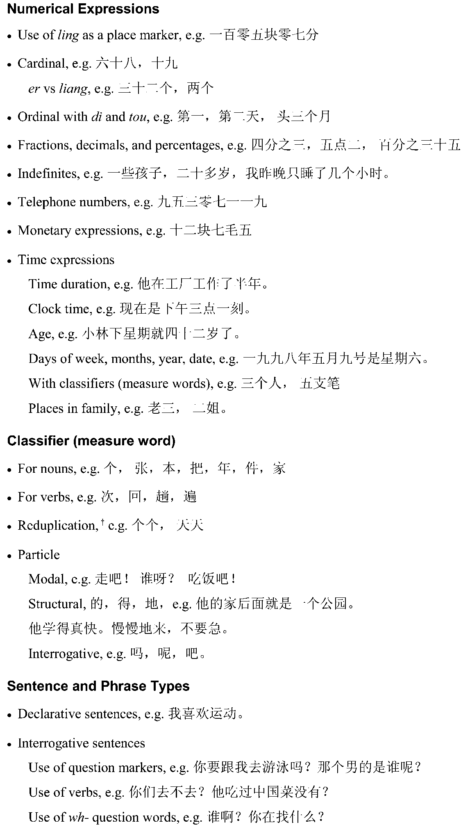
† for receptive use only

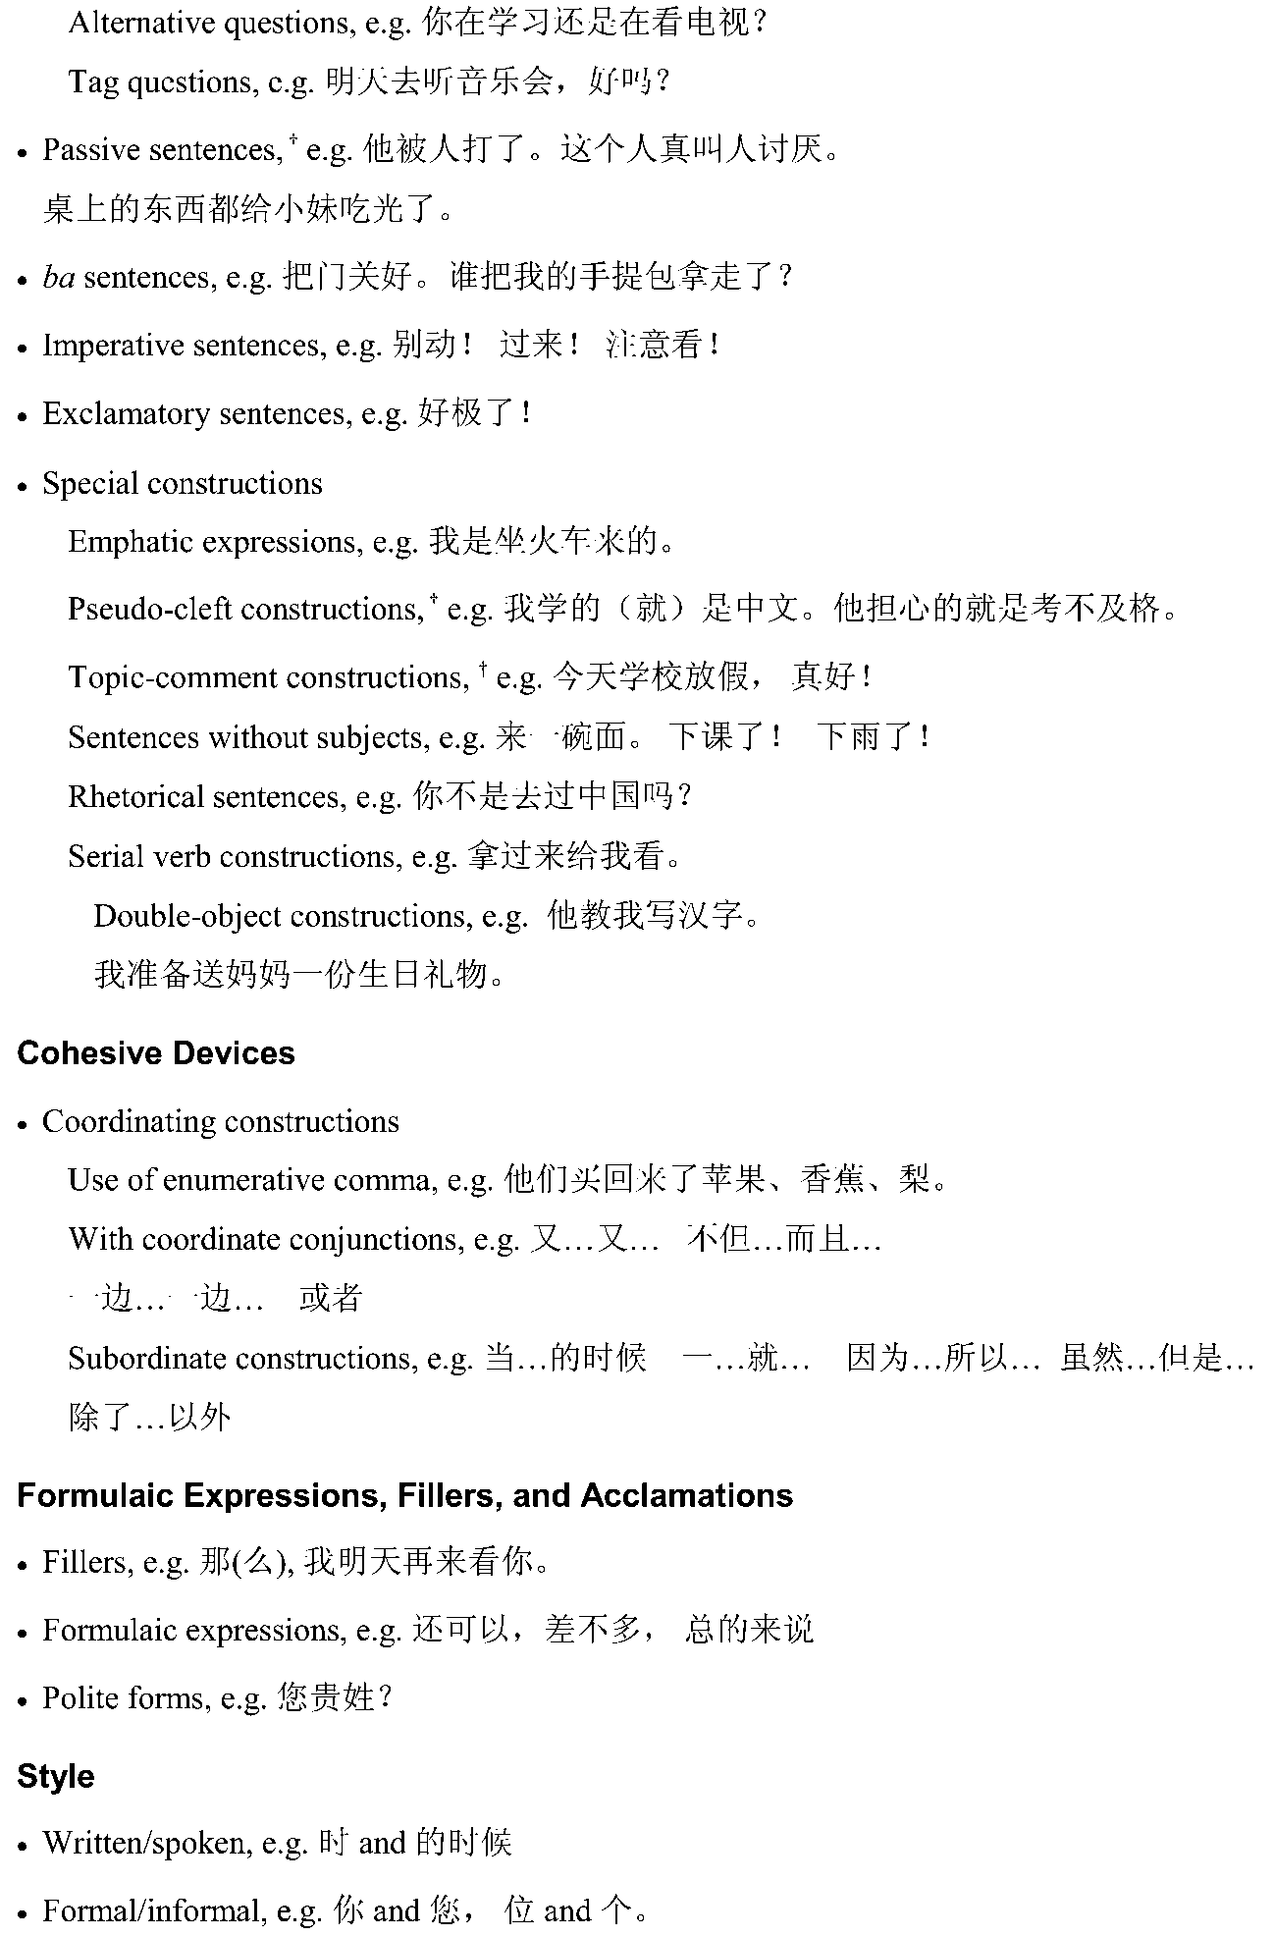
† for receptive use only

French
The Language
The language to be studied and assessed is modern standard French.
Although the focus of study will be the French spoken in metropolitan France, students may also encounter French spoken in other French-speaking countries. Students should be aware of different levels of language, for example, formal and informal language, some colloquialisms, and slang. Students are expected to know that dialects exist; however, they are not required to study them.
The correct use of recognised non-binary pronouns is acceptable in examination and school assessment responses.
Themes, Topics, and Subtopics
There are three prescribed themes:
- The Individual
- The French-speaking Communities
- The Changing World.
The following table shows the prescribed themes, prescribed topics, and suggested subtopics.
The Individual | The French-speaking Communities | The Changing World
- Personal Identity  Examples  Stages of life  Love and memories  - Relationships  Examples  Family and friends  - School Life and Aspirations  Examples  Hopes  School experiences  - Leisure and Interests  Examples  Hobbies  Sport | - Daily Life or Lifestyles  Examples  Routines  City and rural life  Regions  Cuisine  - Historical Influences on Modern-day Life  Examples  Traditions, customs, celebrations, festivals  Historical events and figures  - The Arts and Entertainment  Examples  Cinema  Music | - The World of Work  Examples  Careers and occupations  Men and women in the workplace  Unemployment  - Current Issues  Examples  Prominent people and events  Technology  The environment  - A Young Person’s World  Examples  Youth cultures  Youth issues
Note: Bold = prescribed themes, bold italics = prescribed topics, italics = suggested subtopics
Text Types
Refer to pages 23 to 24 for information.

Grammar
Grammar can be described as the organisation and relationship of all the elements that constitute a language as it functions.
There are many different theories of grammar, and a number of different approaches to its teaching and learning. The categories used below are not intended to promote or favour any particular theory of grammar.
Students will already have a reasonable understanding of the function of grammar in French through prior knowledge or study.
Developing students’ ability to convey meaning effectively in a range of contexts will, however, necessarily involve extending their awareness of the system of structures that underlie the language, as well as their ability to apply and adapt this knowledge.
Students studying French in a continuers-level program are expected to recognise and use the following grammatical items:
Verbs
Person and number, e.g. 1st person singular: je crois, 1st person plural: nous croyons
Regular -er, -ir, -re verbs, e.g. donner, finir, vendre
Frequently occurring irregular verbs, e.g. aller, faire
Reflexive verbs, e.g. se lever, se parler
Modal verbs, e.g. devoir, pouvoir, savoir, vouloir
Impersonal verbs, e.g. il pleut, il faut, il est interdit
Causative verbs, e.g. j’ai fait construire un garage.
Tense
Infinitives
Present and past, e.g. après avoir fait mes devoirs
Verbs with infinitives, e.g. je viens de manger, je vais faire
Simple
Present, e.g. je donne, il dort, elle prend
Imperfect, e.g. nous mangions, vous faisiez
Future, e.g. on ira, tu prendras
Conditional (see ‘Mood’), e.g. je dormirais, ils vendraient
Past historic/passé simple,† e.g. il alla, je donnai
Compound
Perfect, e.g. j’ai fini, elle est allée
Pluperfect, e.g. nous avions fait, tu avais fini
Future perfect, e.g. on aura vendu, il sera parti
Conditional perfect, e.g. vous auriez bu, tu aurais été
Participles
Present, e.g. tout en mangeant
Past, e.g. Il m’a offert un cadeau. Il est né.
Voice
Active, e.g. Les Bordelais ont gagné le match.
Passive, e.g. Le match a été gagné par les Bordelais. L’image a été créée.
Use of on, e.g. On parle français ici.
† for receptive use only

Mood
Indicative, e.g. Je fais mes devoirs.
Subjunctive — only the most common uses
Present, e.g. Il faut que je fasse mes devoirs.
Perfect, e.g. Je suis contente que tu aies pu venir.
Imperative, e.g. Fais tes devoirs!
Conditional
Present, e.g. Je ferais mes devoirs si j’avais le temps.
Past, e.g. J’aurais fait mes devoirs si j’avais eu le temps.
Adjectives
Gender and number, e.g. beau, belle, beaux, belles
Position, e.g. ma propre chambre/ma chambre propre
Demonstrative, e.g. ce garçon/cet homme/cette école/ces enfants
Possessive, e.g. mon école, nos amis
Interrogative, e.g. quel âge as-tu?
Exclamatory, e.g. quelle horreur!
Numerals: cardinal, e.g. un, deux, trois
Numerals: ordinal, e.g. le premier mai, la deuxième fois
Comparative and superlative
Regular, e.g. intelligent/plus intelligent/le plus intelligent
Irregular, e.g. bon/meilleur/le meilleur.
Pronouns
Subject, e.g. je mange, il voit
Object, e.g. je les mange, il nous cherche
Reflexive, e.g. nous nous lavons
Possessive, e.g. le mien, la mienne
Demonstrative, e.g. je prends celui-ci ou celle-là
Interrogative indefinite, e.g. qui/qui est-ce qui/que
Interrogative definite, e.g. Voici deux robes, laquelle préf ères-tu?
Relative, e.g. qui/que/dont/lequel
Disjunctive, e.g. moi/toi/lui/elle.
Prepositions
Indicating time, location, direction, e.g. après, chez, vers
With verbs, nouns, adjectives, e.g. j’essaie de comprendre, j’ai l’intention de . . . c’est facile à faire, je commence à comprendre.
Sentence and Phrase Types
Statement, e.g. Il va au stade.
Question, e.g. Est-ce qu’il va au stade? Va-t-il au stade? Il va au stade?
Exclamation, e.g. Mon Dieu! Qu’est-ce qu’il est beau!
Negative constructions, e.g. je ne comprends rien, personne n’y va
Time phrases, e.g. il attend depuis une heure, pendant, pour
Conjunctions and connectives, e.g. donc, mais, parce que, malgré, pourtant
Si clauses, e.g. S’il fait beau, nous sortirons ensemble.

German
The Language
The language to be studied and assessed is the modern standard or official version of German. This includes the use of colloquialisms where they are appropriate, and an awareness of regional differences. The SACE Board uses the new spelling system in external examinations. Since January 2006, students have been expected to use the new spelling system.
The correct use of recognised non-binary pronouns is acceptable in examination and school assessment responses.
Themes, Topics, and Subtopics
There are three prescribed themes:
- The Individual
- The German-speaking Communities
- The Changing World.
The following table shows the prescribed themes, prescribed topics, and suggested subtopics.
The Individual | The German-speaking Communities | The Changing World
- Personal Identity  Examples  Self-image  My home  Community  Family and friends  Relationships  Pressure and influences  - School and Aspirations  Examples  School  Education systems  Future plans and pathways  Student exchanges  - Leisure and Interests  Examples  Holidays  Sports  Hobbies  Keeping fit and healthy | - People and Places  Examples  Lifestyles  Daily life  Cultural diversity  Traditions  Cultural heritage  Regional and national festivals  - Past and Present  Examples  Historical perspectives  Changing face of German-speaking countries and communities  - Arts and Entertainment  Examples  Music and songs  Film and theatre  Media  Writers and literature  Movements in art  Popular culture | - The World of Work  Examples  Technology and design  Jobs and careers  Globalisation and its effects  - Social Issues  Examples  Youth issues  The environment  Equality  Anxiety for the future  Health issues  - Tourism and Hospitality  Examples  Travel at home and abroad  Interacting with visitors in Australia
Note: Bold = prescribed themes, bold italics = prescribed topics, italics = suggested subtopics
Text Types
Refer to pages 23 to 24 for information.

Grammar
Grammar can be described as the organisation and relationship of all the elements that constitute a language as it functions.
There are many different theories of grammar, and a number of different approaches to its teaching and learning. The categories used below are not intended to promote or favour any particular theory of grammar.
Students will already have a reasonable understanding of the function of grammar in German through prior knowledge or study.
Developing students’ ability to convey meaning effectively in a range of contexts will, however, necessarily involve extending their awareness of the system of structures that underlie the language, as well as their ability to apply and adapt this knowledge.
Students studying German in a continuers-level program are expected to recognise and use the following grammatical items:
Nouns
Gender, number, case (all four cases)
Adjectival nouns, e.g. Alles Gute zum Geburtstag!
Infinitives used as nouns, e.g. Wir wissen, dass Rauchen ungesund ist. Das Wandern ist des Müllers Lust.
Articles
Definite, e.g. der, die, das
Indefinite, e.g. ein, kein.
Adjectives
Common adjectives, e.g. klein, interessant
Agreement, predicative and attributive position, e.g. Das Wetter ist schön. Das ist ein witziges Lied.
Demonstrative, e.g. dieser, jener, solcher
Indefinite, e.g. jeder, mancher, irgendein, kein, alle
Possessive, e.g. mein, dein, sein
Comparative and superlative forms, e.g. Dieser Sommer ist wärmer als der letzte. Sie ist die erfolgreichste Schwimmerin in diesem Jahr.
Interrogative, e.g. Was für ein? Welcher?
Adjectives derived from place names, e.g. Münchner Bier, Schweizer Schokolade, das Brandenburger Tor.
Pronouns
Personal pronouns, e.g. ich, du, er, sie
Nominative, accusative, dative cases, e.g. ihn, ihr
Reflexive, e.g. mich, dich, mir, dir, sich, uns, euch
Indefinite, e.g. man, etwas, einer, jemand, niemand, nichts
Interrogative, e.g. wer, wen, wem, wessen, was
Relative (nominative, accusative, dative, genitive), e.g. der, die, das . . . Das ist die Frau, deren Mann arbeitslos ist. Kennst du den Mann, mit dem Karl gerade spricht? Die CD-Rom, die er zum Geburtstag bekommen hat, funktioniert nicht.

Verbs — Regular and Irregular (strong, weak)
Tenses
Present, e.g. Ich lerne Deutsch.
Perfect, e.g. Gestern sind wir ins Kino gegangen.
Future, e.g. Wir werden die Wahl gewinnen.
Imperfect, e.g. Hänsel und Gretel verliefen sich im Wald. Es war so finster und auch so bitter kalt.
Pluperfect, e.g. Ich hatte ihn in einer Disco kennengelernt.
Using the present plus an adverb indicating future, e.g. Morgen fliegt er nach Österreich.
Inseparable, e.g. Sie überholte den Lastwagen.
Separable, e.g. Morgen fangen die Ferien an.
Reflexive, e.g. Sie konnte sich an die Kälte gar nicht gewöhnen.
Modals, e.g. dürfen, können, mögen, müssen, sollen, wollen
Mood
Imperative, e.g. Lies mal vor!
Subjunctive (in requests, and conditional clauses), e.g. würde, hätte, wäre, könnte, müsste, sollte. Würden sie mir bitte noch ein Stück Kuchen reichen? Wenn ich Millionär wäre, könnte ich mir einen Porsche kaufen.
Passive voice, e.g. Das Parkhaus wird um 24 Uhr geschlossen.
Impersonal expressions, e.g. Es gibt . . . Es stimmt, dass . . . Es ist schade, dass . . .
Infinitives with verbs of perception, motion, and with lassen, e.g. Ich hörte ihn kommen. Wir gehen schwimmen. Meine Mutter lässt mich nie fernsehen.
Verbs taking prepositional objects, e.g. Ich freue mich auf deinen Besuch. Sie entschuldigt sich bei der Lehrerin.
Verbs taking the dative, e.g. Ich danke dir. Er hilft/folgt seinem Freund. Das gehört ihm . . .
Adverbs
Positive, comparative, and superlative forms, e.g. gern, lieber, am liebsten
Prepositions
The cases with prepositions, e.g. Ich gehe jetzt in die Schule. Ich lerne Deutsch in der Schule.
Contracted forms with articles, e.g. beim, zum, im . . .
Wo und da(r) compounds, e.g. womit, wozu, damit, dazu, dabei, darauf . . .
Sentence Structures
The various parts of the sentence, e.g. subject, direct object, indirect object
Statements, questions, commands
Subordinate or main clauses, e.g. Obwohl er noch zur Schule geht, hat er schon einen Job.
Conjunctions
Coordinating, e.g. und, aber, oder, denn, sondern . . .
Subordinating, e.g. weil, wenn, als, dass . . .
Correlative, e.g. entweder . . . oder, weder . . . noch, nicht nur . . . sondern auch, sowohl . . . als auch
Relative clauses, e.g. Wie heißt der Fluss, an dem Hamburg liegt?
Indirect questions, e.g. Ich möchte gern wissen, wie er heißt.
Word Order
Position of nicht in a clause, e.g. Er hat seine Hausaufgaben nicht gemacht.
Position of adverbs and adverbial phrases — time, manner, place, e.g. Er fährt jeden Tag fröhlich zur Arbeit.
Position of past participles, e.g. Er hat seine Hausaufgaben schon gemacht.
Infinitives with zu and um . . . zu, e.g. Um den Führerschein zu bekommen, muss man viele Fahrstunden nehmen. Sandra überredet Antje, etwas anderes anzuziehen.

indonesian
The Language
The language to be studied and assessed is the standard version of Indonesian.
The correct use of recognised non-binary pronouns is acceptable in examination and school assessment responses.
Themes, Topics, and Subtopics
There are three prescribed themes:
- The Individual
- The Indonesian-speaking Communities
- The Changing World.
The following table shows the prescribed themes, prescribed topics, and suggested subtopics.
The Individual | The Indonesian-speaking Communities | The Changing World
- Personal Identity  Examples  Personal details and qualities  Relationships with family and friends  Daily life  Making arrangements  Free time and leisure activities  Health and fitness  - Education and Aspirations  Examples  Future study  School life  Career choices  Personal goals  Travel  Student exchanges  - Values, Attitudes, and Opinions  Examples  The place of individuals in their world  Social issues, ideas, and opinions expressed through literature, film, and other resources | - Arts, Crafts, and Entertainment (modern and traditional)  Examples  Dance  Music  Drama  Wayang  Film  TV  Internet  Media  Batik  Ikat  - Visiting Indonesia  Examples  Planning  Travel experiences  Shopping  Finding accommodation  Obtaining assistance or advice  Visiting friends  Health  - Stories from the Past  Examples  Historical perspectives  Famous people  Significant events  Personal recollections  Oral history  The past expressed through literature, film, and other resources | - Contemporary Issues  Examples  Social  Political  Economic  Religious  Environmental  Technological  Australian and Indonesian relations  The impact of tourism  - The World of Work  Examples  People at work  Types of jobs  Work in rural and urban areas  Division of labour  Unemployment  Exploitation of labour  Work experience  Careers
Note: Bold = prescribed themes, bold italics = prescribed topics, italics = suggested subtopics.

Text Types
Refer to pages 23 to 24 for information.
Grammar
Grammar can be described as the organisation and relationship of all the elements that constitute a language as it functions.
There are many different theories of grammar, and a number of different approaches to its teaching and learning. The categories used below are not intended to promote or favour any particular theory of grammar.
Students will already have a reasonable understanding of the function of grammar in Indonesian through prior knowledge or study.
Developing students’ ability to convey meaning effectively in a range of contexts will, however, necessarily involve extending their awareness of the system of structures that underlie the language, as well as their ability to apply and adapt this knowledge.
Students studying Indonesian in a continuers-level program are expected to recognise and use the following grammatical items:
Phonology
Quality of vowel sounds
The glottal stop, e.g. bapak, tidak
Non-aspiration of t, d, b, and p
Indonesian trilled r
Nasalisation of verbal roots, e.g. ny and ng, ngg sound
Pattern and rhythm
Intonation and stress.
Verbs
Unaffixed verbs, e.g. makan
Affixed verbs using, for example, ber-, ber . . . an, me-, me . . . kan, me . . . i, memper-, ke . . . an, ter . . . e.g. berjalan, berpamitan, menjual, memberikan, menemani, memperbaiki, ketinggalan, terdapat
Active, passive, and imperative forms
With reduplication, e.g. makan-makan, berlari-lari (repetitive, varied, or non-specific action) surat-menyurat, berpamit-pamitan (reciprocity)
With markers and modifiers, e.g. sudah, telah, sedang, akan, harus, dapat, bisa, boleh, suka, ingin, mau, lagi, kembali
With negators, e.g. tidak, belum
With accompanying prepositions, e.g. bergantung pada, ingat akan, minta maaf atas, percaya pada.
Nouns
Unaffixed nouns, e.g. pintu
Affixed nouns using, for example, ke . . . an, pe-, pe . . . an, per . . . an, -an, -wan/-wati,
e.g. kecepatan, pencuri, pelajaran, perjalanan, makanan, jutawan, wisatawati
With reduplication, e.g. surat-surat kabar, adat-istiadat (plurality, showing variety) obat-obatan (showing collectivity)
With the negator bukan.
Personal Pronouns
1st person: saya, aku, kami, kita
2nd person: kamu, Anda, engkau, kau-, kalian, kamu sekalian, Anda sekalian
3rd person: dia, ia, beliau, mereka
Other terms used in the place of pronouns, e.g. Bapak, Ibu, Adik, Kakak, Saudara, name of person
With the negator bukan.
Deictics, e.g. ini, itu, sini, sana, situ, begini, begitu.
Quantifiers
Cardinal numbers
Collectives, e.g. ketiga pemain, kami berenam, berpuluh-puluh, ratusan
With terms of measurement, e.g. meter, liter, gram, rupiah
Indefinite terms, e.g. banyak, berbagai, beberapa, sedikit, semua, seluruh, segala
Ordinal numbers, e.g. kesatu or pertama, kedua, kesepuluh
Fractions, e.g. sepertiga
Classifiers, e.g. orang, buah, ekor (others as passive knowledge when encountered)
Singularity, e.g. se-, satu, suatu
Plurality, e.g. through duplication, through context, through use of para/kaum.
Adjectives
Unaffixed adjectives, e.g. mahal
Me . . . kan with adjectival function, e.g. menyenangkan
Comparatives
Se- + adjective
Sama + adjective + -nya
Lebih/kurang + adjective + daripada
Yang/paling/ter- + adjective
With degree markers: tidak terlalu kecil, akan sangat senang
With other modifiers: harus lebih mudah, tidak sakit lagi
With negators: tidak, belum.
Adverbs
Dengan + base, e.g. dengan baik
Duplication of base, e.g. diam-diam
Se + adjective-adjective + nya, e.g. setinggi-tingginya, sesungguh-sungguhnya.
Prepositions, e.g. akibat, antara, bersama, buat, dalam, dari, dekat, dengan, di, karena, ke, kecuali, kepada, lewat, melalui, mengenai, menurut, oleh, pada, sama, sampai, sebab, sebagai, sejak, sekeliling, sekitar, selama, sepanjang, seperti, tanpa, tentang, untuk, akan, atas, bagi, selain, terhadap
With locative nouns, e.g. di bawah, ke muka, oleh karena, sampai dengan, di antara.
Conjunctions, e.g. agar, atau, bahwa, dan, dengan, di samping, hanya, kalau, karena, kecuali, kemudian, ketika, lalu, oleh karena (itu), sambil, sampai, seandainya, sebab, sebelum, sedangkan, sehingga, sejak, selain (itu), selama, seolah-olah, sesudah, setelah, setiap, supaya, tanpa, tetapi, tiap kali, untuk, waktu, walaupun, akan tetapi, akibat, asal, baik . . . maupun, dalam, demikian, jika . . . (maka), lagi (pula), melainkan, meskipun (begitu), namun, padahal, sebagai, sementara, serta, tidak hanya . . . tetapi juga.
Interjections, e.g. sialan, asyik, ayo, wah, aduh.
Articles, e.g. sang, para, si.
Particles, e.g. -kah, -lah.

Phrases and Sentences
Simple and more complex phrases, e.g. berteriak keras-keras/tidak perlu merasa tersinggung
Single clauses
Subject + predicate
Subject + verb (+ phrase)
Subject + verb + object (+ indirect object)
Compound clauses, e.g. Dia rajin membaca, baik waktu dia masih mahasiswa, maupun setelah dia bekerja.
Siapa pun yang minta, Pak Anwar selalu bersedia menolong.
Use of ini/itu to point to a particular referent in a noun phrase, e.g. pakaian yang dilemparkan ke laut di Parangtritis itu.
Use of adalah/ialah to mark the subject–predicate break, e.g. Pengangguran tersembunyi di kota-kota besar adalah masalah yang serius.
Use of yang as a relative clause marker, e.g. Tempat berpiknik yang paling disenangi oleh orang Jakarta. Kepala pabrik yang hanya mementingkan dirinya sendiri.
Extension of basic sentences by the addition of information on place, instrument, time, purpose, participant, means, similarity, cause.
Statements
Commands
Use of -lah, jangan, tolong, coba, silakan
Use of passive to soften
Questions
With question words
With rising intonation
With -kah
Using bukan/belum/tidak at the end of the sentence
Exclamations using aduh, bukan main, alangkah, -nya
Emphatic sentences using -lah followed by yang
Active and passive sentences
Direct and indirect speech.

Italian
The Language
The language to be studied and assessed is modern standard Italian. Italian belongs to the family of Romance languages, and a great deal of terminology in science, technology, medicine, pharmacy, and law derives from its Latin ancestor, while musical terminology draws directly on Italian.
Standard Italian is the language of Italy. Apart from being the language of everyday communication, it is the language of education, all levels of government, and the mass media. It is important to be aware of, and acknowledge, the role of regional dialects and their provincial variants. These dialects have often survived better in the communities outside Italy (albeit with local intrusions) than in Italy, where, because of the internal population shifts from the second half of the twentieth century, and the influence of the mass media, the dialects are being eroded. However, in Italy dialects are now being revalued and, in some instances, revived.
Like other languages, Italian is changing rapidly, particularly in the spoken form. Some examples of this include:
- the more commonly accepted use of gli to replace loro and le
- the use of voi to replace the loro form in some formal situations
- the more frequently spoken form of the past definite in some geographical locations, particularly southern Italy
- the increasing use of the indicative instead of the subjunctive
- the increasing use of the present indicative instead of the future indicative
- the use of the present indicative in place of the conditional when making requests
- the disappearance of the capital letter to indicate polite form register, except in legal and diplomatic language
- efforts to simplify and update bureaucratic language
- English words (e.g. computer, weekend, picnic, Internet, best seller).
The formal and informal forms of address are important aspects of the language as they reflect the conventions of social relationships among Italian-speaking people.
The correct use of recognised non-binary pronouns is acceptable in examination and school assessment responses.
Themes, Topics, and Subtopics
There are three prescribed themes:
- The Individual
- The Italian-speaking Communities
- The Changing World.
The following table shows the prescribed themes, prescribed topics, and suggested subtopics.

The Individual | The Italian-speaking Communities | The Changing World
- Personal Identity  Examples  Who am I?  Adolescence  Memories  Relationships  - Health and Leisure  Examples  Leisure time  Part-time work  Sport  Holidays  - Education and Aspirations  Examples  School  Personal aspirations  Cultural exchanges | - Historical Perspectives  Examples  Italy from unification to the present day  Emigration  The European Union  - Lifestyle in Italy and Abroad  Examples  Italian passions  Italian cuisine  The young or the elderly  Festivals and traditions  The arts  Entertainment  - Social and Contemporary Issues  Examples  The environment  Aspects of modern society  Cultural identity  The contribution of Italians to Australia | - The World of Work  Examples  Different types of jobs/professions/trades  Employment in the future  Entering the world of work  - Technology  Examples  International multimedia  Information technology  The sociocultural impact of technology  - Trade and Tourism  Examples  Made in Italy  Italian–Australian trade relations  Travel in Italy  Tourism in Australia
Note: Bold = prescribed themes, bold italics = prescribed topics, italics = suggested subtopics
Text Types
Refer to pages 23 to 24 for information.
Grammar
Grammar can be described as the organisation and relationship of all the elements that constitute a language as it functions.
There are many different theories of grammar, and a number of different approaches to its teaching and learning. The categories used below are not intended to promote or favour any particular theory of grammar.
Students will already have a reasonable understanding of the function of grammar in Italian through prior knowledge or study.
Developing students’ ability to convey meaning effectively in a range of contexts will, however, necessarily involve extending their awareness of the system of structures that underlie the language, as well as their ability to apply and adapt this knowledge.
Students studying Italian in a continuers-level program are expected to recognise and use the following grammatical items:

Nouns
Regular forms
Gender and number
Common irregular forms (singular and plural)
Compound nouns, e.g. l’altoparlante, il portafoglio
Collective nouns, e.g. la gente
Invariable forms in the plural, e.g. la città, le città: il film, i film
Use of suffixes and prefixes,† e.g. sorellina, inutile.
Articles
Definite and indefinite articles
Use of all forms, and their omission
Omission or inclusion of definite articles with titles
Inclusion of definite articles before nouns used in a general or abstract sense, e.g. il coraggio è una virtù
Partitive articles (some, any), e.g. del pane.
Adjectives
Regular formation
Agreement with nouns
Position
Common irregular adjectives that precede masculine nouns, e.g. bello, buono
Adjectives that commonly precede nouns, e.g. primo, ultimo, buono, bello, giovane, vecchio, altro, stesso, molto, poco, grande, piccolo
Demonstrative adjectives, e.g. questo, quello
Possessive adjectives — form and uses, including their use before terms indicating family relationships
Indefinite adjectives, e.g. ogni, qualche, qualsiasi/qualunque, ciascuno, nessuno, altro, molto, alcuno
Interrogative adjectives, e.g. che? quale? quanto?
Comparative and superlative forms
Regular and irregular types.
Adverbs
Formation
Position
Classes (manner, place, time, quantity), e.g. bene, qui, prima, molto
Adverbial phrases, e.g. all’improvviso, poco fa, nel frattempo, d’ora in poi, in ritardo, fra poco, qui vicino
Comparative and superlative forms
Regular and irregular types, e.g. meglio, peggio, bene, benissimo
Use of adverbs, e.g. molto, poco, troppo.
Pronouns
Personal pronouns
Subject, direct object, indirect object
Use and position
Elision, e.g. l’ho visto
and past participle, e.g. li ho comprati
Combined, e.g. te lo spedisco
† for receptive use only

Relative pronouns (including word order), e.g. che, cui, chi, il quale
Interrogative pronouns, e.g. chi? che (cosa)? quale? quanto?
Demonstrative pronouns, e.g. questo, quello, ciò
Indefinite pronouns, e.g. uno, qualcuno, ciascuno, nessuno
Possessive pronouns, e.g. mio fratello, la mia amica
Reflexive pronouns, e.g. si veste
Disjunctive pronouns, e.g. a me, per te
Common uses of
si, e.g. si mangia bene qui
ci and vi, e.g. ci sono andata
ne, e.g. cosa ne pensi? Hai dello zucchero? Sì, ne ho.
Verbs
Conjugation
Regular forms
Frequently occurring irregular forms
Reflexive verbs
Mood
Indicative
Present
Present perfect
Imperfect
Pluperfect†
Future
Future perfect†
Past historic†
Past anterior†
Conditional
Present
Perfect†
Subjunctive
Present
Perfect†
Imperfect, ‘if’ clause
Pluperfect†
Imperative (including its use in formal and informal address and with pronouns), e.g. da’!, dammi!, dammelo!
Gerundio
Present, e.g. guardando
Past, e.g. essendo partito(a)
Stare with gerundio, e.g. sto mangiando
Infinitive structure
Prima di with infinitive
Infinitive used as a noun,† e.g. il leggere
Lasciare construction,† e.g. lascia stare, lasciami stare
Auxiliaries — essere and avere
Participles
Passive voice,† e.g. è stato costruito da . . .
Impersonal verbs and expressions, e.g. bisogna che, basta che
† for receptive use only

Modal verbs (dovere, potere, volere)
Piacere in the present, present perfect, imperfect, and future tenses of the indicative, and in the present conditional
Idiomatic use of avere and fare, e.g. avere fame, fare colazione
Causative construction,† e.g. ho fatto riparare la macchina.
Prepositions
Simple and articulated forms
Common prepositional phrases, e.g. parto per Milano, partiamo da Roma
Special usage of a, di, da, e.g. vado a scuola, vieni da me.
Numerals
Cardinals, ordinals, decimals, dates
Fractions, e.g. un quarto, metà
Time
Common measurements, e.g. è alta un metro e ottanta
Collective numbers, e.g. paio, coppia, decina, dozzina, centinaio, migliaio
Mathematical signs, e.g. più, meno, diviso, per.
Conjunctions
Common conjunctions, e.g. e, ed, anche, ma, però, infatti, né . . . né
Fillers, e.g. quindi, magari, cioè.
Negation
Use of non
Double negative.
False Friends
Italian words that closely resemble English words but may not always have the same meaning, e.g. parenti, sensibile, fattoria.
Sentence and Phrase Types
Italian word order is more flexible than English word order; this may be related to the presence of gender and number markers. However, attention should be given to word order in:
statements
questions
the position of object pronouns.
† for receptive use only

Japanese
The Language
The language to be studied and assessed is modern standard Japanese in both written and spoken forms. Some dialect variations in pronunciation and accent are acceptable. Students should be familiar with informal and formal levels of language as prescribed in this subject outline. Hiragana and katakana syllabaries and a prescribed number of kanji (Chinese characters) will be studied.
The correct use of recognised non-binary pronouns is acceptable in examination and school assessment responses.
Themes, Topics, and Subtopics
There are three prescribed themes:
- The Individual
- The Japanese-speaking Communities
- The Changing World.
The following table shows the prescribed themes, prescribed topics, and suggested subtopics.
The Individual | The Japanese-speaking Communities | The Changing World
- Personal Identity  Examples  Personal information  Family and friends  Home and neighbourhood  - Daily Life  Examples  Routines  Health and sickness  - Leisure  Examples  Hobbies  Making arrangements  Past experiences  - Education  Examples  School life  Future plans | - Life in Japan  Examples  Home and family life  Shopping and eating  School life  Leisure  Significant people and events  - Visiting Japan  Examples  Tourist and cultural attractions  Getting around (directions, tickets, accommodation, and reservations)  Homestay experiences  Visiting people  Gift-giving | - Working Life  Examples  Casual work  Different jobs/occupations  - Current Issues  Examples  Technology  Youth issues  Social issues
Note: Bold = prescribed themes, bold italics = prescribed topics, italics = suggested subtopics
Text Types
Refer to pages 23 to 24 for information.
Vocabulary
A vocabulary list, comprising basic vocabulary relevant to the topics and suggested subtopics, will be on the SACE website (www.sace.sa.edu.au). Students do not need to know all the words on the list in order to be successful in a program based on this subject outline. It is provided as a resource for teachers and students to use in preparing for oral and written examinations.
The written examination may include words that are not on the list. In such cases the words will be glossed in English, or they will be of the kind that do not impede overall understanding of the text and will be able to be found in any of the recommended dictionaries.
The prescribed kanji list (below) includes 150 kanji for active use in writing in Japanese and 50 kanji for recognition when reading texts in Japanese.

Prescribed Kanji
Active Use Receptive Use
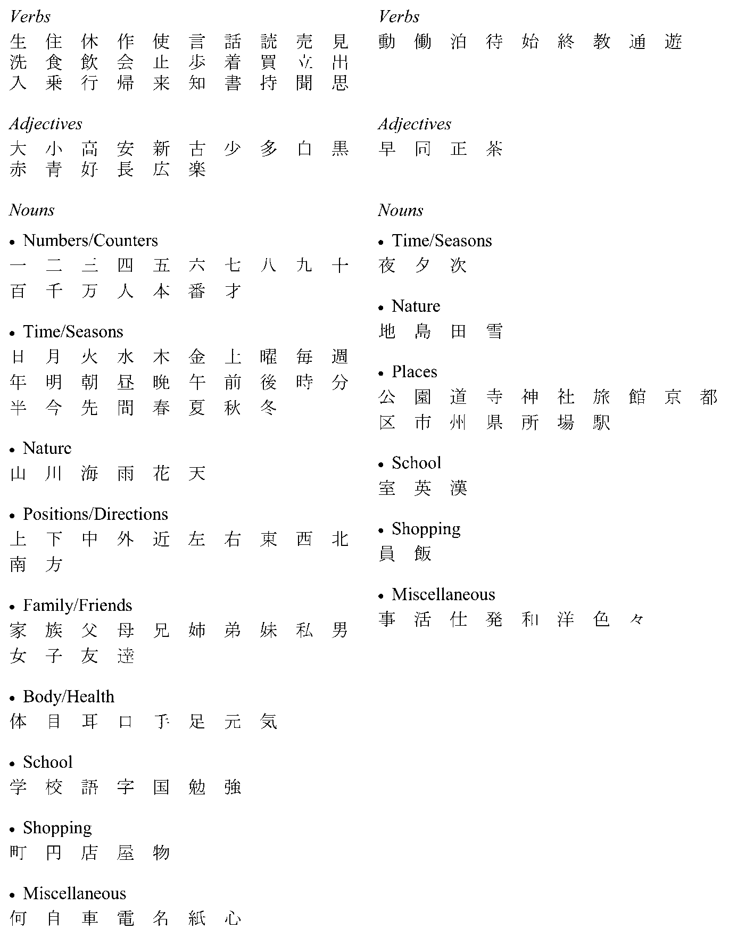

Grammar
Grammar can be described as the organisation and relationship of all the elements that constitute a language as it functions.
There are many different theories of grammar, and a number of different approaches to its teaching and learning. The categories used below are not intended to promote or favour any particular theory of grammar.
Students will already have a reasonable understanding of the function of grammar in Japanese through prior knowledge or study.
Developing students’ ability to convey meaning effectively in a range of contexts will, however, necessarily involve extending their awareness of the system of structures that underlie the language, as well as their ability to apply and adapt this knowledge.
Students studying Japanese in a continuers-level program are expected to recognise and use the following grammatical items:

Summary of forms of verbs and adjectives
Finite forms — plain forms
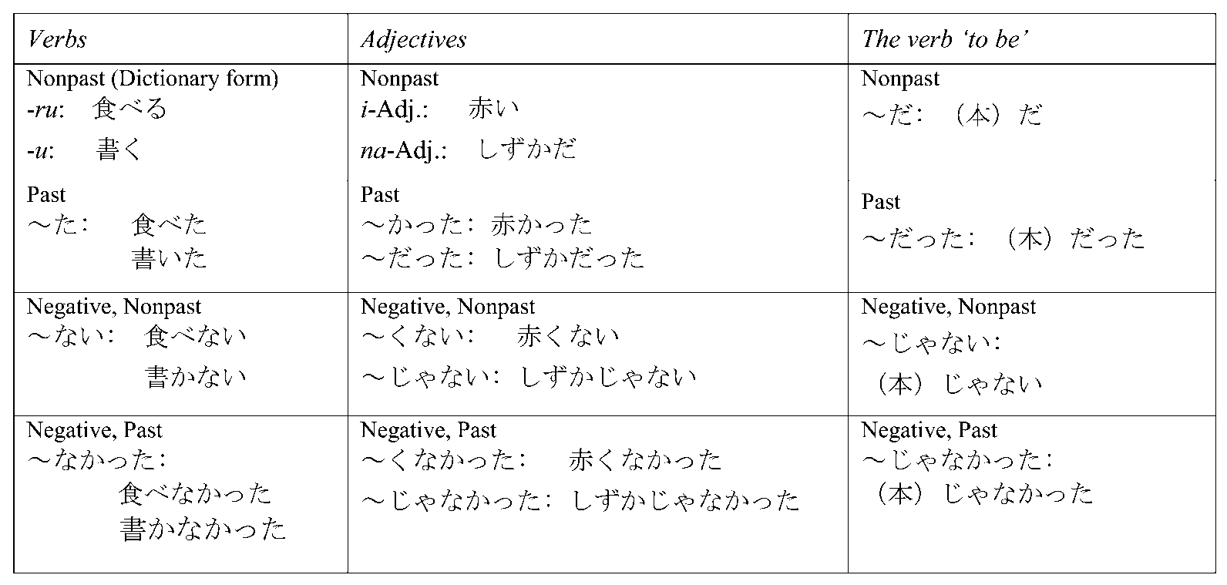
Finite forms — polite forms
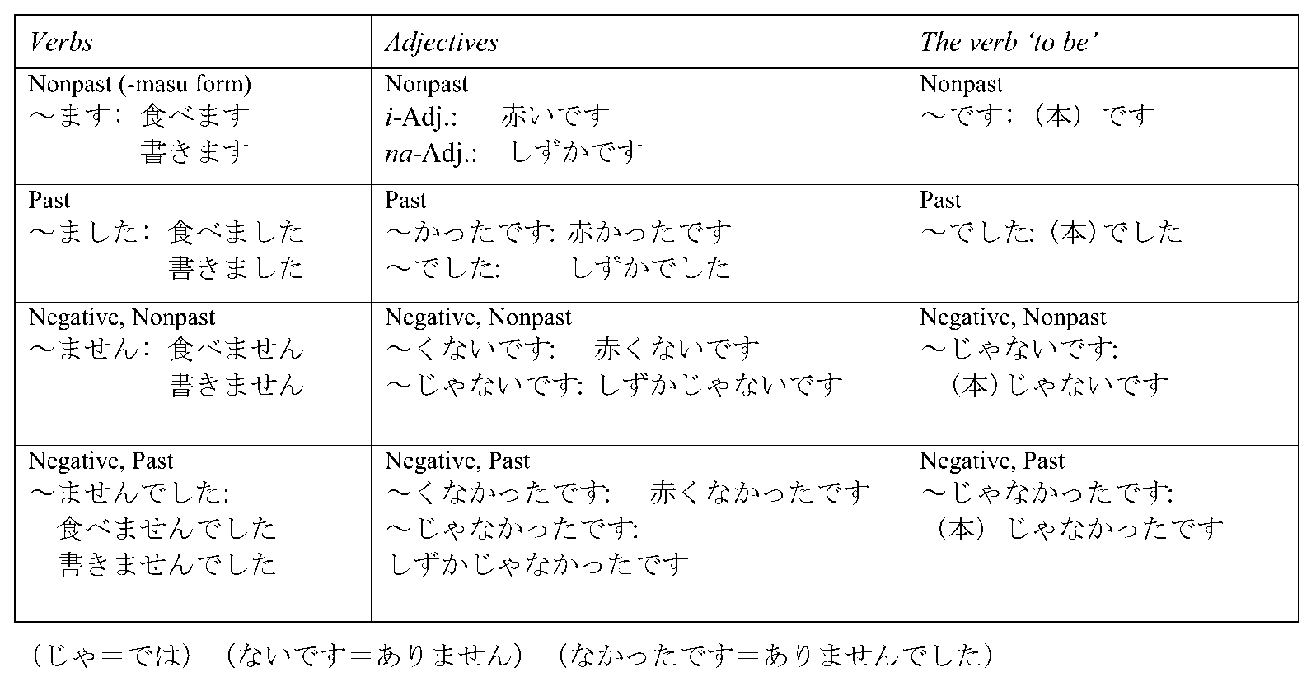

Finite form (plain) + . . .
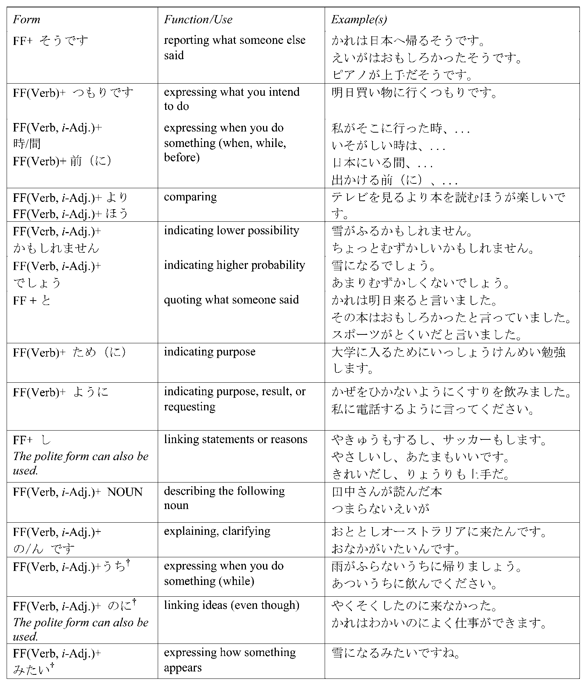
† for receptive use only

て form + . . .
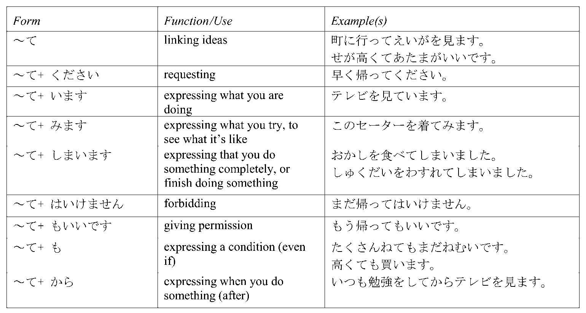
て form verb + verbs of giving and receiving
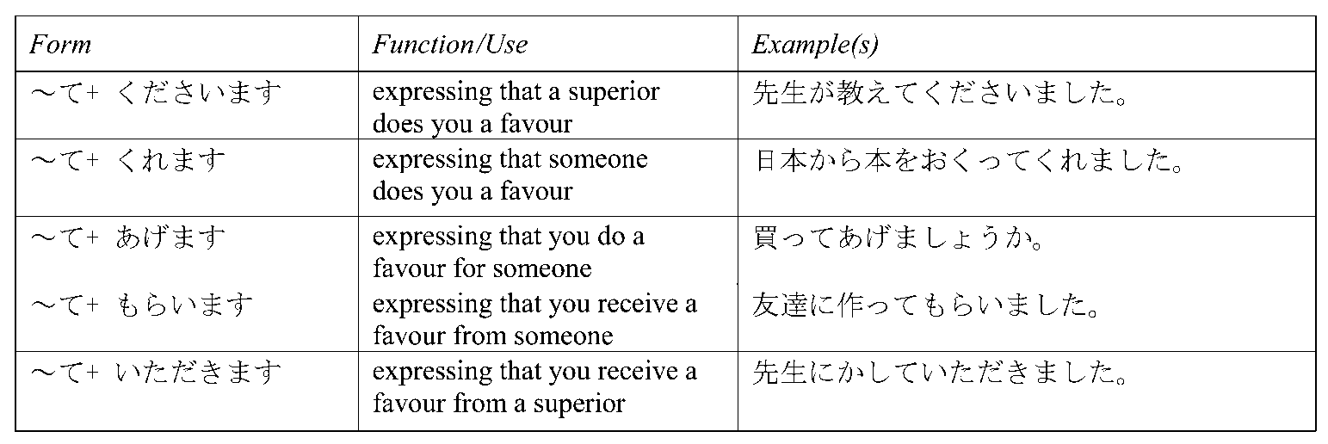
た、たら、たり forms
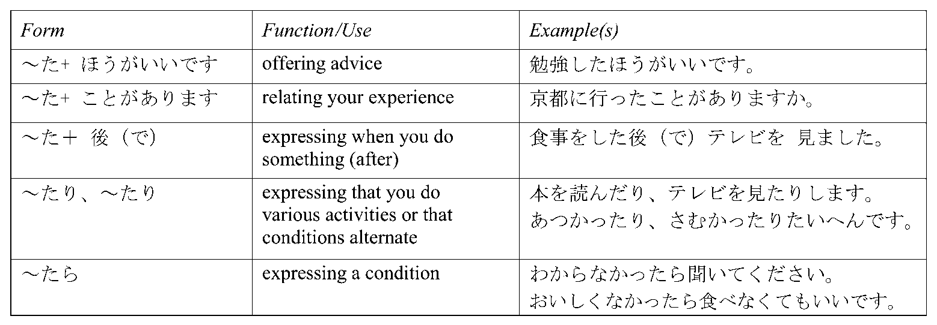
Verbます base + . . .
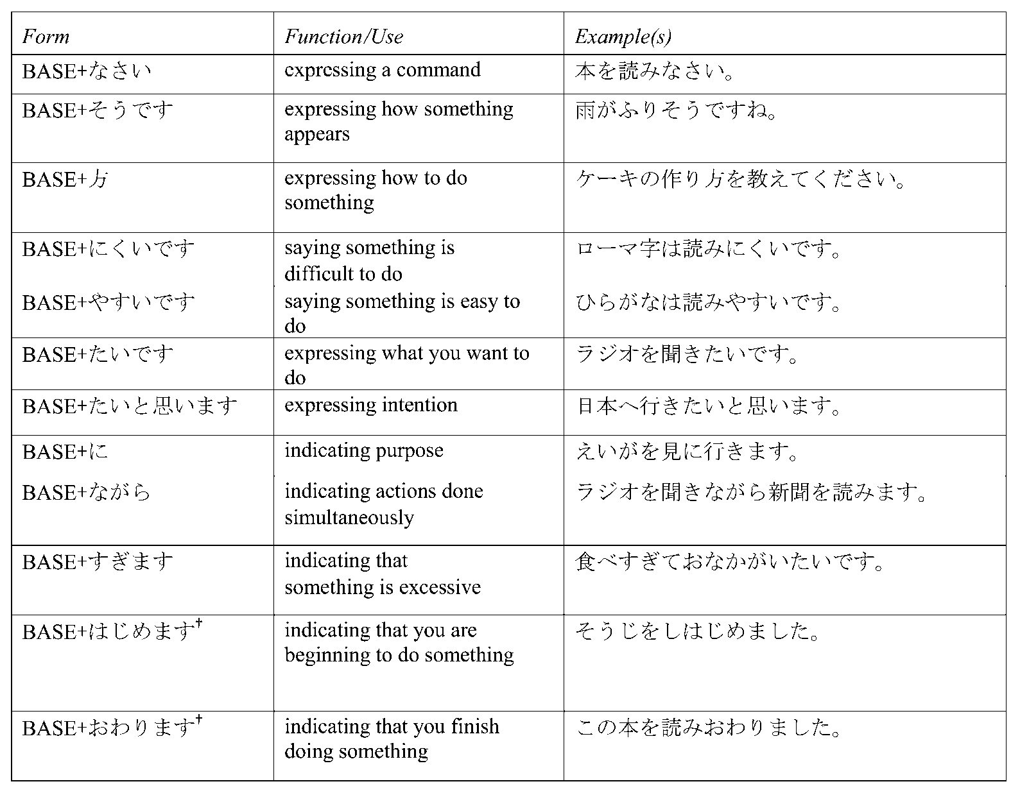
Verbない base + . . .
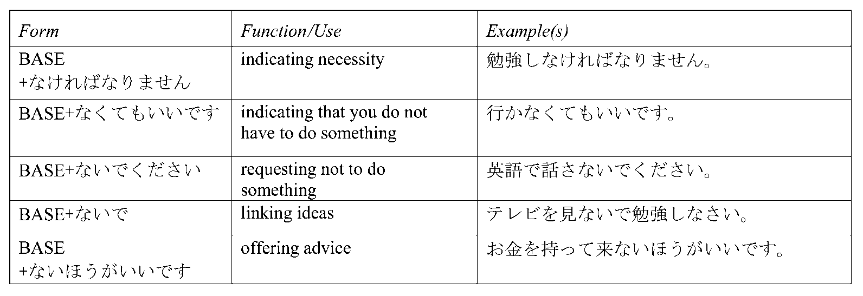
† for receptive use only

Verb -e/-re base + ば
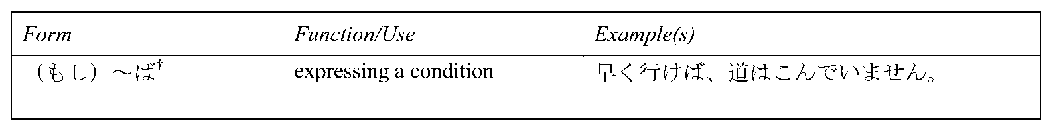
i-Adjective -kere + ば
Verb -ou/-you base
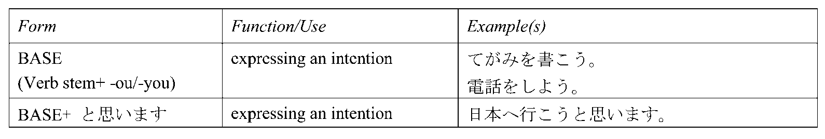
Verb -eru /-rareru form
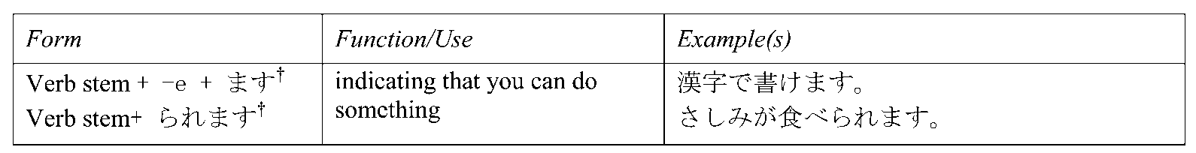
Adverbial forms
Particles
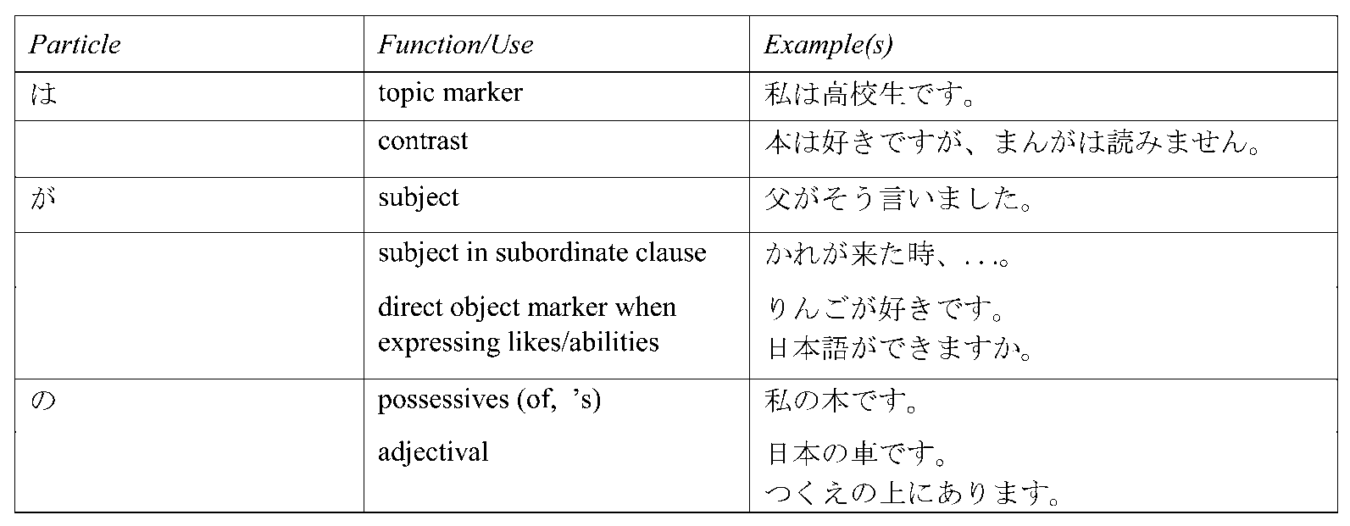
† for receptive use only

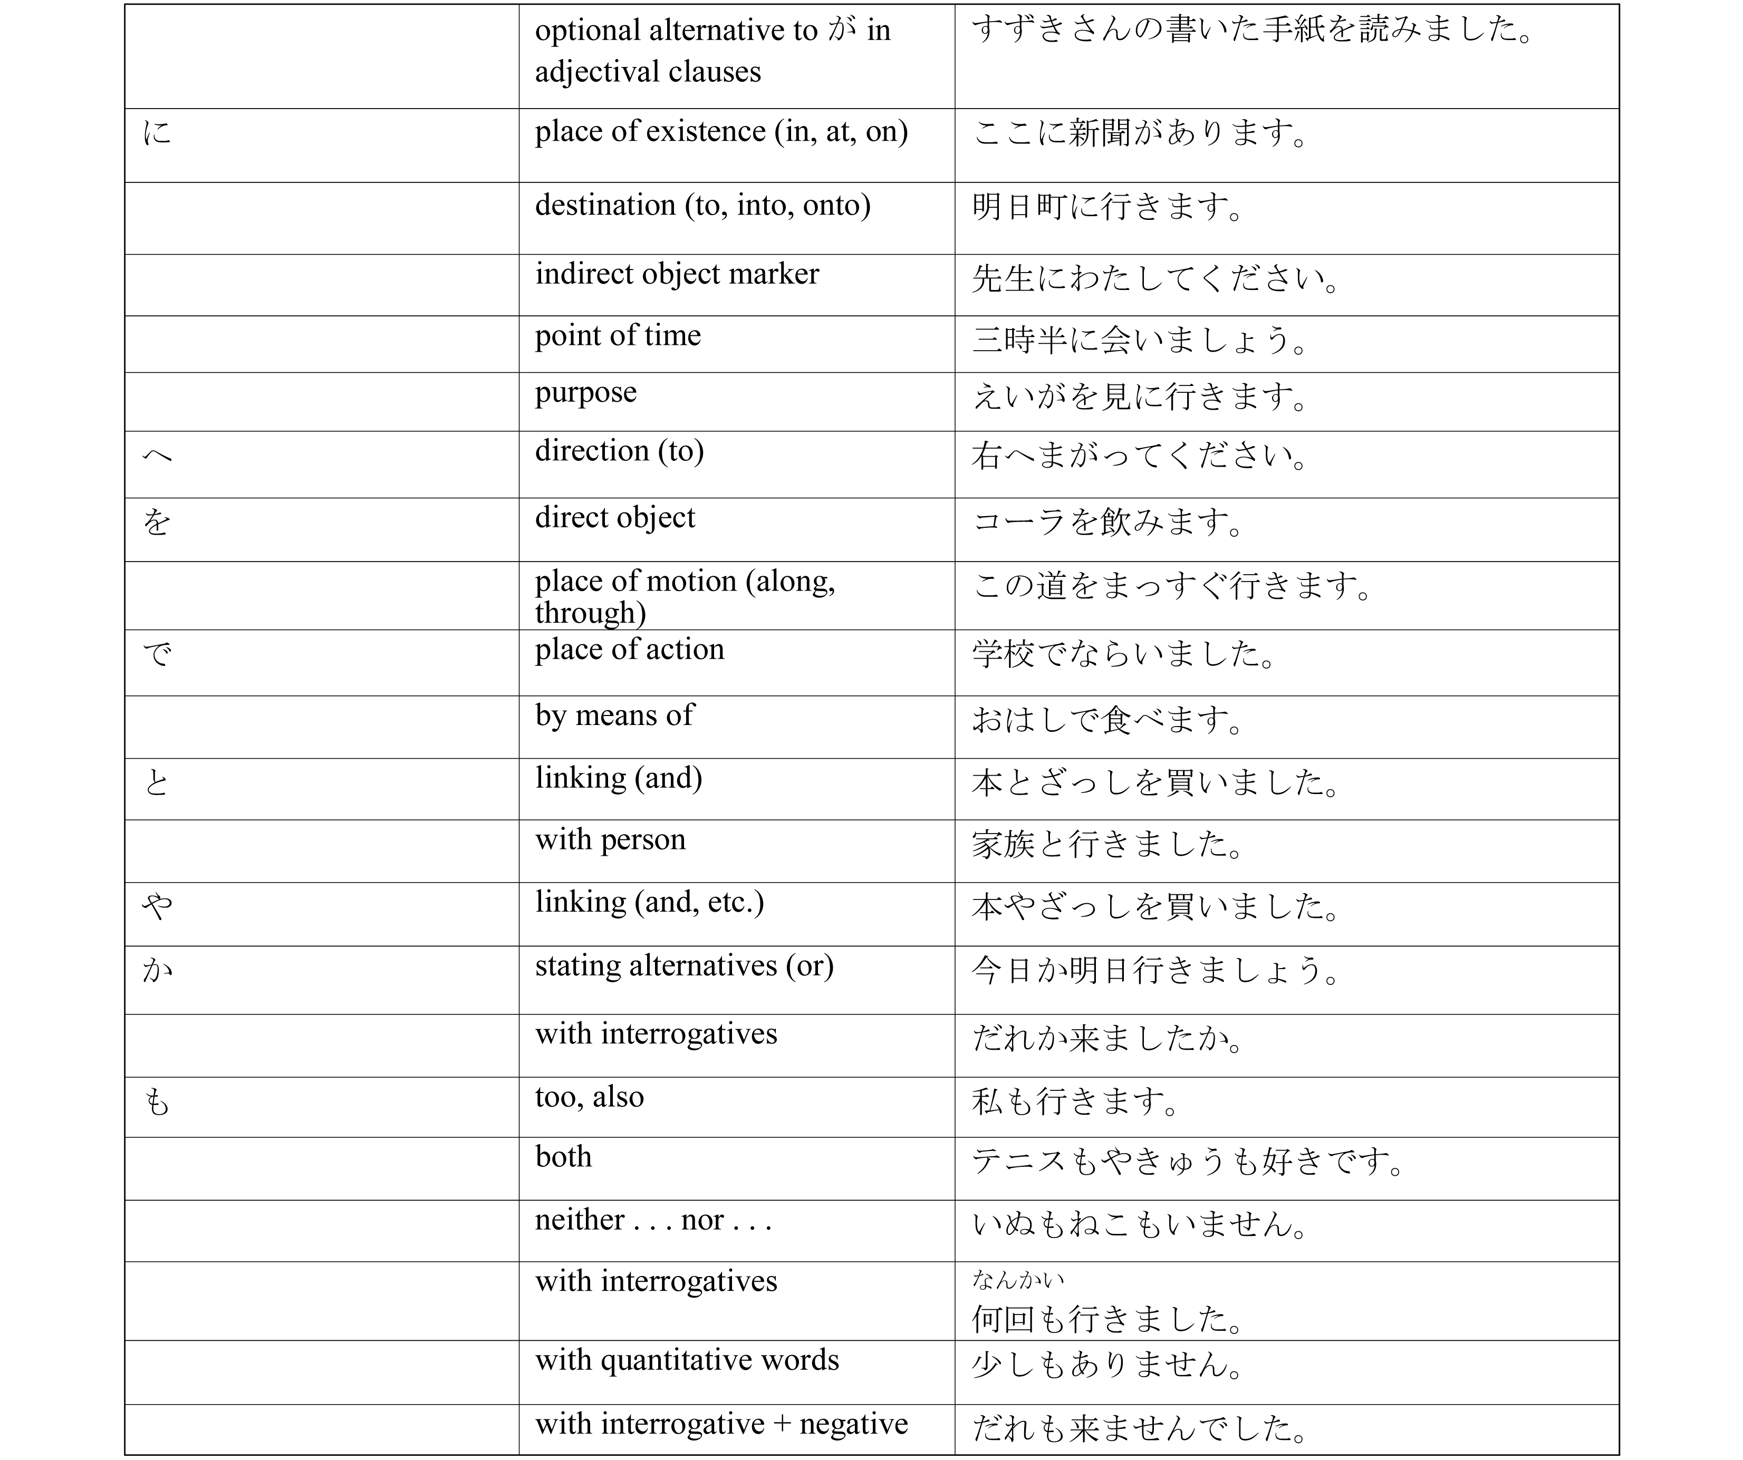
Words indicating extent
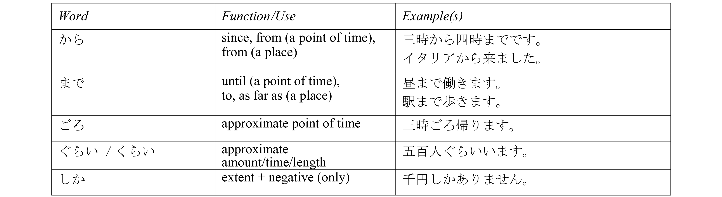
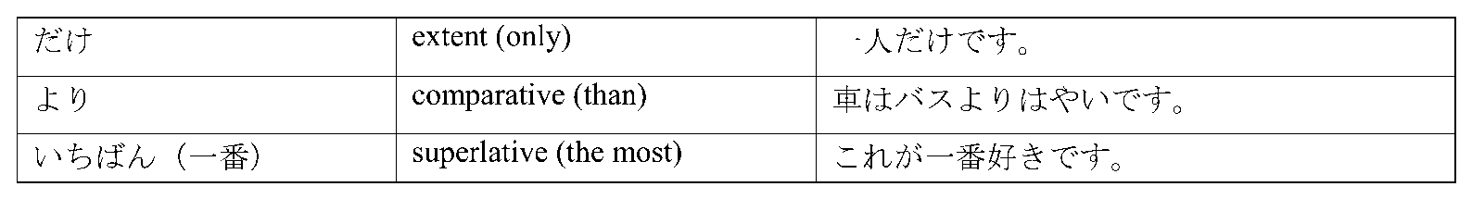
Conjunctions
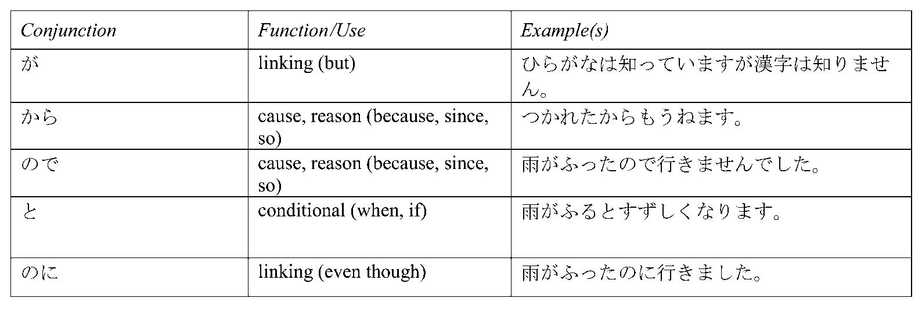
Nominalisers
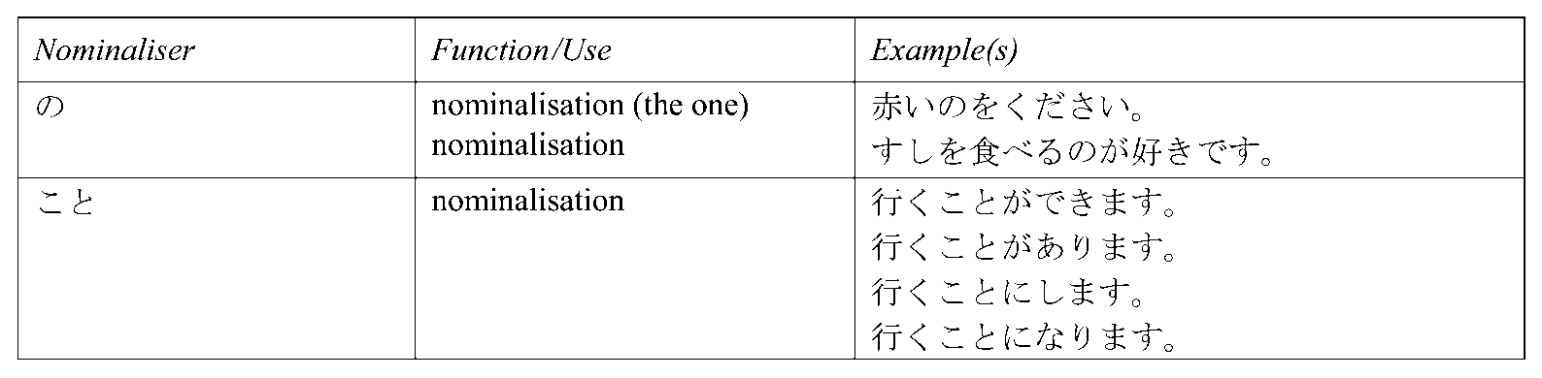
Sentence final particles
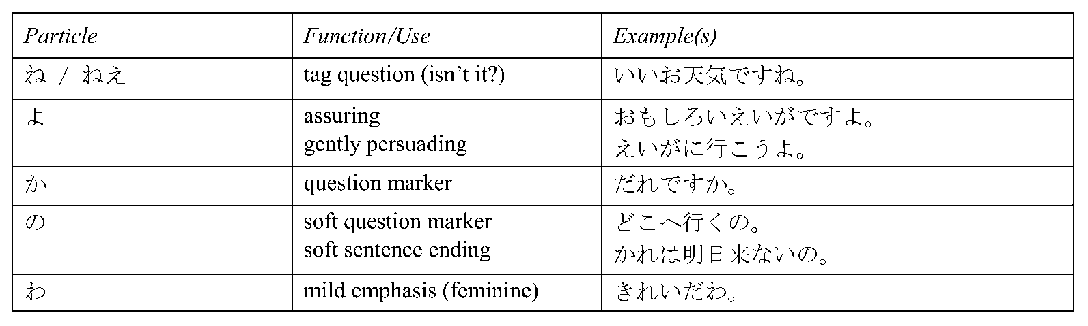

Modern Greek
The Language
The language to be studied and assessed is the standard version of Modern Greek — the demotic form of the written and spoken language. Students will be required to use both formal and informal registers, current language use incorporating spelling reforms, and the monotonic system of accentuation. The Greek alphabet is the only script to be used in the written form.
Non-standard regional varieties, even dialect variations, may be acceptable in the appropriate context and to the extent that they do not impede the students’ ability to communicate effectively in standard Modern Greek.
Anglicisms and non-standard linguistic transfers from English in vocabulary, expressions, and word order are not acceptable. However, words and expressions that have been officially incorporated and adapted into the language are acceptable.
The correct use of recognised non-binary pronouns is acceptable in examination and school assessment responses.
Themes, Topics, and Subtopics
There are three prescribed themes:
- The Individual
- The Modern Greek-speaking Communities
- The Changing World.
The following table shows the prescribed themes, prescribed topics, and suggested subtopics.
The Individual | The Modern Greek-speaking Communities | The Changing World
- Personal Identity  Examples  Personal profile  Neighbourhood  Hobbies and pastimes  - Relationships  Examples  Friends and peers  Family  School life  - School Experience  Examples  Subjects  Aspirations | - Lifestyles  Examples  Travel  Cultural interests  Sport  Greek cuisine  - Special Traditions  Examples  Festivals  Celebrations  National days or religious days  - Contemporary People and Events  Examples  Literary figures  Popular entertainers  Sporting heroes or events  - The Legacy of Greece  Examples  The Olympic Games  Science  Music  Art  The migrant experience | - Youth Issues  Examples  Entertainment  Drugs and alcohol  The disadvantaged  - The World of Work  Examples  Occupations or pathways  Careers  Unemployment  - Environmental Issues  Examples  Global warming  Pollution  World conflict
Note: Bold = prescribed themes, bold italics = prescribed topics, italics = suggested subtopics

Text Types
Refer to pages 23 to 24 for information.
Grammar
Grammar can be described as the organisation and relationship of all the elements that constitute a language as it functions.
There are many different theories of grammar, and a number of different approaches to its teaching and learning. The categories used below are not intended to promote or favour any particular theory of grammar.
Students will already have a reasonable understanding of the function of grammar in Modern Greek through prior knowledge or study.
Developing students’ ability to convey meaning effectively in a range of contexts will, however, necessarily involve extending their awareness of the system of structures that underlie the language, as well as their ability to apply and adapt this knowledge.
Students studying Modern Greek in a continuers-level program are expected to recognise and use the following grammatical items:
Verbs
Auxiliary — είμαι, έχω
Regular verbs (active and passive)
Tense
Present, e.g. λύνω, διαβάζω, λύνομαι
Past simple, e.g. έλυσα, διάβασα
Past continuous, e.g. έλυνα, διάβαζα
Present perfect, e.g. έχω λύσει, έχω διαβάσει
Past perfect, e.g. είχα λύσει, είχα διαβάσει
Future simple, e.g. θα λύσω, θα διαβάσω
Future continuous, e.g. θα λύνω, θα διαβάζω
Conditional, e.g. θα έλυνα, θα διάβαζα
Mood
Subjunctive, e.g. να λύνω, να διαβάσω
Imperative, e.g. λύνε, διαβάστε
Participle, e.g. λύνοντας, διαβάζοντας
Irregular verbs, e.g. πηγαίνω, βγαίνω
Impersonal verbs, e.g. πρέπει, μπορεί
The verb μου αρέσει
Negation, e.g. δεν θέλω, δεν θα πάω.
Articles
Definite, e.g. ο, η, το
Indefinite, e.g. ένας, μία, ένα.

Nouns
Regular nouns
Masculine, e.g. ο πίνακας, ο μαθητής, ο δρόμος
Feminine, e.g. η φίλη, η θάλασσα
Neuter, e.g. το πρόβατο, το νηοί, το μάθημα
Singular or plural, e.g. ο μαθητής – οι μαθητές, το νησί – τα νησιά
Case
Nominative, e.g. ο νικητής
Genitive, e.g. της μαθήτριας
Accusative, e.g. τον πίνακα
Vocative, e.g. δάσκαλε
Article agreement, e.g. των μολυβιών, τις χώρες
Imparisyllabic nouns, e.g. ο παππούς – οι παππούδες, η γιαγιά – οι γιαγιάδες
Scholarly nouns, e.g. ο συγγραφέας, η πόλη, το μέλλον
Indeclinable nouns, e.g. το ρεκόρ, το τράμ.
Adjectives
Regular, e.g. καλός, καλή, καλό / νέος, νέα, νέο
Irregular, e.g. πολύς, πολλή, πολύ
Agreement and position, e.g ο όμορφος κήπος
Comparative and superlative, e.g. ψηλός, πιο ψηλός/ψηλότερος, ο πιο ψηλός/ψηλότατος.
Pronouns
Demonstrative, e.g. αυτός, τέτοιος, εκείνος
Interrogative, e.g. ποιος, πού, πώς
Reflexive, e.g. τον εαυτό μου
Relative, e.g. που, πως
Indefinite/Definite, e.g. κανένας, κάποιος, όποιος
Distributive, e.g. καθένας
Personal — strong and weak forms, e.g. εγώ ... εμείς (strong), εμένα ... εμάς (weak)
Possessive, e.g. μου ... μας.
Prepositions
Simple and compound types, e.g. με, σε, για, από
Use with nouns, e.g. με τον Κώστα, στο μάθημα, από την Ελλάδα.
Conjunctions, e.g. αλλά, επειδή, γιατί.
Adverbs
Position in word order
Comparatives, e.g. γρηγορότερα
Formation from adjectives, e.g. ωραία, χαμηλά
Phrases of time, manner, and place, e.g. κάπου-κάπου, πότε-πότε, εκεί που
With personal pronouns, e.g. μαζί μας.
Numbers
Date, e.g. έξι του μηνός
Time, e.g. τρεις η ώρα
Agreement, e.g. ο πρώτος παίχτης
Fractions, e.g. μισός χρόνος
Percentages, e.g. εκατό τοις εκατό
Collective numerals, e.g. μία ντουζίνα, εκατοντάδες.

Spanish
The Language
The language to be studied and assessed is modern standard Spanish.
Spanish is a Romance language that derives from the Vulgar Latin brought to Western Europe by the Romans. Its development reflects the history of the Iberian peninsula, with its most notable influences being Greek and Arabic, the latter having contributed thousands of words to the vocabulary.
In the fifteenth century, as a result of the arrival of the Spaniards in the Americas, Spanish continued to develop as it was influenced by Indigenous languages.
The maintenance of modern standard Spanish is now the joint responsibility of the Real Academia of each of the countries in which Spanish is an official language. The linguistic integrity of the Spanish language is maintained with the acknowledgment of significant variations between countries, regions, and social groups. These variations are phonetic, morphological, syntactic, and semantic, and do not constitute dialects. However, a number of other languages are spoken in Spanish-speaking countries, with some, such as Basque, Catalan, and Galician in Spain and Guaraní in Paraguay, sharing official language status.
The correct use of recognised non-binary pronouns is acceptable in examination and school assessment responses.
Themes, Topics, and Subtopics
There are three prescribed themes:
- The Individual
- The Spanish-speaking Communities
- The Changing World.
The following table shows the prescribed themes, prescribed topics, and suggested subtopics.

The Individual | The Spanish-speaking Communities | The Changing World
- Personal Identity  Examples  Family and self  Daily routine  Home and community  Contact with the Spanish-speaking world  - My Life Now and in the Future  Examples  School life  Spanish studies  Work  Future plans  - Leisure and Interests  Examples  Hobbies  Spare time  Friends  Holidays | - Different Lifestyles  Examples  Routines (work, school, leisure)  Housing and accommodation  Eating and drinking  Celebrating (festivals and traditions)  - Background Knowledge  Examples  History and geography (significant events, figures, and places)  People(s), cultures, and languages  Food (social and historical importance)  - Cultural Expression  Examples  Cinema (films, videos), and television  Folk and Indigenous art and crafts  Music, dance, musical instruments, and songs  Painting, sculpture, and architecture  Literary extracts, short stories, and poems | - Environmental Issues  Examples  Key environmental issues and their effects on different societies  The role of individuals, governments, and organisations in addressing environmental issues  - The World of Work  Examples  Spanish for tourism  - Technology in Daily Life  Examples  Communications  Education and work  Home and leisure  - Social Issues  Examples  Social roles  Migration (internal and overseas)  Health and fitness  Employment
Note: Bold = prescribed themes, bold italics = prescribed topics, italics = suggested subtopics
Text Types
Refer to pages 23 to 24 for information.
Grammar
Grammar can be described as the organisation and relationship of all the elements that constitute a language as it functions.
There are many different theories of grammar, and a number of different approaches to its teaching and learning. The categories used below are not intended to promote or favour any particular theory of grammar.
Students will already have a reasonable understanding of the function of grammar in Spanish through prior knowledge or study.
Developing students’ ability to convey meaning effectively in a range of contexts will, however, necessarily involve extending their awareness of the system of structures that underlie the language, as well as their ability to apply and adapt this knowledge.
Students studying Spanish in a continuers-level program are expected to recognise and use the following grammatical items:

Articles
Definite, e.g. el, la, los, las
Indefinite, e.g. un, una
The form lo and adjective to express abstract ideas, e.g. lo mejor de esta idea
Omission of article (e.g. with profession), e.g. Soy estudiante.
Nouns
Gender, e.g. amigo, amiga
Number, e.g. amigos, amigas, clases.
Adjectives
Demonstrative, e.g. este, ese, aquel . . .
Possessive, e.g. mi, tu, su, nuestro, vuestro . . .
Interrogative, e.g. ¿qué?, ¿cuántos?, ¿cuál?
Descriptive, e.g. es una mujer rica
Apocopated (shortened), e.g. buen/gran/mal/algún.
Numerals
Cardinal, e.g. uno, dos, tres . . .
Ordinal, e.g. primero, el primer año.
Pronouns
Subject, e.g. Yo hablo español.
Direct object, e.g. Susana los tiene.
Indirect object, e.g. Juan le entregó el libro a ella.
Double object, e.g. La profesora me lo explicó.
Reflexive, e.g. Me levanto a las seis.
Prepositional, e.g. Es para ti.
Possessive, e.g. Aquellos libros son tuyos.
Demonstrative, e.g. éste, ése, aquél
Relative, e.g. la revista que compré
Emphatic, e.g. A mí me gusta mucho.
Position in relation to an imperative, e.g. Llámame mañana.
Position in relation to an infinitive, e.g. Quiero verlo.
Position in relation to a progressive tense, e.g. Estoy haciéndolo ahora.
Verbs
Use of ser, estar, saber, conocer, poder, tener, hacer, gustar, haber, faltar, parecer, importar — idiomatic and special uses
Indicative (the following tenses)
Present, e.g. hablo, abro, vivo
Present continuous, e.g. Estoy bailando con ella
Preterite, e.g. hablé, comí, escribí
Perfect, e.g. he cantado, han llegado
Future, e.g. hablaré, comeré, reiré
Imperfect, e.g. hablaban, comían, iban
Conditional, e.g. cantaría, bebería, saldría
Impersonal construction, e.g. aquí se habla español.
Subjunctive mood
Present, e.g. hable, coma, diga
Imperfect, e.g. hablara (-ase), comiera (-ese), dijera (-ese).

Adverbs
Formation
Regular forms, e.g. fácil — fácilmente
Common irregular forms, e.g. bien, mal, tan, cuán.
Prepositions
Simple, por/para, e.g. Vino por el médico. Compré las flores para ella.
Compound, e.g. delante de la casa
Articulated, e.g. conmigo
Contracted, e.g. Fuimos al baile
Prepositional verbs, e.g. Empezó a llover.
Conjunctions
All commonly used, e.g. y, ni, o, sin embargo, o sea, es decir
Y/e, o/u, e.g. madre e hijas, plata u oro.
Negatives
Common negative words, e.g. nadie, nada, nunca, ni . . . ni, ningún, tampoco
Double negation, e.g. No hablo con nadie.

Vietnamese
The Language
The language to be studied and assessed is standard Vietnamese. The Roman script Chữ Quốc Ngữ (National Language Script) is used in the Vietnamese writing system. Although some regional variations in pronunciation and accent will be accepted, standard syntax, morphology, and the toneme system should be used when writing Vietnamese.
The correct use of recognised non-binary pronouns is acceptable in examination and school assessment responses.
Themes, Topics, and Subtopics
There are three prescribed themes:
- The Individual
- The Vietnamese-speaking Communities
- The Changing World.
The following table shows the prescribed themes, prescribed topics, and suggested subtopics.
The Individual | The Vietnamese-speaking Communities | The Changing World
- Personal World  Examples  Self  Family and friends  Relationships  Home and community  Daily routine  - Education and Aspirations  Examples  School life and experiences  Pressures and influences  Future plans and pathways  - Leisure and Interests  Examples  Hobbies  Sports  Entertainment  Spare time  Holidays | - Migration  Examples  Experiences of migration  Contributions of migrants to Australia  - Lifestyles/People and Places  Examples  Daily life  City and rural life  Cultural diversity  Famous people  Vietnamese cuisine  - The Arts and Entertainment  Examples  Contemporary literature/ folk tales  Music and songs  Art  Films and theatre  TV and media  - Traditions and Values  Examples  Celebrations and festivals  Family values  Changing values  Influence of the past on the present | - The Environment  Examples  Impact of tourism  Impact of development  Pollution  - The World of Work  Examples  Careers and occupations  Work conditions  Male and female roles  - Social Issues  Examples  Youth issues, peer pressure, street kids  Impact of technology  Unemployment  Cultural identity  Widening gap between rich and poor  Tourism
Note: Bold = prescribed themes, bold italics = prescribed topics, italics = suggested subtopics
Text Types
Refer to pages 23 to 24 for information.

Grammar
Grammar can be described as the organisation and relationship of all the elements that constitute a language as it functions.
There are many different theories of grammar, and a number of different approaches to its teaching and learning. The categories used below are not intended to promote or favour any particular theory of grammar.
Students will already have a reasonable understanding of the function of grammar in Vietnamese through prior knowledge or study.
Developing students’ ability to convey meaning effectively in a range of contexts will, however, necessarily involve extending their awareness of the system of structures that underlie the language, as well as their ability to apply and adapt this knowledge.
Students studying Vietnamese in a continuers-level program are expected to recognise and use the following grammatical items:
Tones
Distinction between six tone markers, e.g. ma, má, mà, mạ, mả, mã.
Intonation
Question, statement, negation, e.g. lên giọng, xuống giọng.
Initial Consonants
Distinction between tr and ch, s and x, v and d, etc., e.g. trẻ – chẻ; sa – xa; vì – dì.
Final Consonants
Distinction between n and ng, c and t, etc., e.g. đan – đang; mặc – mặt.
Punctuation
Comma (,), full stop (.), semi-colon (;), colon (:), hyphen (-), exclamation mark (!), question mark (?), etc., e.g. Hôm nay, tôi đi học.
Verbs
Tense (present, past, future), e.g. đang, đã, rồi, sẽ, sắp, hôm qua, hôm nay, ngày mai.
Voice (active and passive), e.g. Tôi phạt nó. Nó bị phạt.
Adverbs
Time, place, manner, e.g. Lúc 2 giờ, ở Việt Nam, rất đẹp.
Nouns
Common or proper, e.g. sông, Cửu Long.
Singular or plural, e.g. nhà, nhiều nhà.
Compound, e.g. áo quần, thợ điện.
Pronouns
Personal, demonstrative, interrogative, e.g. tôi, ông kia, ai, gì.
Adjectives
Simple or compound, e.g. đẹp, duyên dáng.
Comparative or superlative, e.g. bằng, hơn, nhất.

Numerals
Cardinal, e.g. một, hai.
Ordinal, e.g. thứ nhất, thứ nhì.
Phrase Types
Adverbial, e.g. Nói một cách tổng quát.
Noun, e.g. Hai học sinh giỏi được lãnh phần thưởng.
Verb, e.g. Chú bé đang đi chầm chậm.
Adjectival, e.g. Đẹp tuyệt vời.
Sentence Types
Statement, e.g. Trẻ em Việt Nam học chăm chỉ.
Affirmative, e.g. Em ấy là người Việt.
Negative, e.g. Tôi không hút thuốc.
Question, e.g. Bạn thích món ăn Việt Nam không?
Simple, e.g. Tôi đến trễ.
Compound, e.g. Tôi đến trễ vì tôi bị kẹt xe.
Cohesive Devices
Coordinating conjunctions, e.g. và, hay.
Connective particles, e.g. thế, thì, mà.
Response words and polite particles, e.g. dạ, vâng, ạ.
Style
The forms of address
Contrast between written and spoken forms
Style variations related to social relationships
Distinction between formal and informal styles, e.g. thưa, kính thưa, thân mến.

