Stage 2 Earth and Environmental Science

Program 1: Assessment Type 1: Investigation Folio

Groundwater Design Practical Investigation

Purpose
This assessment allows you to develop and demonstrate your practical investigation skills using a groundwater model, like the one shown in figure 1. The model represents a cross-section of a groundwater system.

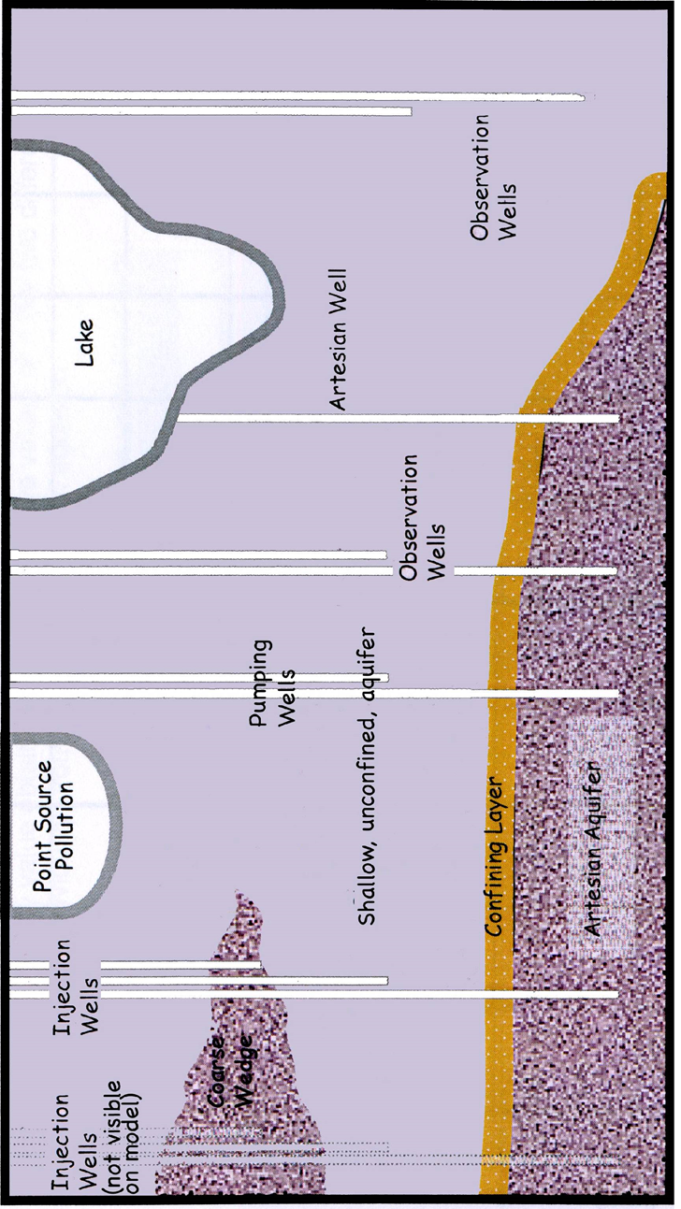
Figure 1 – Illustration of a sand- tank groundwater system model

You will need to complete the formative activity ‘Exploring a ground water system through a sand tank model’ to understand the connections between the various elements in the sand-tank model. This will help you to think about the relationships between ground water and surface water systems. You will then identify a problem involving the movement of water through an aquifer and use the model to collect data.

Part A: Design Proposal (design pre- investigation with modifications during investigation). IAE1
Individually, research the principles of movement of groundwater
You will then be placed in groups of three to formulate possible questions that you can investigate using the sand-tank groundwater model. For example, you could consider the impact of withdrawal rate from the artesian aquifer on water level in the lake.

Proposal Development
Purpose: Deconstructing a problem to determine the most appropriate method for investigation
- State the specific purpose of your investigation.

Hypothesis: Formulating investigable questions and hypotheses
- State the hypothesis for the investigation

Variables and Constants Identifying variables
- State the independent variable.
- Describe how the independent variable is to be varied.
- State the dependent variable.
- Describe how the dependent variable will be measured.
- Identify factors that should be kept constant and describe how, or whether, they will be kept constant.

Materials and Equipment: Selecting and using appropriate equipment, apparatus, and techniques
- List all chemicals and equipment, including the quantities, required

Method: Selecting and using appropriate equipment, apparatus, and techniques
- Describe your procedure, using clear and detailed steps that others can follow.
- Consider the number of samples to test and the need for repetition.
- Complete a risk assessment and determine equipment requirements.
- Describe potential safety issues and how you will minimise them.
- Describe any ethical issues and how you will minimise them.

Due date for design proposal:

Part B: Conducting the investigation (collaborative) IAE1
Trial the method you have proposed and modify to suit the conditions.
Conduct your investigation recording raw data in a suitable format for analysis. Observations could include quantitative measures, sketches or photographs.

Part C: Report (individual) IAE2, 3, 4; KA1, 4
The practical report should include:
- introduction with relevant earth and environmental concepts and either a hypothesis and variables or an investigable question (IAE1, KA1)
- materials/apparatus*(IAE1)
- method/procedure outlining the steps to be taken*(IAE1)
- identification and management of safety and/or ethical risks*(IAE1)
- results*(IAE2)
- analysis of results, identifying trends, and linking results to concepts (IAE3, KA1)
- evaluation of procedures and data, and identifying sources of uncertainty including reasoning behind modifications to the original design proposal (IAE4)
- conclusion, with justification (IAE3)

The report should be a maximum of 1500 words or the equivalent in multimodal form.

A summary sheet outlining the deconstruction process should be attached to the report*. Suggested formats for the summary sheet include flow charts, concept maps, tables or notes.
*The five asterisked sections of materials/apparatus, method/procedures, risks, results and deconstruction are excluded from the word count.

Due date for the report:

Performance Standards for Stage 2 Earth and Environmental Science
- | Investigation, Analysis, and Evaluation | Knowledge and Application
A | Designs a logical, coherent, and detailed earth and environmental science investigation.  Obtains, records, and represents data, using appropriate conventions and formats accurately and highly effectively.  Systematically analyses and interprets data and evidence to formulate logical conclusions with detailed justification.  Critically and logically evaluates procedures and their effect on data. | Demonstrates deep and broad knowledge and understanding of a range of earth and environmental science concepts.  Develops and applies earth and environmental science concepts highly effectively in new and familiar contexts.  Critically explores and understands in depth the interaction between science and society.  Communicates knowledge and understanding of earth and environmental science coherently, with highly effective use of appropriate terms, conventions, and representations.
B | Designs a well-considered and clear earth and environmental science investigation.  Obtains, records, and represents data, using appropriate conventions and formats mostly accurately and effectively.  Logically analyses and interprets data and evidence to formulate suitable conclusions with reasonable justification.  Logically evaluates procedures and their effect on data. | Demonstrates some depth and breadth of knowledge and understanding of a range of earth and environmental science concepts.  Develops and applies earth and environmental science concepts mostly effectively in new and familiar contexts.  Logically explores and understands in some depth the interaction between science and society.  Communicates knowledge and understanding of earth and environmental science mostly coherently, with effective use of appropriate terms, conventions, and representations.
C | Designs a considered and generally clear earth and environmental science investigation.  Obtains, records, and represents data, using generally appropriate conventions and formats with some errors, but generally accurately and effectively.  Undertakes some analysis and interpretation of data and evidence to formulate generally appropriate conclusions with some justification.  Evaluates procedures and some of their effect on data. | Demonstrates knowledge and understanding of a general range of earth and environmental science concepts.  Develops and applies earth and environmental science concepts generally effectively in new or familiar contexts.  Explores and understands aspects of the interaction between science and society.  Communicates knowledge and understanding of earth and environmental science generally effectively, using some appropriate terms, conventions, and representations.
D | Prepares the outline of an earth and environmental science investigation.  Obtains, records, and represents data, using conventions and formats inconsistently, with occasional accuracy and effectiveness.  Describes data and undertakes some basic interpretation to formulate a basic conclusion.  Attempts to evaluate procedures or suggest an effect on data. | Demonstrates some basic knowledge and partial understanding of earth and environmental science concepts.  Develops and applies some earth and environmental science concepts in familiar contexts.  Partially explores and recognises aspects of the interaction between science and society.  Communicates basic earth and environmental science information, using some appropriate terms, conventions, and/or representations.
E | Identifies a simple procedure for an earth and environmental science investigation.  Attempts to record and represent some data, with limited accuracy or effectiveness.  Attempts to describe results and/or interpret data to formulate a basic conclusion.  Acknowledges that procedures affect data. | Demonstrates limited recognition and awareness of earth and environmental science concepts.  Attempts to develop and apply earth and environmental science concepts in familiar contexts.  Attempts to explore and identify an aspect of the interaction between science and society.  Attempts to communicate information about earth and environmental science.

