STAGE 1 philosophy

ASSESSMENT type 1: iNTERACTION

The Truman Show

Purpose:
Students interact in a community of inquiry (group work) and use evidence to explain their learning about philosophical issues and positions. They use reasoning to support or contest positions taken.

Task Description
1. In groups, students discuss philosophical issues raised by the film, The Truman Show using Coil’s Creative Thinking Model.
2. In an individual oral task, students answer a question about The Truman Show produced as a result of their group interaction.

Requirements
Each student prepares an individual oral response to the issue that should be no longer than 4 minutes in length. At the conclusion of the oral, each student must hand in their notes which should be constructed in note form and not exceed 400 words.

Audience: Teacher and peers

Assessment Design Criteria:

Learning Requirements | Assessment Design Criteria | Capabilities
1. Identify philosophical issues and positions  3. Provide reasons to support philosophical issues and positions | Knowledge and Understanding KU1  Reasoning R1 | - Communication  - Learning  - Personal Development

Exemplified with the kind permission of Janet Farrall, from Wilderness School.

Performance Standards for Stage 1 Philosophy

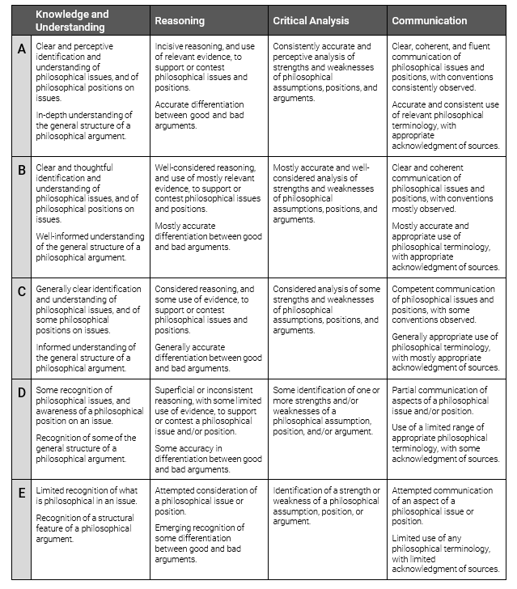

Appendix 1

Coil’s Lateral Thinking Model | Activity or Activities
1. List
2. Compare and Contrast
3. What would happen if….?
- Would you rather…..?

- How would you feel…..?

6. What…….?

7. Why…………..?

8. Active Question:

Appendix 2

Coil Lateral Thinking Questions for Group Discussion: The Truman Show

1. List the people who betrayed Truman.

2. What are the similarities between the Allegory of the Cave and The Truman Show?

3. What would happen if Truman was introduced to the real world?

4. Would you rather have been the wife or the best friend?

5. How would you feel if you were asked to be an actor on The Truman Show?

6. What was actually wrong in The Truman Show?

7. Why was the director able to get away with The Truman Show for over 30 years?

8. Active Questions:
What questions would Truman have asked of the director?

What questions would Truman have asked of Sylvia?

What questions would Truman have asked of the viewing public?

Appendix 3

The Truman Show: Philosophical issues raised by the class

- What is real? How is this issue demonstrated in The Truman Show?
- What is truth? How is this issue demonstrated in The Truman Show?
- Do we have free will? How is this issue demonstrated in The Truman Show?
- What are the similarities between Plato’s Allegory of the Cave and the film, The Truman Show? How do they differ?
- What are the similarities between The Matrix and The Truman Show? How do they differ?
- At the end of the film, Truman asks: “Was none of it real?” How would you have answered him?
- Consider the advertising on The Truman Show. Was it morally right for the TV network to use Truman’s life as a means of financial gain?
- Why was Sylvia the only person who tried to tell Truman the truth?
- How ethical was Christof and/or Meryl and/or Marlon and/or Truman’s father/mother?
- The television audience watched The Truman Show for 30 years? Is it morally responsible for what happened to Truman?
- What are the philosophical issues raised by the film, The Truman Show? Choose one and show how it is demonstrated in the film?
- Do we “accept the reality of the world with which we have been presented” as the creator of The Truman Show asserts?
- Is there more truth in the world than in The Truman Show?
- To what extent are human beings controlled by their environments? Refer closely to The Truman Show in your answer.
- In what ways are Christof and the television network similar to God? In what ways are they different?
- Would you have made the same choice Truman made at the end of the film? Why? Why not?
- Is reality any less of a lie than The Truman Show?
- Is it wrong to deceive someone of the truth if you believe you are doing the right thing?
- Does being a legal guardian give you the right to determine how someone lives their life?
- What would have happened if Truman remained on the show?
- Consider Sylvia’s badge: “How does it end? (the show)” How would you have answered?
- Is it right to entrap a human being, even if they are unaware?
- Why did Christof believe that Truman would be happier in his fabricated world, rather than being in the real world? Why was he wrong?
- To what extent should we be allowed to push ethical boundaries in order to create art?'
- Is the audience or the television network more morally responsible for what happened to Truman?"

