Stage 2 Physics

The following examination-style questions are suitable for assessing evidence of learning in Topic 2.

They do not constitute a complete test.

- The diagram below shows the electric field created by two point charges, q₁ and q₂, in a vacuum.
q1
q2

  - State the sign of q₂. Give a reason for your answer.

(2 marks)

  - State how the diagram shows that the magnitude of q₁ is greater than the magnitude of q₂.

(1 mark)

- A photocopier uses an electric force to transfer positively charged toner particles from the drum of the photocopier to the paper. The drum and the paper are both negatively charged. A toner particle with a charge of + 4.51 × 10–10 C is between the drum and the paper, as shown in the diagram below.
Ignore gravity in all parts of this question.

drum

toner particle

paper

  - The electric force that the drum exerts on the toner particle is 9.57 × 10–2 N, vertically up this page.
Determine the magnitude of the electric field of the drum at the location of the toner particle.

(2 marks)

  - The electric force that the paper exerts on the toner particle is 0.252 N, vertically down this page.
Calculate the net force on the toner particle.

(2 marks)

- When a metal is heated to a high enough temperature, it may emit charged particles. In 1897 physicist Joseph John Thomson measured the charge-to-mass ratio q of particles that were
m

emitted from a heated metal cathode and accelerated through a potential difference Δ V from rest to speed v. The charge-to-mass ratio q of a charged particle can be determined by measuring the
m
speed v of the particle.

  - Show that the charge-to-mass ratio of the accelerated charged particle is given by

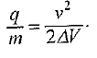

(3 marks)

  - A charged particle is accelerated through a potential difference of 2400 V, to a speed of
2.9 × 107 m s–1.

    - Show that the charge-to-mass ratio for this particle is 1.8 × 1011 C kg–1.

(1 mark)

    - Determine whether this particle is an electron or whether it is a proton.

(2 marks)

- The diagram below shows a cyclotron that is used to accelerate protons, in order to produce radioisotopes. The cyclotron has a radius of 0.600 m and a magnetic field of magnitude 0.979 T.

alternating potential difference

target

(a) Explain why the protons follow a circular path in the dees of the cyclotron.

- marks)

- Show that the kinetic energy of the protons emerging from the cyclotron is given by

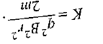

- marks)

- Calculate the kinetic energy of the protons emerging from the cyclotron. Write your answer in MeV.

- marks)

- The diagram below shows a solenoid and a magnetic field sensor, which detects the magnitude of a magnetic field.

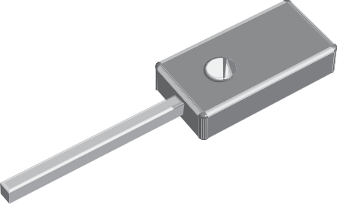
solenoid
magnetic field sensor

[This diagram is not drawn to scale.]

This equipment can be used to investigate the relationship between the magnitude of the current in a solenoid and the magnitude of the magnetic field that is produced.
A group of students wishes to investigate this relationship.
- State a suitable hypothesis for this investigation and describe the variables that they need to consider. For the controlled variables, explain how and why they are controlled.
(6 marks)

- Describe a procedure for this investigation. Include safety considerations and a blank data table.
(6 marks)

