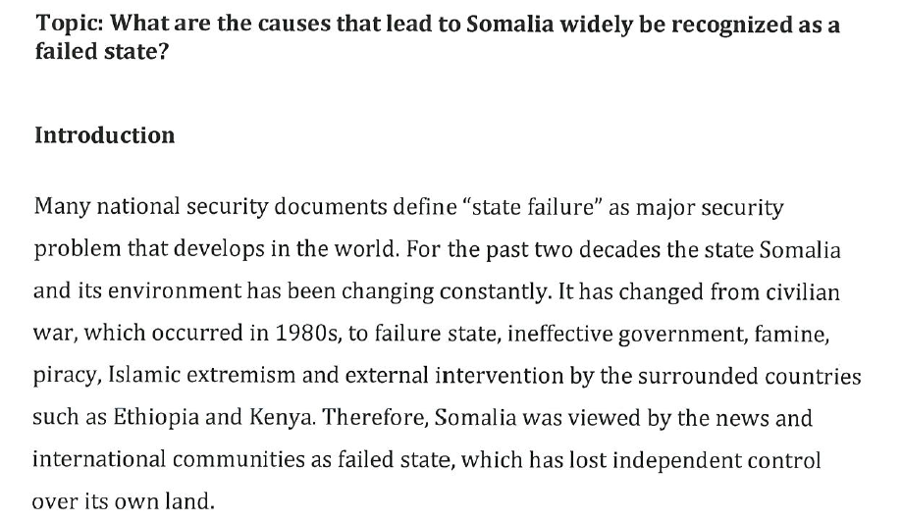

The topic is not about the language and culture of a community. There is no evidence of an investigation into the linguistic and cultural background and how this shapes personal identity in the Australian context

[Type a quote from the document or the summary of an interesting point. You can position the text box anywhere in the document. Use the Drawing Tools tab to change the formatting of the pull quote text box.]

[Type a quote from the document or the summary of an interesting point. You can position the text box anywhere in the document. Use the Drawing Tools tab to change the formatting of the pull quote text box.]

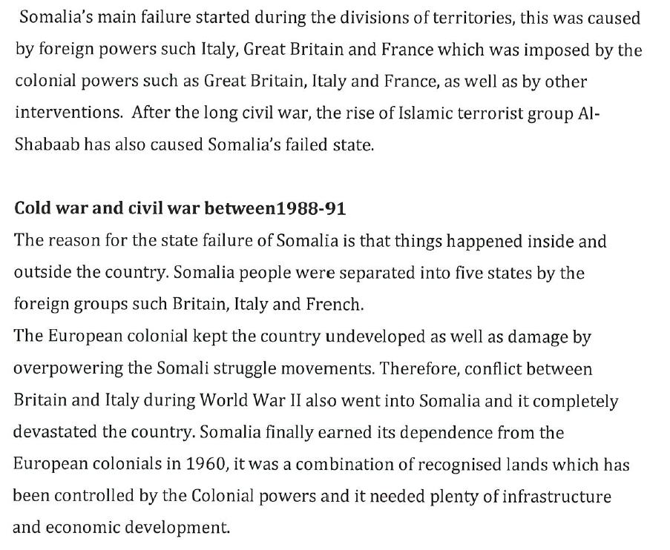



[Type a quote from the document or the summary of an interesting point. You can position the text box anywhere in the document. Use the Drawing Tools tab to change the formatting of the pull quote text box.]

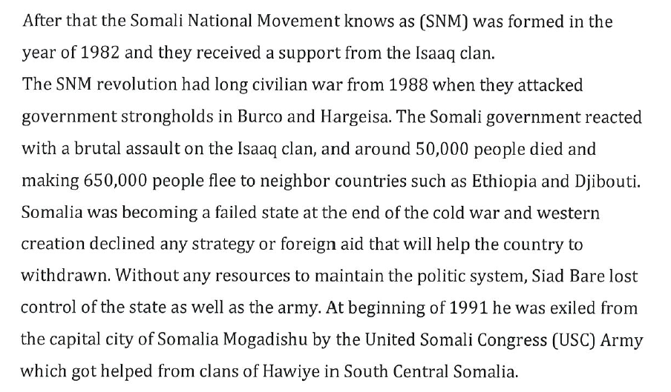

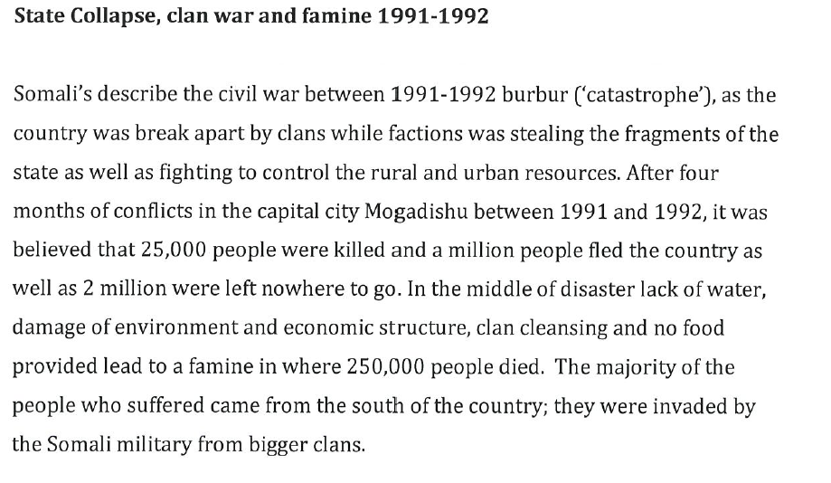

There is evidence of a range of accurate and appropriate ideas and expression. (IE1)

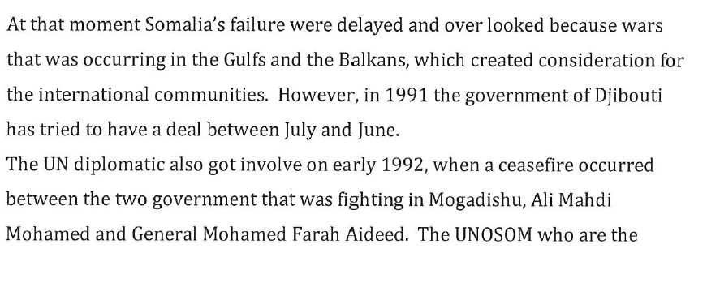

The report has a coherent structure with a logical sequence of ideas. A range of cohesive devices are used.

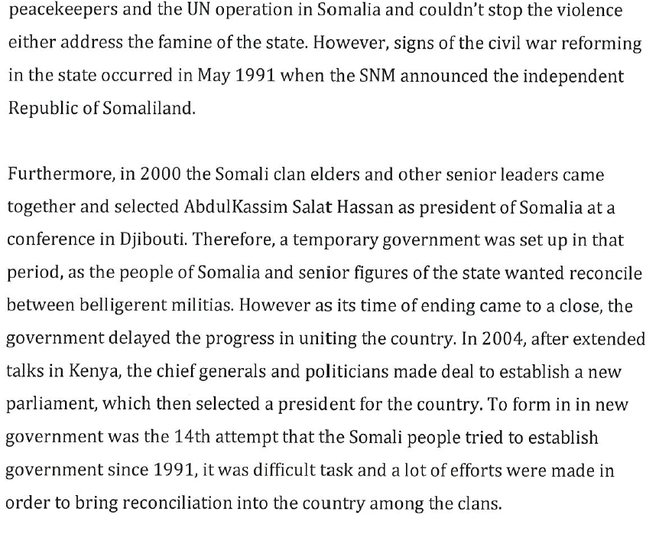

There is depth of treatment of ideas (IE2). However, there is no evidence of reflection on the ways in which culture is created, expressed and communicated through language. (AR2)

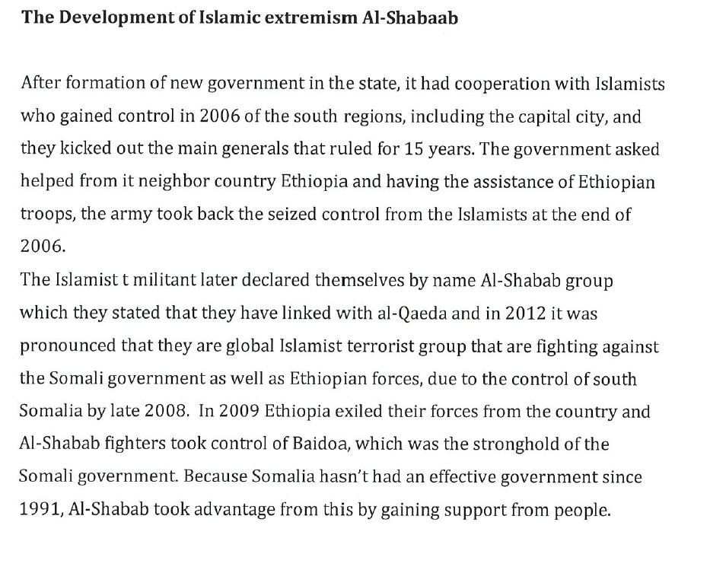

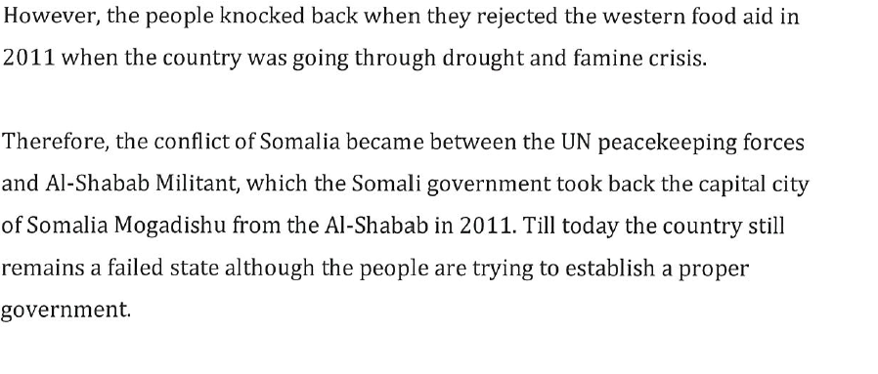

[Type a quote from the document or the summary of an interesting point. You can position the text box anywhere in the document. Use the Drawing Tools tab to change the formatting of the pull quote text box.]

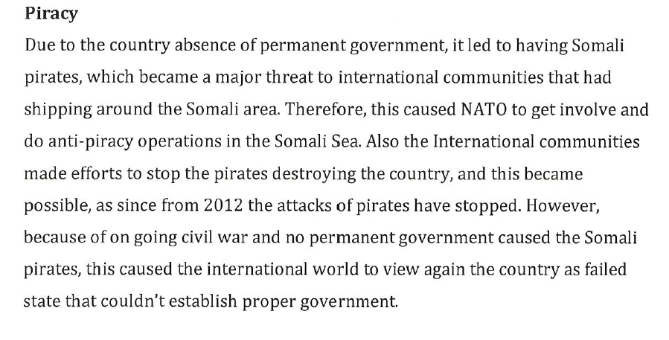

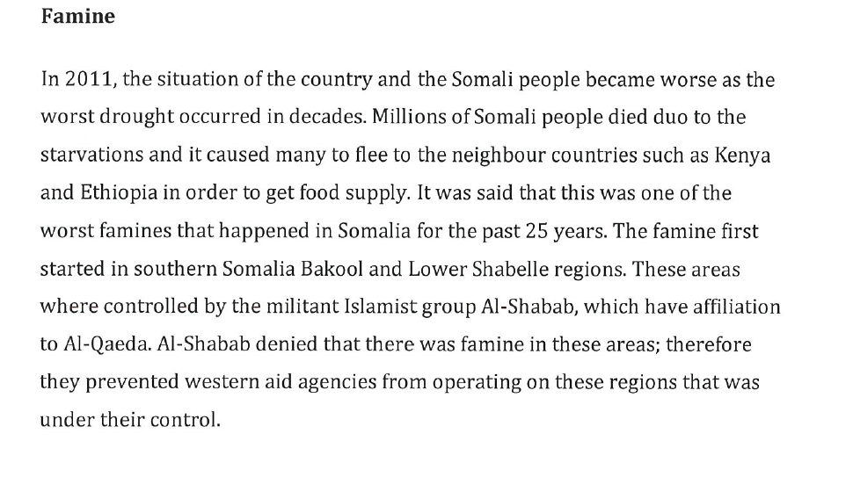

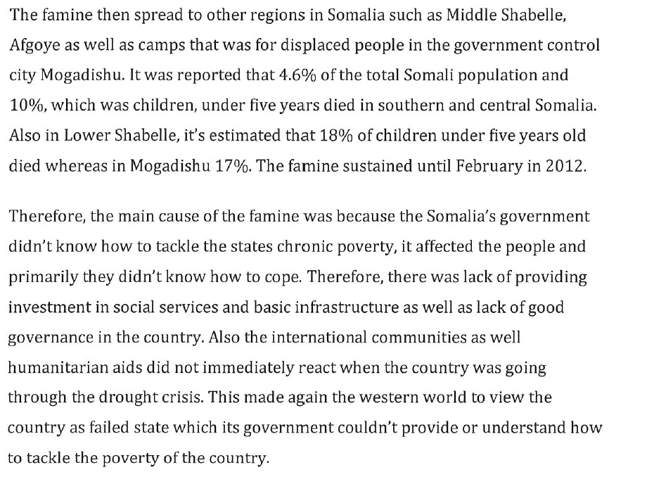

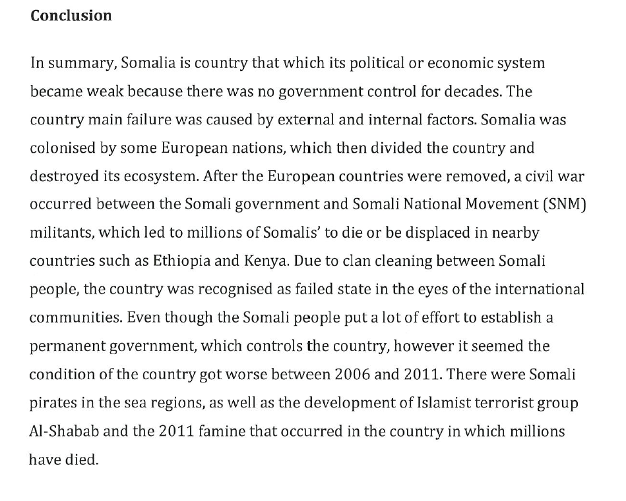

**Additional comments**

**Overall Grade: C-**

The topic is well researched and presented but there is no evidence of reflection on how language and cultural background relate to an individual’s sense of personal identity in the Australian context (AR2). There is no evidence of knowledge and understanding of language and culture in different contexts (KU1)