Student Work
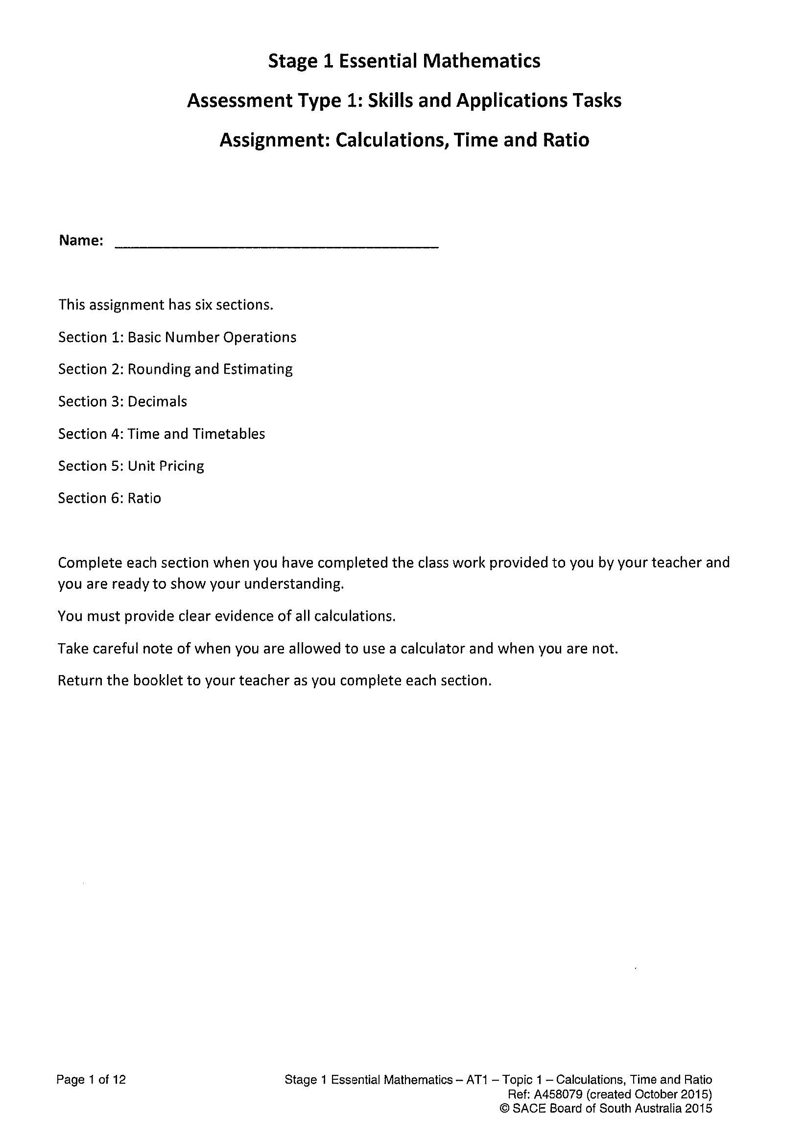

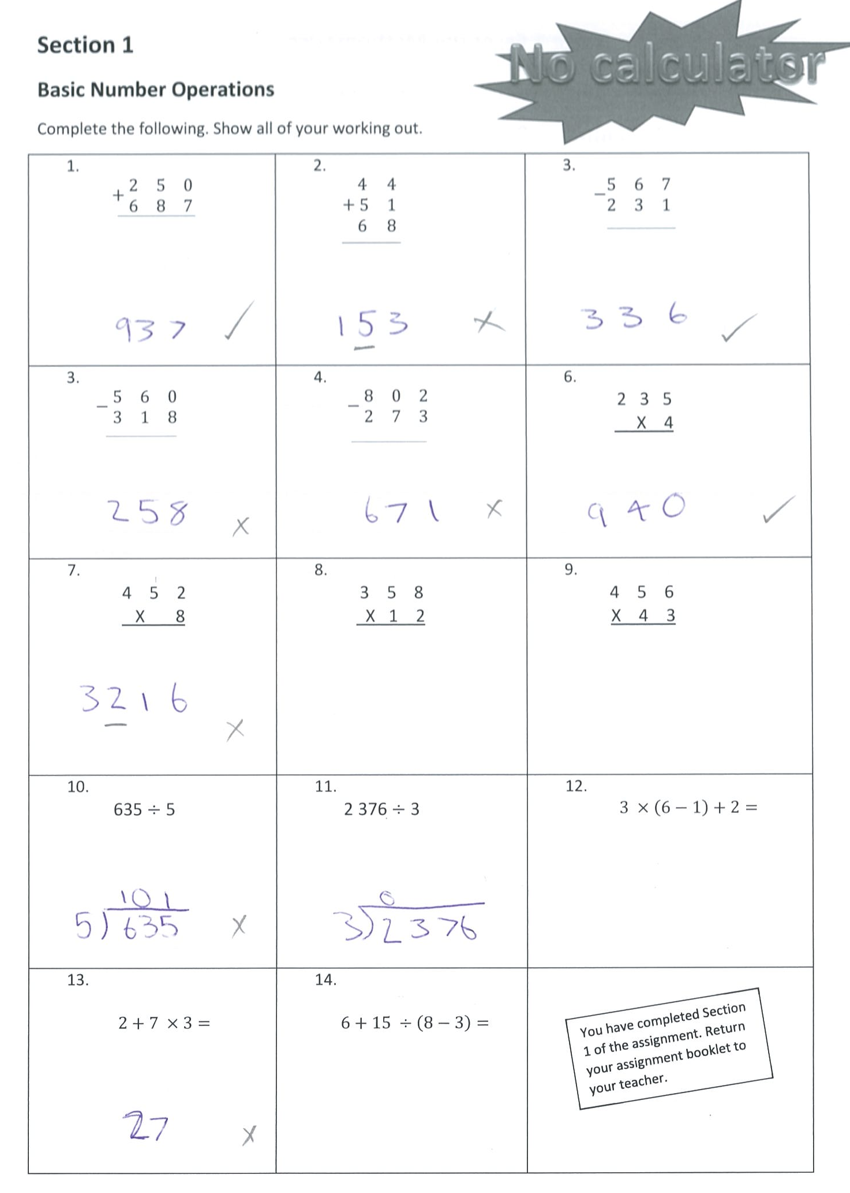
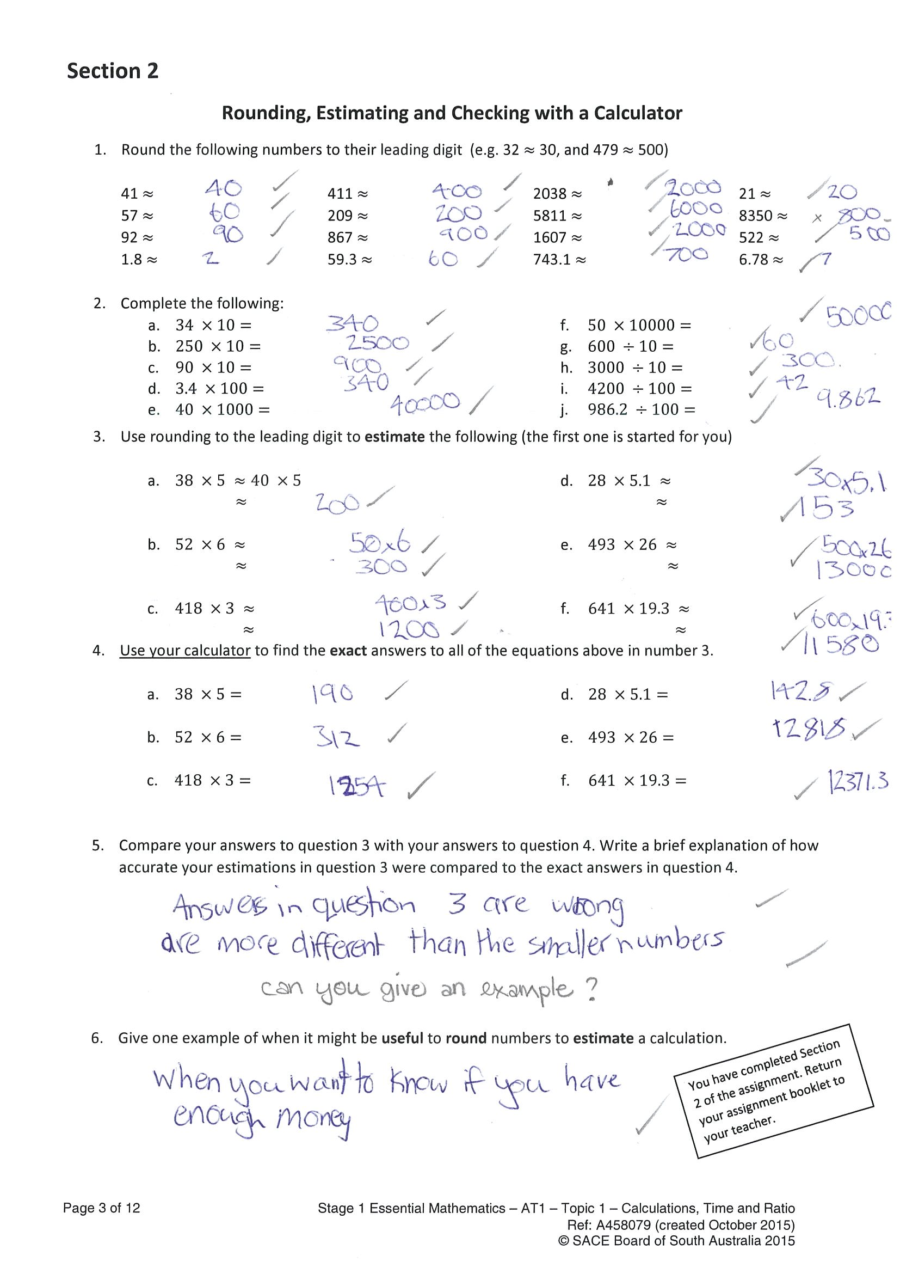
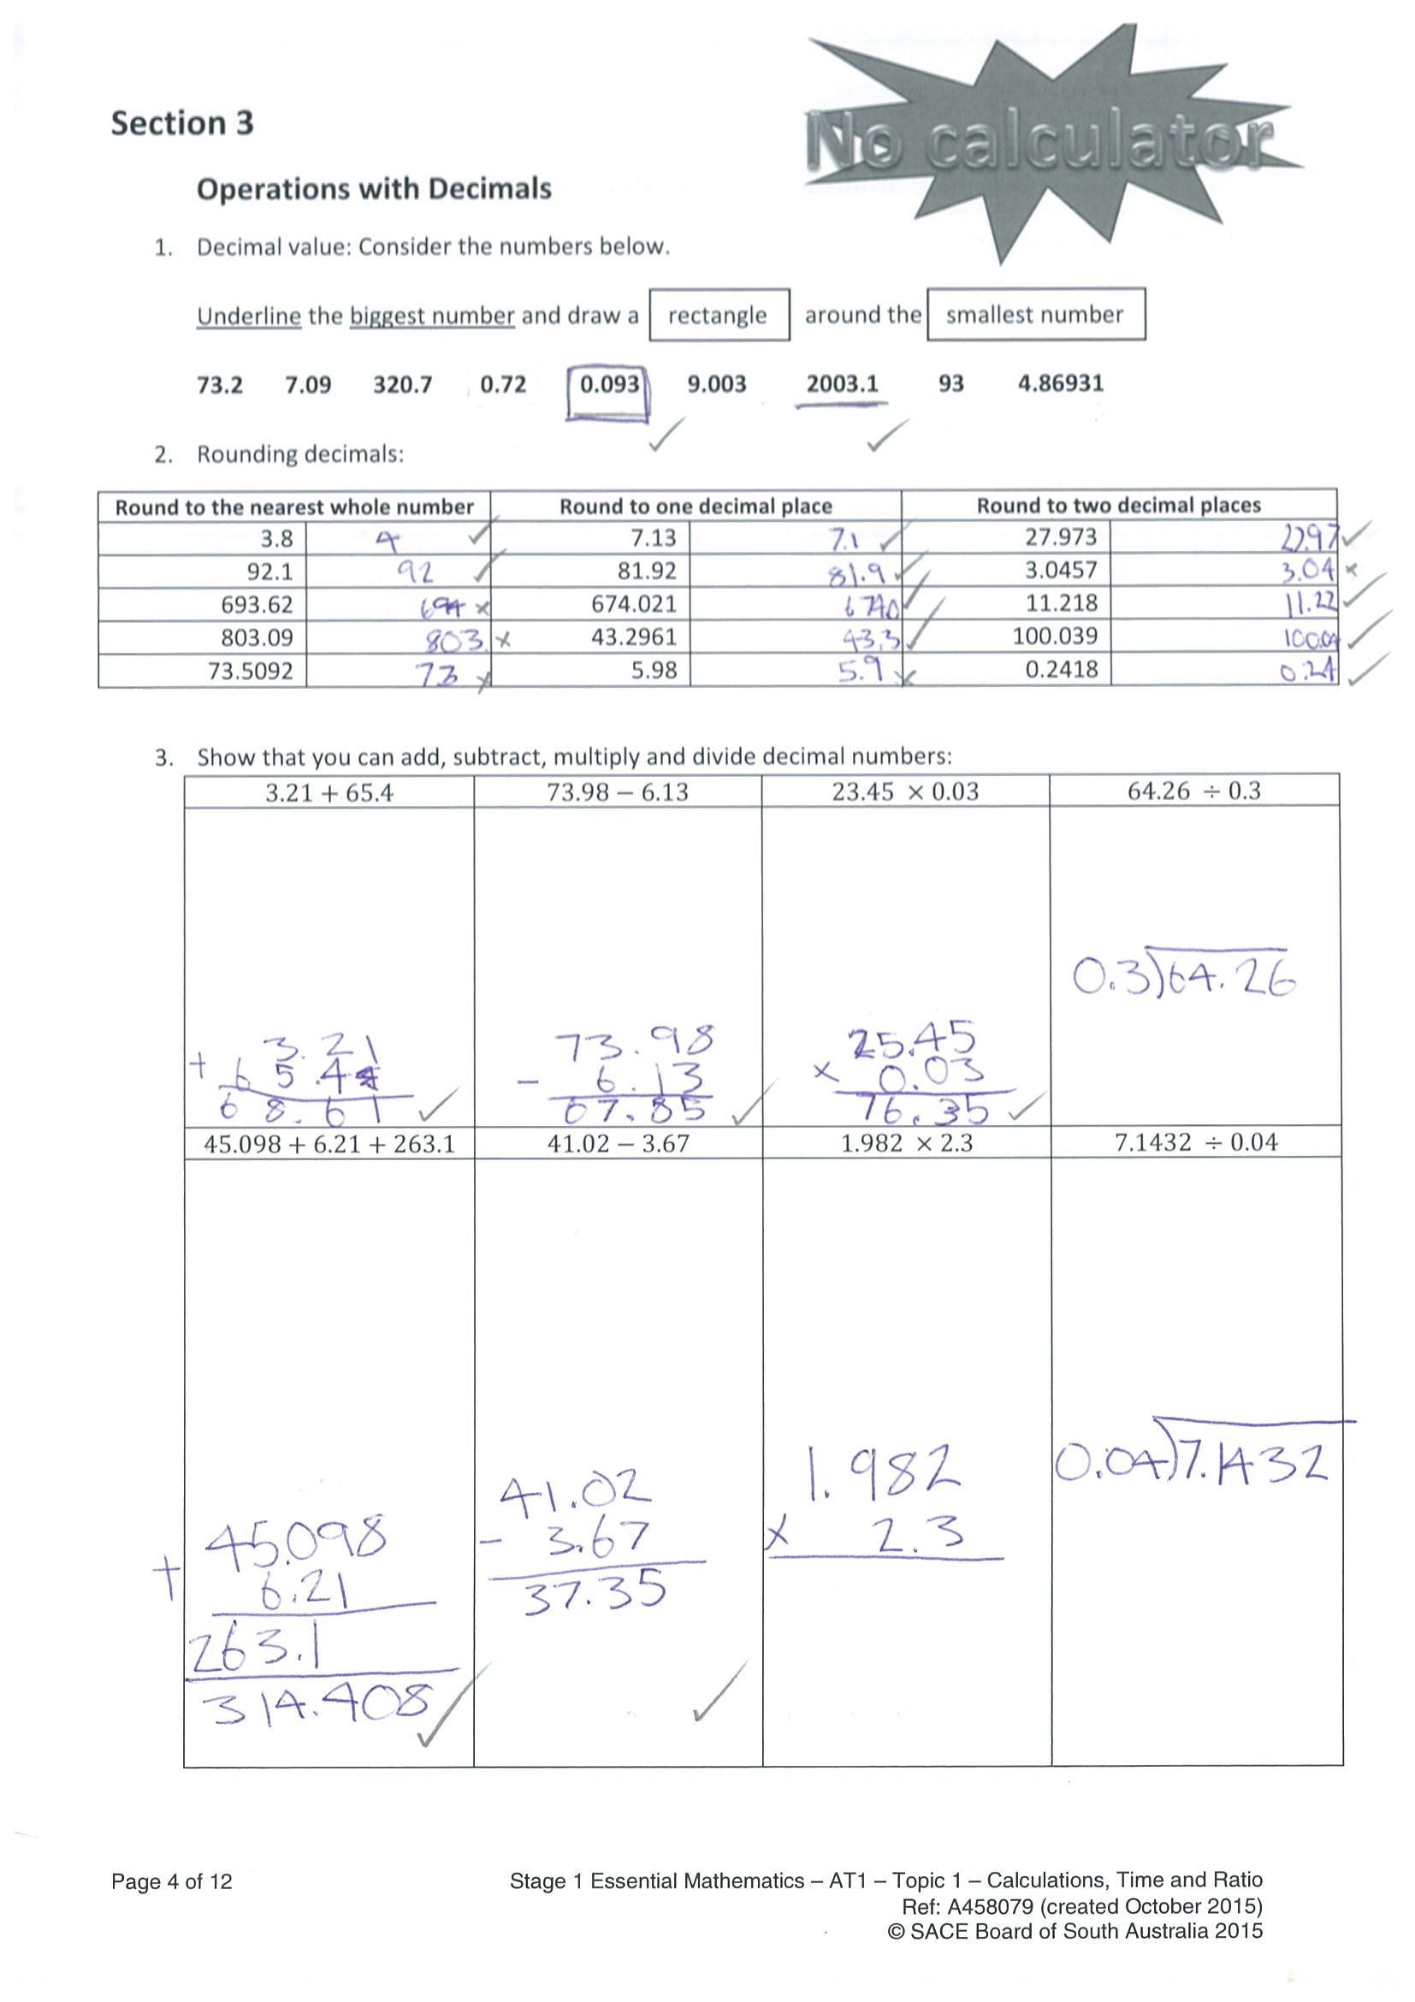
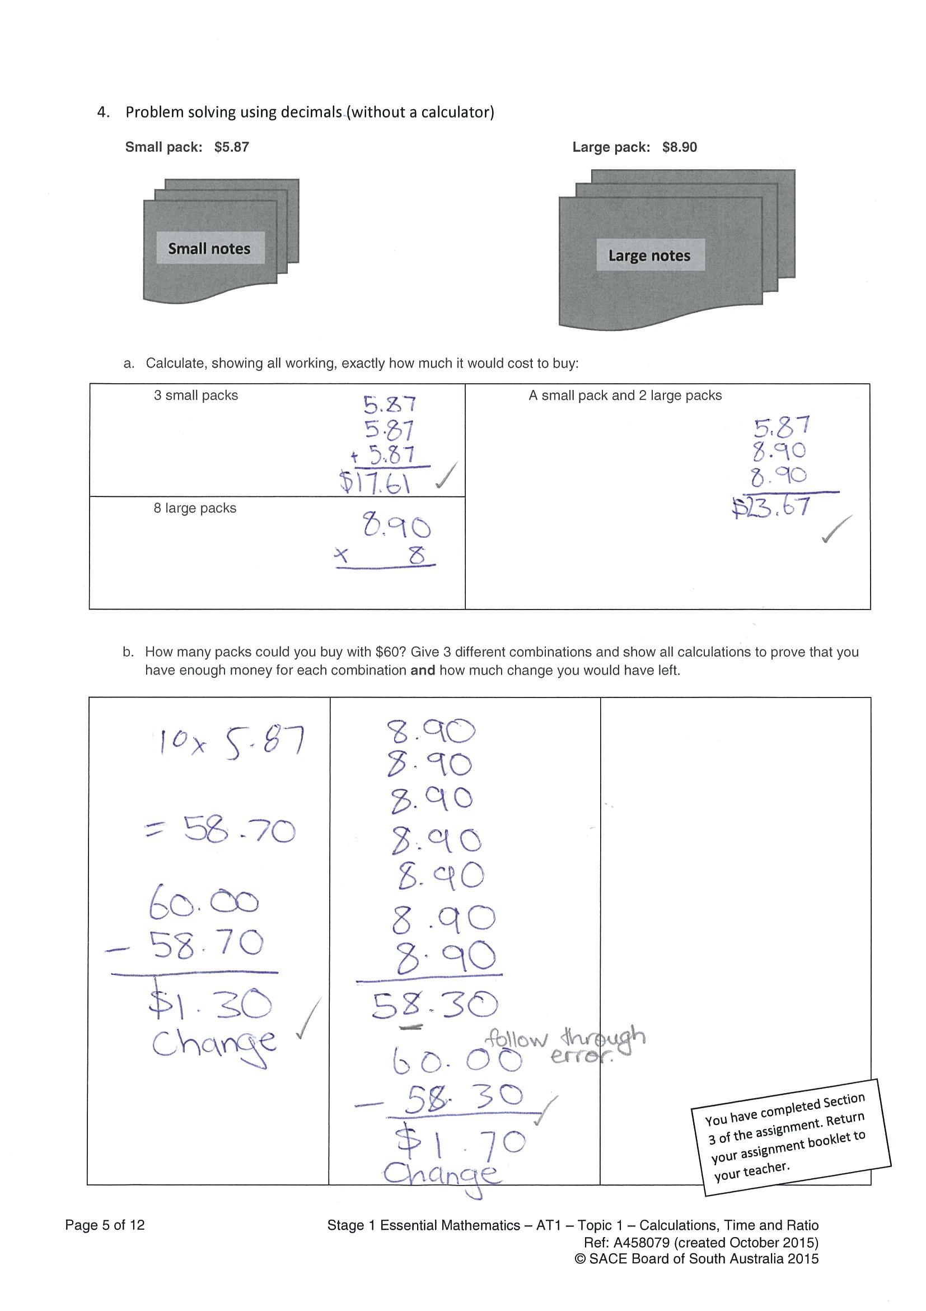
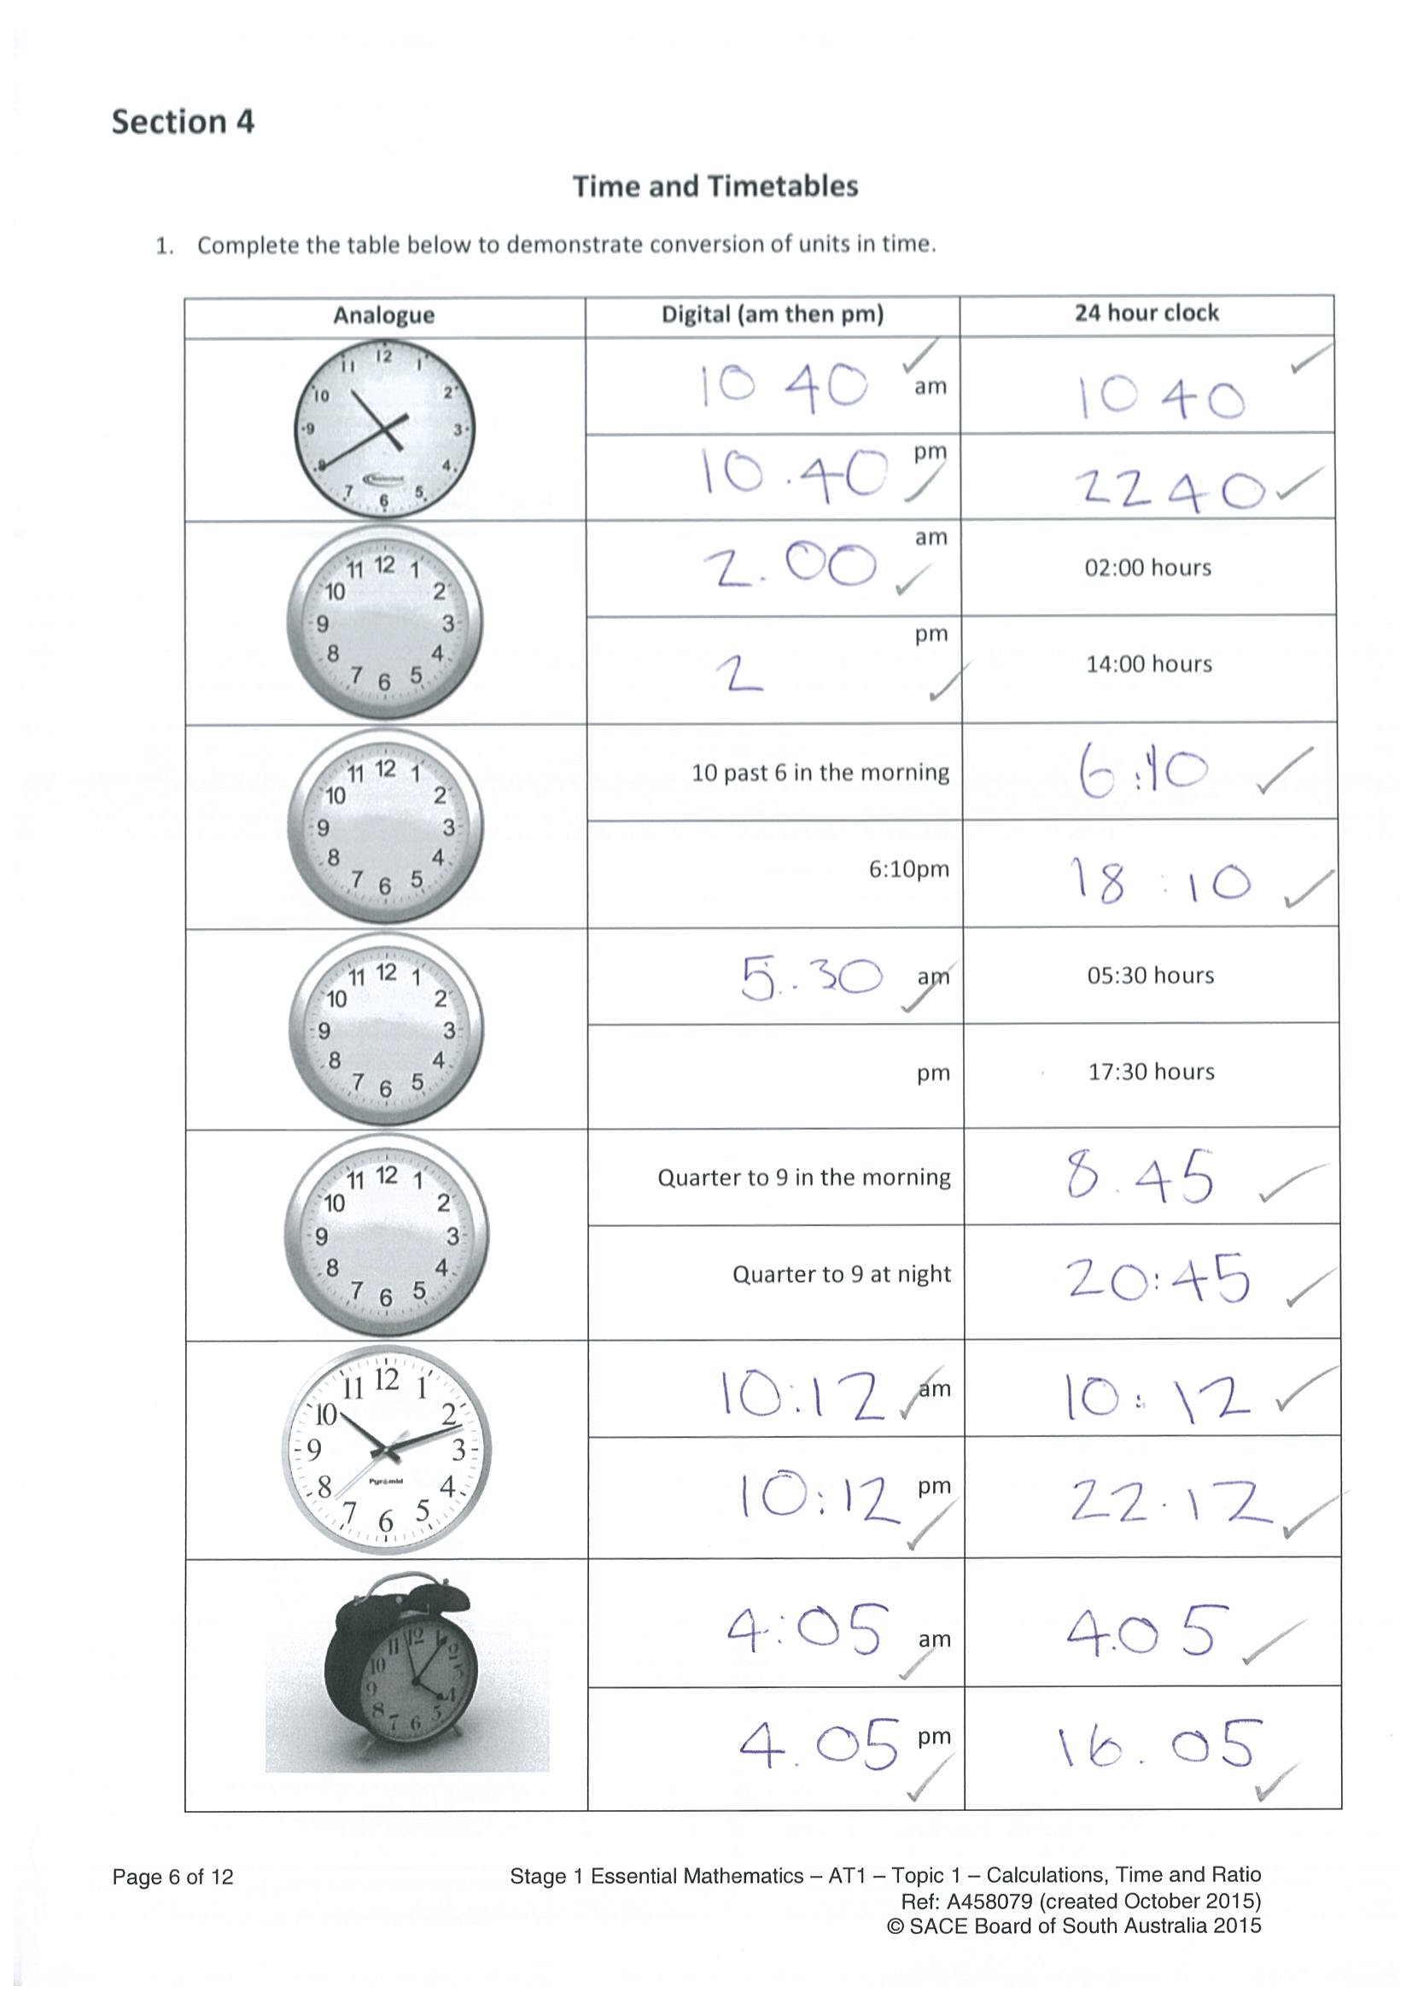

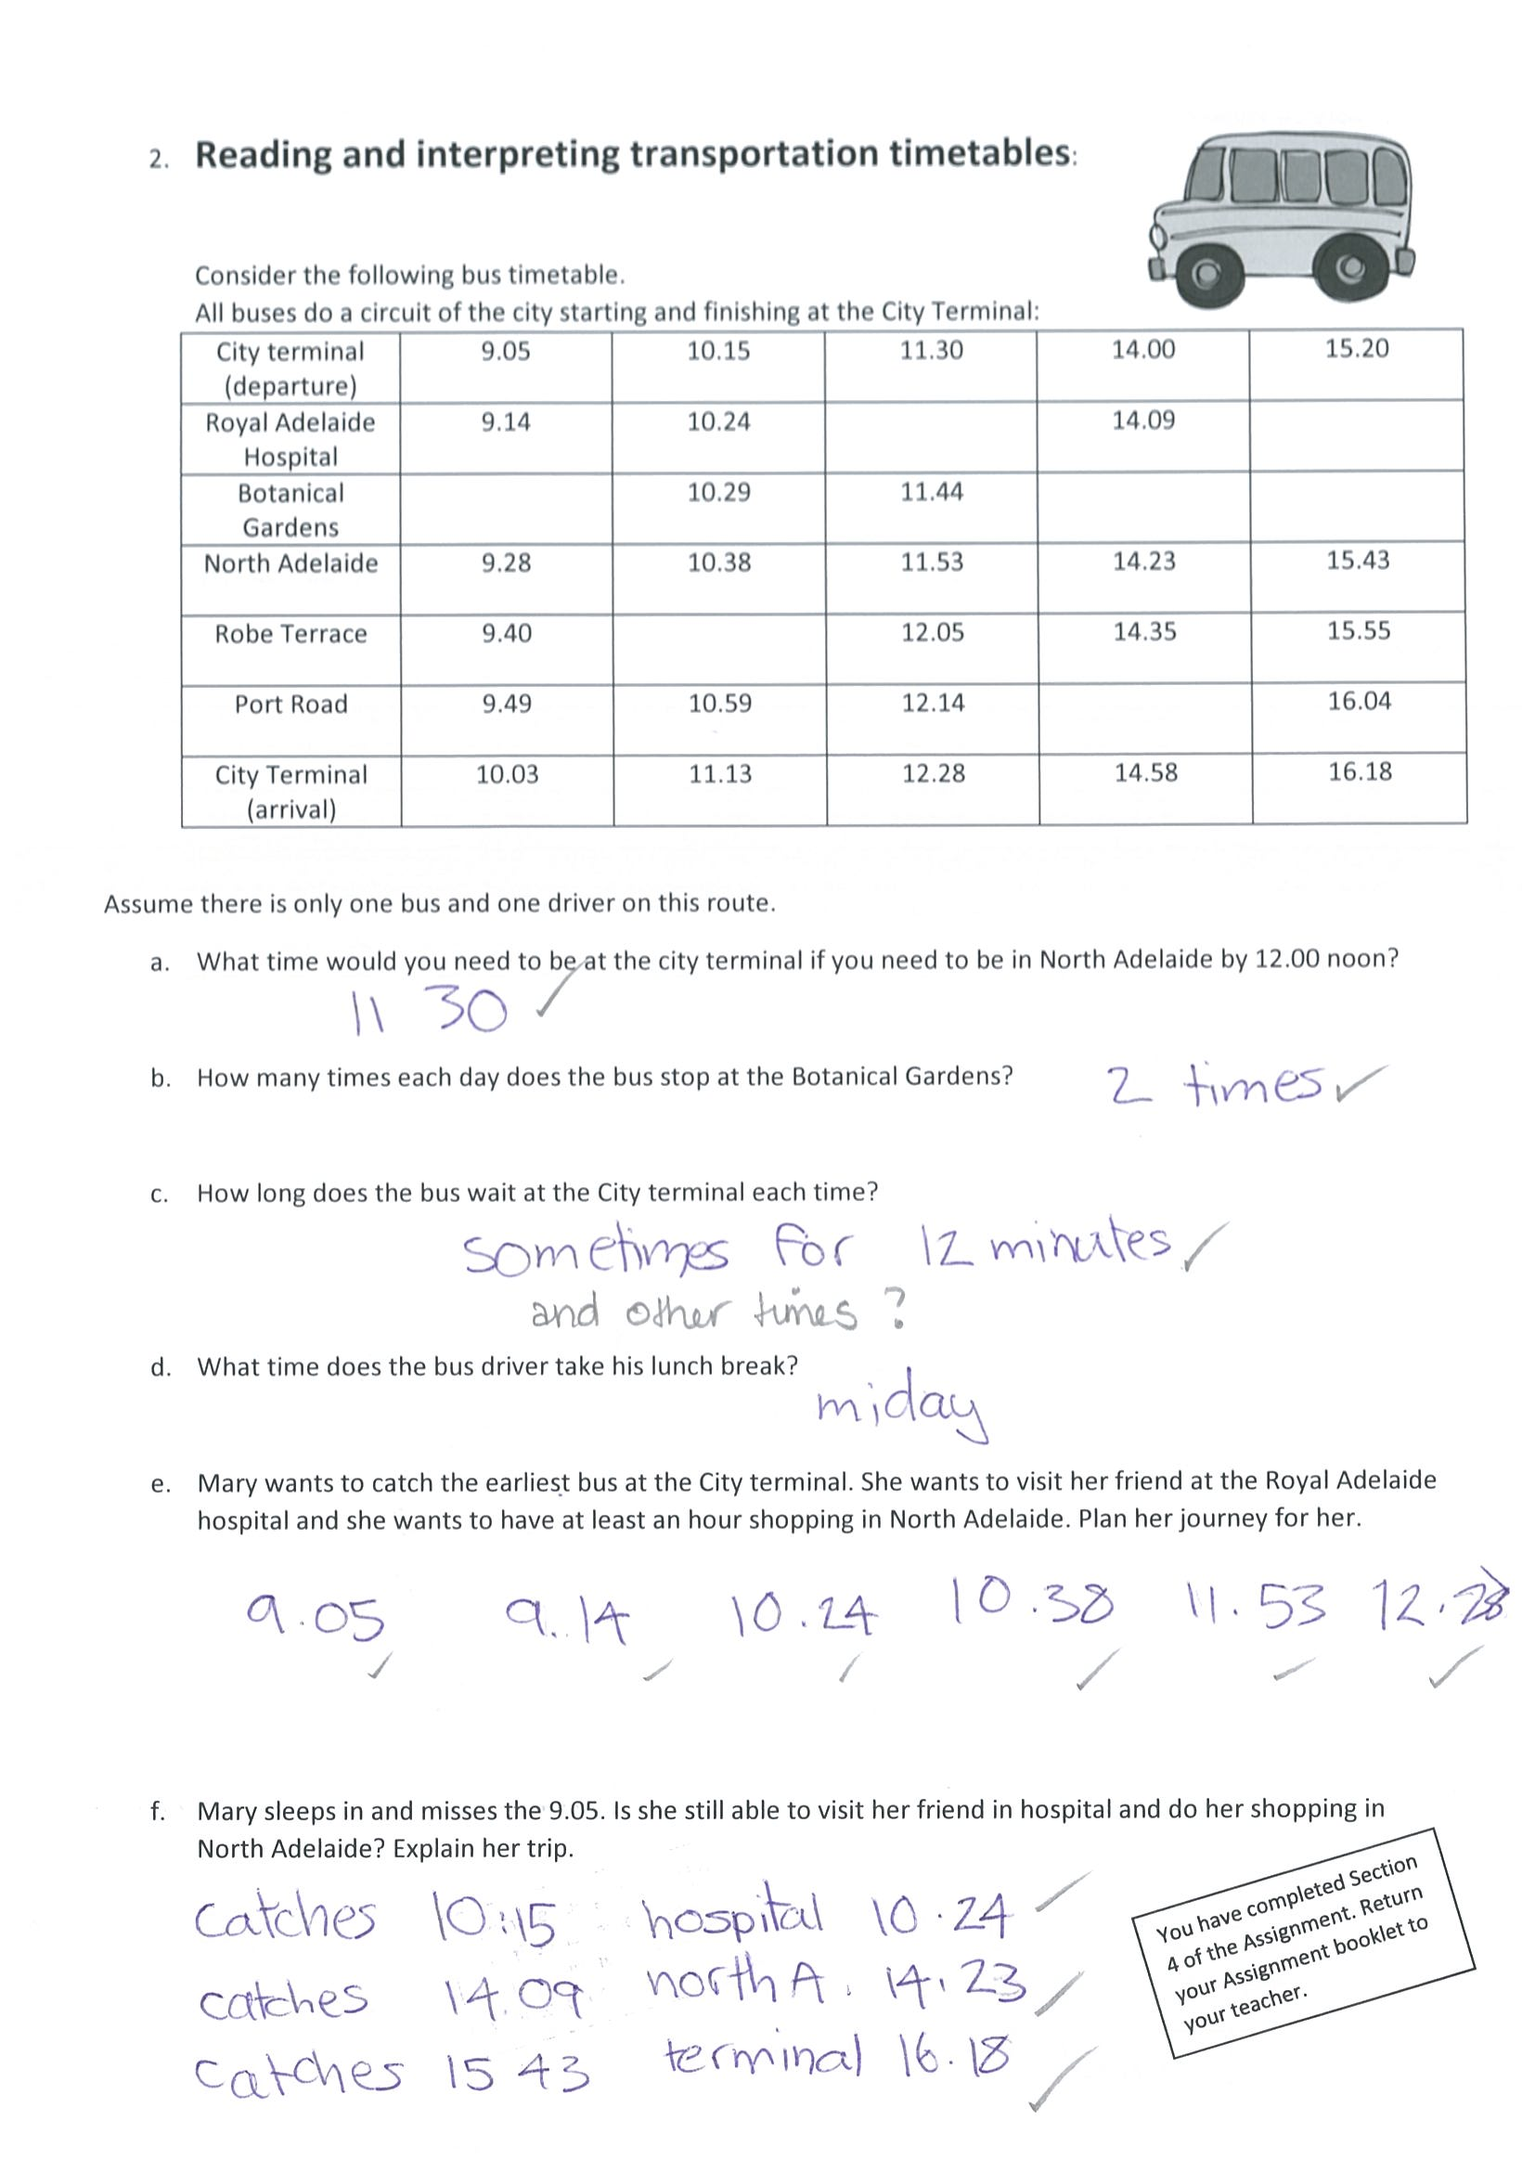

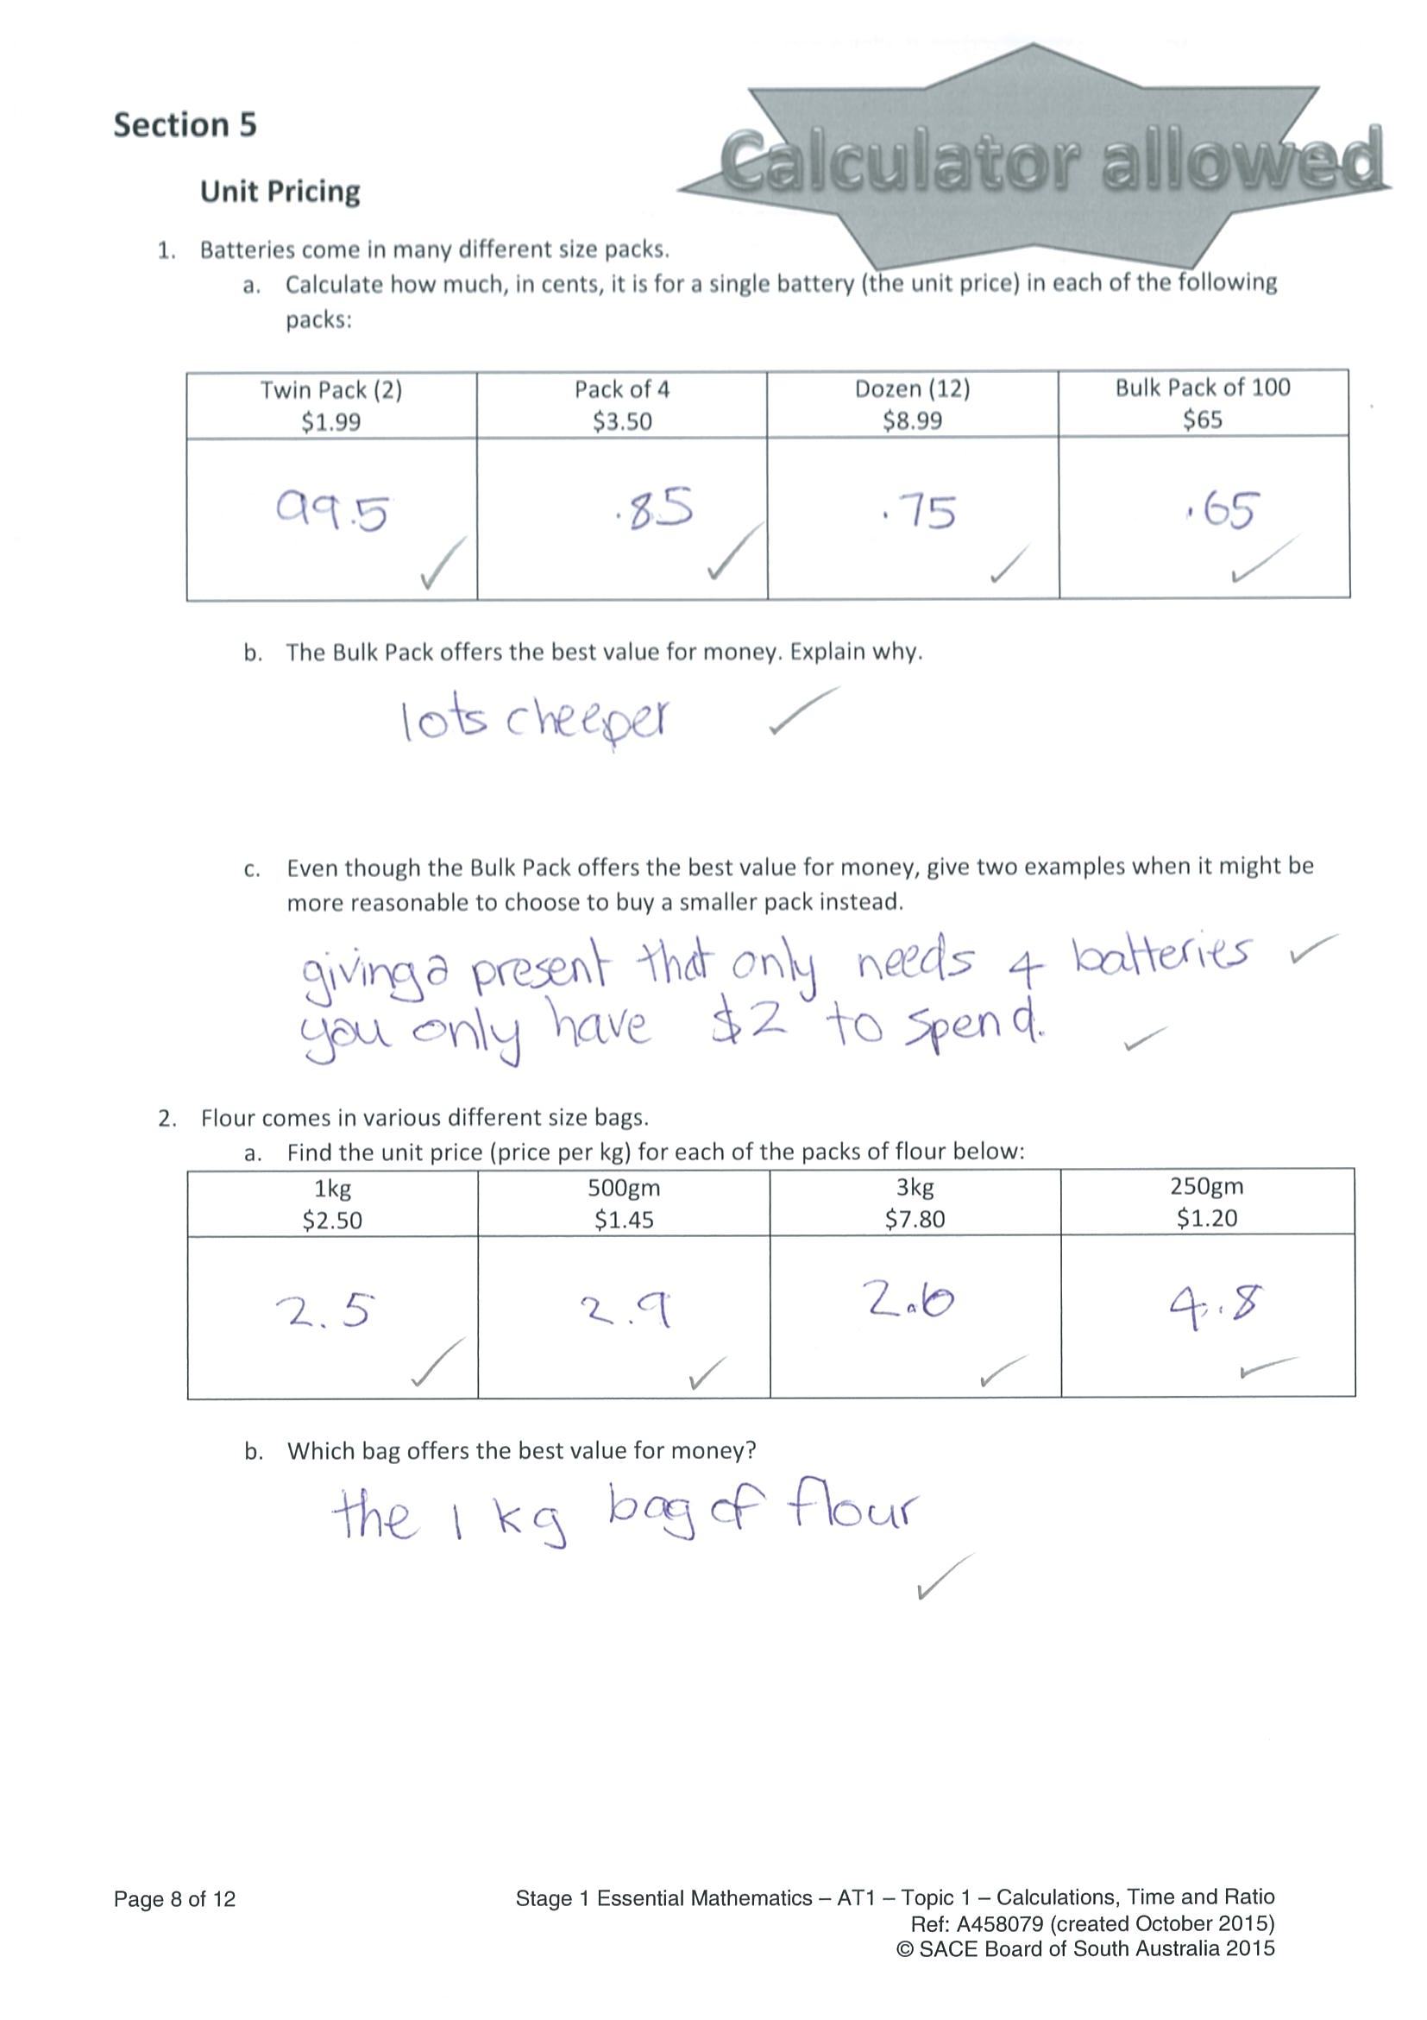
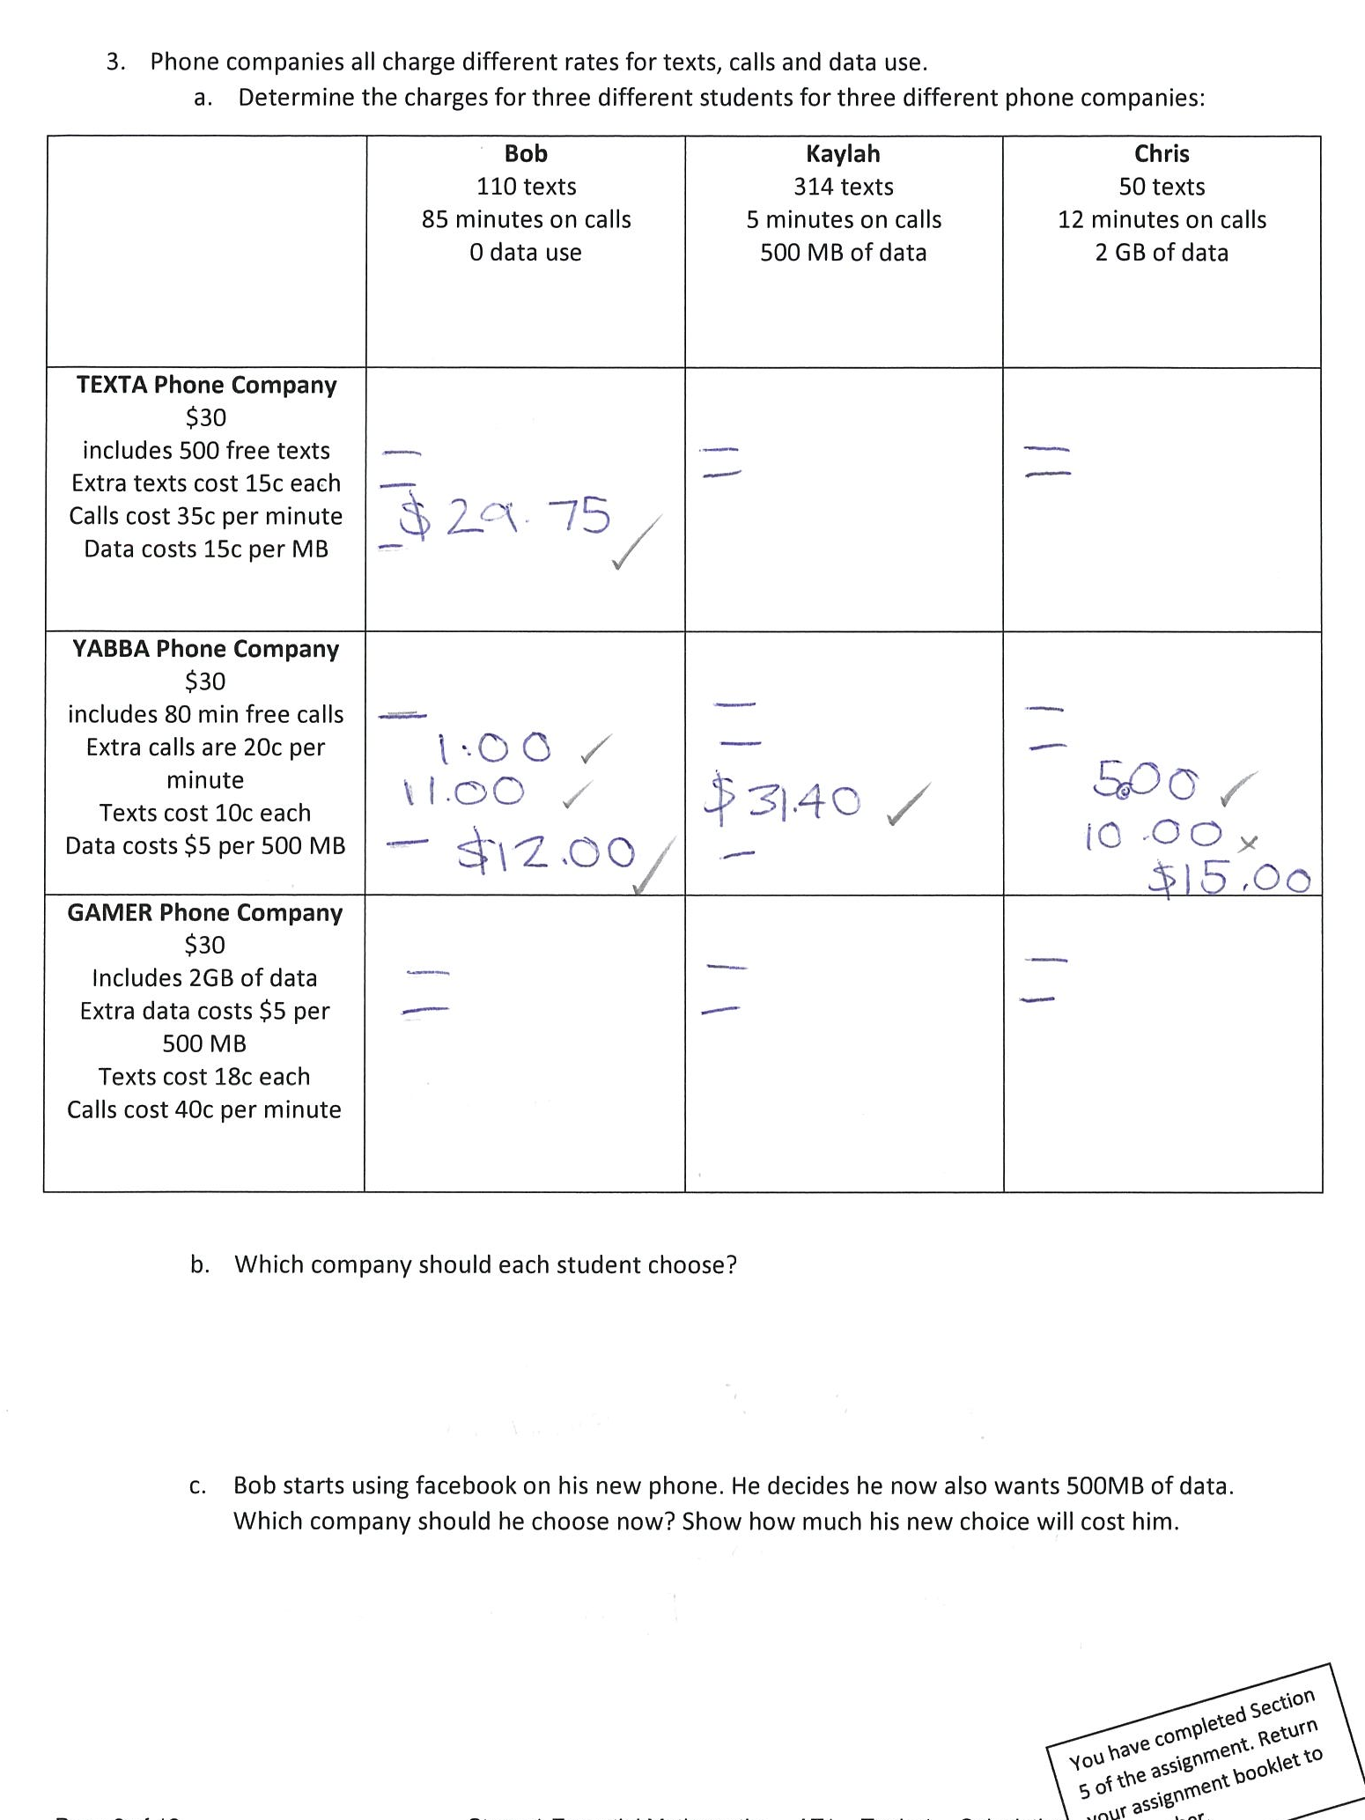
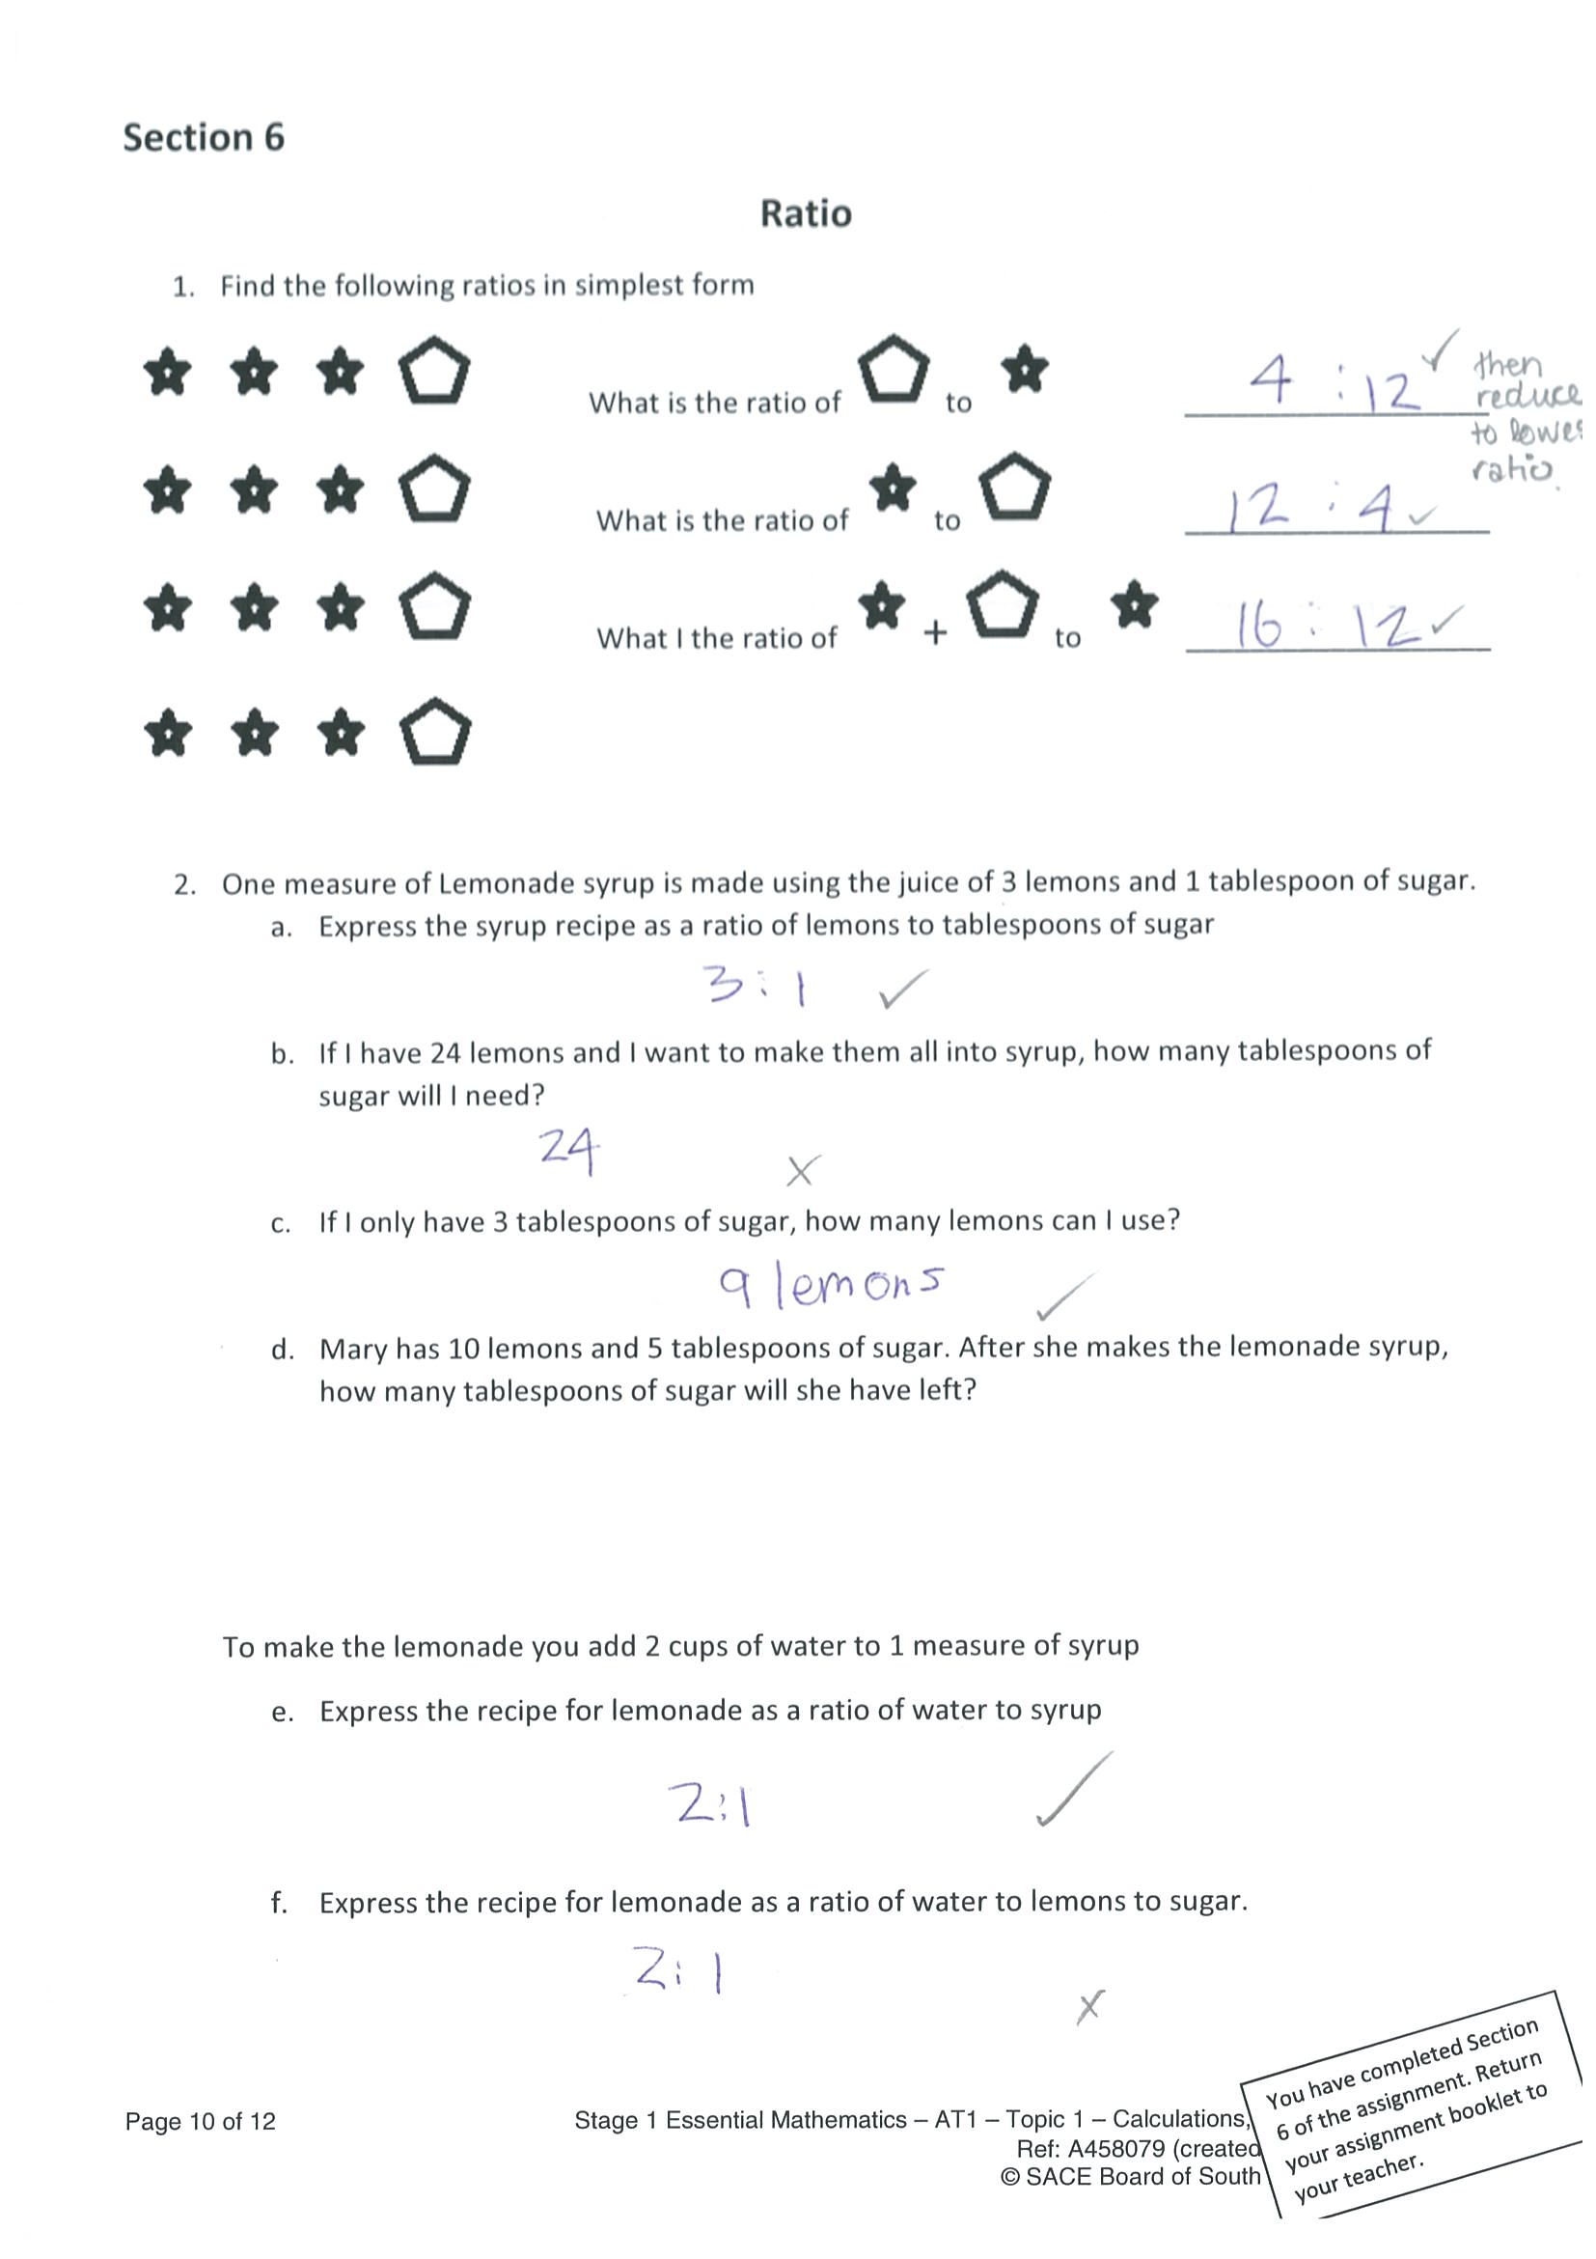

- | Concepts and Techniques | Reasoning and Communication
C | Knowledge and understanding of simple mathematical information and concepts in familiar contexts.  Application of some mathematical skills and techniques to find solutions to routine problems in familiar contexts.  Gathering, representation, and interpretation of data in familiar contexts.  Generally appropriate and some effective use of electronic technology to find solutions to routine problems. | Generally accurate interpretation of mathematical results in familiar contexts.  Appropriate use of mathematical reasoning to draw conclusions and consider the appropriateness of solutions to routine problems.  Generally appropriate use of familiar mathematical notation, representations, and terminology.  Appropriate communication of mathematical ideas and information.

Benchmark decision = C

Assessment Type 1: Skills and Application Tasks

Concepts and Techniques
CT1 @ C the student has provided evidence of knowledge and understanding of simple mathematical information and concepts in familiar contexts e.g. Topic 2 Rounding, Estimating and Checking with a Calculator and Topic 4 Times and Timetables part 1. Other examples can be found in Topic 5 Unit Pricing, questions 1 and 2.
CT2 @ C the student applied some mathematical skills and techniques to find solutions to routine problems in familiar contexts. While Topic 1 Basic Number Operations evidence in the D grade, the overall assessment of a C grade was confirmed in Topic 2 Rounding, Estimating and Checking with a Calculator together with responses to Topic 4, Times and Timetables converting digital and 24-hour formats.

Reasoning and Communication
RC1 @ C evidence of generally accurate interpretation of mathematical results in familiar contexts can be located in Topic 2 - Rounding, Estimating and Checking with a Calculator in questions 5 and 6, and again in Topic 4 Time and Timetables question 2, Reading and Interpreting Transportation timetables.
RC3 @ C an overall C grade assessment decision as student responses to question 2 Topic 4, Times and Timetables, provide evidence of notation, representations, and terminology as do the responses provided in Topic 5.

