The Weimar Government – Sources Analysis
Sources

The Weimar Republic was established in 1919 upon Germany’s surrender in WWI and subsequent signing of the Treaty of Versailles. The Republic would end when Hitler became Führer of Germany in 1934. The sources below are related to the Weimar Republic prior to Nazi control.

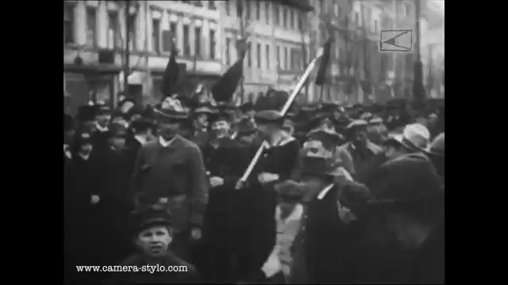
Source 1: Weimar Germany in the 1920s - Social unrest, riots and uprisings show the other side of the "Golden Twenties" in Berlin. Compilation of clips from 1918-1933. (Note: no narration, music only)

Source: Weimar Germany in the 1920s (online) LA CAMERA STYLO Film Collection 2017 [YouTube] https://www.youtube.com/watch?v=GkiPHthjp2c Accessed 12/2/21

Source 2: An historian’s account of the benefits of the Weimar constitution.

The Weimar Republic had the most explicit statement of civil rights ever produced in a constitutional document. Germans were guaranteed 'equality before the law' (Article 109) and 'liberty of travel and residence' (Article 111 ). Their 'personal liberty' was 'inviolable' (Article 114), while 'the house of every German' was 'his sanctuary' (Article 115). In addi­tion, each individual had 'the right ... to express his opinion freely by word, in writing, in print, in picture form, or in any other way' (Article 118): indeed, censorship was 'forbidden' (Article 142).1 On the other hand, these articles were diluted by provisions that permitted 'excep­tions ... by authority of law'. The effect of the guarantees was nullified whenever Article 48 came into use. Social and intellectual freedoms could therefore be interpreted politically - a fundamental contradiction with dangerous implications.

Source: Lee, Stephen J (2010) The Weimar Republic: Questions and Analysis in History. Routledge. New York. Pg. 135-6.
Source 3: The German artist George Grosz recalls life in Berlin during the Golden Age of Weimar (1924-29) in his autobiography, written in 1946.

“The capital of our new German Republic was like a bubbling cauldron. You could not see who was heating the cauldron; but you could merely see it merrily bubbling, and you could feel the heat increasing. There were speakers on every street corner and songs of hatred everywhere. Everybody was hated: the Jews, the capitalists, the gentry, the communists, the military, the landlords, the workers, the unemployed, the Freikorps, the Allied control commissions, the politicians, the department stores, and again the Jews. It was a real orgy of incitement, and the Republic was so weak that you hardly took notice of it. All this had to end with an awful crash. It was a completely negative world, with gaily coloured froth on top that many people mistook for the true, the happy Germany before the eruption of the new barbarism. Foreigners who visited us at that time were easily fooled by the apparent light-hearted, whirring fun on the surface, by the nightlife and the so-called freedom and flowering of the arts. But that was really nothing more than froth. Right under that short-lived, lively surface of the shimmering swamp were fratricide and general discord, and regiments were being formed for the final reckoning. Germany seemed to be splitting into two parts that hated each other, as in the saga of the Nibelungs [an epic poem in Middle High German dating back to the 500CE]. And we knew all that; or at least we had forebodings.”

Source: Weimar Republic Documents. [online] Alpha History (2018): http://alphahistory.com/weimarrepublic/grosz-golden-age-of-weimar-1946/. Accessed 25/2/18
Source 4: An historian’s account of the threats to the Republic

…there had also been a series of political threats. These came from both ends of the political spectrum, the far left and the radical right. In January 1919, the Spartacists, recently reformed as the KPD, tried to seize power in Berlin. At the same time there was a communist coup in Bavaria which resulted momentarily in a Soviet Republic. In 1920 and 1921 there were further disturbances in the Ruhr, Saxony and Thuringia. The activities of the far right were even more threatening. Fringe groups organised and carried out the assassination of two prominent politicians, Erzberger and Rathenau and attempted to kill ex-Chancellor Sheidemann. In 1920 Wolfang Kapp and General Lüttwitz tried to take over Berlin and overthrow the Republic. The government withdrew to Stuttgart and a general strike paralysed the essential services so that Kapp had to give up the attempt. In 1923 Hitler tried to seize control in Munich, intending to take advantage of the financial crisis of the Republic and march on Berlin. This was put down by the Bavarian authorities.

Source: Lee, Stephen J (2010) The Weimar Republic: Questions and Analysis in History. Routledge. New York. Pg. 73.

Source 5: Metropolis (1928), a triptych depicting three scenes of the nightlife of Weimar Germany. The artist, Otto Dix was a German painter and printmaker, noted for his ruthless and harshly realistic depictions of Weimar society and the brutality of war.

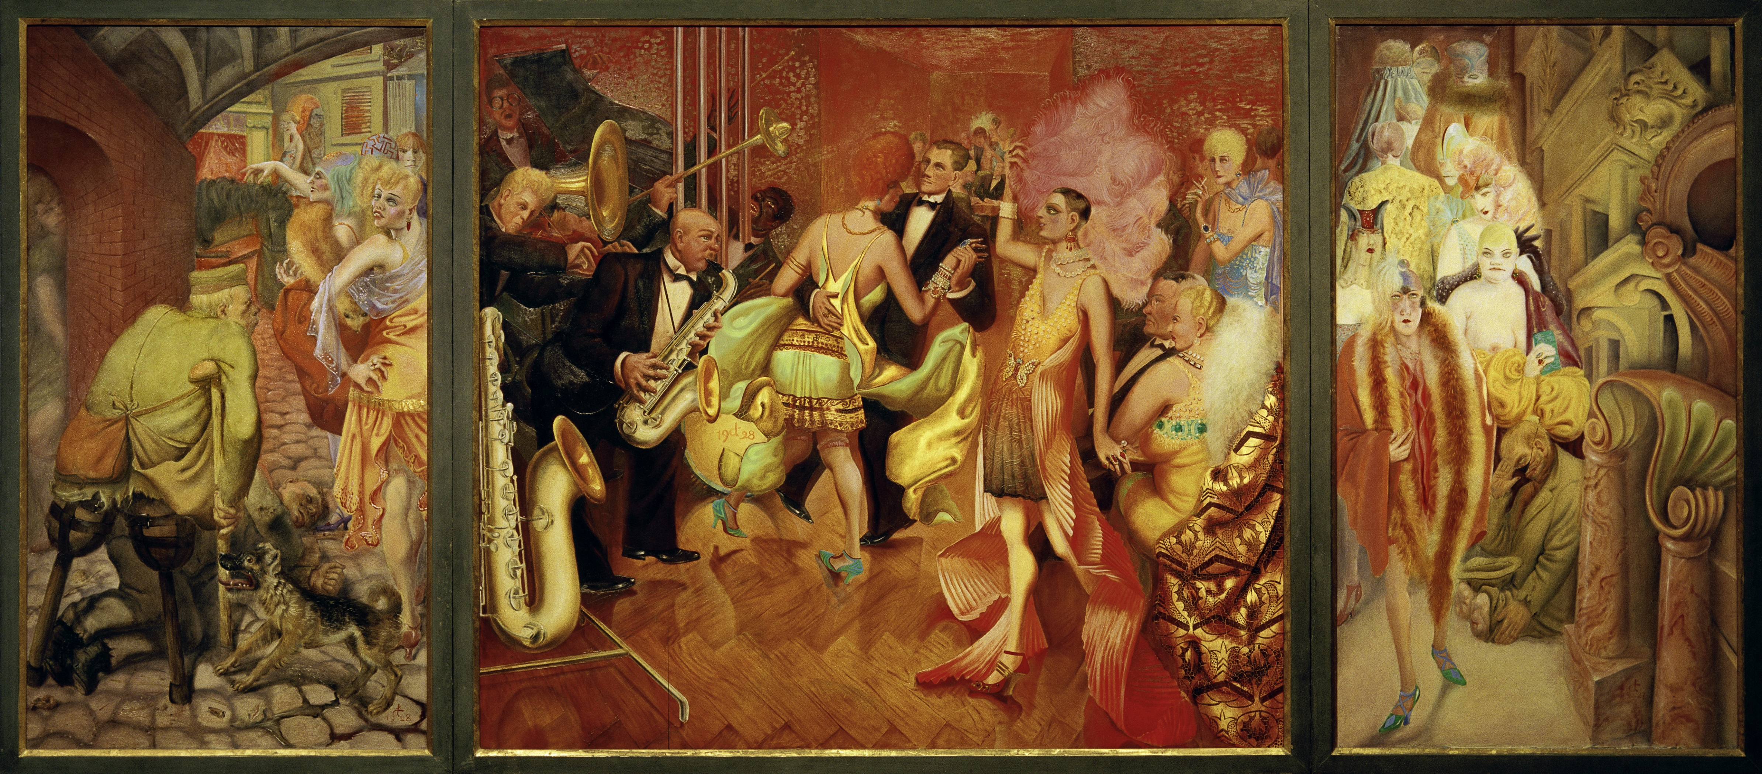

Source: Dix, Otto. Metropolis (1928). Großstadt (Metropolis),1927-1928. [online] Artsty: https://www.artsy.net/artwork/otto-dix-grossstadt-metropolis. Accessed 21/2/18

Source 6: An historian’s assessment of the importance of economic issues within Weimar Germany

Germany emerged from World War I with huge debts incurred to finance a costly war for almost five years. The treasury was empty, the currency was losing value, and Germany needed to pay its war debts and the huge reparations bill imposed on it by the Treaty of Versailles, which officially ended the war. The treaty also deprived Germany of territory, natural resources, and even ships, trains, and factory equipment. Her population was undernourished and contained many impoverished widows, orphans, and disabled veterans. The new German government struggled to deal with these crises, which had produced a serious hyperinflation. By 1924, after years of crisis management and attempts at tax and finance reform, the economy was stabilised with the help of foreign, particularly American, loans. A period of relative prosperity prevailed from 1924 to 1929. This relative "golden age" was reflected in the strong support for moderate pro-Weimar political parties in the 1928 elections. However, economic disaster struck with the onset of the world depression in 1929. The American stock market crash and bank failures led to a recall of American loans to Germany. This development added to Germany's economic hardship. Mass unemployment and suffering followed. Many Germans became increasingly disillusioned with the Weimar Republic and began to turn toward radical anti-democratic parties whose representatives promised to relieve their economic hardships.

Source: 1929: A Turning Point During the Weimar Republic (2017). Facing History and Ourselves [online] https://www.facinghistory.org/weimar-republic-fragility-democracy/readings/1929-turning-point. Accessed 22/2/18

