Stage 2 Essential Mathematics: Business Applications
Skills and Applications Task (calculator allowed)

Name ___________________________

- A small business is considering two building options.
Building A is available for lease. It has 750 square meters and costs $436 per week

- Calculate the cost of building A per month

[2 marks]
- Calculate the cost of Building A per square meter per month

[1 mark]
Building B costs $2.80 per square meter per month.
- If Building B costs $2016 per month to lease, determine the size of Building B

[2 marks]
Building B costs more per square meter than Building A
- State two reasons why someone might choose to lease Building B instead of Building A

[2 marks]
- A group of students have decided to sell lunch bags for a fundraising project. Each lunch bag will be made up of: a brown paper bag (costing $0.08 each), a banana (costing $0.50 each), yoghurt costing ($2.40 each) and a muffin (costing $1.95 each). The students are renting a venue which costs $35 and the advertising is estimated to cost $15. The students plan to sell each bag for $6.50.

- Calculate the total variable costs for a single lunch bag.

[1 mark]

- Calculate the total fixed costs.

[1 mark]

- Use this information to complete the table below.
Number Sold | 0 | 20 | 40

Fixed Costs

Variable Costs

Total Costs
Income
[3 marks]

- Draw and label the graphs of Income and Total Costs below.

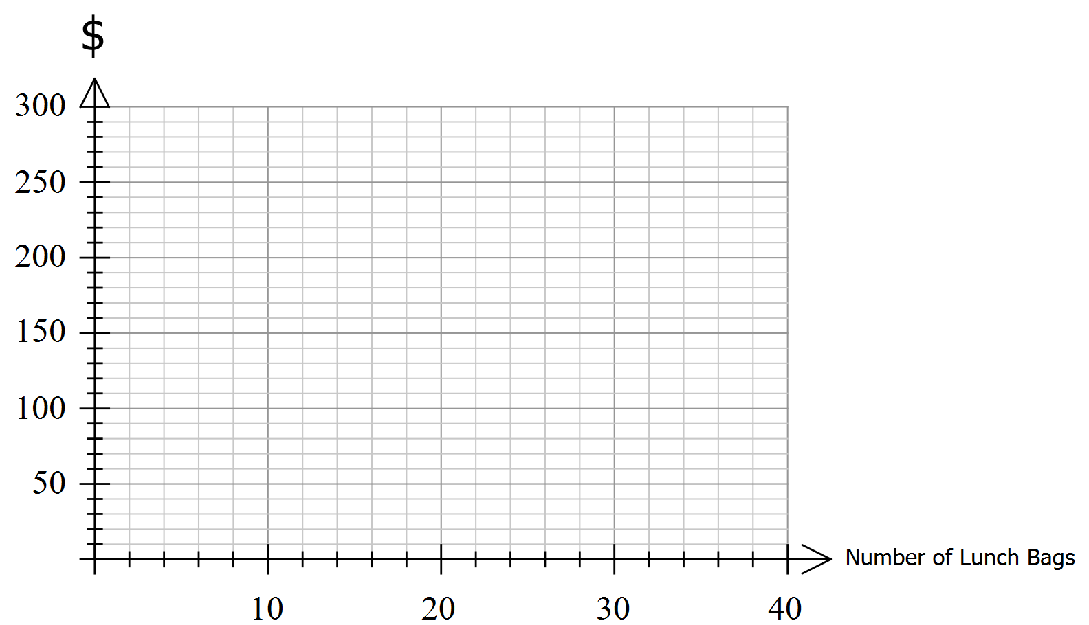

[2 marks]

- Use the graph to estimate approximately how many bags need to be made and sold to break even.

[1 mark]

- Use the graph to estimate what sales income is needed to break even.
[1 mark]

- Calculate the marginal income per item

[1 mark]

- Use the marginal income per item method to calculate the exact number of Lunch Bags needed to break
even. Show all working.

[2 marks]

- Calculate the profit if 60 lunch bags were made and sold.

[3 marks]

- A landscaper purchases a new wheelbarrow for $460 on March 1st. She is offered the following settlement discount terms: 12/7, 5/14, n/30. How much would the wheelbarrow cost her if she paid:
- On 10th March?

[1 mark]
- On 3rd of March?

[1 mark]
- On the 21st of March?

[1 mark]

- A Tiler purchases a new tile cutter for $240 from a local trade store in a clearance sale. He is offered 15% discount for cash and a 5 % trade discount.

Calculate the amount he pays for the new cutter, showing all working.

[2 marks]

- The accounts for the last twelve months of the Best Bakery are shown below:
Sales $925 000 Opening Stock (1.07.18) $ 2 000
Depreciation of equipment $ 4 800 Closing Stock (30.06.19) $ 3 900
Salaries $ 269 000 Purchases $ 154 000
Insurance Premiums $ 2 500 Advertising $ 3 500 Stationery $ 1 750 Cleaning $ 5 400 Rent $ 28 500 Electricity $ 6 480 Internet $ 850

- Calculate the Cost of Goods Sold:

[2 marks]
- Use this information to prepare a Profit and Loss Statement for the year ended 30/06/2023
Best Bakery Profit and Loss Statement for year ended 30 June 23
Sales Revenue
Less - Cost of Goods Sold
Gross Profit
Less - Other Expenses
Net Profit
[4 marks]
- Suggest two changes Best Bakery might make to increase their profit.

[2 marks]

- The Best Bakery buys a new industrial oven for their business. It costs $12 500 and is expected to have a residual value of $7 000 after 4 years.

- Using the straight line method, calculate the depreciation on the oven per annum

[1 mark]

- Using the information in part (a) complete the straight line depreciation method table below.

Age | Annual Depreciation | Book Value | Cumulative Depreciation
0 | - | 12 500 | 0
1
2
3
4
[4 marks]

The Perfect Pastries Shop purchased the same industrial oven as Best Bakery above. They decide to use the Reducing Balance Depreciation method, depreciating at a rate of 25% per annum.

- Calculate the depreciation Perfect Pastries can claim in their first year

[1 mark]

- Using the information in part (c) complete the Reducing Balance Depreciation Method table below.

Age | Annual Depreciation | Book Value | Cumulative Depreciation
0 | - | 12 500 | 0
1
2
[4 marks]

- Using the data, explain which method better enables business to minimise their tax liabilities at the end of the second year.

[3 marks]

- Jan and Jim are married and run a small tuition business together. The business earns $86,400 in one year.
Current tax rates are tabled below:

Income tax rates for 2018/2019 financial year

Income | Marginal tax rate | Tax payable
$0-$18,200 | 0% | Nil
$18,201- $37,000 | 19% | 19 cents for each $1 over $18,200
$37,001-$90,000 | 32.5% | $3,572 plus 32.5 cents for each dollar over $37,000
$90,001-$180,000 | 37% | $20,797 plus 37 cents for each dollar over $90,000

- Compare the tax they would pay if they set their business up as a sole trader versus a 80%/20% partnership split.

[5 marks]

- Which method explored above should Jan and Jim choose?

[1 mark]
- | Concepts and Techniques | Reasoning and Communication
A | CT1: Comprehensive knowledge and understanding of concepts and relationships.  CT2: Highly effective selection and application of mathematical techniques and algorithms to find efficient and accurate solutions to routine and complex problems in a variety of contexts.  CT3: Successful development and application of mathematical models to find concise and accurate solutions.  CT4: Appropriate and effective use of electronic technology to find accurate solutions to routine and complex problems. | RC1: Comprehensive interpretation of mathematical results in the context of the problem.  RC2: Drawing logical conclusions from mathematical results, with a comprehensive understanding of their reasonableness and limitations.  RC3: Proficient and accurate use of appropriate mathematical notation, representations, and terminology.  RC4: Highly effective communication of mathematical ideas and reasoning to develop logical and concise arguments.  RC5: Formation and testing of appropriate predictions, using sound mathematical evidence.
B | Some depth of knowledge and understanding of concepts and relationships.  Mostly effective selection and application of mathematical techniques and algorithms to find mostly accurate solutions to routine and some complex problems in a variety of contexts.  Attempted development and successful application of mathematical models to find mostly accurate solutions.  Mostly appropriate and effective use of electronic technology to find mostly accurate solutions to routine and some complex problems. | Mostly appropriate interpretation of mathematical results in the context of the problem.  Drawing mostly logical conclusions from mathematical results, with some depth of understanding of their reasonableness and limitations.  Mostly accurate use of appropriate mathematical notation, representations, and terminology.  Mostly effective communication of mathematical ideas and reasoning to develop mostly logical arguments.  Formation and testing of mostly appropriate predictions, using some mathematical evidence.
C | Generally competent knowledge and understanding of concepts and relationships.  Generally effective selection and application of mathematical techniques and algorithms to find mostly accurate solutions to routine problems in different contexts.  Application of mathematical models to find generally accurate solutions.  Generally appropriate and effective use of electronic technology to find mostly accurate solutions to routine problems. | Generally appropriate interpretation of mathematical results in the context of the problem.  Drawing some logical conclusions from mathematical results, with some understanding of their reasonableness and limitations.  Generally appropriate use of mathematical notation, representations, and terminology, with reasonable accuracy.  Generally effective communication of mathematical ideas and reasoning to develop some logical arguments.  Formation of an appropriate prediction and some attempt to test it using mathematical evidence.
D | Basic knowledge and some understanding of concepts and relationships.  Some selection and application of mathematical techniques and algorithms to find some accurate solutions to routine problems in some contexts.  Some application of mathematical models to find some accurate or partially accurate solutions.  Some appropriate use of electronic technology to find some accurate solutions to routine problems. | Some interpretation of mathematical results.  Drawing some conclusions from mathematical results, with some awareness of their reasonableness.  Some appropriate use of mathematical notation, representations, and terminology, with some accuracy.  Some communication of mathematical ideas, with attempted reasoning and/or arguments.  Attempted formation of a prediction with limited attempt to test it using mathematical evidence.
E | Limited knowledge or understanding of concepts and relationships.  Attempted selection and limited application of mathematical techniques or algorithms, with limited accuracy in solving routine problems.  Attempted application of mathematical models, with limited accuracy.  Attempted use of electronic technology, with limited accuracy in solving routine problems. | Limited interpretation of mathematical results.  Limited understanding of the meaning of mathematical results, their reasonableness or limitations.  Limited use of appropriate mathematical notation, representations, or terminology, with limited accuracy.  Attempted communication of mathematical ideas, with limited reasoning.  Limited attempt to form or test a prediction.

