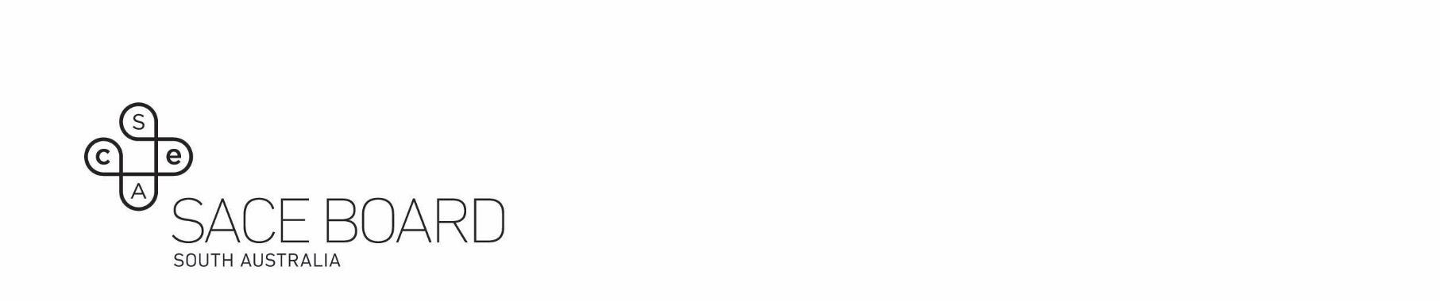
Aboriginal Cultural Knowledge and Learning

Student-led learning — Criteria and indicator checklist Stage 2
Assessment | Assessment conditions
Evidence of learning may include but is not limited to:  - an interview/verbal plus any other relevant/practical demonstration  - demonstrating skill/knowledge in action  - a product or artifact of learning  - a letter of support  - photos/videos  - teacher meeting notes  Discussion based interviews  - single interview/presentation  - multiple discussions/check ins | - Option for a support person to attend the interview with the student (family, community member, Elder, teacher etc.)  - Assessor to clarify with student and any community members that culturally significant information does not need to be shared within the assessment process.

Student name: | SACE reg no: | SACE credits awarded (10 or 20)
* Please attach the Record of Evidence note sheet with any supporting evidence provided (if applicable).

☐ I confirm that the evidence described below is an accurate record of the evidence provided.
☐ I confirm that the evidence described is equivalent to a 60-hour SACE Stage 2 course

Assessor name and signature |  | Date
Second assessor/advocate name and signature (optional) |  | Date

Stage 2 10 or 20-credit learning criteria indicator checklist
Learning criteria | Number of indictors required | Indicator | Indicator Achieved
Knowing  Knowledge and Understanding | Students must show evidence of learning in three (3) of these seven (7 indicators for a 10-credit subject and five (5) of these 7 indicators for a 20-credit subject | Demonstrates deep understanding of cultural knowledge/skills/practice
 |  | Reflects on the impact of the relevant individuals, groups and communities’ impact on cultural knowledge and learning
 |  | Compares and contrasts the diverse perspectives within and between Aboriginal and non-Aboriginal communities in Australia, highlighting the richness of their cultural contexts.
 |  | Demonstrates a significant understanding of the (ongoing) impact of historical events for Aboriginal people and/or communities
 |  | Demonstrates knowledge and relevance of current affairs and current and emerging themes relevant to Aboriginal people
 |  | Demonstrates understanding of the application of cultural knowledge, skills and/or practices in different contexts
 |  | Evaluates the process of development of cultural knowledge and learning using a range of evidence to support understanding (as appropriate)
Doing  Impact and contribution | Students must show evidence of learning in three (3) of these six (6) indicators for a 10-credit subject and five (5) of these 6 indicators for a 20-credit subject | Provides examples of a range of meaningful interactions with Aboriginal Communities (Elders, Leaders and community members)
 |  | Demonstrates ability to successfully apply knowledge and learning in a practical manner for both self and others
 |  | Develops learning/skills/practices to contribute to the wider Aboriginal community
 |  | Engages with others/communities to apply skills/knowledge and practices to contribute to cultural events/activities
 |  | Can confidently incorporate Aboriginal language of their choice to demonstrate aspects of their learning.
 |  | Confidently shares cultural learning with others
Being  Personal Meaning | This is an essential criterion and must be met for 10 or 20 credits | Reflects on the value of cultural knowledge and/or learning/activity for self and others

Record of evidence
Student name | SACE Number | SACE credits awarded (10 or 20 credits)

This form is to be used by the assessor to make notes during the student’s interview/discussions as a record of evidence presented by the student.
Please also note any artefacts etc that were shared.

Knowing
Knowledge and understanding

Doing
Impact and contribution

Being
Personal meaning

☐ I confirm that the evidence described above is an accurate record of the evidence provided.
Signature of student |  | Date
Signature of assessor |  | Date

