Stage 1 Scientific Studies:

Assessment Type 1: Inquiry Folio

Science Inquiry Skills – Scientific Data Task

The following is an online task.

In this task you will demonstrate your understanding of the representation and analysis of data.
You will gather and use data provided to formulate and justify conclusions.

- The task can be accessed online through the school intranet using this link:
Insert school link here.

- Create a new Word document and name it using the standard SACE convention:
SACE registration number-1STU10-AT1-scientific data task

- Record your responses electronically in this word document.

- Save your word document and email it to your teacher at the end of the lesson

Note: The maximum number of pages for your responses to this task is 2 A4 single-sided pages, minimum font size 10 point.

Assessment Design Criteria
Your work will be assessed against the following Performance Standards
- Investigation, Analysis, and Evaluation: IAE 3, 4
- Knowledge and Application: KA 1
Advice for teachers:
- If using this as an online task, you will need to add a link to where the task is located on your school network.
- If you are providing this task to students in hard copy form, you will need to alter the instructions.
- If you wish the students to record their responses electronically, you will need to provide the appropriate information for them to send their response to you or to store the response.
- If you wish the students to hand write their responses to the task you will need to indicate the 2 page limit for their responses is irrespective of the size of their handwriting.

Stage 1 Scientific Studies subject outline, Page 23:
For a 10-credit subject, the set of science inquiry skills tasks should be a maximum of 6 pages or the equivalent in multimodal form.
You may wish to remove this list before printing the task

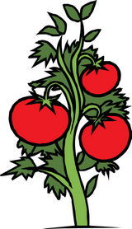
Question 1

A student is undertaking an investigation on the effects of music on the growth of plants. Two tomato plants, Plant A and Plant B, are grown in a window and each receives the same amount of water. Plant A is exposed to classical music using headphones attached to the soil. Throughout the growth period, the student counts the number of tomatoes produced by each plant.

Plant A = 35 Tomatoes

Plant B = 55 Tomatoes

- Identify the independent variable in this investigation?

- Based only on the results obtained by the student, state one conclusion that can be made from this investigation.

- Explain, with reasons, any limitations of this conclusion.

- Re-design the method of this investigation so that the results are more reliable. Give reasons for the changes you suggest.

Question 2

Go to station A.
- You will find 5 different measuring cups (A, B, C, D, E) used in the kitchen.
- As accurately as you can, in each cup, measure out 250 ml of water.
- Pour the water from the cup into a measuring cylinder.
- Record the volume of water in the measuring cylinder.

- Identify the cup that is the most accurate.

- Explain any limitations for your conclusion.

Extensive laboratory tests on another set of measuring cups have shown that when the cups are used to try to measure out 250 ml of liquid, these were following results:
- Cup P 246 ml
- Cup Q 265 ml
- Cup R 257 ml
- Cup S 244 ml
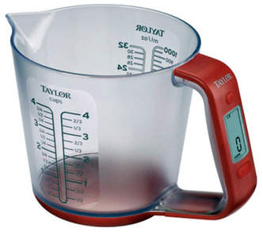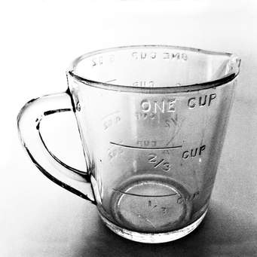

All the measuring cups have graduations marked on the side, like in the image above.

- Explain why there is such a large variation in the results when these cups are used to measure out the ‘same’ volume.

Question 3

Read the following information:

Chewing Gum Kills Bad-Breath Germs
A particular company boasted that its mints had the ability to kill bad breath-causing bacteria. Advertisements claiming that a new ingredient in the mints, a tree bark extract, could kill the microorganisms that cause bad breath while other mints in the market could only mask the smell of bad breath. In their advertisements, the company said: ‘In a survey, seven out of ten dentists agree that these mints will protect people against bad breath.’
There are several claims made in this report.
- Construct a table that summarises:
- three claims made in the report
- how the evidence to support each claim could be collected
- what the outcome would be if each of the claims was supported

Question 4

A student was undertaking an investigation to determine the effect of the number of hours of sunlight on the growth of a plant.

The student represented the results of the investigation as shown in the graph below.

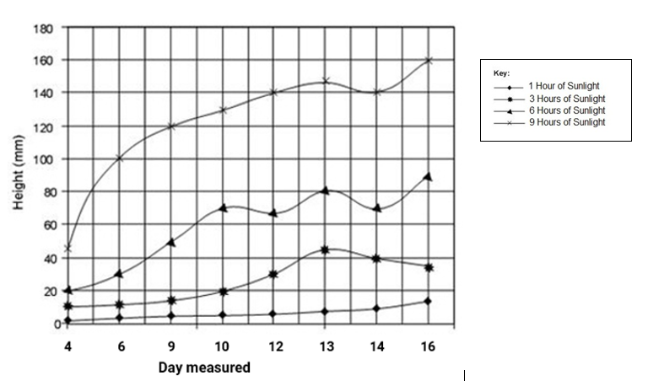

- Identify two errors in the way in which the student has represented the data.

- State one factor that might be difficult to control in this investigation. Describe how this could have affected the data obtained.

- What does the data show happened to the height of the plants between Day 13 and Day 14 for the plants receiving 6 hours of sunlight? Give a possible explanation for this result.

Performance Standards for Stage 1 Scientific Studies
- | Investigation, Analysis, and Evaluation | Knowledge and Application
A | Critically deconstructs a problem and designs a logical, coherent, and detailed scientific investigation using a scientific method and/or engineering design process.  Obtains, records, and represents data, using appropriate procedures, conventions and formats accurately and highly effectively.  Systematically analyses and interprets data and evidence to formulate logical conclusions with detailed justification.  Critically and logically evaluates procedures and their effect on data.  Critically and perceptively evaluates the effectiveness of collaboration and its impact on results/outcomes. | Demonstrates deep and broad knowledge and understanding of a range of science inquiry skills and scientific concepts.  Applies science inquiry skills and scientific concepts highly effectively in new and familiar contexts.  Critically explores and understands in depth the interaction between science and society.  Communicates knowledge and understanding of science concepts coherently, with highly effective use of appropriate terms, conventions, and representations.
B | Logically deconstructs a problem and designs a well-considered and clear scientific investigation using a scientific method and/or engineering design process.  Obtains, records, and represents data, using appropriate procedures, conventions and formats mostly accurately and effectively.  Logically analyses and interprets data and evidence to formulate suitable conclusions with reasonable justification.  Logically evaluates procedures and their effect on data.  Critically evaluates the effectiveness of collaboration and its impact on results/outcomes. | Demonstrates some depth and breadth of knowledge and understanding of a range of science inquiry skills and scientific concepts.  Applies science inquiry skills and scientific concepts mostly effectively in new and familiar contexts.  Logically explores and understands in some depth the interaction between science and society.  Communicates knowledge and understanding of science concepts with mostly coherent and effective use of appropriate terms, conventions, and representations.
C | Deconstructs a problem and designs a considered and generally clear scientific investigation using a scientific method and/or engineering design process.  Obtains, records, and represents data, using generally appropriate procedures, conventions and formats with some errors but generally accurately and effectively.  Undertakes some analysis and interpretation of data and evidence to formulate generally appropriate conclusions with some justification.  Evaluates procedures and some of their effect on data.  Evaluates the effectiveness of collaboration and its impact on results/outcomes. | Demonstrates knowledge and understanding of a general range of science inquiry skills and scientific concepts.  Applies science inquiry skills and scientific concepts generally effectively in new or familiar contexts.  Explores and understands aspects of the interaction between science and society.  Communicates knowledge and understanding of science concepts with generally effective use of appropriate terms, conventions, and representations.
D | Prepares a basic deconstruction of a problem and an outline of a scientific investigation using a scientific method and/or engineering design process.  Obtains, records, and represents data, using procedures, conventions, and formats inconsistently, with occasional accuracy and effectiveness.  Describes data and undertakes some basic interpretation to formulate a basic conclusion.  Attempts to evaluate procedures or suggest an effect on data.  Attempts to evaluate the effectiveness of collaboration and its impact on results/outcomes. | Demonstrates some basic knowledge and partial understanding of science inquiry skills and scientific concepts.  Applies some science inquiry skills and scientific concepts in familiar contexts.  Partially explores and recognises aspects of the interaction between science and society.  Communicates basic scientific information, using some appropriate terms, conventions, and/or representations.
E | Attempts a simple deconstruction of a problem and a procedure for a scientific investigation using a scientific method and/or engineering design process.  Attempts to use some procedures and record and represent some data, with limited accuracy or effectiveness.  Attempts to describe results and/or interpret data to formulate a basic conclusion.  Acknowledges that procedures affect data.  Acknowledges the effectiveness of collaboration and its impact on results/outcomes. | Demonstrates limited recognition and awareness of science inquiry skills and/or scientific concepts.  Attempts to apply science inquiry skills and/or scientific concepts in familiar contexts.  Attempts to explore and identify an aspect of the interaction between science and society.  Attempts to communicate information about science.

