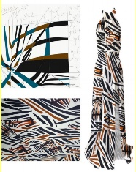

Mathematical Investigation: Print design investigation
Background Information
For the following Mathematical Investigation task, students use Mathematics creatively to design an aesthetically pleasing pattern that can be used in real life by textile industry to produce fabric prints.
This activity is not covered in class creating a greater challenge for students, as one must utilize appropriately, concepts covered in calculus, including differentiation and integration techniques of various functions studied in our course, then apply their independent learning to completing the task.
Note: Use of Desmos, GeoGebra or any other maths software programs, including the graphic calculator, is indicated as an exploration tool in order to develop deeper and more meaningful connections between each question, sections of the investigation and consequently the entire Mathematical Investigation.

Mathematical Investigation Task must include:

- An introduction that demonstrates an understanding of the features of the problem or situation being investigated.
- Appropriate presentation of information used calculations and results.
- Analysis and conclusion.
For this investigation there will be minimal teacher direction (initial guideline questions are provided with no background and students are expected to research relevant material)
Students must extend the investigation in an open-ended context.
Stage 2 Mathematical Methods Subject Outline, 2023, SACE board of SA, https://www.sace.sa.edu.au/
“Students complete a report for the mathematical investigation.
In the report, students interpret and justify results, and draw conclusions. They give appropriate explanations and arguments. The mathematical investigation provides an opportunity to develop, test, and prove conjectures.

The investigation report, excluding bibliography and appendices if used, must be a maximum of 15 A4 pages if written minimum font size 10, or the equivalent in multimodal form.
For this assessment type, students provide evidence of their learning in relation to the following assessment design criteria:
- concepts and techniques
- reasoning and communication.”

Mathematical Investigation Task: Print design investigation

To simplify the complex shapes found in nature, artists often reduce them into basic geometric shapes or families of curves. This allows them to create new forms that are inspired by nature but have their own unique appearance. By abstracting natural shapes in this way, artists can produce interesting and attractive designs. For instance, instead of drawing a leaf in all its intricate details, an artist might represent it as a simple triangle.
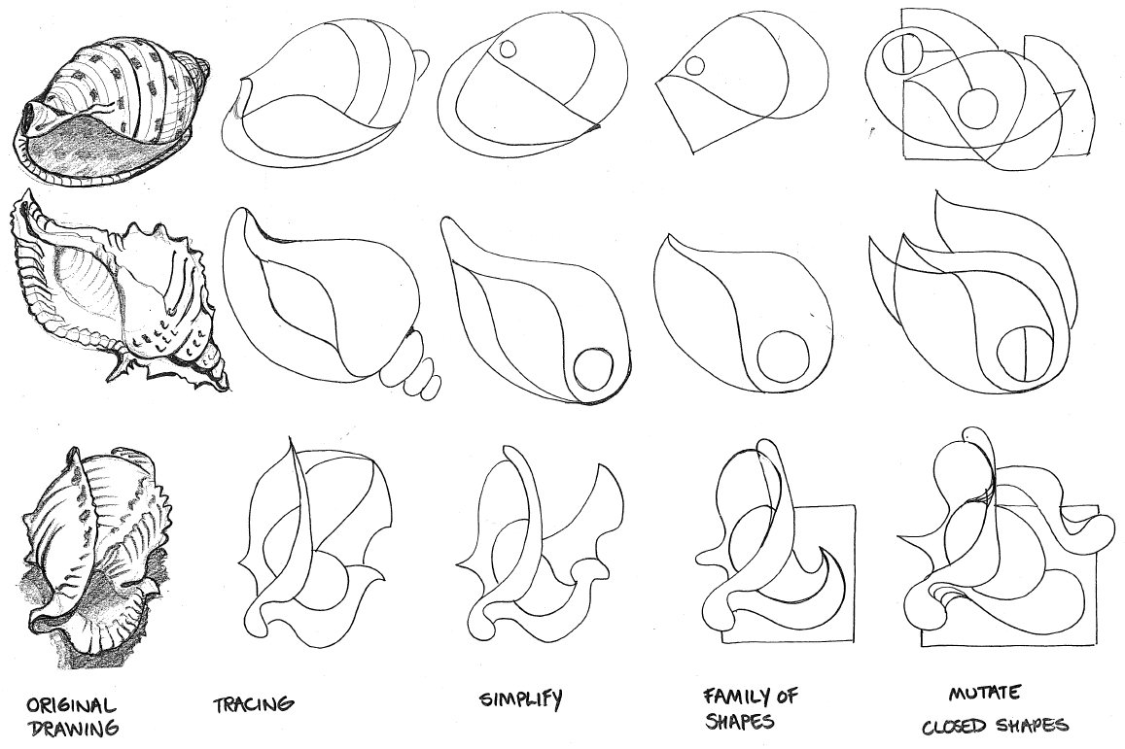
The following are examples of shells and their simplified abstract forms.

This investigation explores how complex functions, differentiation and integration can be used to create a graphic design for a fabric.

Introductory Task (Example):
A pattern has been designed below.
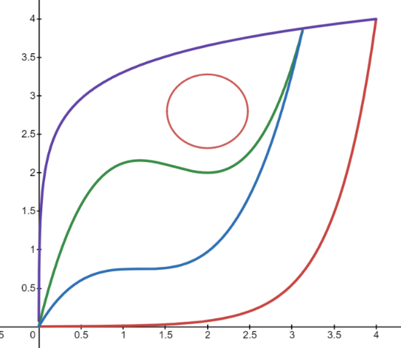

The following functions/relations have been used to design this pattern:
- one logarithmic function and its inverse
- two cubic functions
- one circle
Recommended function types:
$$y_{1}=f(x)=a_{1}\ln\left(b_{1}x+c_{1}\right)$$
$$y_{2}= f^{ -1}(x)$$
$$g\left(x\right)=a_{2}x^{3} + b_{2}x^{2}+c_{2}x+d_{2}$$
$$h\left(x\right)=a_{3}x^{3} + b_{3}x^{2}+c_{3}x+d_{3}$$
All constants are non-zero.
The relationship between the curves and shapes are given below:
- the four functions start at the origin
- the logarithmic function and its exponential inverse end at (4,4)
- the logarithmic function has $a_{1}=0.5$
- the point of inflection of the top cubic (green) is located at $x=1.6$
- the local maximum point of the top cubic (green) aligns vertically with the stationary point of inflection of the bottom cubic (blue)
- the local minimum point of the top cubic (green) is located at $(2, 2)$
- the two cubic functions always meet on the logarithmic function
- the circle must fit between the top cubic (green) and the logarithmic function
Based on the above information the four functions and the equation of the circle can be found and the relationships between them analysed. The circle may be found such that the circle fits within the shape developed by $y_{1} , y_{2} , g\left(x\right) and h(x)$.
(The above example can be used as a class activity. You are not required to present your findings in your report.)
PART 1
Create your own print design stating the type of composition structure used and based on the following requirements:
- In its final form your design should not exceed a A4 piece of paper.
- Use at least three different functions out of which:
- one complex function
- one derivative
- At least two areas should be in a ratio of your choice (you may consider the Golden ratio as a feature in your design when choosing colours for various areas).
- Create conditions for your functions with connections (e.g. inflection points and turning points could be common or intersecting other functions, etc..).
- For the final print, preferably 4 identical panels of the design should be joined together by using and manipulating functions’ transformation properties (e.g. vertical & horizontal dilation, reflection, rotation, etc…).
- At most three colours can be used and a statement of colour usage should be also included (area usage related).
- Calculations, interpretation of results and analysis should be comprehensive throughout the investigation.

PART 2
Investigate how the shape you designed is altered by considering changing the requirements set by your conditions above and/or by changing the coefficients.

Your investigation will be assessed using the following assessment design criteria
Concepts and Techniques
CT1 Knowledge and understanding of concepts and relationships.
CT2 Selection and application of mathematical techniques and algorithms to find solutions to problems in a variety of contexts.
CT3 Application of mathematical models.
CT4 Use of electronic technology to find solutions to mathematical problems.
Reasoning and Communication
RC1 Interpretation of mathematical results.
RC2 Drawing conclusions from mathematical results, with an understanding of their reasonableness and limitations.
RC3 Use of appropriate mathematical notation, representations, and terminology.
RC4 Communication of mathematical ideas and reasoning to develop logical arguments.
RC5 Development, testing, and proof of valid conjectures.

Performance Standards
- | Concepts and Techniques | Reasoning and Communication
A | Comprehensive knowledge and understanding of concepts and relationships.  Highly effective selection and application of mathematical techniques and algorithms to find efficient and accurate solutions to routine and complex problems in a variety of contexts.  Successful development and application of mathematical models to find concise and accurate solutions.  Appropriate and effective use of electronic technology to find accurate solutions to routine and complex problems. | Comprehensive interpretation of mathematical results in the context of the problem.  Drawing logical conclusions from mathematical results, with a comprehensive understanding of their reasonableness and limitations.  Proficient and accurate use of appropriate mathematical notation, representations, and terminology.  Highly effective communication of mathematical ideas and reasoning to develop logical and concise arguments.  Effective development and testing of valid conjectures, with proof.
B | Some depth of knowledge and understanding of concepts and relationships.  Mostly effective selection and application of mathematical techniques and algorithms to find mostly accurate solutions to routine and some complex problems in a variety of contexts.  Some development and successful application of mathematical models to find mostly accurate solutions.  Mostly appropriate and effective use of electronic technology to find mostly accurate solutions to routine and some complex problems. | Mostly appropriate interpretation of mathematical results in the context of the problem.  Drawing mostly logical conclusions from mathematical results, with some depth of understanding of their reasonableness and limitations.  Mostly accurate use of appropriate mathematical notation, representations, and terminology.  Mostly effective communication of mathematical ideas and reasoning to develop mostly logical arguments.  Mostly effective development and testing of valid conjectures, with substantial attempt at proof.
C | Generally competent knowledge and understanding of concepts and relationships.  Generally effective selection and application of mathematical techniques and algorithms to find mostly accurate solutions to routine problems in a variety of contexts.  Successful application of mathematical models to find generally accurate solutions.  Generally appropriate and effective use of electronic technology to find mostly accurate solutions to routine problems. | Generally appropriate interpretation of mathematical results in the context of the problem.  Drawing some logical conclusions from mathematical results, with some understanding of their reasonableness and limitations.  Generally appropriate use of mathematical notation, representations, and terminology, with reasonable accuracy.  Generally effective communication of mathematical ideas and reasoning to develop some logical arguments.  Development and testing of generally valid conjectures, with some attempt at proof.
D | Basic knowledge and some understanding of concepts and relationships.  Some selection and application of mathematical techniques and algorithms to find some accurate solutions to routine problems in some contexts.  Some application of mathematical models to find some accurate or partially accurate solutions.  Some appropriate use of electronic technology to find some accurate solutions to routine problems. | Some interpretation of mathematical results.  Drawing some conclusions from mathematical results, with some awareness of their reasonableness or limitations.  Some appropriate use of mathematical notation, representations, and terminology, with some accuracy.  Some communication of mathematical ideas, with attempted reasoning and/or arguments.  Attempted development or testing of a reasonable conjecture.
E | Limited knowledge or understanding of concepts and relationships.  Attempted selection and limited application of mathematical techniques or algorithms, with limited accuracy in solving routine problems.  Attempted application of mathematical models, with limited accuracy.  Attempted use of electronic technology, with limited accuracy in solving routine problems. | Limited interpretation of mathematical results.  Limited understanding of the meaning of mathematical results, their reasonableness or limitations.  Limited use of appropriate mathematical notation, representations, or terminology, with limited accuracy.  Attempted communication of mathematical ideas, with limited reasoning.  Limited attempt to develop or test a conjecture.

Mathematical Report
Introduction
- The purpose of the investigation (the type of functions that will be analysed, etc.)
- Any background information that may be useful (the scenario if you have been given one, definitions of terminology or methods that will be used in the investigation)
- An overview of the methods that will be used in the investigation.

Method and Results
- Each part must have a brief introduction and conclusion and a statement of results where appropriate
- The answers to all questions, with full working out
- Any necessary diagrams and graphs (labelled: Table 1, Graph 1, Figure 1, etc. to refer to within your discussion).
- Comments on observations made, following each graph/table/calculation.

* Main headings should be used to structure your work, but directed steps (a), (b), etc. should not be included in your final copy of the assignment.
Limitations, Reasonableness and Assumptions
- Factors that limit your results and observations or which bias your results
- Assumptions that are being made in the investigation about the accuracy of the results of methods used that may not be true for all cases or for real world applications and hence discuss the reasonableness.
- Improvements that could be made to improve the accuracy of the results given the assumptions and limitations highlighted.
Conclusion
- Provides a summary of results and observations (what DID you find out in this investigation?)
- Address the purpose of the investigation - at this stage you should reread your introduction to ensure that you have completed what you proposed to do.
- Answer the main question/aim/purpose of the investigation.
References
Use Harvard referencing style
Appendices
Any extra information as well as calculations that help to justify your answers that have not been included in the investigation (such as screen shots from various sources, Excel Worksheets with data used with formulas if used showing to justify the accuracy of calculations or additional calculations that can be checked for accuracy but don’t need to be repeated).

