2021 Music Performance – Solo Subject Assessment Advice
Overview
Subject assessment advice, based on the 2021 assessment cycle, gives an overview of how students performed in their school and external assessments in relation to the learning requirements, assessment design criteria, and performance standards set out in the relevant subject outline. They provide information and advice regarding the assessment types, the application of the performance standards in school and external assessments, and the quality of student performance.
Teachers should refer to the subject outline for specifications on content and learning requirements, and to the subject operational information for operational matters and key dates.
School Assessment
Assessment Type 1: Performance
Students present a solo performance, or set of performances, of a single work or a set of works by one or more composers to a maximum of 6–8 minutes.
The more successful responses commonly:
- presented a highly fluent and cohesive performance that demonstrated thorough preparation
- presented musical works that were soloistic in nature, i.e. students performed the predominant part in the music
- presented works that were appropriately aligned with the technical and musical capabilities of the student
- showed great attention to all musical aspects during the performance
- demonstrated consistently high control of tone, dynamics, intonation and fluency within the range of styles presented
- demonstrated a high level of musicianship in presenting a range of techniques
- demonstrated a confident level of engagement and stage presence
The less successful responses commonly:
- included performances that were under-prepared
- performed repertoire that was outside the scope of the student’s technical level
- demonstrated inconsistent technique and fluency within the performance of the repertoire
- presented works that limited students’ ability to demonstrate a variety of techniques or styles
- showed a partial understanding of the stylistic aspects of the repertoire
- prepared repertoire that was simplistic in nature
- presented a part of an ensemble work as a solo performance
- used backing tracks as accompaniment that included the solo part.

Additional advice for teachers
- Compress video files where possible to MP4 for quicker upload and download.
Assessment Type 2: Performance and Discussion
For this assessment type students present a solo performance or set of performances to a maximum of
6–8 minutes, of a single work or a set of works by one or more composers. This assessment also includes a discussion of key musical elements of the chosen repertoire, with a critique of strategies to improve and refine the student’s performance to a maximum of 800 words if written, 4 minutes as an oral presentation, or the multimodal equivalent.
The more successful responses commonly:
- demonstrated a high level of technique and confidence within the Performance(s)
- performed with poise and engaged with their repertoire
- addressed the structural and stylistic elements of the chosen repertoire within the Discussion
- included a discussion that focused on the analysis of a variety of musical elements
- addressed practice strategies used to develop and prepare their performance within the Discussion
- included consistent, accurate, and highly effective use of musical terminology
- gave a clear account of their repertoire discussing musical elements in detail, explaining how this informed their performance
- showed evidence of their understanding through relevant examples and annotations
- included a word count in the case of written Discussions
- featured students clearly in videoed performances.
The less successful responses commonly:
- did not submit the Discussion which is a requirement of Assessment Type 2
- submitted Discussions that focused on irrelevant historical and/or biographical aspects
- focused purely on analysis within the Discussion, and didn’t include refinements and strategies developed to improve their skills, technique or accuracy within the Performance
- submitted Discussions that focused more on evaluative features rather than analytical information
- did not use appropriate musical terminology within the Discussion
- did not elaborate on practice strategies used by the student in the development and preparation of their performance
- focused on a limited number of musical elements within the Discussion (e.g. dynamics, key signature, time signature)
- lacked technical fluency and stylistic understanding within the performance of the work(s)
- included performances that did not allow the student to demonstrate a variety of techniques and skills.
Additional advice for teachers
- Please include performance notes sheets in the moderation materials for each individual student.
- Teachers are encouraged to assist students in selecting repertoire that allows for an in-depth level of analysis.
- Ensure that the Discussion is submitted in a separate file with the performance. The focus of the Discussion should be on the musical elements — particularly analysis of structure and style, and practice strategies developed by the student to improve and refine their performance(s).

- Ensure students understand the differences between the purpose of the Discussion in Assessment Type 2, and the Evaluation in Assessment Type 3. The Discussion focuses on analytical and stylistic features of the repertoire (RM1), and practice techniques used to develop and refine the performance given in Assessment Type 2. The Evaluation in Assessment Type 3 focuses on an evaluation and critique of the final performance and the learning undertaken throughout the year (RM2).
- Mark all of the student’s evidence for the assessment type holistically. Teachers are reminded that there is no weighting to the Discussion. Teachers can mark against the features of the criteria as indicated in the diagram below:
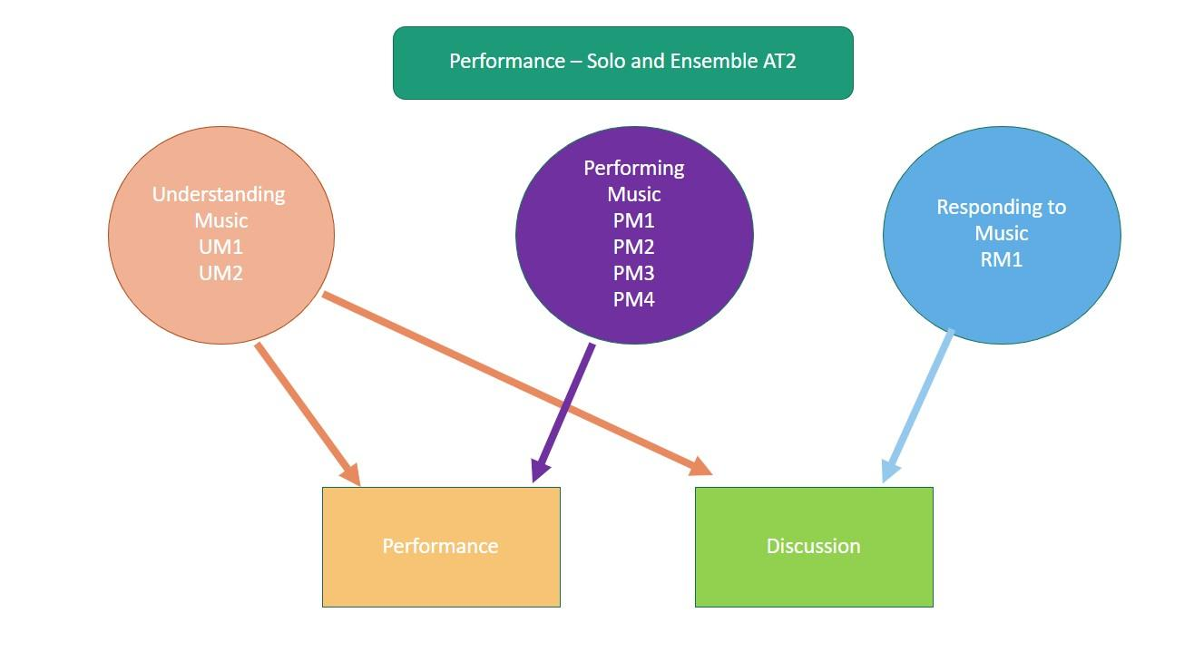
External Assessment
Assessment Type 3: Performance Portfolio
For this assessment type students present a solo performance or set of performances to a maximum of
6–8 minutes, of a single work or a set of works by one or more composers. This assessment also includes an evaluation of their learning journey to a maximum or 500 words if written, 3 minutes as an oral presentation, or the multimodal equivalent.
The more successful responses commonly:
- demonstrated a high level of technical facility and stylistic understanding within the performance
- reflected a high level of energy and focus throughout the performance
- ensured that the balance in the recording was satisfactory, where the student was heard clearly over the accompanying instrument
- demonstrated sophisticated control of tone and a wide variety of dynamics and articulations within the performance
- successfully critiqued skills, accuracy, and technique of the chosen repertoire within the Evaluation
- addressed how their preparation throughout their study influenced their final performance for the assessment
- critically evaluated their stage presence, engagement and confidence as a performer
- completed the Evaluation soon after the Performance had occurred
- avoided irrelevant, extensive biographical details about the composer/original recording artist.

The less successful responses commonly:
- did not submit the Evaluation
- made limited use of musical terminology in relation to the elements of music
- presented ensemble parts to a backing track that were outside the scope of the subject (i.e. presenting an ensemble performance as a solo performance)
- demonstrated limited use of dynamic contrast, a variety of articulations and a range of tone colours
- did not address how their preparation influenced their final performance for the assessment
- only evaluated their stage presence, engagement and confidence as a performer
- lacked detail or omitted a critique of skills relating to accuracy and technique within the Evaluation
- submitted Evaluations that made statements without providing supporting evidence or examples
- analysed the structure and style of the chosen repertoire (this is assessed in the Discussion in Assessment Type 2)
- lacked technical fluency and accuracy within the performance
- lacked attention to detail of musical indications marked on the score (where provided).
Additional advice for teachers
- Teachers should include musical scores relevant to the chosen repertoire to support student achievement.
- Ensure the Evaluation is submitted for each and every student. The focus of the evaluation should be on performance preparation, critique of their performance and aspects of stage presence. Refer to the subject outline for further detail.
- Ensure students understand the differences between the purpose of the Evaluation in Assessment Type 3 and the Discussion in Assessment Type 2. The Discussion focuses on analytical and stylistic features of the repertoire (RM1), and practice techniques used to develop and refine the performance given in Assessment Type 2. The Evaluation in Assessment Type 3 focuses on an evaluation and critique of the final performance as well as their learning throughout the year (RM2).
- Take note of the differences in the discussion points between the two performance subjects (Solo and Ensemble). Refer to the subject outline for further details.
- Mark all of the student’s evidence for the external assessment AT3 holistically. Teachers are reminded that there is no weighting to the Evaluation. Teachers should mark against the features of the criteria as indicated in the diagram below:

